MA473 – Computational Finance Laboratory

Lab – 12

Dipanshu Goyal 210123083

# Question – 1

FTCS

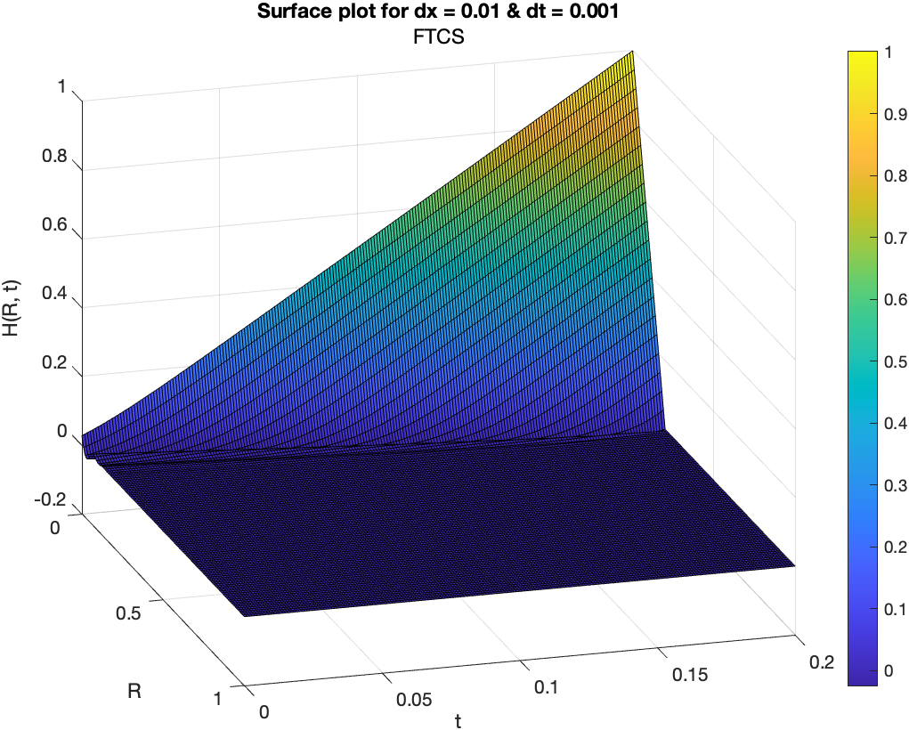

BTCS

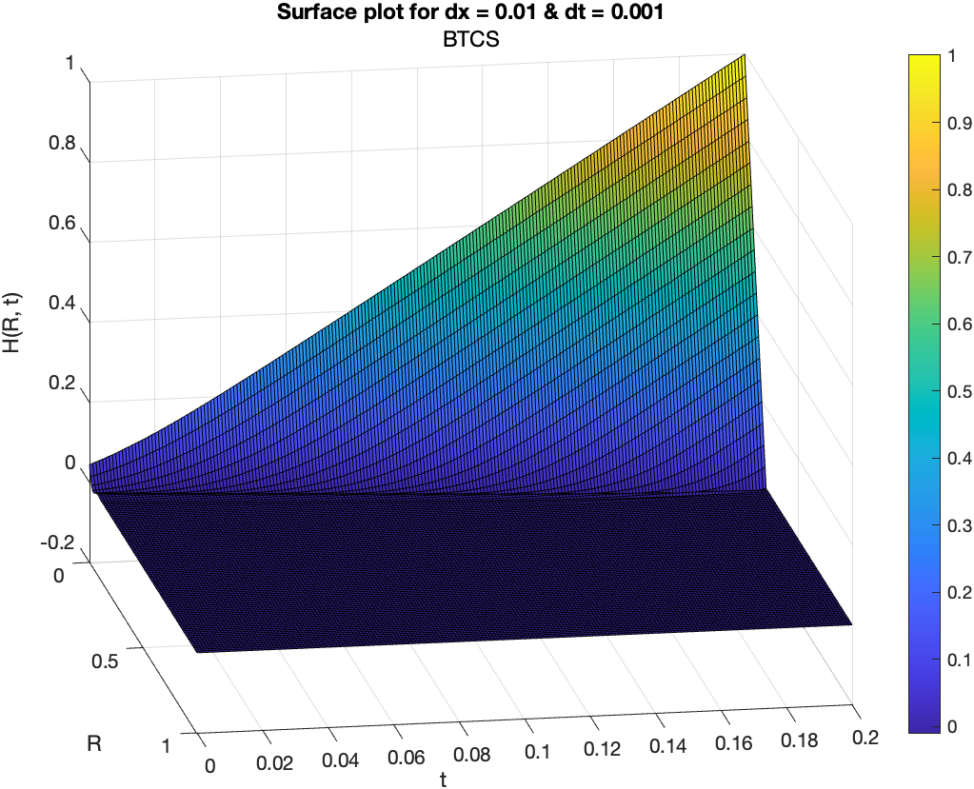

CTCS

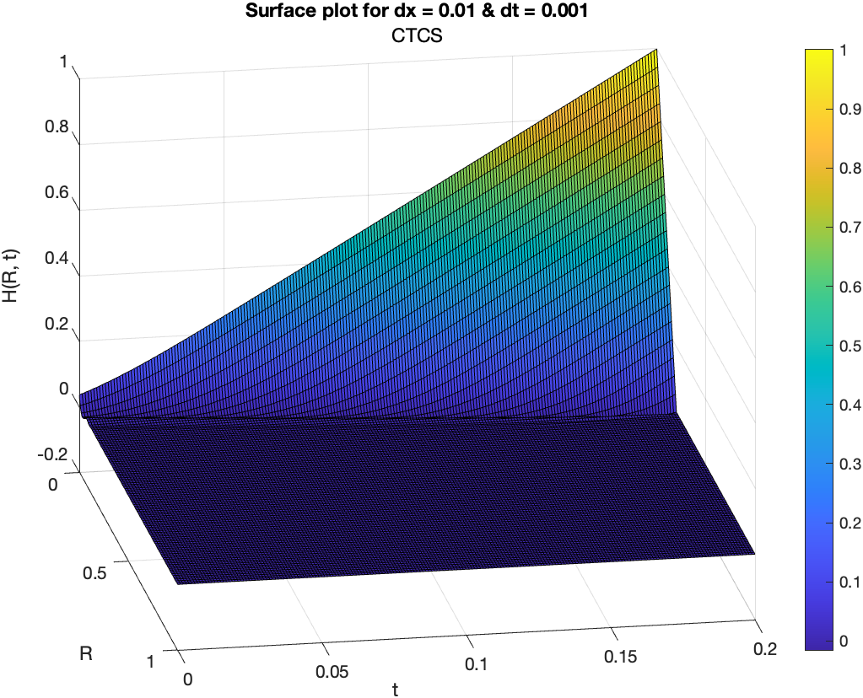

# Question – 2

FTCS



BTCS



CTCS

