MA473 – Computational Finance Laboratory

Lab – 13

Dipanshu Goyal 210123083

# Question – 1

The exact solution of the Black-Scholes diffusion equation is:

𝑋(𝑡) = 𝑋(0) exp ((𝜇 − 0.5σ2)𝑡 + 𝜎𝑊(𝑡))

After solving the SDE using Euler-Maruyama method and First-order Milstein Scheme, following order of convergence plot was constructed (loglog plot):

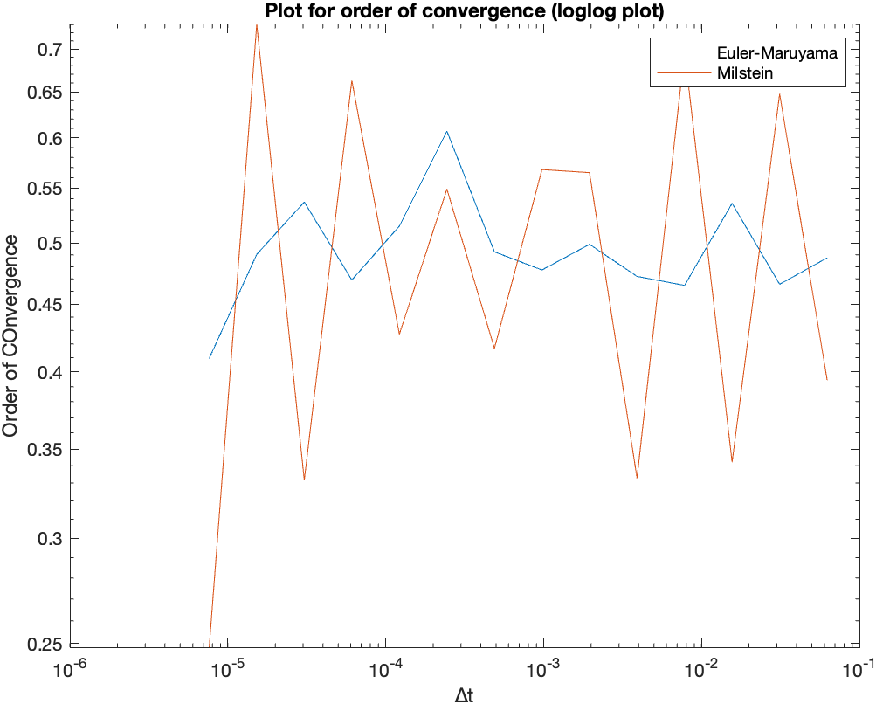

**Observations:**

We can observe that the Euler-Maruyama method has order of convergence fluctuating around 0.5 while the Milstein scheme shows somewhat higher convergence rate than the Maruyama method.

# Question – 2

After solving the SDE using Euler-Maruyama method and First-order Milstein Scheme,

following order of convergence plot was constructed (loglog plot):

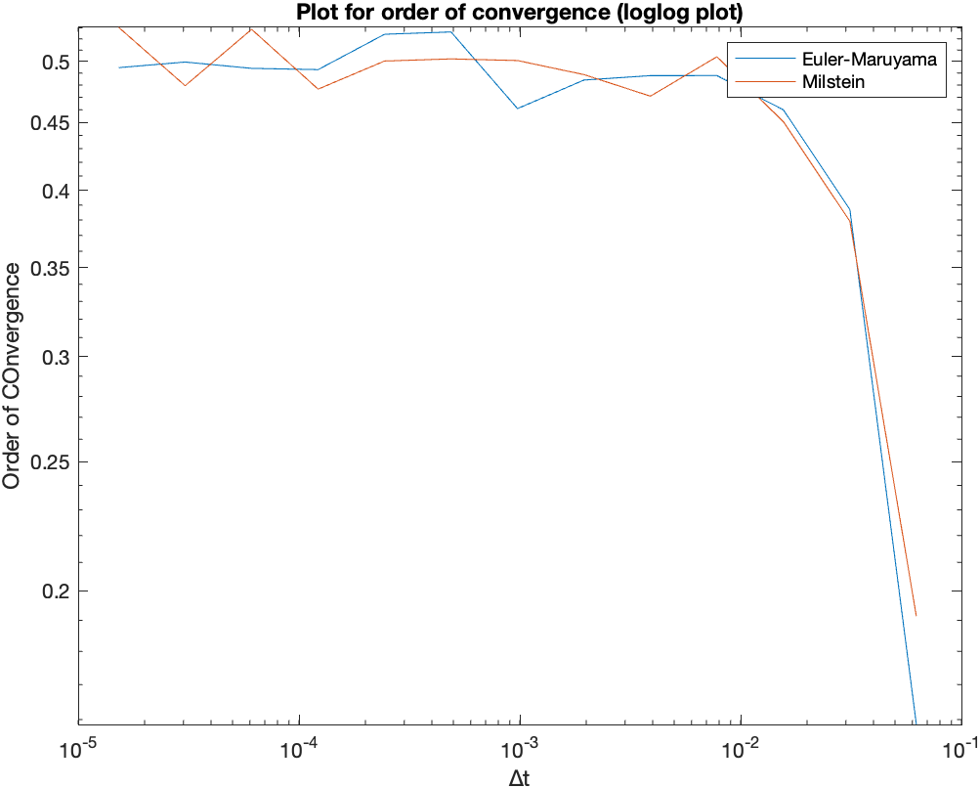

**Observations:**

We can observe that both the schemes show similar order of convergence in Langevin SDE

because the b’(X) term is 0 in Milstein scheme. Hence both the schemes become equivalent

and has order of convergence 0.5, which is also demonstrated by the plot.