CardioMRI v2.0



User Manual

Fall 2015 Sr Design Group

Dillon Beck
Josh Farrar
F. Davis Quarles
Kullen Williams

CardioMRI User Manual by Dillon Beck, Josh Farrar, F. Davis Quarles, Kullen Williams is licensed under a Creative Commons Attribution-NonCommercial-ShareAlike 4.0 International License.

The accompanying Software CardioMRI, unless specified otherwise, is covered by GNU General Public License v2.0

Copyright (c) 2015, Dillon Beck, Josh Farrar, F. Davis Quarles, Kullen Williams, Dr. Thomas Denney

This Software also contains software libraries under the following licenses

PixelMed™ Java DICOM Toolkit

Copyright (c) 2001-2015, David A. Clunie DBA PixelMed Publishing. All rights reserved.

BSD-3 License

JUnit

Copyright © 2002-2015 JUnit. All Rights Reserved.

Eclipse Public License – v1.0
Table of Contents
1. Preface 1
2. Installation 2
Windows 7/8/10 2
Mac OS X 2
Linux 2
Developer Installation 2
3. Operation 4
Main Interface 4
Start Up 5
Annotation 10
Contours 10
Landmarks 12
Saving/Loading Contours and Landmarks 14
Saving 14
Loading 15
Exporting 16
5. Frequently Asked Questions 17
6. Developer Contact Information 18

1. Preface
This software allows a cardiologist to annotate sequences of images of a heart for various purposes. The heart images are created by MRI scans, and produce slices for multiple axis. The cardiologist will be able to mark a section of a heart with a curve on two slices, and these curves can be exported to an external program that will calculate the intermediate curves and then calculate the volume of the heart from the curves. The cardiologist will also be able to mark certain “landmark” points in the images, which will allow tracking of important heart landmarks. These annotations will ultimately help researchers better analyze MRI scans of hearts, and reduce some of their workload by compiling several useful functions into a single piece of software. This Software is provided in the hopes it will be useful.

Thanks to
Dr. Thomas Denney
Dr. Richard Chapman
Austin Hancock
All The Senior Design Groups who came before us on this project
Auburn University

2. Installation

Windows 7/8/10
Requirements: Java Runtime Environment
Download the JAR file and place it in the directory of your choosing
To run the program, double click on the JAR

Mac OS X
Requirements: Java Runtime Environment
Download the JAR file and place it in the directory of your choosing
To run the program, double click on the JAR

Linux
Requirements: Java Runtime Environment
Download the JAR file and place it in the directory of your choosing
To run the program, double click on the JAR

Developer Installation
Requirements:
Eclipse Integrated Development Environment
JDK 1.8
Git
Import Source:
Open Eclipse then File → Import.
Open the Git folder and select Projects from Git and click next.
On the next screen select Clone URI and click next.
Input https://github.com/kullen/MRI.git into the URI field and click next
Select the branches you would like to clone and click Next. This step is optional as they are all selected by default, just click Next.
Provide the directory you would like the project to be located in and click Next.
Import the CardioMRI project into Eclipse. After this is complete you will be able to modify the project. Thanks for contributing!

3. Operation

Main Interface
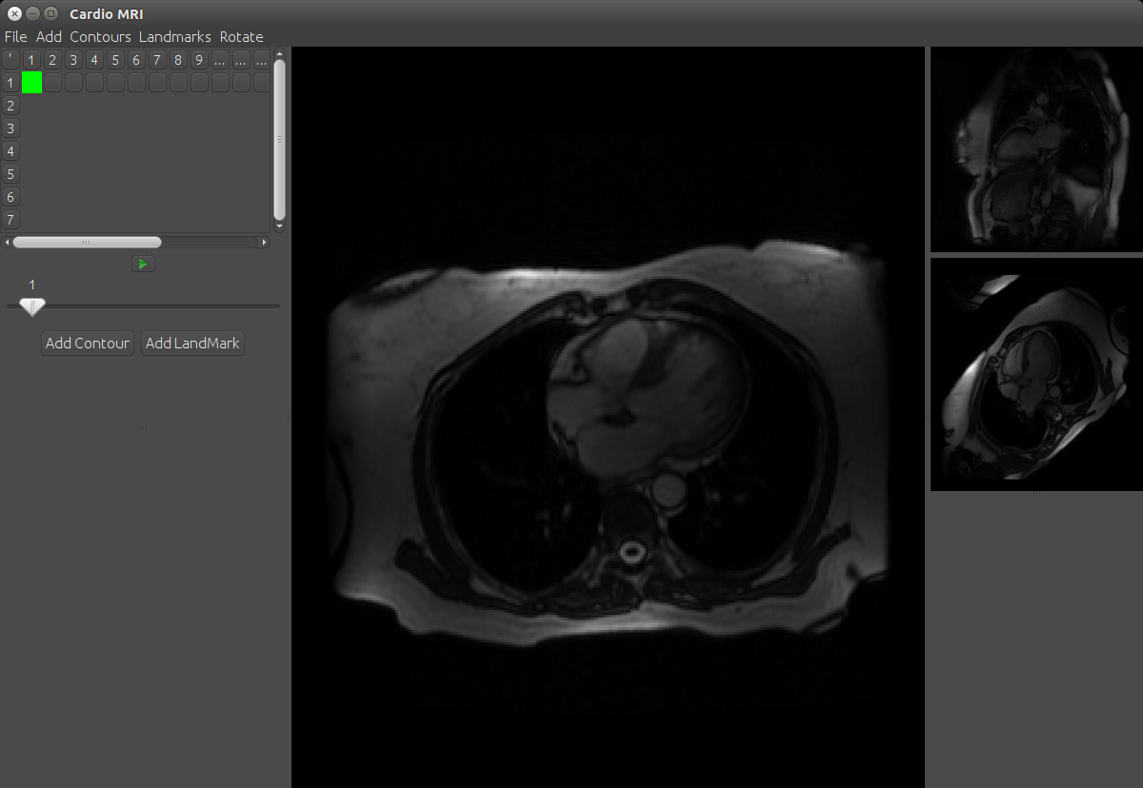
[2]
[3]
[5]
[6]
[7]
[4]
[1]
[1] Main Image Area
Area where active editing of the image takes place.
[2] Image Grid Control Area
Shows which image you are currently editing. Rows are time in the series; Columns are slices.
[3] Play/Stop Button
Controls the animation of the series.

[4] Speed Control
This slider controls how fast the animation plays
[5] Add Contour
Select this to add a new contour.
[6] Add Landmark
Select this to add a new Landmark.
[7] Other Views
This shows the other views you selected while setting up the study. Rotate on the menu will move the next image into the Main Image Area

Start Up
New Study
Select New Study on the presented menu.
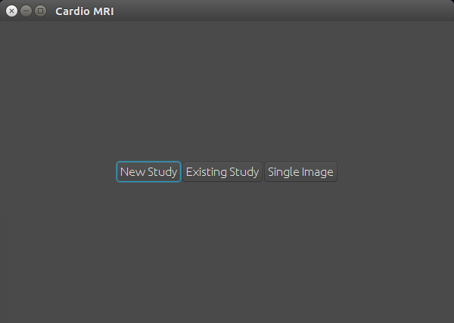

Select a folder containing a MRI study and click Ok.
NOTE: On less powerful machines this step may take some time, please be patient.
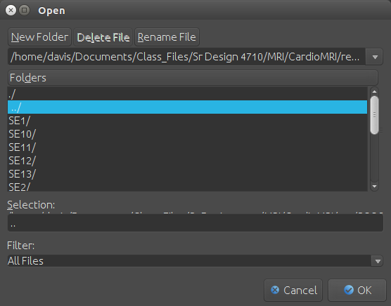

Select the appropriate options for the selected study. Then click Continue.
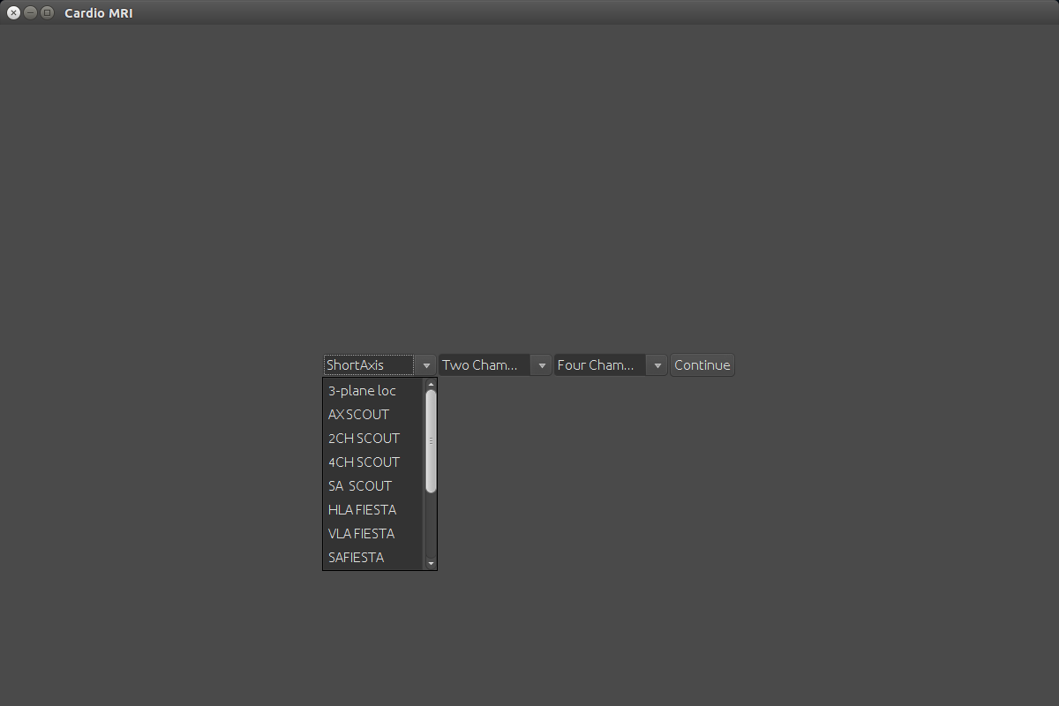

You will now be at the main interface for the program.

Annotation

Contours
Select Add Contour button, and Select the appropriate contour.
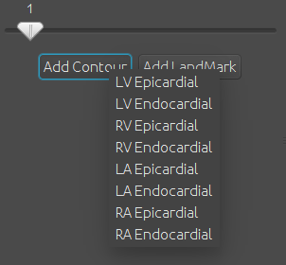

Once you have selected the appropriate contour, begin adding points in the main image area, by clicking where you want a control point to be added.
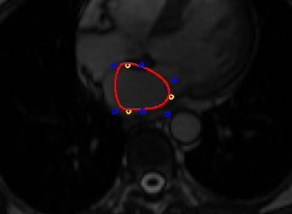
Control Points
Tension Points

The Control Points set the primary features of the contour. The Tension points edit the shape of the adjacent sections of the contour.
NOTE: By default the tension points are set to Locked, meaning the curve remains smooth through the control point. This can be changed by right clicking on the Control Point and changing its Locked status.
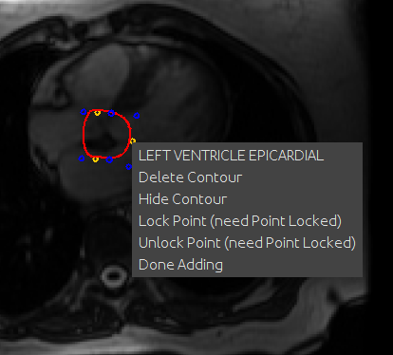

This menu also contains information about the selected Contour, as well as the option to Delete Contour/Hide Contour the contour, and to finish adding control points by selecting Done Adding

Landmarks
Select the Add Landmark button, and select the appropriate landmark type.
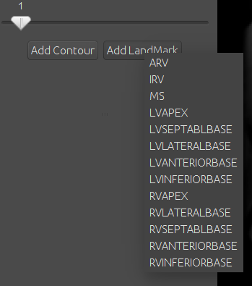

Then click where you would like the Landmark to be added in the Main Image area. Landmarks are shown as crosses.
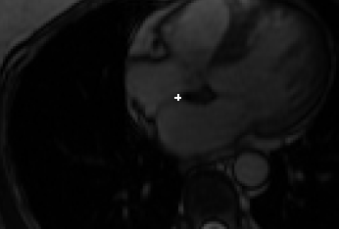

Repeat this process until all landmarks have been added.
Right Click on a landmark to see more information about it, or to hide or delete it.
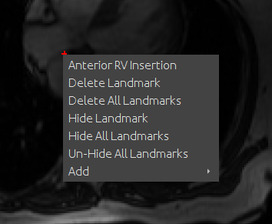

NOTE: Hidden Contours and Images can be un-hidden in the menu bar under the appropriate Contours or Landmarks Menu

Saving/Loading Contours and Landmarks

Saving
To save a study click Contours in the menu bar. Then select Save Contours.
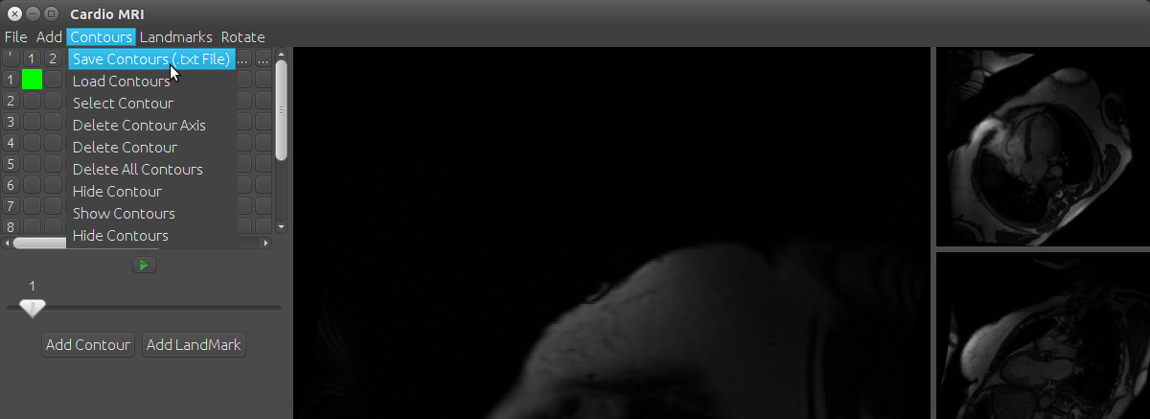
NOTE: Save and Save As currently do not save the study.
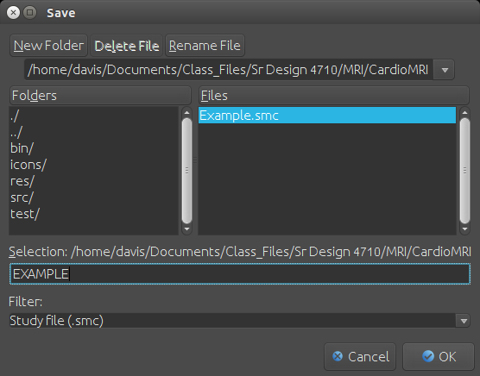
In the next window give the file a name (EXAMPLE in the image below). Then click Ok.

Loading
To load an existing study, click Contours in the menu bar, then click Load Contours.
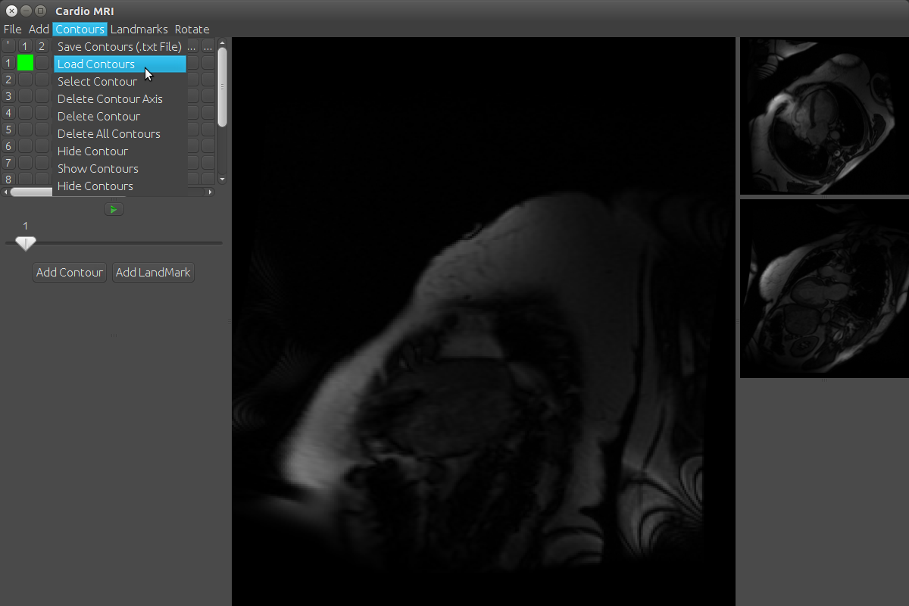
You will then be presented with a window to select the appropriate file. Select the appropriate file, then click Ok.
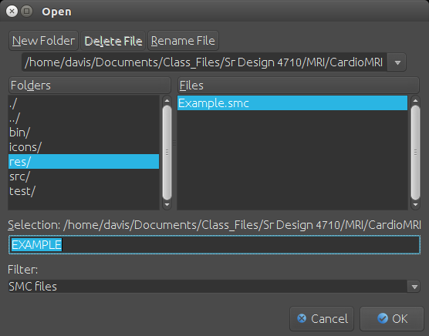

Exporting
In previous versions the saving of the study and exporting of contours for analysis in other programs. In this version the same file made by saving contours, saves the study as well as having the information for analysis.
To export click Contours then Save Contours
You will then be presented with a window to select the appropriate file. Select the appropriate file, then click Ok.
This file can then be imported for analysis.

5. Frequently Asked Questions
Q. How do I export the annotations for analysis?
A. Go to the Contours menu and select save contours. Then save the file. This file can be imported for analysis.
Q. How can I tell which contour or landmark is which?
A. Right click on the object of interest. The first line in the context menu is the Type for each.
Q. What is the answer to life the universe and everything?
A. Forty-Two.
Q. When I move one tension point another one moves?
A. This is intentional behavior. This ensures the contour is smooth through the control point. If you need to draw a sharp corner, right click the control point and click unlock smooth.
Q. How can I Delete a control point or landmark?
A. Right click on the point and click Delete.
Q. I have to many objects and it is difficult to see my work?
A. You can hide individual contours and landmarks, or hide all the objects for an easier editing experience.

6. Developer Contact Information
Sr Design Group Fall 2015
Dillon Beck, Auburn University DAB0021@auburn.edu
Josh Faraar, Auburn University JKF0008@auburn.edu
F. Davis Quarles FDQ0001@auburn.edu
Kullen Williams KWA0026@auburn.edu

Source Code can be found at https://github.com/kullen/MRI
Project Documentation can be found at https://tree.taiga.io/project/squarles2007-mri/

