
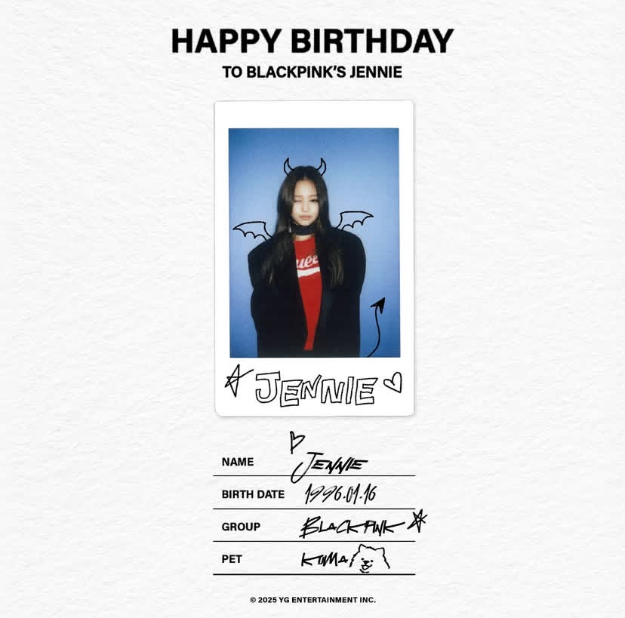
INFAAN
3//05//GGGG
HAPPY BIRTHDAY
L L {LITTLE LION}
INFAAN

