Tesseract installed

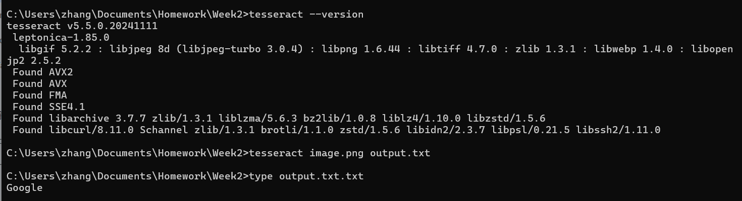

Working with Python too:  
