Design and Implementation

Cameron Farzaneh, Greg Bertolacci  
[cfarzaneh3@gatech.edu](mailto:cfarzaneh3@gatech.edu), gbertolacci3@gatech.edu

# Summary

With the current push for Electronic Health Records and other healthcare information it is important for data and processes to be standardized and interoperable. This is where Fast Healthcare Interoperability Resources (FHIR) comes in. “The HL7® FHIR® standard defines how healthcare information can be exchanged between different computer systems regardless of how it is stored in those systems” (What Is FHIR®?).

With so many different groups trying to standardize their data using FHIR there is bound to be overlap an in efforts. Currently, the FHIR team is un-able to identify what projects overlap and what projects are still active. Because there are limited resources to provide support, it is important for the FHIR team to know where to invest their efforts and reduce redundancy.

This project aims to provide insight into metadata, provided by Implementation Guides, on which projects are currently being developed and which projects have overlapping dependencies. By providing this information resources can be better allocated to ongoing projects.

# Tools and Technology

For this project we will make use of:

* FHIR release 4
* FHIR Package Registry – to provide data on Implementation Guides
* Python – to process and analyze data
* JSON files – to extract data from FHIR packages
* Lucid Charts – to visualize and plan our concepts
* HTML – to display information
* CSS – to present the information in a friendly way
* GH Pages

# Data Source

The data that this project will use comes from the FHIR package registry and provides FHIR Implementation Guides or IG. These guides provide contents on how these packages should be used and what they should be used for. These IGs also provide examples on how to use the packages to help aid in deployment.

The FHIR package registry has thousands of resources that are stored “like a directory with a JSON file-per-resource” and these resources use the Node Package Manager standard (What are FHIR PACKAGES?).

# Architecture Diagram

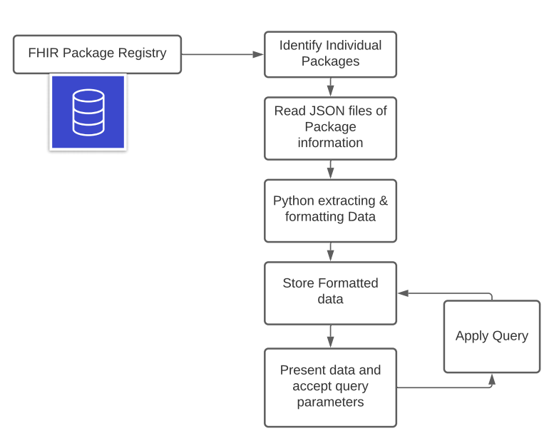

1. Architecture Diagram, Made in LucidChart (Lucid Chart)

# Screen Mock-Ups

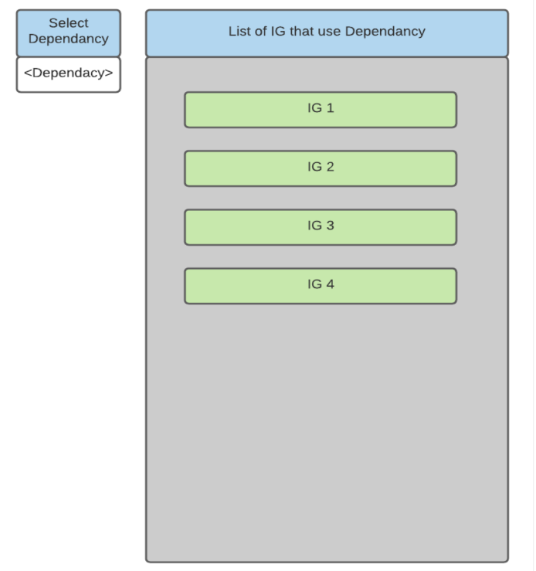

1. 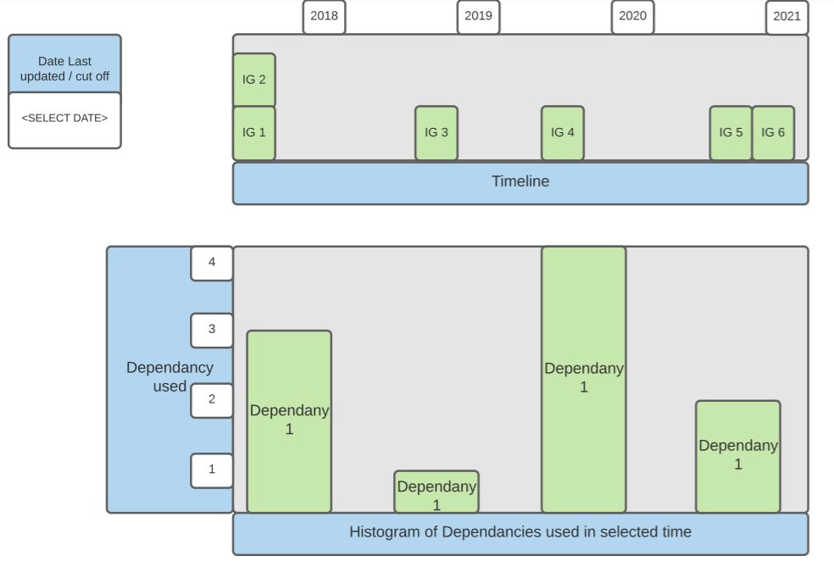List of IGs that contain a specific Dependency, Made in LucidChart (Lucid Chart)
2. Timeline of IGs by date of last commit, made in LucidChart (Lucid Chart)

# Project Tasks and risks

The tasks for this project include:

* first understanding what Implementation Guides consist of and how to interact with them. Here we will need to make sure we reach out if we have questions early.
* The next step is to then build a function to pull 1 IG and then multiple IGs into Python.
* Once the data is in Python the task is to extract the information that we need and think about how to present it. A risk here is that we need to be careful with how we clean the data and mindful of how we store the formatted data.
* Then we need to figure out and finalize what graphs work best to convey the information that we have gathered and begin to present the data in GH Pages or some other deployment structure.
* During the final week we will finalize the UI and submit the project

# PRoject Timeline

1. Gantt Project Timeline, Made in Gantt Project (S.r.o)

# References

1. What Is FHIR®? (n.d.). Retrieved March 19, 2021, from https://www.healthit.gov/sites/default/files/2019-08/ONCFHIRFSWhatIsFHIR.pdf
2. What are FHIR PACKAGES? (n.d.). Retrieved March 20, 2021, from http://registry.fhir.org/learn
3. S.r.o, B. (n.d.). Free project management tool for Windows, macOS and Linux. Retrieved March 20, 2021, from https://www.ganttproject.biz/
4. Lucid Chart. (n.d.). Retrieved March 20, 2021, from https://lucid.app/documents#/dashboard