EXPERIMENT NO.:- 02

NAME:- UMAR FAROOQUE ROLL NO:- 21CO57

BATCH:- 4

Star Schema for DATA WAREHOUSE FOR TEXTILE INDUSTRY

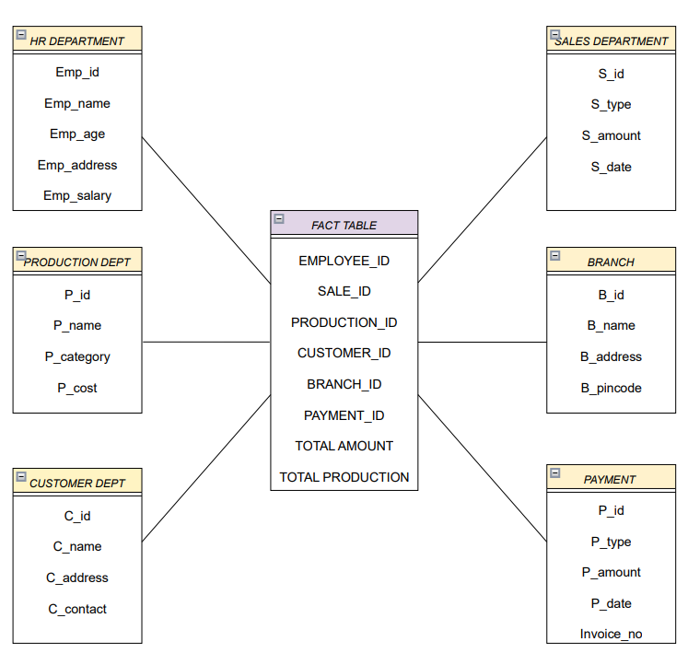

Snowflake Schema for DATA WAREHOUSE FOR TEXTILE INDUSTRY

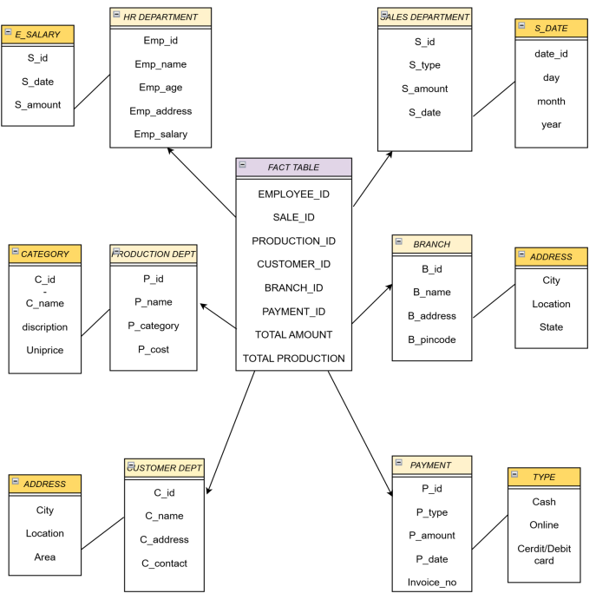

Conclusion:- Hence,we have created the star & snowflake schemas of the Textile Industry to learn about the Data Mining process.

