EXPERIMENT NO.:- 03

NAME:- Umar Farooque ROLL NO:- 21CO57

BATCH:- 4

OLAP operations for DATA WAREHOUSE FOR TEXTILE INDUSTRY

OLAP stands for Online Analytical Processing Server. It is a software technology that allows users to analyze information from multiple database systems at the same time. It is based on a multidimensional data model and allows the user to query on multi-dimensional data. OLAP databases are divided into one or more cubes and these cubes are known as Hyper-cubes.

1) Drill Down : In drill-down operation, the less detailed data is converted into highly detailed data. It can be done by:
- Moving down in the concept hierarchy
- Adding a new dimension
In the cube given in the overview section, the drill down operation is performed by moving down in the concept hierarchy of Time dimension (Quarter - Month).

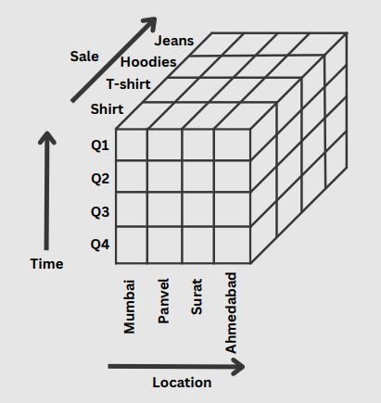

2) Roll Up : It is just the opposite of the drill-down operation. It performs aggregation on the OLAP cube. It can be done by:
- Climbing up in the concept hierarchy
- Reducing the dimensions
In the cube given in the overview section, the roll-up operation is performed by climbing up in the concept hierarchy of Location dimension (City - States).

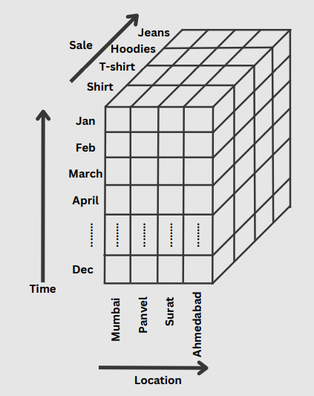
3) Dice : It selects a sub-cube from the OLAP cube by selecting two or more dimensions. In the cube given in the overview section, a sub-cube is selected by selecting following dimensions with criteria :

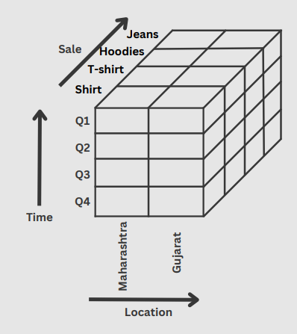

4) Slice : It selects a single dimension from the OLAP cube which results in a new sub-cube creation. In the cube given in the overview section, Slice is performed on the dimension Time = “Q1”.
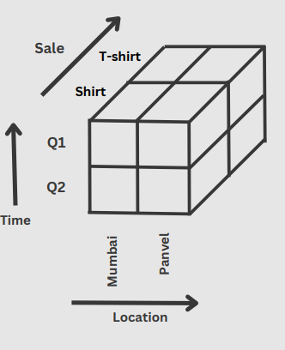
5) Pivot : It is also known as rotation operation as it rotates the current view to get a new view of the representation. In the sub-cube obtained after the slice operation, performing pivot operation gives a new view of it.
