Experiment No. 07

Aim: Implementation of clustering algorithm (K-means)

Name of Student | Umar Farooque
Roll No. | 21CO57
Batch | 4

Theory:
K-means is one of the most popular Unsupervised Machine Learning Algorithms Used for Solving Classification Problems in data science and is very important if you are aiming for a data scientist role. K Means segregates the unlabeled data into various groups, called clusters, based on having similar features and common patterns. This tutorial will teach you the definition and applications of clustering, focusing on the K means clustering algorithm and its implementation in Python. It will also tell you how to choose the optimum number of clusters for a dataset.

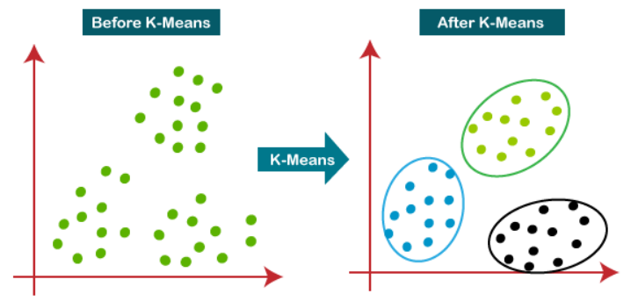

What is k-means Clustering?
K-means clustering is the simplest clustering algorithm. In the K-Clustering algorithm, the dataset is partitioned into K clusters. An objective function is used to find the quality of partitions so that similar objects are in one cluster and dissimilar objects in other groups. In this method, the centroid of a cluster is found to represent a cluster. The centroid is taken as the center of the cluster which is calculated as the mean value of points within the cluster. Now the quality of clustering is found by measuring the Euclidean distance between the point and center. This distance should be maximum.

Implementation of the K-Means Algorithm :
Step 1 : Select the value of K to decide the number of clusters (n_clusters) to be formed.

Step 2 : Select random K points that will act as cluster centroids (cluster_centers).

Step 3 : Assign each data point, based on their distance from the randomly selected points (Centroid), to the nearest/closest centroid, which will form the predefined clusters.

Step 4 : Place a new centroid of each cluster.

Step 5 : Repeat step no.3, which reassigns each datapoint to the new closest centroid of each cluster.

Step 6 : If any reassignment occurs, then go to step 4; else, go to step 7.

Step 7 : Finish

Program :
import pandas as pd
import matplotlib.pyplot as plt

# Reading the database
data = pd.read_csv('cluster.csv')

print("\n")
# Printing the data
print(data.head())

plt.title('K-means Algorithm')

plt.scatter(data['Longitude'],data['Latitude'])
plt.xlim(-180,180)
plt.ylim(-90,90)

# Adding the legends
plt.show()

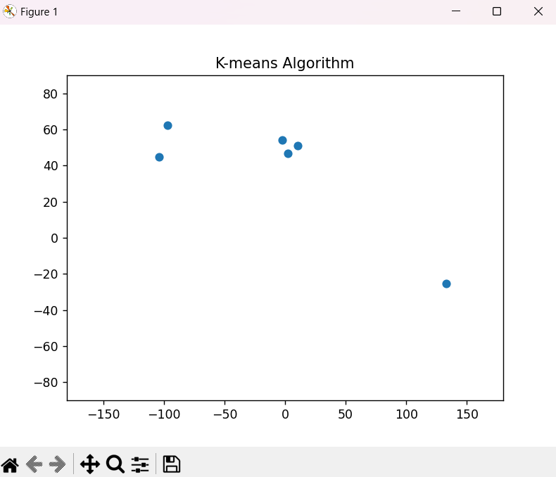
Output :

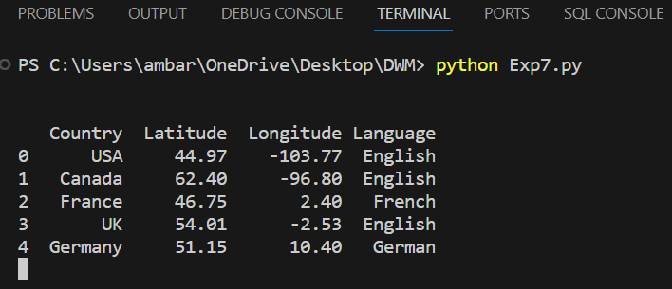

Conclusion :
In conclusion, K-means clustering is a key unsupervised machine learning algorithm widely used in data science for classification. It divides unlabeled data into clusters based on similar features and patterns. The goal is to optimize clustering quality, ensuring similar objects are in one cluster and dissimilar ones in separate clusters. This is achieved by computing centroids (cluster centers) as mean values of cluster points and using the Euclidean distance to evaluate clustering quality..

