Experiment No. 08

Aim: Implementation of clustering methods

Name of Student | Umar Farooque
Roll No. | 21CO57
Batch | 4

Theory :
- Hierarchical Clustering:
Hierarchical clustering is another unsupervised machine learning algorithm, which is used to group the unlabeled datasets into a cluster and also known as hierarchical cluster analysis or HCA. In this algorithm, we develop the hierarchy of clusters in the form of a tree, and this tree- shaped structure is known as the dendrogram.
Hierarchical Clustering is of two types :

Divisive Hierarchical Clustering :
Divisive Hierarchical Clustering is also termed as a top-down clustering approach. In this technique, entire data or observation is assigned to a single cluster. The cluster is further split until there is one cluster for each data or observation.

Agglomerative Hierarchical Clustering :
Agglomerative Hierarchical Clustering is popularly known as a bottom-up approach, wherein each data or observation is treated as its cluster. A pair of clusters are combined until all clusters are merged into one big cluster that contains all the data.

Agglomerative Hierarchical clustering Algorithm :
Let X = {x₁, x₂, x₃, ..., x_{n}} be the set of data points.
- Begin with the disjoint clustering having level L(0) = 0 and sequence number m = 0.
- Find the least distance pair of clusters in the current clustering, say pair (r), (s), according to d[(r), (s)] = min d[(i), (j)] where the minimum is over all pairs of clusters in the current clustering.
- Increment the sequence number: m = m +1. Merge clusters (r) and (s) into a single cluster to form the next clustering m. Set the level of this clustering to L(m) = d[(r), (s)].
- Update the distance matrix, D, by deleting the rows and columns corresponding to clusters (r) and (s) and adding a row and column corresponding to the newly formed cluster. The distance between the new cluster, denoted (r,s) and old cluster(k) is defined in this way: d[(k), (r,s)] = min (d[(k),(r)], d[(k),(s)]).
- If all the data points are in one cluster, then stop, else repeat from step 2).

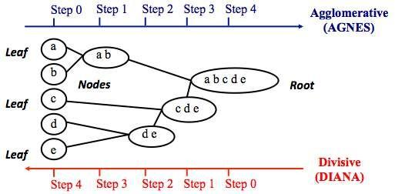
b. Divisive Hierarchical clustering - It is just the reverse of Agglomerative Hierarchical approach.
Program :
import matplotlib.pyplot as plt
import pandas as pd
import scipy.cluster.hierarchy as sc
from sklearn import datasets
from sklearn.cluster import AgglomerativeClustering

# Import iris data
iris = datasets.load_iris()

iris_data = pd.DataFrame(iris.data)
iris_data.columns = iris.feature_names
iris_data["flower_type"] = iris.target
iris_data.head()

# Visualize the classes
iris_X = iris_data.iloc[:, [0, 1, 2, 3]].values
iris_Y = iris_data.iloc[:, 4].values
plt.figure(figsize=(10, 7))
plt.scatter(
iris_X[iris_Y == 0, 0], iris_X[iris_Y == 0, 1], s=100, c="blue", label="Type 1"
)
plt.scatter(
iris_X[iris_Y == 1, 0], iris_X[iris_Y == 1, 1], s=100, c="yellow", label="Type 2"
)
plt.scatter(
iris_X[iris_Y == 2, 0], iris_X[iris_Y == 2, 1], s=100, c="green", label="Type 3"
)
plt.legend()
plt.show()
# Plot dendrogram plt.figure(figsize=(20, 7)) plt.title("Dendrograms")
# Create dendrogram
sc.dendrogram(sc.linkage(iris_X, method="ward"))

plt.title("Dendrogram")
plt.xlabel("Sample index")
plt.ylabel("Euclidean distance")

cluster = AgglomerativeClustering(n_clusters=3, affinity="euclidean", linkage="ward")
cluster.fit(iris_X)
labels = cluster.labels_
print(labels)
plt.figure(figsize=(10, 7))
plt.scatter(
iris_X[labels == 0, 0], iris_X[labels == 0, 1], s=100, c="blue", label="Type 1"
)
plt.scatter(
iris_X[labels == 1, 0], iris_X[labels == 1, 1], s=100, c="yellow", label="Type 2"
)
plt.scatter(
iris_X[labels == 2, 0], iris_X[labels == 2, 1], s=100, c="green", label="Type 3"
)
plt.legend()
plt.show()

Output :
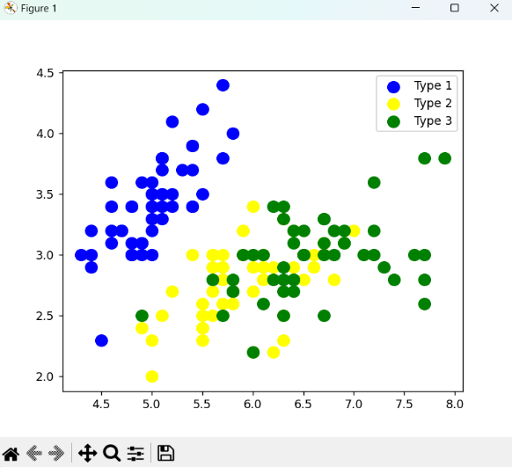
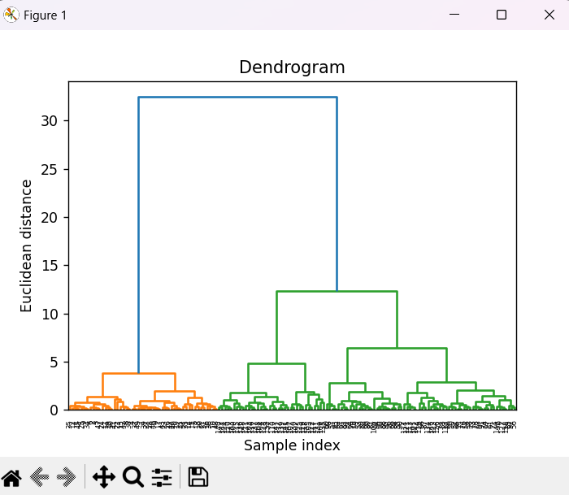

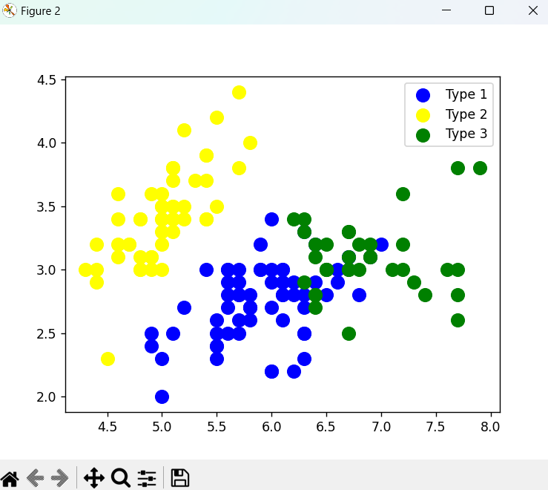
Conclusion :
Thus, we successfully implemented the Hierarchical Clustering method.

