What software development model would we use for our social media app development and why ?
Kanban is a workflow management system that helps teams visualize work, limit work-in-progress, and maximize efficiency. It is a lightweight framework that can be used in any industry or project.

The Kanban model is based on three key principles:

Visualize work: The first step is to visualize all of the work that needs to be done. This can be done using a Kanban board, which is a physical or digital board that shows the different stages of work, such as "To Do," "In Progress," and "Done."

Limit work-in-progress: Once you have visualized all of the work, you need to limit the amount of work that is in progress at any given time. This helps to ensure that teams are not overloaded and that work is flowing smoothly.

Maximize flow: The goal of Kanban is to maximize the flow of work. This means that teams should be able to move work through the different stages of the workflow quickly and efficiently.

The Kanban model is a simple but effective way to manage work. It is a good fit for teams that need to be able to adapt to changing priorities and that want to improve their efficiency.

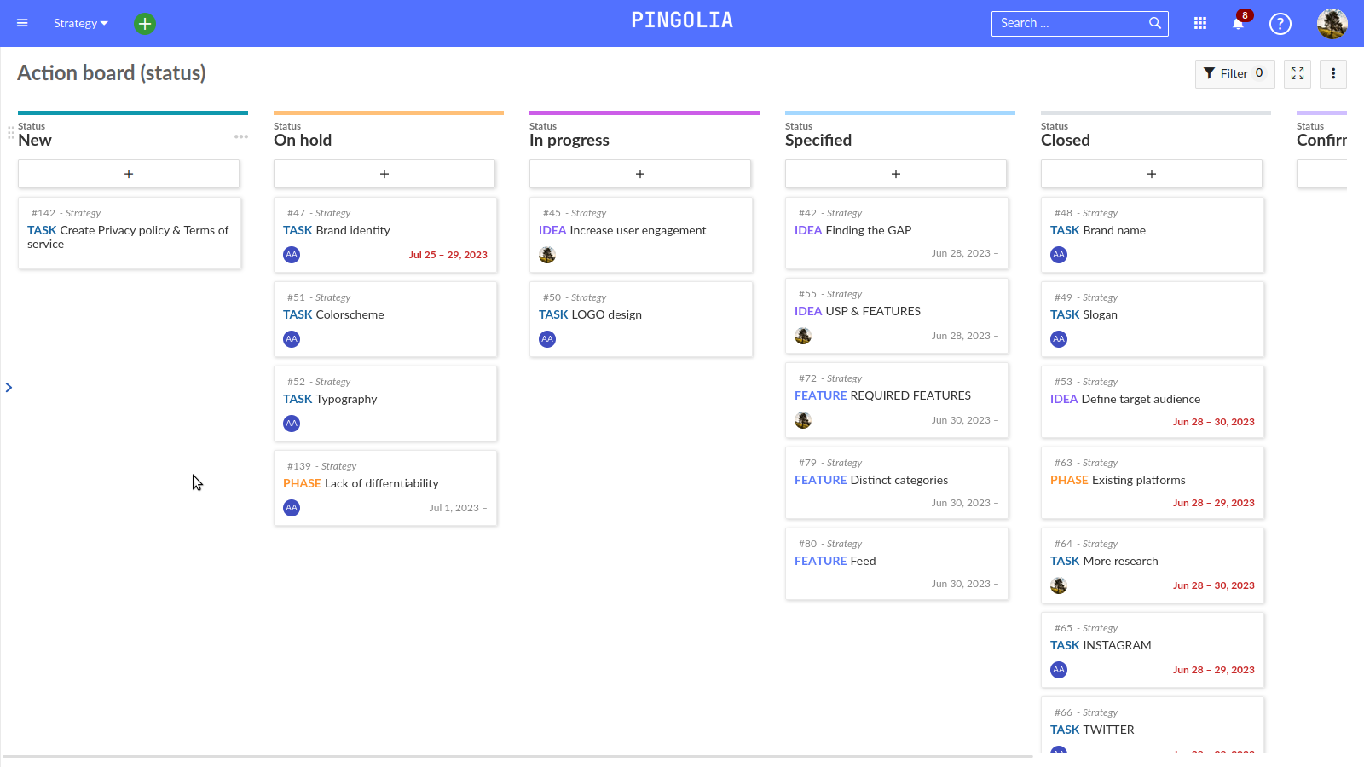

Here are some of the benefits of using the Kanban model to develop social media app:

Improved visibility: The Kanban model helps to improve visibility of work by visualizing all of the work that needs to be done and the current state of each piece of work. This helps teams to identify bottlenecks and areas where they can improve efficiency.
Increased efficiency: The Kanban model can help teams to increase efficiency by limiting work-in-progress and by maximizing the flow of work. This can lead to shorter lead times and improved customer satisfaction.

Improved collaboration: The Kanban model can help to improve collaboration by making it easy for teams to see what work is being done and who is responsible for each piece of work. This can lead to better communication and coordination between team members.
Increased flexibility: The Kanban model is a flexible framework that can be adapted to different industries and projects. This makes it a good choice for teams that need to be able to adapt to changing priorities.

If you are looking for a way to improve the way your team manages work, the Kanban model is a good option to consider. It is a simple but effective framework that can help you to improve visibility, efficiency, collaboration, and flexibility.

Kanban is a great framework for developing social media apps because it is flexible, adaptable, and focused on continuous improvement. Here are some of the specific benefits of using Kanban for social media app development:

Flexibility: Kanban is a lightweight framework that can be adapted to the specific needs of a social media app development project. This is important because social media apps are constantly evolving, and the Kanban framework can be adjusted to accommodate changes in requirements or priorities.
Adaptability: Kanban is a pull-based system, which means that work is only pulled into the development pipeline when it is ready to be worked on. This helps to prevent teams from getting overloaded with work and ensures that they are always working on the most important tasks.

Continuous improvement: Kanban is focused on continuous improvement, which means that teams are constantly looking for ways to improve their workflow and processes. This is important for social media app development because the landscape is constantly changing, and teams need to be able to adapt quickly to new trends and technologies.

Here are some specific examples of how Kanban can be used to develop social media apps:

Visualize the workflow: Kanban boards can be used to visualize the entire workflow for a social media app development project. This helps teams to see what work needs to be done, who is responsible for each task, and the current state of each task.

Limit work-in-progress: Kanban helps teams to limit the amount of work-in-progress (WIP). This ensures that teams are not overloaded and that work is flowing smoothly.

Maximize flow: Kanban helps teams to maximize the flow of work. This means that teams should be able to move work through the different stages of the workflow quickly and efficiently.
Identify bottlenecks: Kanban boards can be used to identify bottlenecks in the workflow. This helps teams to focus their efforts on improving the areas where work is getting stuck.

Measure progress: Kanban boards can be used to measure progress on a social media app development project. This helps teams to track their progress and make sure that they are on track to meet their deadlines.

Overall, Kanban is a great framework for developing social media apps because it is flexible, adaptable, and focused on continuous improvement. If you are looking for a way to improve the way your team develops social media apps, Kanban is a good option to consider.

