Raspberry Pi Scratch Maze Game - Simplified

Tutorial by Andrew Oakley - Public Domain Updated Nov 2017 [www.cotswoldjam.org](http://www.cotswoldjam.org)

# Getting started

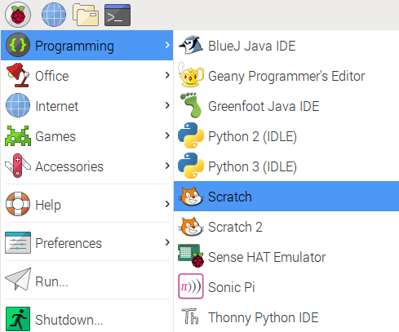1. Click on the Raspberry menu, Programming, Scratch

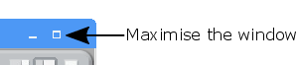

2. Click the Maximise Window button.  
3. Select File menu, Open.  
4. Click the Pi button.  
5. Select Scratch and click OK.  
6. Select simple-maze and click OK.

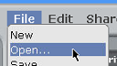  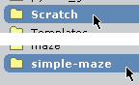

 7. Select smaze1 and click OK. A green and blue maze should appear.

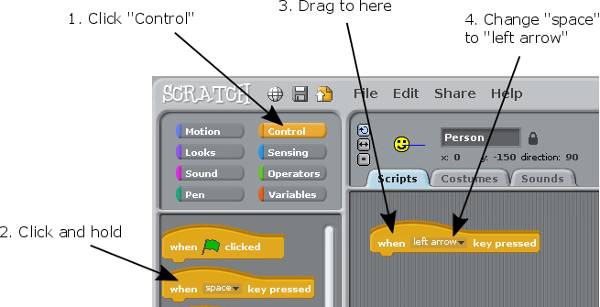

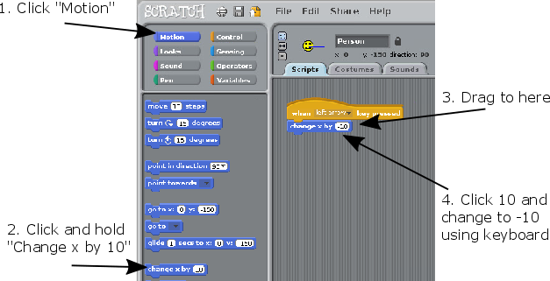

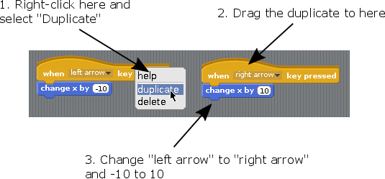

You should now be able to move the Smiley left and right, using the left and right arrow keys.

X is a "variable". A variable can hold a number or a word which can change. X measures left and right position.

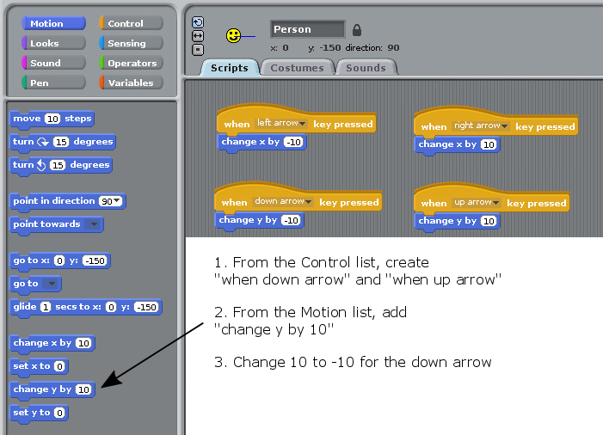

You should now be able to move the Smiley up and down, using the up and down arrow keys. The Y variable measures up and down position.

The Smiley can now move anywhere around the maze, including through the walls.

We need to add rules:

* To make the Smiley go back to the start if it hits a **blue** wall
* To say "You win!" if the Smiley reaches the **white** outline of the exit

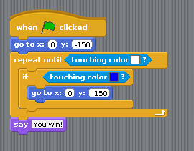Create this new block.

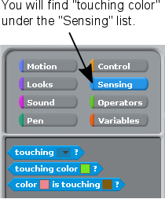

To select a colour:



1. Click the colour box

2. Click the colour you need

To start a new game:

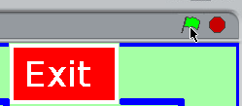Click the green flag

What if you make a mistake?

Right-click any block and click "delete"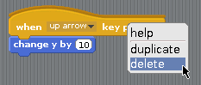

# For teachers / Scout / Guide leaders:

Downloads available from <http://www.cotswoldjam.org/downloads/beavers>

To add the files to Raspbian, go to the terminal: 

cd

mkdir -p "Scratch/simple-maze"

curl "http://www.cotswoldjam.org/downloads/beavers/cjam-scratch-simple-maze-code.zip" -O

unzip cjam-scratch-simple-maze-code.zip

exit

Note that -O is the capital letter O, not zero.