Monitor

A monitor is an output device…

- Refresh rate
- Screen size
- Screen type
- VESA mounts
- Ports - VGA, DVI, HDMI, DisplayPort
- Multi-monitoring
- Adobe RGB

HDMI (High-Definition Multimedia Interface) is a popular digital cable that outputs audio and video from a device to a monitor or television. HDMI is usually associated with modern televisions, though many computer monitors support the standard.

There are two main HDMI specifications,

The maximum length of a HDMI cable without a repeater is 15 metres (50 feet), though common lengths that are sold in the UK are 0.5 metre (1 1/2 feet), 1 metre (3 feet), 2 metres (6 feet), 5 metres (15 feet) and 10 metres (30 feet).

A HDMI cable is easy to identify as it has two notches on either side at the bottom.


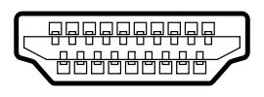
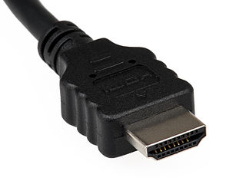

References:
https://www.hdmi.org/spec/index

