iEmu: Run iOS and its apps on Android, Windows, Linux and even iOS itself!
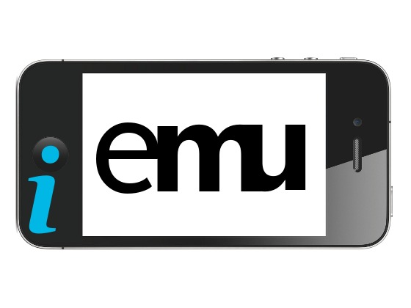
After doing some harmless internet browsing in my favourite web browser Mozilla Firefox, I came across an interesting idea by a hacker/developer Chris Wade.
Wade who crafted one of the first ever iOS jailbreaks (we're talking iOS 1 or 2 here, back when the springboard was black) has finally decided to take the real plunge and attempt to create a fully functional, highly compatible iOS emulator based on QEMU for many popular OS's out there, including Android (though they haven't specified whether it will be for phones, tablets or both).
In order to do this he and a bunch of other crazy hacker/developers will need a whopping $20,000 (£12,500) to fund living costs for three months of development. You can help out by following their Kickstarter project here.
Creating an emulator like this will be extremely difficult as they
will have to hack each component in each iOS device, so far they have succeeded with the hacking of Apple's A4 CPU which is a good start, but there's plenty to do as shown in this list here.
The worry is if Wade and his colleagues succeed and most importantly what will Apple do? As a company they aren't afraid to start legal battles (as shown with Samsung) and iEmu will be the first iOS emulator in existence, even the XCode iOS testing program is a simulator of iOS and isn't a true emulator. I mean you can't install Cydia on it at all!
If this emulator goes to plan it will be free and open-source under GPL licensing and be fully
jailbreakable so we should be able to install Cydia, Icy and Installous just fine.
It can also be synced and restored with iTunes. Firmwares will be loaded as an .ipsw file similar to the way PwnageTool and Redsn0w work (a whole list of .ipsw files are placed here).
Lastly and most importantly, iEmu promises high iOS application compatibility meaning that we can finally run most of those favourite iOS apps that we know and love.
In closing, all I can say is I support the project (not financially, but by concept) and believe that if it turns out as well as
planned it could be seeing me sell my iPhone and just have a rooted Android phone running a emulated, jailbroken iOS. Which is quite a painful concept for Apple. We could also see an increase in iOS app development, for those who choose to code in Objective-C without a Mac or iOS device to develop with.
All in all, it's something to look forward to! :-)
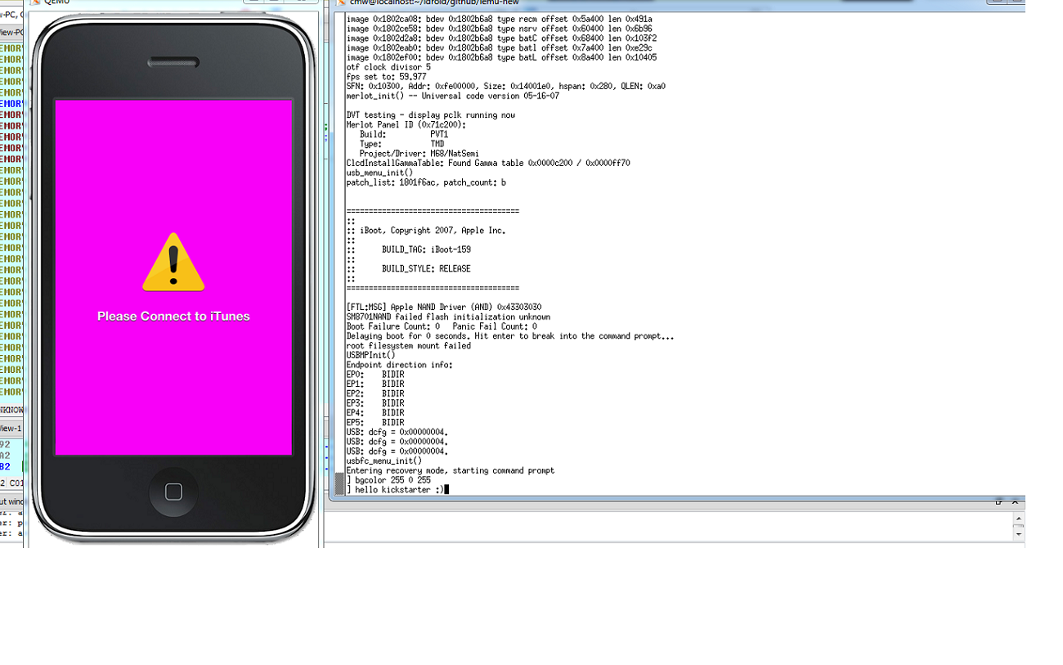
iEmu is still very much work in progress as shown by this screenshot here.
This blog was written primarily using ShapeWriter Pro for iPhone and modified using Microsoft Word 2007 and OpenOffice.org Writer V3.3.0. Special thanks to Josh Parker for letting me host my iOS related blogs on this site (shame he won’t do Android too).

If you liked this blog please Tweet and/or Like it with the appropriate buttons below!

