UMLDiagramTool Diagram

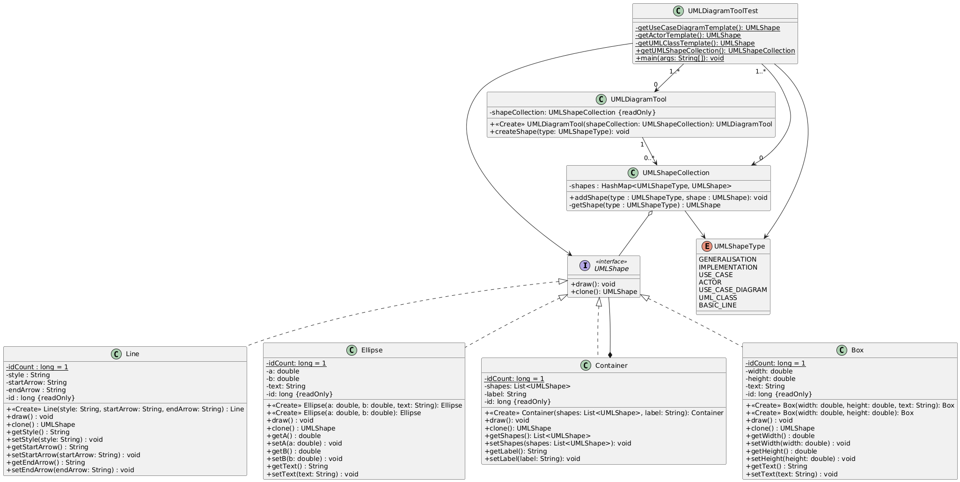

Participants

Protoype: The interface for cloning itself its declared in the UMLShape interface.

ConcretePrototype(s): Box, Container, Ellipse and Line provide implementation for self-cloning.

Client: UMLDiagramTool creates new UMLShape objects by asking the UMLShape to clone itself – returning to the UMLDiagramToolTest.