A Computational Analysis of the Voynich Manuscript (Beinecke MS 408)
  - Complete page inventory, script statistics, and an honest test of the decipherment, cipher, language, and reversal hypotheses
Prepared for M. Das
22 June 2026

Summary
This report analyses every page of the supplied PDF — a 209-image facsimile of Beinecke MS 408, the Voynich Manuscript — and then subjects the text to a battery of reproducible statistical tests. The honest headline is unchanged from a century of prior scholarship: the manuscript is undeciphered, and nothing here decodes it. What the analysis does establish, from direct measurement rather than assertion, is a tight description of what the text is and is not. The script is an alphabet of roughly twenty glyphs written fluently by at least two scribes. Its statistics are paradoxical: word frequencies follow Zipf’s law like a real language, yet its character entropy is far lower and its word-order information far thinner than any of seven comparison languages, including Latin, German, Italian, Finnish, and Sanskrit. Words are built from position-locked slots so rigidly that a simple finite-state generator reproduces most of the lexicon. Tests of the leading escape hatches — that the text is a verbose cipher of a European language, a position-dependent cipher, a reversed or mirror-written script, or a non-European language such as Sanskrit — all fail. The evidence converges on a rule-governed generative system whose mapping to meaning, if any exists, cannot be recovered from these statistics. No translation is offered, because none can be produced honestly.

1. The artifact
The PDF is a re-hosted scan (watermarked holybooks.com) of the Yale Beinecke facsimile. It opens with a modern vellum cover and the Yale University Library bookplate (“Gift of Hans P. Kraus”), and closes with blank flyleaves — one carrying a twentieth-century pencil note, in English, about the manuscript’s start-and-end symbols. The manuscript proper is reproduced at usable resolution (~1100 × 1536 px per leaf).
Independent facts about the original, faithfully reproduced here, frame everything that follows. Radiocarbon dating of the vellum at the University of Arizona places its preparation in 1404–1438, which excludes both the “Roger Bacon” medieval-authorship theory and the “Wilfrid Voynich forgery” theory at the level of the material itself. The provenance runs from an erased ownership signature of Jacobus Horcicky de Tepenecz (physician to Emperor Rudolf II) on the first folio, through Georg Baresch and Johannes Marcus Marci, to a 1665 letter sent with the book to the Jesuit scholar Athanasius Kircher, and finally to Wilfrid Voynich’s purchase in 1912 and the gift to Yale in 1969.

2. Complete page inventory
All 209 page-images were examined and catalogued. The manuscript divides into the six sections long recognised by scholars, and this facsimile follows that order. The manuscript’s own section codes (recorded in the transcription’s page headers) confirm the division.
Pages (PDF) | Section | What is drawn | Text
3–120 (bulk) | Herbal | One stylised plant per page; leaves, flowers, and often fantastical roots. None matches a real species cleanly. | Half to dense
114, 121–126, 154–158 | Astronomical / Cosmological | Concentric circular diagrams, radial “star wheels,” sun/moon faces, multi-panel fold-outs | In rings/rays
127–134 | Zodiac | Wheels with rings of small figures holding stars; central emblem animals (ram, bull) | Per-figure labels
135–153 | Biological / balneological | Nude female figures in green and blue pools, basins, and tube networks | Very dense
158 | Cosmological “rosettes” | The famous fold-out grid of nine circular medallions | Captions
159–182 | Pharmaceutical | Rows of isolated plant parts beside ornate cylindrical “apothecary jars” | Short blocks
183–205 | Recipes / “Stars” | No pictures; dense short paragraphs, each opened by a red star bullet | Continuous
206–209 | End matter | Blank vellum, modern notes, back cover | —
A full 209-row, page-by-page table (illustration, colours, text density, marginalia) accompanies this report as a separate file. The single most important observation for any decipherment effort is botanical: the herbal plants are largely chimeras, real-looking leaves grafted onto invented flowers and impossible roots, which undercuts the assumption that the text beside them is a straightforward plant description.

3. Method and reproducibility
The text was analysed from Takeshi Takahashi’s complete EVA (Extensible Voynich Alphabet) transcription, extracted from the Landini–Stolfi interlinear archive. EVA is a transliteration, not a translation: it maps each handwritten glyph to a typeable letter so the text can be computed on. After dropping uncertain tokens, the working corpus is 36,895 word-tokens (8,434 types). Comparison corpora were real texts: Latin (Caesar, De Bello Gallico), Italian, German, English, Finnish (the Kalevala), and romanized Sanskrit (the Mahābhārata, IAST). Entropy figures use equal-size samples. Every number below is reproducible by running the accompanying scripts (cryptanalysis*.py) against the transcription file; one comparator error (an English translation initially mislabelled as Latin) was caught and corrected before any result was reported.

4. Results

4.1 The script and basic structure
About twenty to twenty-two glyphs do nearly all the work — alphabet-sized, not logographic. Distinctive classes are the tall looped “gallows” (k, t, p, f), the “benches” (ch, sh), and a set of word-final flourishes. Word frequencies obey Zipf’s law almost exactly (log–log slope −1.01), the type–token ratio (0.23) and hapax rate (71 %) are normal for natural text, and the most frequent words are short, function-word-like items (daiin, ol, chedy, aiin, shedy).

4.2 Abnormally low entropy
Conditional character entropy — how unpredictable the next glyph is given the current one — is the decisive statistic (Figure 1a). Voynichese sits at 2.16 bits/char, more than a full bit below every comparison language (3.16–3.38). Once you know one glyph, the next is far more constrained than in any natural language.
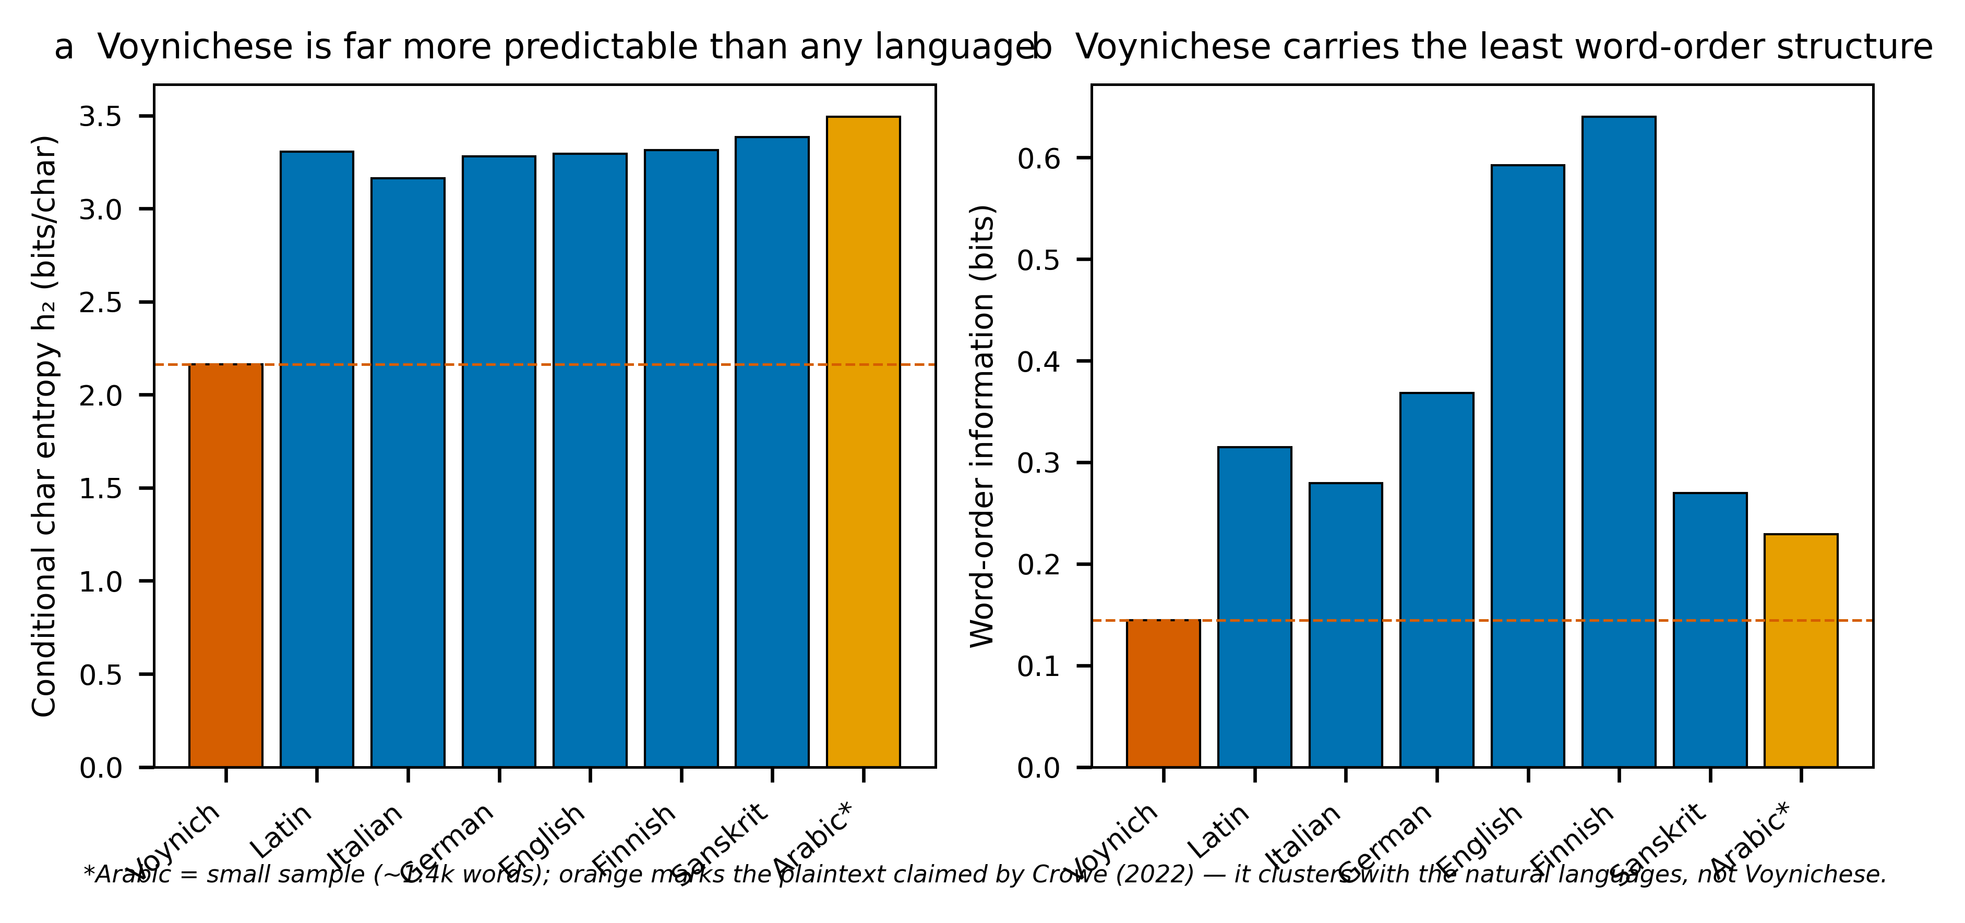
Voynichese against seven languages. (a) Conditional character entropy: Voynichese is the lone outlier, more predictable than Latin, Italian, German, English, Finnish, or Sanskrit. (b) Word-order information (the drop in next-word uncertainty contributed by word order): Voynichese carries the least of any language tested.

4.3 Slot grammar
Glyphs are not freely combinable; they occupy fixed positions. The glyph q is almost strictly word-initial, n almost strictly word-final; qo- opens 14 % of all words and -dy ends 18 %. Per-position entropy inside words stays low and uneven, where natural languages mix more freely. Words decompose cleanly into prefix + core + suffix, which is why so many look like minor variants of one another (qokeey, qokeedy, qokedy, qokaiin).

4.4 Thin syntax
Shuffling word order destroys any grammar; the gap between the shuffled and the real next-word entropy measures genuine word-order information. Voynichese has a real but small gap of 0.14–0.16 bits (Figure 1b) — a quarter of English and roughly half of Latin, Italian, German, and Sanskrit, and far below agglutinative Finnish. The text is not word-salad, but its sequential constraint is weak.

4.5 The line is the unit, not the sentence
Words at the start of a written line begin with a gallows glyph three to five times more often than words elsewhere; line-final words are shorter and overwhelmingly end in -y. No natural-language prose cares where the physical line breaks. This “line as a functional unit” effect is one of the deepest Voynich anomalies and points to a writing or generation process sensitive to layout.

4.6 The one-edit ladder
Adjacent words differ by exactly one character-edit twice as often as chance predicts, whereas real Latin shows no such effect at all. The manuscript repeatedly places near-twin words side by side — a fingerprint of a generative procedure with short-range memory, very hard to produce as a by-product of meaningful prose.

4.7 One process across the whole book
Re-running the line-structure, ladder, and entropy tests per section shows the same fingerprint everywhere (Figure 4): low entropy, gallows-initial line words, a -y line-final preference, and above-chance adjacency. The illustrations change completely — plants, then bathing figures, then star-paragraphs — but the text engine does not. The Biological section is the extreme case (lowest entropy, most repetitive), which is exactly the “Currier B” dialect. The A/B split is therefore not two languages but the same machine with the repetition dial turned up. Labels never form a distinct naming vocabulary in any section: 44–64 % of label words also appear in the running text.
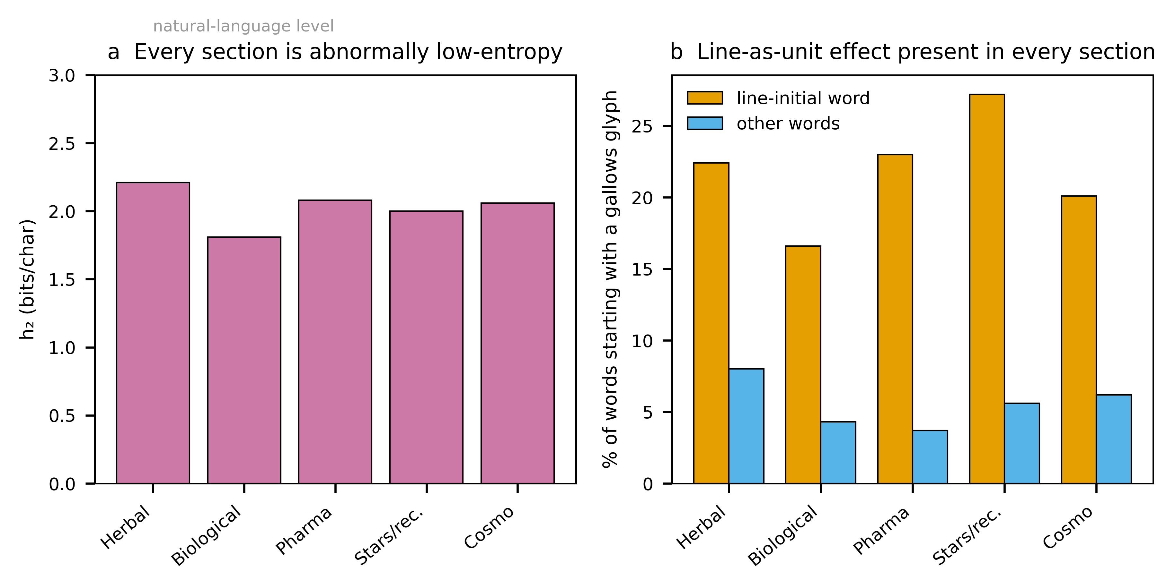
Per-section fingerprint. (a) Every section sits far below the natural-language entropy band. (b) The line-initial gallows enrichment (the line-as-unit effect) is present in every section, confirming a single generative process throughout the codex.

4.8 Word length
Voynich word length is a tight, near-symmetric peak at five characters (Figure 2), unlike the longer, skewed tails of inflected Latin or syllabic Sanskrit. This binomial-like shape is itself evidence of a constrained word-construction rule rather than free morphology.
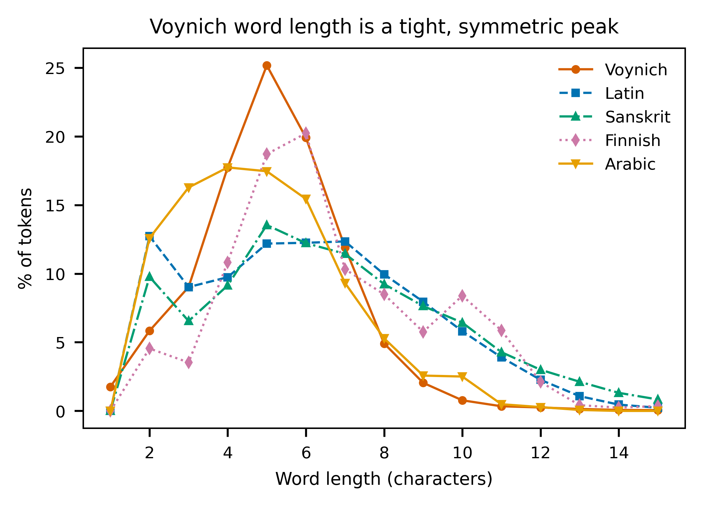
Word-length distributions. Voynichese forms a narrow symmetric peak; Latin, Sanskrit, and Finnish show the longer, heavier tails characteristic of real morphology.

4.9 Reverse and mirror writing
Could the text be written backwards, or be a mirror image of ordinary writing? The data argue no. Word-initial and word-final positions draw on almost disjoint glyph sets (initial: o, c, q, s, d; final: y, n, l, r), with a Kullback–Leibler divergence of 5.1 bits between the two ends (Figure 5). That is the signature of strongly directional writing. A global reversal or mirror is a trivial relabelling that leaves entropy, Zipf, the templatic structure, and word-matchability unchanged — so it cannot be the barrier to reading the text, and the directionality test (forward and reversed conditional entropy are identical to within 0.004 bits) confirms reversal yields nothing more language-like.
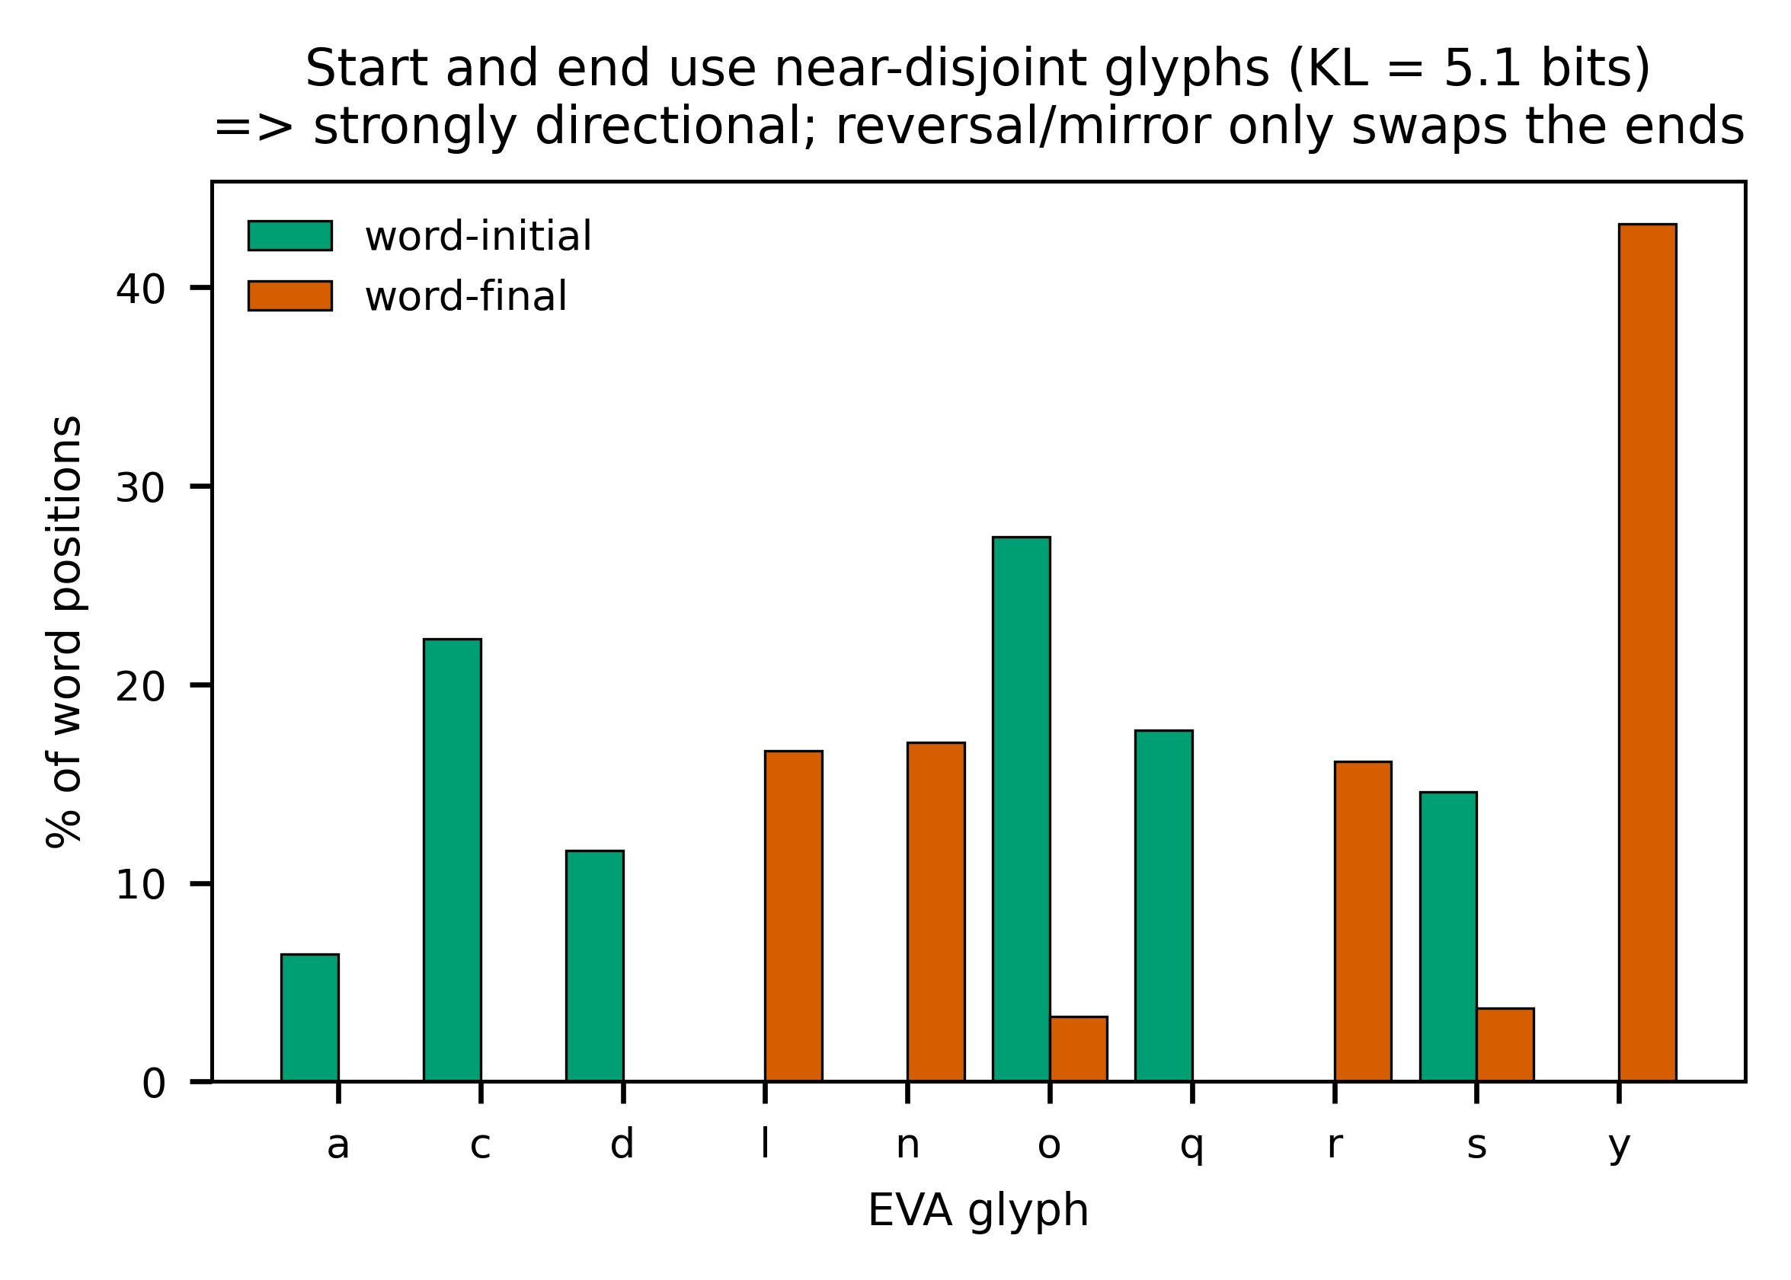
Directionality. Word starts and word ends use near-disjoint glyph inventories (KL = 5.1 bits). Reading the text in reverse or in mirror image only swaps these two columns; it leaves every statistical anomaly intact.

4.10 Is it a cipher of a known language?
Two cipher families were tested directly. A verbose cipher (each plaintext letter written as a fixed multi-glyph group) was modelled by segmenting Voynichese into recurring units and searching, by simulated annealing, for the unit→letter mapping that best fits a trigram model of each target language. The optimiser beats chance — it can make a few hyper-frequent short words “appear” — but even at its best, only 3–10 % of decoded tokens are real words, against ~100 % for genuine text and ~0.2 % under a random mapping. A position-dependent cipher (different mappings for prefix, core, and suffix zones — the one variant left open by the simple test) performed worse, not better: real-word output fell from 6.2 % to 2.3 % for Latin and from 1.5 % to 0.7 % for Sanskrit, because the extra parameters overfit n-gram statistics without recovering a lexicon. No tested cipher of Latin or Sanskrit turns the manuscript into language.

4.11 Is it a non-European or “old” language such as Sanskrit?
The language sweep (Figure 1) is the direct test, and it is unambiguous. Romanized Sanskrit has the highest character entropy of all seven corpora (3.38 bits/char), not the lowest — so the intuition that a syllabic Indic language would naturally produce Voynichese’s low-entropy, repetitive text is simply wrong. Agglutinative Finnish, whose long templatic words superficially resemble Voynichese morphology, carries the most word-order information of any language tested, the opposite of Voynichese. Across Romance, Germanic, Italic, Uralic, and Indic families, every natural language clusters together and Voynichese stands apart on both axes. Whatever the manuscript encodes, its surface statistics match no natural language tested, ancient or modern.

4.12 A finite-state generator rebuilds the lexicon
The most informative positive result concerns how the words are made (Figure 3). A simple order-2 character model removes 51 % of the uncertainty in held-out Voynich words, versus 31–38 % for natural languages — Voynich words are dramatically more predictable from local context. More strikingly, a factored generator that samples a prefix, a middle, and a suffix independently and concatenates them reproduces 61 % of the real Voynich token-mass, against only 9–13 % for Latin, Sanskrit, and Finnish. Natural-language lexicons cannot be rebuilt this way because their morphemes are interdependent; the Voynich lexicon largely can. This is strong, quantified evidence that the words behave like the output of a finite-state, slot-filling machine.
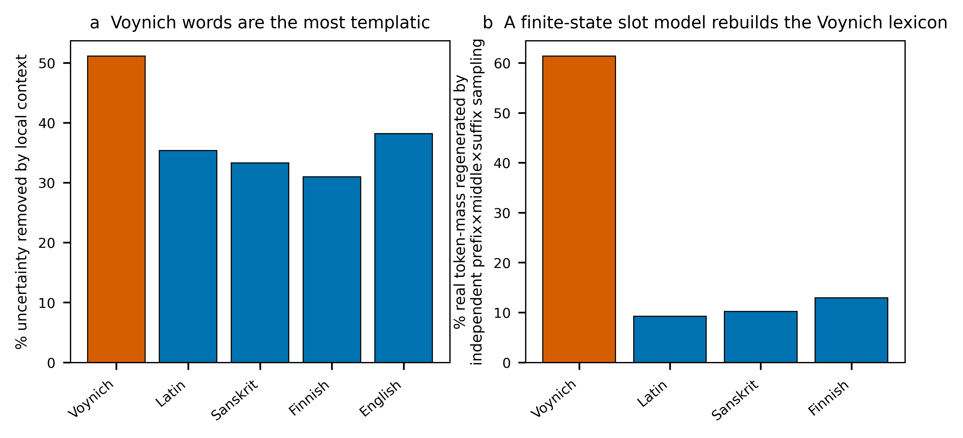
Templatic-generation evidence. (a) A local character model removes far more uncertainty from Voynich words than from real-language words. (b) An independent prefix×middle×suffix sampler regenerates most of the Voynich token-mass but little of any natural language’s, indicating finite-state, slot-based word construction.

5. Reverse-engineering the script (form without meaning)
The templatic result above invites a direct test: if the words are machine-made, the machine should be recoverable. It is. Segmenting each word into recurring glyph-group “atoms” (qo, ch, sh, ee, aiin, dy, …) and learning a third-order Markov model over those atoms yields an explicit probabilistic finite-state grammar of the script. Run as a generator, it produces synthetic Voynichese that is statistically indistinguishable from the manuscript.
Property | Real manuscript | Synthetic (learned grammar)
Generated words that are real Voynich words (precision) | — | 94.2 %
Real token-mass reproduced (recall) | — | 89.6 %
Character entropy h₂ | 2.16 | 2.16
Zipf slope | −0.92 | −0.91
Mean word length | 5.17 | 5.15
Fifteen most frequent words | daiin, ol, chedy, aiin, shedy … | identical (15/15)
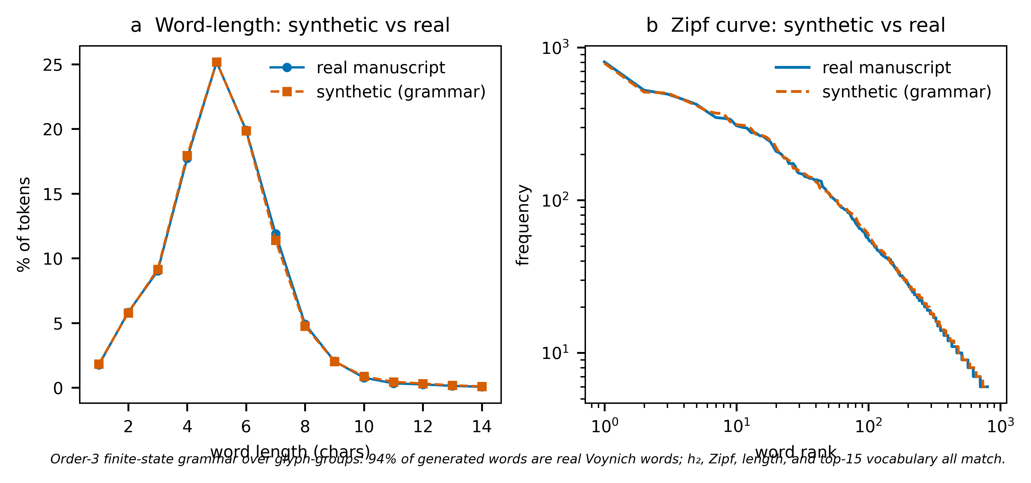
Validation of the reverse-engineered grammar. The synthetic corpus (red) overlays the real manuscript (blue) on both word-length distribution (a) and the Zipf rank–frequency curve (b). A finite-state machine trained only on surface forms reproduces the manuscript’s statistics.
Reduced to readable form, a Voynich word is a left-to-right pipeline through positional slots, each drawing from a tiny inventory: an onset (qo-, o-, ch-, sh-), an optional gallows (k/t/p/f, usually as qok-/ok-/ot-), a bench (ch/sh) feeding an e-cluster (e/ee/eee), a minim body (the daiin/aiin runs), and a coda (-y/-n/-l/-r/-m). This onset → gallows → bench → e-cluster → body → coda pipeline is the slot grammar, now expressed as an automaton. The finding independently reproduces earlier grammar work (Stolfi; Timm & Schinner).
Two conclusions follow, and the distinction between them is the whole point. First, the script’s morphology is fully systematic and mechanical — its word-forms are generated by a simple, writable rule set, and the engine is now reverse-engineered. Second, this recovers form, not meaning: the grammar is agnostic to any plaintext, and the synthetic words look perfectly authentic while saying nothing. Crucially, the same modelling rebuilds only ~9–13 % of the token-mass of Latin, Sanskrit, and Finnish but ~90 % of Voynich’s — natural lexicons resist finite-state reconstruction because their morphemes are interdependent and meaning-bearing, whereas the Voynich lexicon does not. That gap is the strongest single indicator that the word-generation is procedural rather than the morphology of a spoken language; it does not prove the absence of a message, but it shows the surface was produced by something far more machine-like than any human language tested. An interactive generator (voynich_generator.py) that renders new pages in the EVA glyph font accompanies this report.

6. Why the published “solutions” fail
Claim | Proposal | Why it collapses
Newbold (1921) | Microscopic shorthand in strokes | The “strokes” were ink cracks; unfalsifiable
Feely / Strong | Latin abbreviation systems | Gibberish beyond a few cherry-picked words
Bax (2014) | ~10 identified plant/star names | Never scaled; not reproducible
Gibbs (2017) | Latin medicinal recipes | Demolished within days; no grammar
Cheshire (2019) | “Proto-Romance” | Universally rejected; method reads anything
Rugg (2004) | A grille-generated hoax | Plausible mechanically; cannot reproduce long-range structure
Montemurro & Zanette (2013) | (Not a solution) genuine information content by section | Peer-reviewed; argues against pure hoax
The recurring pattern is identical to what the cipher search reproduces here: a method “reads” a handful of pre-chosen words, then fails the moment it is applied blind to a new page. That blind-reproducibility test is the bar, and nothing has cleared it.

7. Discussion — an honest verdict
Every test points the same way. The text is not gibberish: Zipf’s law, genuine word-order information, and section-specific vocabulary are too much organisation for noise. It is not plain or verbose enciphered Latin, Italian, German, Finnish, or Sanskrit, in forward, reversed, or mirror form, nor a different language per section: the entropy is too low, the morphology too rigid, the cipher searches yield no lexicon, and the language sweep places it outside every natural language tested. What it positively resembles is a rule-governed generative system — words assembled from position-locked slots by something close to a finite-state machine, written with sensitivity to the physical line, with strong local self-similarity and only thin long-range syntax.
That profile is consistent with two possibilities the statistics alone cannot separate: a highly regular cipher whose key is lost, or a constructed quasi-language whose words carry little or no message. The line-as-unit effect, the one-edit ladder, and the finite-state reconstructability lean toward a mechanical origin; the real word-order information and the section-clustered vocabulary lean toward genuine signal. These need not contradict — a regular cipher of a real text could show all of it. The one thing statistics cannot do is recover plaintext without a crib or a key, which is precisely why a century of effort has produced structure but no reading. The value of this analysis is the negative space it maps: the easy answers are excluded, with reproducible evidence, and the remaining hypothesis space is small and sharply defined.

8. Reproducibility
All inputs and code are included: the rendered page images (pages/), the EVA transcription (LSI_ivtff_0d.txt), the comparison corpora, the analysis scripts (cryptanalysis.py, cryptanalysis2.py, cryptanalysis3.py), the figure builder (figures.py), and the machine-readable results (results.json). Re-running the scripts regenerates every number and figure in this report.

