Software Requirements Specification
for
Traffic Sign Recognition system

Prepared by Prashant Gupta, Asish Kumar, Anubhav Kumar
KIET group of Institutions, Ghaziabad
March 10, 2024
Table of Contents
Table of Contents ii
Revision History ii
1. Introduction 1
1.1 Purpose 1
1.2 Document Conventions 1
1.3 Intended Audience and Reading Suggestions 1
1.4 Product Scope 1
1.5 References 1
2. Overall Description 2
2.1 Product Perspective 2
2.2 Product Functions 2
2.3 User Classes and Characteristics 2
2.4 Operating Environment 2
2.5 Design and Implementation Constraints 2
2.6 User Documentation 2
2.7 Assumptions and Dependencies 3
3. External Interface Requirements 3
3.1 User Interfaces 3
3.2 Hardware Interfaces 3
3.3 Software Interfaces 3
3.4 Communications Interfaces 3
4. System Features 4
4.1 System Feature 1 4
4.2 System Feature 2 (and so on) 4
5. Other Nonfunctional Requirements 4
5.1 Performance Requirements 4
5.2 Safety Requirements 5
5.3 Security Requirements 5
5.4 Software Quality Attributes 5
5.5 Business Rules 5
6. Other Requirements 5
Appendix A: Glossary 5
Appendix B: Analysis Models 5
Appendix C: To Be Determined List 6

Revision History
Name | Date | Reason For Changes | Version
Traffic sign recognition system

Introduction

Purpose
The purpose of this document is to present a detailed description of the traffic sign recognition system. It will explain the purpose and features of the software, the interfaces of the software, what the software will do and the constraints under which it must operate. This document is intended for users of the software and also potential developers.

Document Conventions
This Document was created based on the IEEE template for System Requirement Specification Documents.

Intended Audience and Reading Suggestions
Typical users such as students who want to learn more about traffic sign recognition system and machine learning algorithms used in building this project. The main aim of this project and convention is to target mainly those people who are more into advancement of the cars features besides people who are interested in new technology and wanted to work as well as contributing to the current scenario.

Product Scope
It is a system which is capable of recognizing the traffic signals. This system can be installed in any car which is having ADAS (advanced driver assistant system) with a external camera mounted on it. It will then monitor the traffic signs and performs the desired task

References

[1] A. Nikonorov, P. Yakimov, M. Petrov, Traffic sign detection on GPU using color shape regular expressions, VISIGRAPP IMTA-4, Paper 8 (2013).

[2] R. Belaroussi, P. Foucher, J.P. Tarel, B. Soheilian, P. Charbonnier, N. Paparoditis, Road Sign Detection in Images, A Case Study, 20th International Conference on Pattern Recognition (ICPR), 2010, pp. 484-488

[3] Aditya, A.M., & Moharir, S. (2016). Study of Traffic Sign Detection and Recognition Algorithms.

[4] Mogelmose, M. M. Trivedi and T. B. Moeslund, "Vision-based traffic sign detection and analysis for intelligent driver assistance systems: Perspectives and survey", IEEE Trans. Intell. Transp. Syst., vol. 13, pp. 1484-1497, Dec. 2012.

[5] P. Viola and M. J. Jones, "Robust real-time face detection", Int. J. Comput. Vis., vol. 57, no. 2, pp. 137-154, 2004.

[6] L. Fletcher, N. Apostoloff, L. Petersson and A. Zelinsky, "Vision in and out of vehicles", IEEE Intell. Syst., vol. 18, no. 3, pp. 12-17, May/Jun. 2003

[7] S. Lafuente-Arroyo, P. Gil-Jimnez, R. Maldonado-Bascn, F. Lpez-Ferreras and S. Maldonado-Bascn, "Traffic sign shape classification evaluation I: SVM using distance to borders", Proc. IEEE Intell. Veh. Symp., pp. 557-562, 2005-Jun.

[8] V. Balali, A. A. Rad and M. Golparvar-Fard, "Detection classification and mapping of U.S. traffic signs using Google street view images for roadway inventory management", Vis. Eng., vol. 3, no. 1, pp. 15, 2015.

[9] K. C. P. Wang, Z. Hou and W. Gong, "Automated road sign inventory system based on stereo vision and tracking", Computer.-Aided Civil Infrastructure. Eng., vol. 25, no. 6, pp. 468-477, 2010.

Overall Description

Product Perspective
Traffic sign recognition system is a system in which we have used machine learning and to be specific we have used CNN algorithm in it. Basically it is a system which is capable of recognizing the traffic signals. This system can be installed in any car which is having ADAS (advanced driver assistant system) with an external camera mounted on it. It will then monitor the traffic signals and performs the desired task.

Product Functions
This system can be installed in any car which is having ADAS (advanced driver assistant system) with a external camera mounted on it. It will then monitor the traffic signals and performed the desired task.
Let’s see a scenario in which a car is running with a speed of 120km/hr. and if our system detects the sign board which says that the speed limit on this road is 100km/hr. system will automatically reduced to its speed limit as the car is laced with ADAS and all the things of car can be controlled electronically.

User Classes and Characteristics
Typical users such as students who want to learn more about traffic sign recognition system and machine learning algorithms used in building this project. Traffic signs can be analyzed using forward-facing cameras in many modern cars, vehicles and trucks. One of the basic use cases of a traffic-sign recognition system is for speed limits. Most of the GPS data would procure speed information, but additional speed limit traffic signs can also be used to extract information and display it in the dashboard of the car to alert the driver about the road sign. This is an advanced driver-assistance feature available in most high-end cars. They can be used by various cars companies which aim in advancement of the car system and its features

Operating Environment
• Windows 11
• Windows 7
• Windows 8
• Windows 10
• Mac OS X
• Linux

Design and Implementation Constraints
The design is combination of hardware and software. That means failure of any module can leads to failure of whole project. The design is simple, external camera will provide the input to the algorithm and after that algorithm will process it .
Anything which takes input will limit the function of the system. Hardware like camera, wires , couplers and mount should have to perform better and every time in order to continuously provide the input.
Algorithm failure and slow system can lead to failure of project. As the algorithm have to respond as soon as it gets the input.

User Documentation
There is a quick guide available on the link :-

Below is some image to understand the user manual easily.

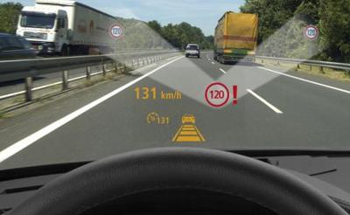

Assumptions and Dependencies
The assumptions for this project is that roads should have proper traffic signs and camera should be placed at the proper angle to capture all the traffic signs and CPU of car should be fast enough to process the data. There will be many problems associated with the model such as it works as underfitting or overfitting on the dataset. Issues associated with the working model whether it will work properly on the real life applications or not. Design issues will be there with a lot lacking feature. In future there will be advance feature which will be developed for image recognition system and our model will lack in that place.

External Interface Requirements

User Interfaces
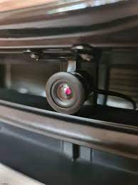
In this we are going to use a camera module which will act as an eye for capturing the images of the traffic signs and process this through the CNN network and gives the output as display and warn if there is audio output.

Hardware Interfaces
The first things is the coupler to connect the camera to the CPU of the car.
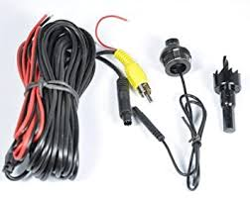
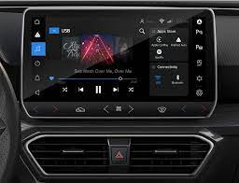

The second thing we required is a front camera in a car.

Third thing required is the infotainment system or CPU in a car.

Software Interfaces
Here the software can be described as the trained model using the machine learning and data science technology. We also use python as well as its certain libraries such as NUMPY, PANDAS, SKLEARN, MATPLOTLIB, SEABORN, TENSORFLOW, KERAS, PYTORCH and to communicate with the database we can use SQLITE3 and connect it to localhost application. We use ANACONDA NAVIGATIOR which provide various application such as JUPYTER NOTEBOOK, PYCHARM and many more for Data science and machine learning applications.

Communications Interfaces
Communication interface is recognized by the display screen of the car, which will feature as an output display of the output as well as an audio output, if that feature is made available in the system of the cars.

Other Nonfunctional Requirements

Performance Requirements
We basically need a model who has been trained with various datasets of traffic signs and a car on which this whole system will be attached for testing purpose. Mainly OpenCV is used for image processing. OpenCV is an Open-source Computer Vision library designed for computational efficiency with a strong focus on real time applications. It can be implemented on the automobile with an aim of detecting and recognizing all emerging traffic signs. There are many reasons why we miss the traffic signs. Wavering concentration, tiredness, sleep deprivation are few common reasons. Some of the other factors that contribute to missing the signals are poor illumination, an influence of the exterior environment and weather conditions. Yet it seems illogical to have a person next to us warning us about the traffic signs. It is a lot more acceptable to instead have a system that can detect the traffic signs to guide and warn the driver, hence its performance is enhanced.

Safety Requirements
In real traffic scenes, traffic sign detection faces many difficulties including small size, viewpoint, occlusion, illumination and so on. Video source recognition depends on the quality of an image sensor and output format of an image. Issues can arise not only by settings of a camera but also if the camera is not correct fixed in a vehicle so vibration and blurring can be appeared on the video sequences. Image can also be affected by the bright daylight and night or by influencing of source of light. To overcome this drawback, we should be fully involved with the installing mechanism of the camera as well to ensure that the camera lens is fully free from dust and small particles which may cause unrecognizable image. For this the camera lens should be cleaned with dust removal product (Should be specified in the user manual).

Security Requirements
There are not many securities related issues surrounding the product but it does involve the use of the car system such as display, video screen and audio output. Also, there can be a feature to start or close the recognition feature but as it is related to safety of the driver hence it should on default setting.

Software Quality Attributes
Camera-based traffic-sign recognition systems identify signs in real-time by processing the videos that are captured through a front-facing camera mounted on a vehicle. They help the driver by providing warnings, commands and sometimes by taking control of the vehicle itself. The system installed on a particular car system can be also be tested on others car system. It is in-built feature so it is obvious that there is portability feature. The system is flexible in the sense as if in future any different types of traffic sign gets developed or even we need to add new feature to it we can do it on the particular system by making some minor changes in the software or hardware specification.
It will be easy for the users to maintain the system feature as all of its command will be in their hands as well as they have user manual to figure out something, they want to test about. Now comes the availability of the system, it will be available for other cars system if their car system is compatible with it and for some cars it will be in-built feature.

Basic Requirements
Thera are many other requirements which we need to specify and implement in the upcoming future if possible. Adding new traffic signs if ever produced in the near future. I there were any changes to the hardware requirements change then it should be possible with the modern technology. One of the major requirements is the noticeable board which depends on the Authority of the sign placement and road major government because an unnoticed and blurry sign board can’t be detected by the system hence there may be fatal accidents. There is requirement of best pixelated images dataset of the signs to keep updated with the pace of the world.

Reuse environment
The objective of the project is clear that it should be able to recognize the signs as fast as it can and alert the driver if there is any need of it. Since this project is based on vast majority problems hence the project itself is flexible, it means there will be reusability of the objective of the project for better and smart production of highly enhanced product in the near future.

Appendix A: Analysis Models

Below is the set of diagrams representing the diagrammatic representation of the traffic sign recognition system model in the developing stages and the various features used to complete the system building.
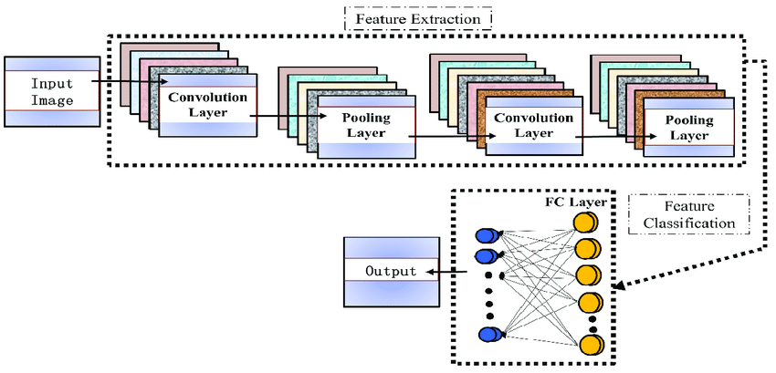

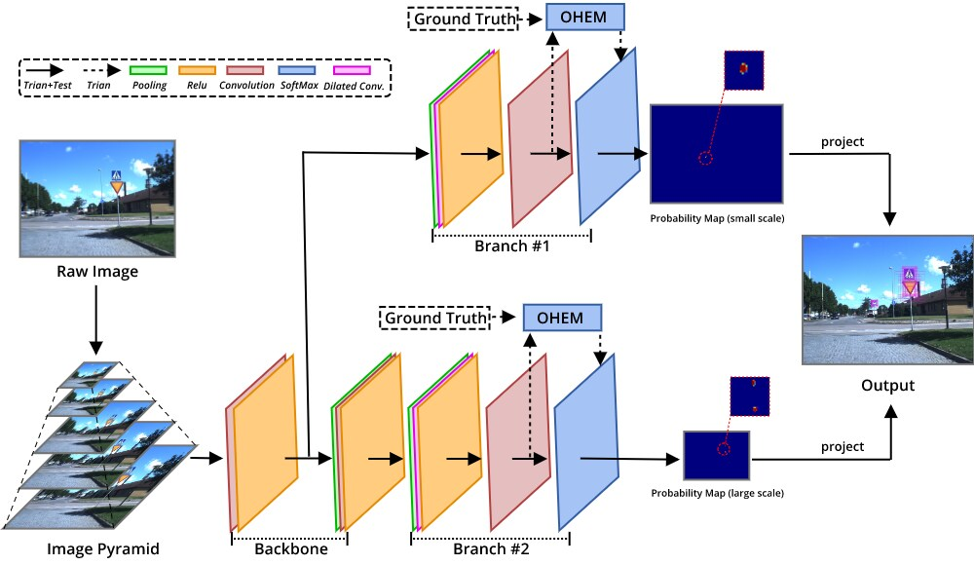

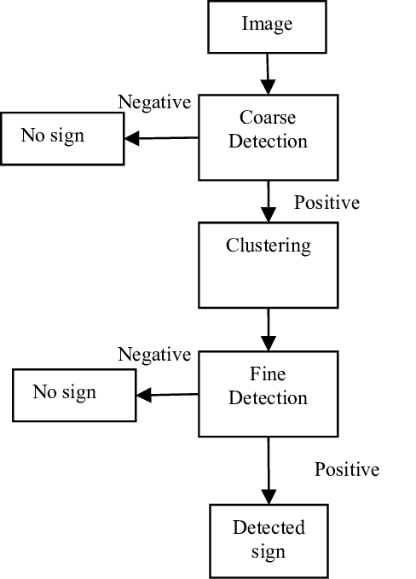
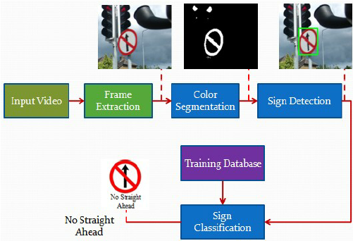

APPENDIX B: SOME REAL-TIME IMAGES DURING TRAINING
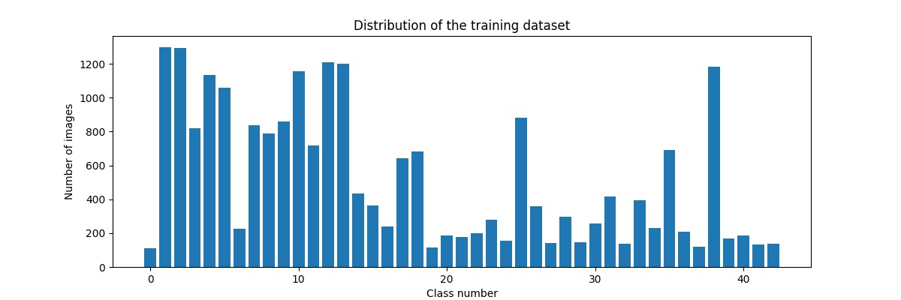
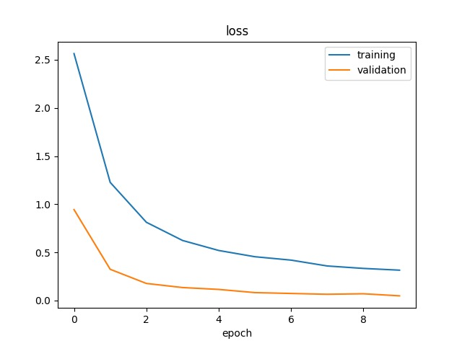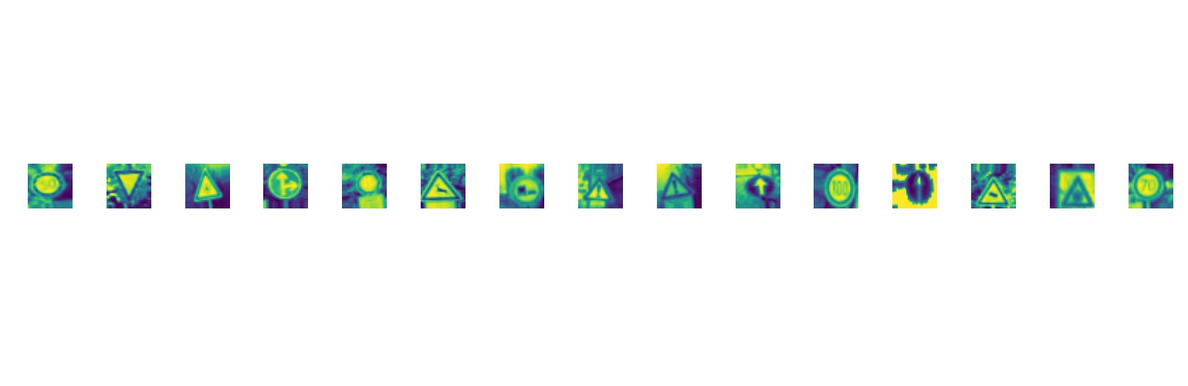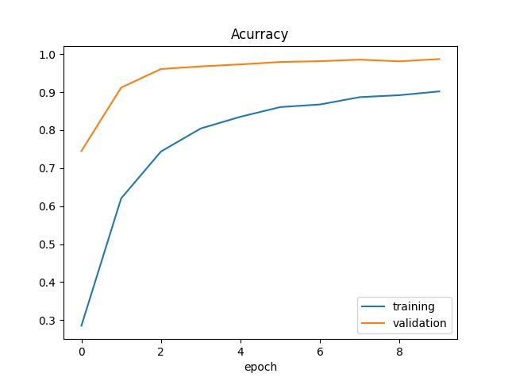

DFD LEVEL 0

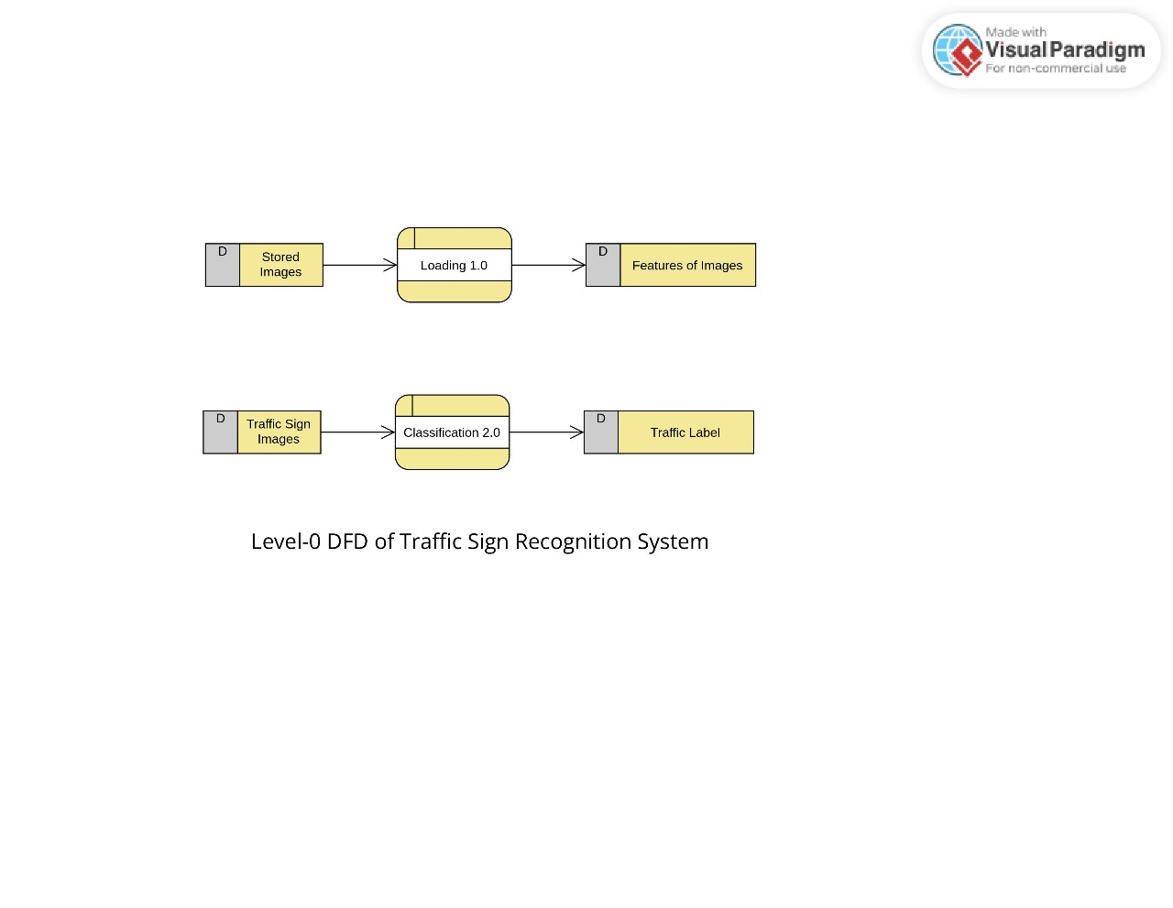

DFD LEVEL 1

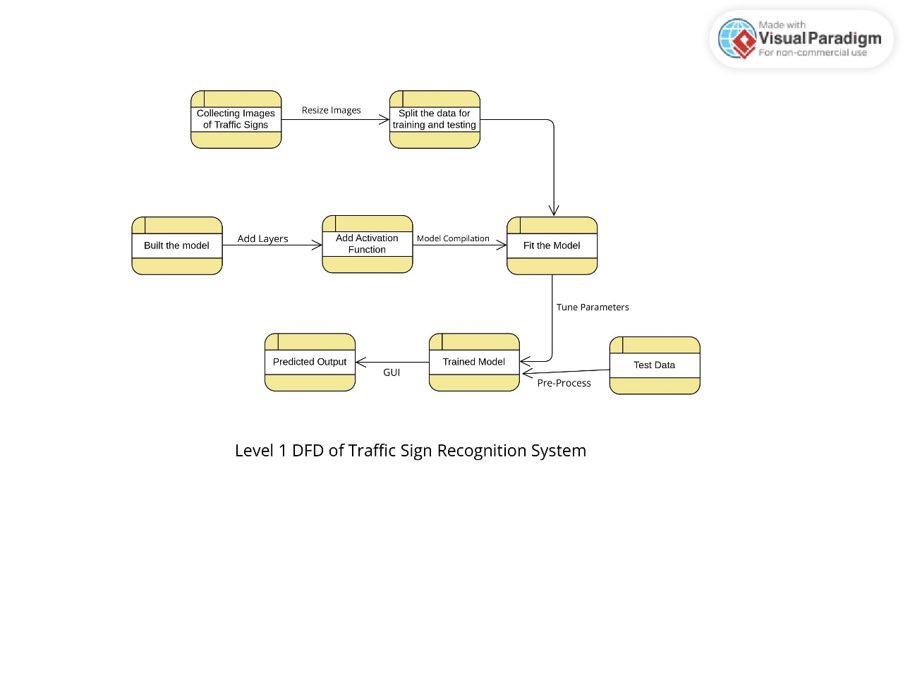

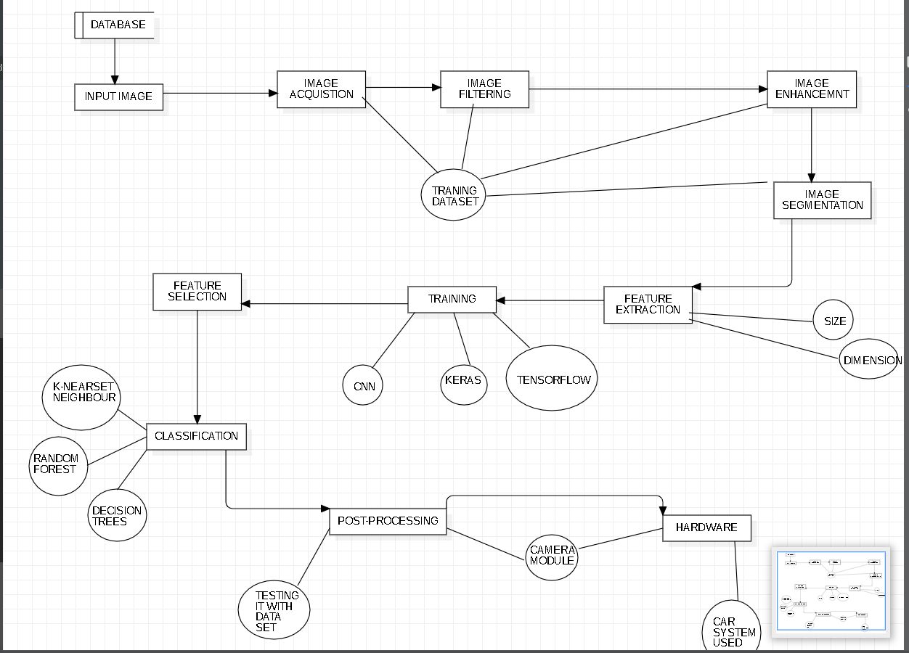
DFD LEVEL 2

ER Diagram
