TEST PLAN FOR
TRAFFIC SIGN
RECOGNITION SYSTEM

ChangeLog

Version | Change Date | By | Description
version number | Date of Change | Name of person who made changes | Description of the changes made

1 Introduction
1.1 Scope
1.1.1 In Scope
1.1.2 Out of Scope
1.2 Quality Objective
1.3 Roles and Responsibilities
2 Test Methodology
2.1 Overview
2.2 Test Levels
2.3 Test Completeness
3 Test Deliverables
4 Resource & Environment Needs
4.1 Testing Tools
4.2 Test Environment

Introduction
The AVDS and ADAS, advanced car driving systems, are designed to not only detect surrounding hazards but also identify driving constraints and opportunities. One crucial aspect for the ADAS is accurately recognizing traffic regulations in a specific area or intersection. By utilizing visual cues, these systems or auto navigation programs become even more reliable. This is essential, as most road accidents occur due to driver distractions and missing crucial signage. So this system presents a vide range of solutions for the traffic sign recognition system and is helpful in the driver car assistance.

Scope

In Scope
In this various parameter are considered for the testing purposes which is essential as well as necessary for the traffic sign recognition system to work properly. Some of the parameters are given below.

A] Features Scope: Test cases in this category will assess the features related to driver safety, which may include:
● Traffic sign detection algorithms.
● Alert mechanisms, such as sound notifications or visual indicators.
● User interaction with the driver safety system through a mobile app or dashboard.

Functional Requirements: Test cases will focus on the functional aspects, ensuring that the system accurately detects signs of traffic and responds appropriately.

Non-Functional Requirements: These may involve latency in alert generation, system responsiveness, and reliability in various driving conditions.

B] Features Scope: Integration test cases focus on the interaction between different components of the system, ensuring seamless communication between the driver safety and monitoring modules.

Functional Requirements: These tests assess how well the different modules work together, confirming that they share data and respond cohesively.

Non-Functional Requirements: This may involve the system's overall performance and resource utilization during simultaneous monitoring tasks.

C] Accuracy: In this we define the system ability to correctly classify and recognize traffic signs from a given datasets.

D] Detection rate: How well the system can detect traffic signs in various lighting, conditions, weather conditions as well as under challenging scenarious.

E] Recognition Time: Measure the time it takes for the system to recognize as well as classify the traffic signs.

Out of Scope
This contains some parameters which we can’t test it. Some of them are given below.

A] Legal Compliance: In this we can define and classify the traffic signs, but we can’t verify whether the sign is correctly placed or not.

B] Human Interpretation: We can’t control or test human intervention as we have trained the model only for traffic sign recognition system.

Quality Objective

The overall objective of the traffic sign recognitioon system, beyond the scope of testing, is to ensure the road safety and traffic mangaement by providing an automated and reliable means of detecting and interpreting traffic signs. Some of them will be as follows:

A] Safety Enhancement: Improve safety by recognizing and communicating the presence of and meaning of traffic signs to drivers and automated vehicles.

B] Accessibility: Ensure that tarrfic sign information is accessible to all road users.

C] Data collection and Analytics: Gather valuable data on traffic sign visibility which can be used for traffic management.

D] Efficiency and Cost Savings: Achieve efficiency by identifying and addressing issues early in the development process, potentially saving time and resources that would otherwise be spent on post-deployment fixes and maintenance.

E] User Satisfaction and Confidence: Instill confidence in end-users, whether they are vehicle owners, drivers, or other stakeholders, by delivering a thoroughly tested and reliable Traffic sign recogniton system. Meeting or exceeding user expectations for safety is paramount.

F] Risk Mitigation: Mitigate risks associated with the Traffic signs system's deployment by identifying and addressing issues during the testing phase. This includes reducing the risk of false recognition, inaccurate readings, and system failures that could compromise safety conditions.

Roles and Responsibilities

- QA Analyst:
  - Asish Kumar
  - Prashant Gupta
- Test Manager:
  - Mr. Pawan Kumar Pal
- Configuration Manager:
  - Mr. Pawan Kumar Pal
- Developers
  - Asish Kumar
  - Prashant Gupta
  - Anubhav Kumar
- Installation Team
  - Asish Kumar
  - Prashant Gupta

Test Methodology

Overview

The Agile model's flexibility and iterative nature make it well-suited for traffic sign recognition using CNNs, as it allows the development team to respond to changing requirements, address challenges, and continuously improve the model's accuracy and reliability in a dynamic real-world context. Agile allows the team to adapt to changing requirements, such as the need to recognize new traffic signs or accommodate variations in environmental conditions.

Agile can be particularly suitable for a traffic sign recognition system for several reasons.
- Changing Requirements
- Iterative Development
- User Feedback
- Continuous Improvement

Test Levels

The testing to be performed is Manual Testing. The testing is performed by the developers' team along with QA and Configuration Manager.

A] Unit Testing: Unit testing focuses on testing individual components of the system, such as specific CNN layers or image preprocessing functions. It helps ensure that each component performs as expected.

B] Integration Testing: Integration testing assesses how different components of the system work together. For traffic sign recognition, this would involve testing how image preprocessing, the CNN model, and post-processing components interact.

C] Functional Testing: Functional testing verifies that the system's functionality aligns with the specified requirements. It tests whether the traffic sign recognition system correctly identifies and classifies different types of traffic signs.

D] Performance Testing: Performance testing evaluates the system's speed and efficiency. In the context of traffic sign recognition, this may involve measuring the inference time for sign detection and classification.

E] Scale Testing: Scale testing evaluates how the system handles a large volume of data and traffic signs. It ensures that the system remains accurate and efficient when processing a high number of images.

F] Robustness Testing: Robustness testing assesses how well the system performs in adverse conditions, such as varying lighting, weather, or occlusions. It aims to identify potential vulnerabilities and improve the system's resilience.

Test Completeness
- 100% test coverage
- Most of the Manual test cases executed.

Test Deliverables

TEST CASES
S. NO. | TEST DATA/IMAGE | INPUT | OUTPUT (IDENTIFIED OR NOT)
1 | STOP SIGN DETECTION | IMAGE CONTAINING A STOP SIGN | YES
2 | SPEED LIMIT SIGN RECOGNITION | AN IMAGE WITH SPEED LIMIT | YES
3 | NO PASSING SIGN DETECTION | AN IMAGE WITH A YIELD SIGN | YES
4 | NO ENTRY SIGN DETECTION | AN IMAGE WITH NO ENTRY SIGN | YES
5 | ROUNDBOUT SOGN RECOGNITION | AN IMAGE WITH SCHOOL ZONE SIGN | YES
6 | PEDESTRIAN SIGN RECOGNITION | IMAGE OF PEDESTRIAN CROSSING SIGN | YES
7 | KEEP LEFT SIGN DETECTION | IMAGE SHOWING LEFT SIGN | YES
8 | KEEP RIGHT DETECTION | IMAGE SHOWING KEEP RIGHT | YES
9 | BUMPY ROAD SIGN | IMAGE OF SIGN | YES
10 | ONE WAY STREET SIGN | IMAGE OF THE SIGN

BOUNDRY VALUE ANALYSIS

Some of the cases are given below

A] Edge Cases: Test the system with challenging cases, such as extremely small or large signs, to check how it handles boundary conditions.

B] Speed Limit Sign Recognition
Lower Bound: The lowest speed limit sign is typically 5 mph. So, the system should correctly recognize a "Speed Limit 5" sign and indicate a speed limit of 5 mph.

Upper Bound: The highest common speed limit on roads is often around 70 mph. The system should accurately recognize a "Speed Limit 70" sign and indicate a speed limit of 70 mph.

C] Boundary Value Conditions for Stop Sign Recognition
- Lower Bound: Check if the system can recognize a stop sign that are smaller-than-average stop sign image or larger-than-average stop sign image.

- Upper Bound: Ensure the system can recognize a Stop small stop sign image slightly smaller than the lower bound or a large stop sign image slightly larger than the lower bound.

EQUIVALENCE TETS CASE

A] Equivalence Test Case for Speed Limit Sign Recognition
- Input: An image containing a "Speed Limit 35" sign with typical weather and lighting conditions.
- Expected Output: The system should correctly identify the "Speed Limit 35" sign and indicate a speed limit of 35 mph.

B] Equivalence Test Case for Stop Sign Recognition
- Input: An image containing a Stop sign in smaller-than-average stop sign images or larger-than-average stop sign images.

- Expected Output: The system should correctly recognize the smaller stop sign or larger stop sign as a "Stop" sign.

SOME THE OUTPUTS

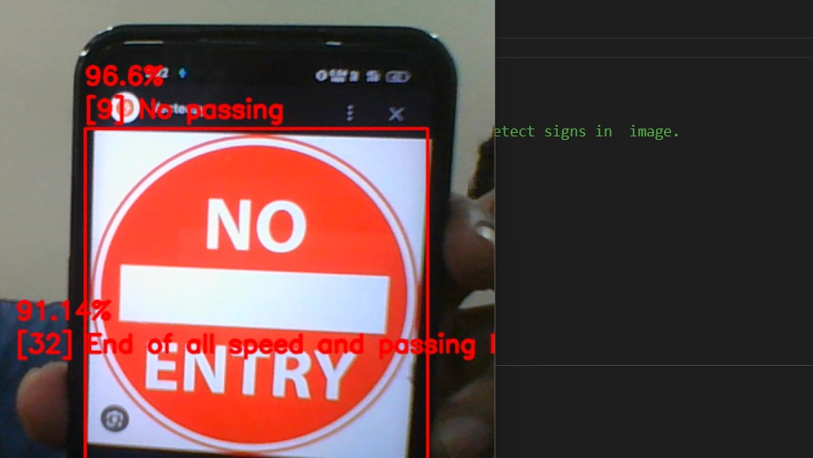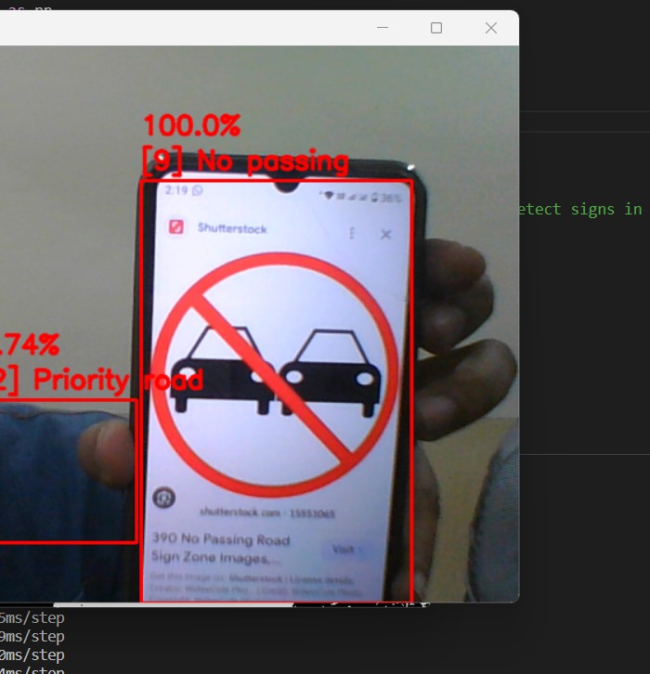

No entry No passing

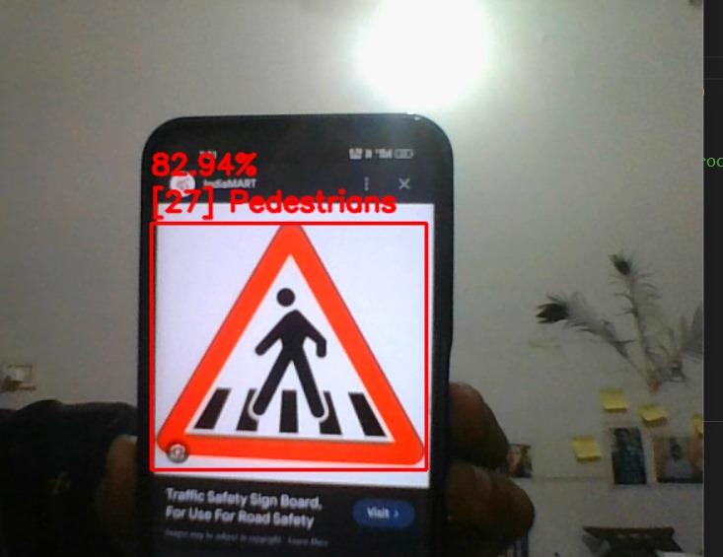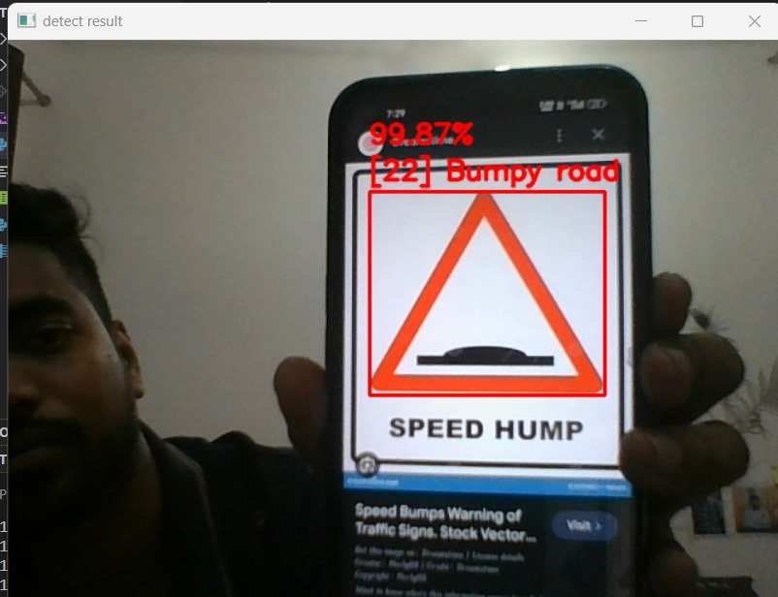

Pedestrains Bumpy Road
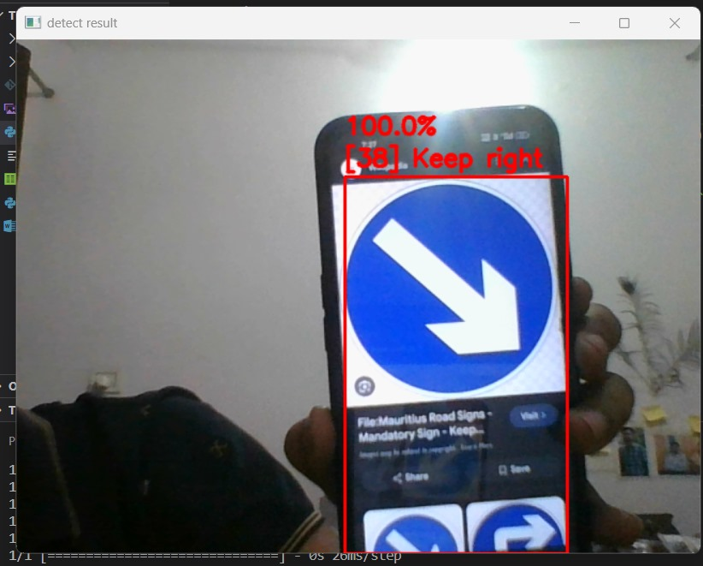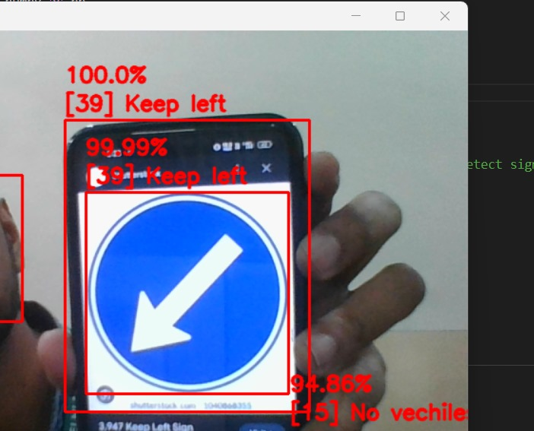

Keep Right Keep Left

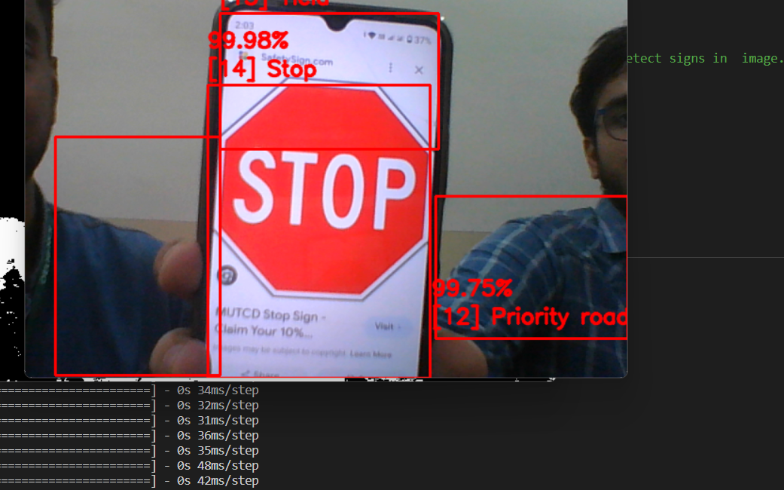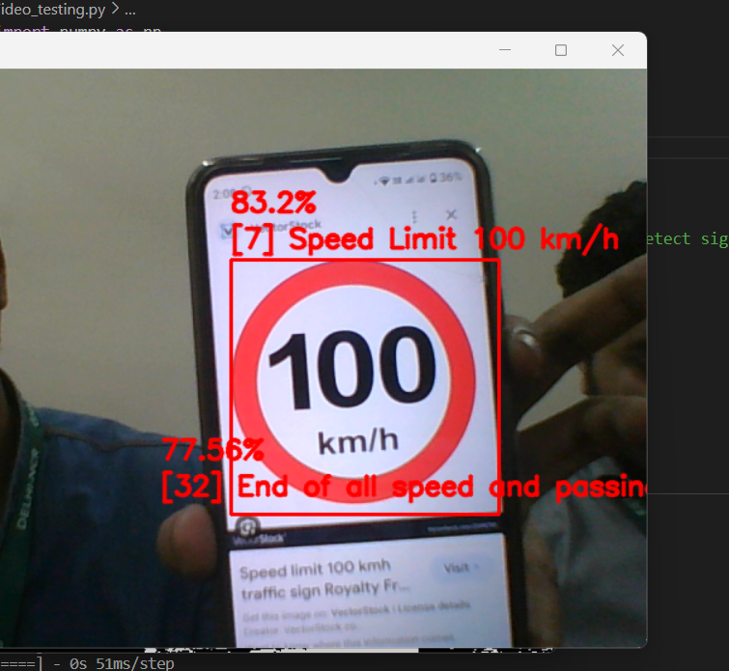

Stop 100 speed limit

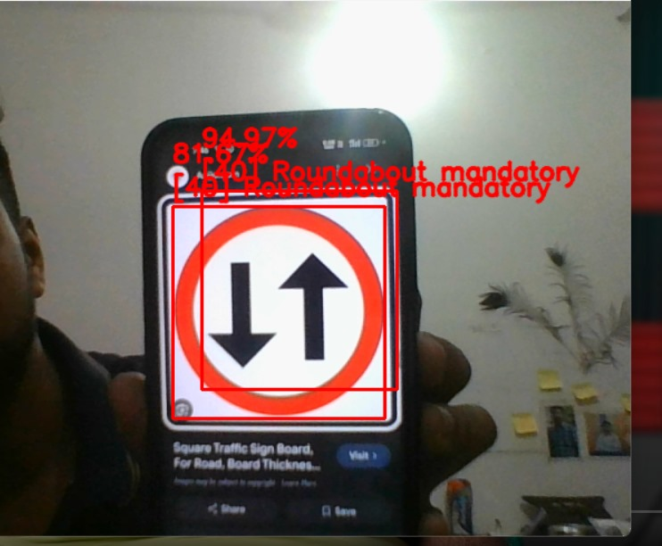

Roundbout

Resource & Environment Needs

Testing Tools

- Manual Testing: A set of test cases were made using traffic signs by showing them in the camera module.

- We can set up a few test cases as per Boundary value analysis.

- We can also set up some cases for Equivalence testing.

Test Environment

Creating a suitable testing environment for a traffic sign recognition system using CNNs is essential to ensure effective testing and validation. The testing environment should replicate real-world conditions as closely as possible while providing control and repeatability.

A] Hardware and Software

- Computers and GPUs: High-performance computers with GPUs for running the recognition system.

- Traffic Sign Recognition Software: Install the recognition system, including the CNN model and related software components.

- Operating System: Choose an OS that supports the software stack used for development and testing.

B] Test Data

- Traffic Sign Dataset: Collect a diverse and representative dataset of traffic signs for testing. This dataset should include various sign types, sizes, conditions, and environmental factors.

C] Test Scenarios

- Realistic Conditions: Create test scenarios that simulate real-world conditions, such as different weather conditions, lighting, and occlusions.

- Boundary Cases: Include scenarios that test the system's performance at the boundary of its capabilities, like small or heavily obstructed signs.

D] Testing Infrastructure

- Camera and Sensors: Use cameras and sensors to capture real-time images or videos for testing.

- Test Environment Setup: Build a controlled testing environment with adequate lighting, weather simulation, and object occlusion capabilities.

E] Feedback and Issue Tracking

- Set up a system for reporting and tracking issues or bugs found during testing.

- Gather feedback from testers, end-users, or domain experts for evaluation and improvement.

F] Safety Measures

- Ensure safety measures in the testing environment to prevent accidents or mishaps, especially if testing involves real-world scenarios.

