**GoPhaser**

Software Design Document

Version 0.9

*Prepared By*

Gokul S Anil

**Document Identifier**

|  |  |
| --- | --- |
| **Project Code** | GoP |
| **Project Name** | GoPhaser |
| **Document Name** | Software Requirement Specification |
| **Version** | 1.0 |
| *File Name* | GoPhaser_SRS.doc |
| *Classification* | Confidential |
| *Client* |  |

|  |  |  |
| --- | --- | --- |
|  | **Name** | **Signature & Date** |
| **Prepared By** | Gokul S Anil |  |
| **Reviewed By** |  |  |
| **Approved By** |  |  |
| **Distribution List** |  | |

**Revision History**

|  |  |  |  |  |
| --- | --- | --- | --- | --- |
| **Version** | **Date** | **Author** | **Reviewer** | **Change Description** |
|  |  |  |  |  |
|  |  |  |  |  |
|  |  |  |  |  |
|  |  |  |  |  |
|  |  |  |  |  |

**Table of Contents**

1. **Introduction………………………………………….** 5

1.1 Purpose……………………………………………………… 5

1.2 Scope………………………………………………………… 5

1.3 Overview…………………………………………………… 5

1.4 Reference Material…………………………………… 5

1.5 Definitions and Acronyms………………………… 6

2. **System Overview……………………………………** 7

3. **System Architecture………………………………**7

3.1 State Chart Diagrams……………………………… 7

4. **Component Design……………………………….** 15

# Introduction

## Purpose

The purpose of the Software Requirements Specification document is to maintain all the functions and the specifications of ‘GoPhaser’. Besides, it contains detailed descriptions of all the requirements specified.

## Scope

The project named ‘GoPhaser’ aims at implementing a software system that hides any form of data in plain sight with military-grade encryption.

GoPhaser can convert any form of data viz. .docx, .pptx, .xlsx, .mp3, .mp4, .mkv, .avi, etc. to a list of words. This steganographic technique is different from the traditional text steganography methods in the sense that we are not embedding the message file in the covering file, rather embedding the covering file in the message file. This makes data hiding in plain sight more effective. Network engineers can use this software to convert data to a list of accepted strings so that they can easily evade data whitelisting and blacklisting. System engineers can find use in this tool in scenarios where they need to store some useful files that may be marked as not safe by inbuilt firewalls or third-party antivirus software. They can convert the file using GoPhaser and store them easily.

## Overview

This document is organized into sections having System Overview, System Architecture, Data Design, Component Design and Human Interface Design.

## Reference Material

IEEE Recommended Practice for Software Requirements Specifications -IEEE Std 830-1998.

## Definitions, acronyms, and abbreviations

### Abbreviations

Stego - Steganography

AES - Advanced Encryption Standard

### Definitions

**Steganography:** Steganography is the practice of concealing a file, message, image, or video within another file, message, image, or video. The word steganography combines the Greek words steganos, meaning "covered or concealed", and graph meaning "writing”.

**Data Whitelisting and Blacklisting:** White lists and blacklists are two ways of filtering data. If you have a white list then you will filter in only data on the white list; if you have a blacklist you will filter out only data on that list.

For example, consider automatically rejecting incoming phone calls. You could have a blacklist of marketing companies, so everyone but they would be able to call you. Or you could have a white list containing your friends' numbers, so only they would be able to call you

Whitelist - only these things.

Blacklist - everything except these things.

# System Overview

GoPhaser is a simple yet interactive software based system that would enable the user to hide confidential files in plain sight, along with various other functionalities like data infiltration and exfiltration. The various functionalities to be dealt by system are classified into different modules.

The proposed software shall have the following modules or functions:

• Encryption

• Decryption

• Enphasing

• Dephasing

• Ciphers

# System Architecture

The software architecture of a program or computing system is the structure or structures of the system which comprise the software components, the

externally visible properties of those components, the relationships among the

components.

Analysis model of GoPhaser consists of various state diagrams, class diagram, component diagram and implementation screen captures.

**3.1 State Chart Diagrams:**

A Statechart diagram is one of the five UML diagrams used to model the dynamic nature of a system. They define different states of an object during its lifetime and these states are changed by events. Statechart diagrams are useful to model the reactive systems. Reactive systems can be defined as a system that responds to external or internal events.

1. Encryption

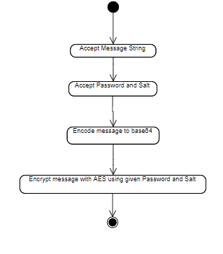

1. Decryption

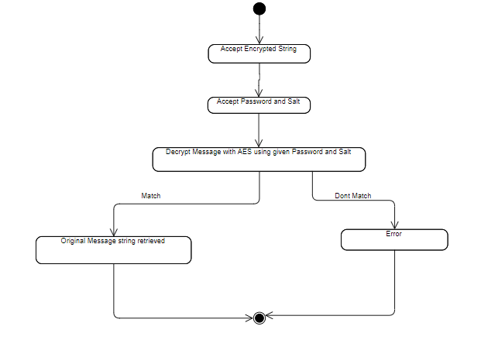

1. Enphasing

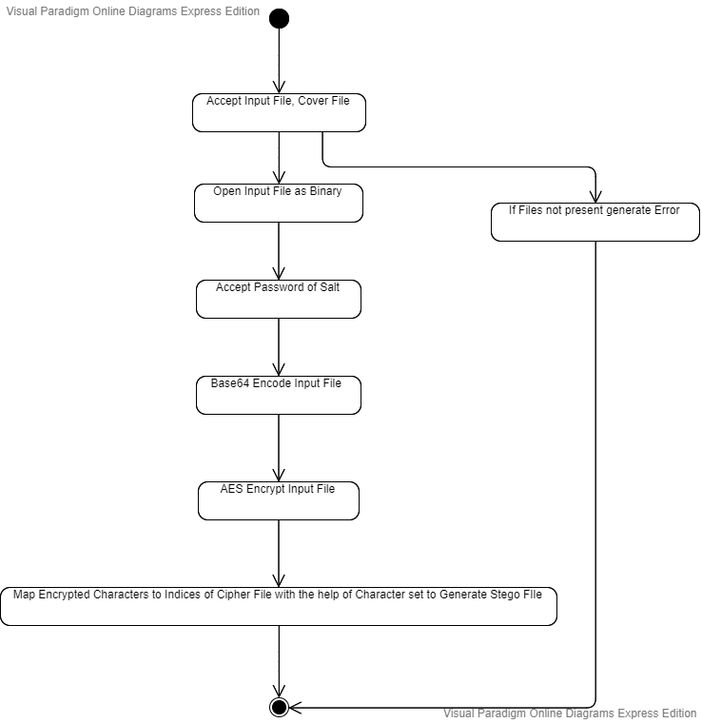

1. Dephasing

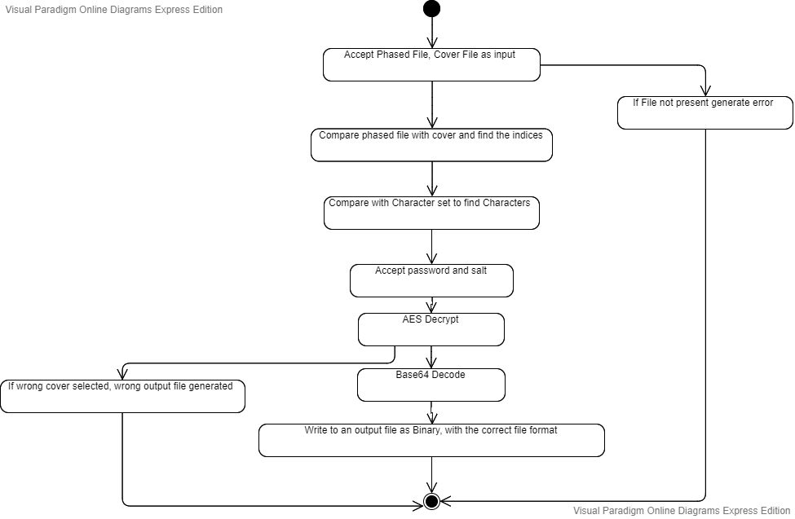

1. Ciphers

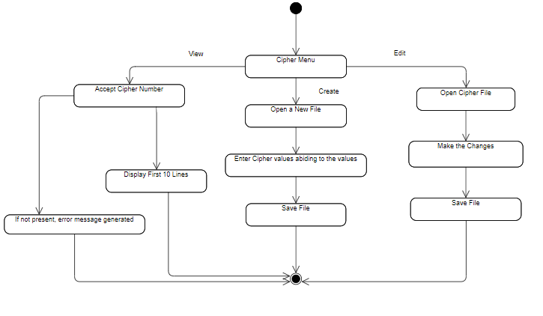

3.2 Class Diagram

Class diagram in the Unified Modeling Language (UML) is a type of static

structure diagram that describes the structure of a system by showing the

systems classes, their attributes, operations (or methods), and the

relationships among objects.

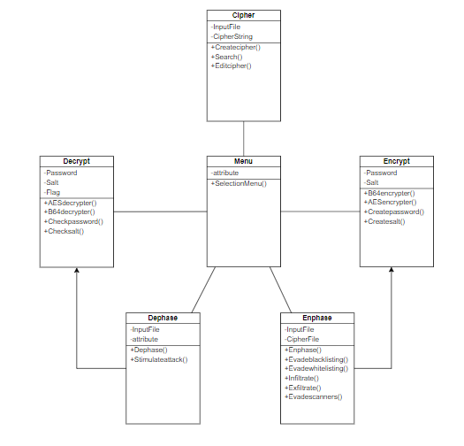

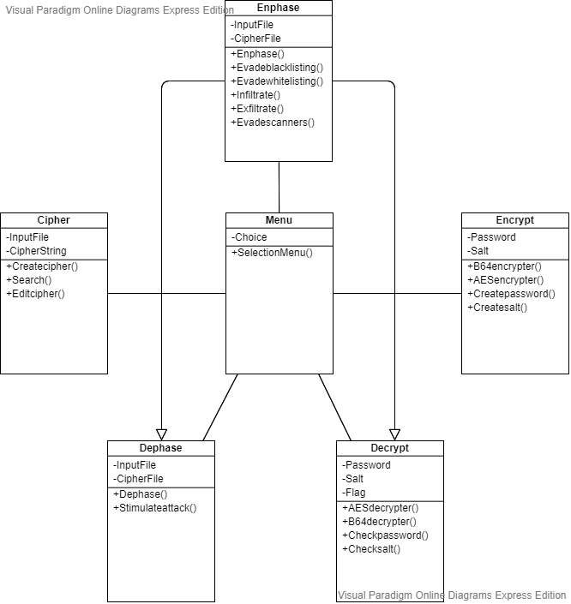

1. Component Design

Component Diagram:

The component diagram’s main purpose is to show the structural relationships

between the components of a system,that is, depicts how components are

wired together to form larger components and or software systems.

