**ENTITY – RELATIONSHIP DIAGRAM**

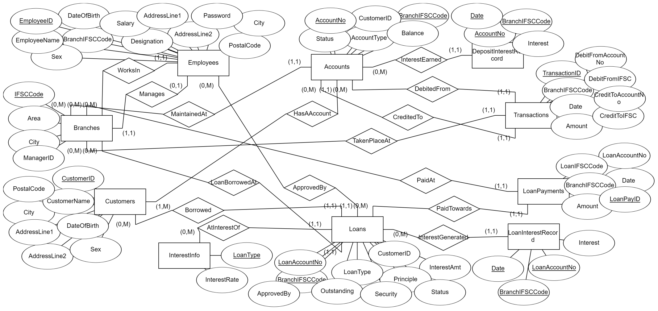

**ER DIAGRAM DESIGNED BY SRINATH S**

**GENERATED AT erdplus.com**

**CARDINALITY AND PARTICIPATION REPRESENTED IN MINIMUM-MAXIMUM REPRESENTATION**

**RELATIONAL SCHEMA**

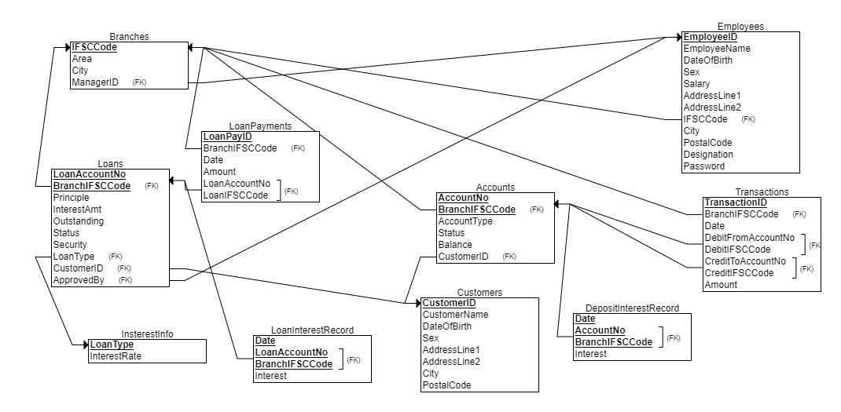

**RELATIONAL SCHEMA DESIGNED BY SRINATH S**

**GENERATED AT erdplus.com**