实验一 TINY语言的词法分析

实验目的

构造tiny语言的词法分析器（扫描器），要求利用第三方的lex工具进行构造。实验结果：构造出的扫描器，能够读入教材样例中给出的tiny语言的示例代码，分解成token输出。

Experimental Requirement

Build the lexical parser (a scanner) of TINY language, using the Lex tool of third party. The experimental result Scanner can receive the sample program of Tiny language, and output is a sequence of tokes that are defined by regular expression.

输入：

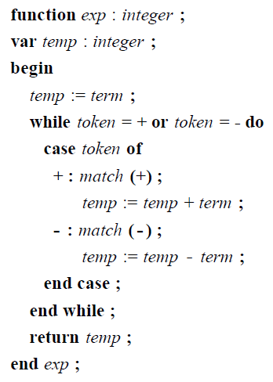

预习要求：

Preview requirements:

1.查阅各种专业文献，针对任意二种现代程序设计语言编译器的词法分析技术，找出各自的标志性的特征点，并加以比较分析和比较，指出其优缺点，并试图给出自已的结论。

Referring to professional literatures, aiming at the lexical analysis technology of any two modern programming language compilers, finds out their respective features, compares them, points out their advantages and disadvantages, and tries to give your Evaluation and conclusions.

2.请描述自已拟定的实验计划和步骤，以及对输入和输出的设计。

Please design your experimental plan and procedures, as well as the design of input and output of the SCANNER

3.选择三方工具，阅读其使用说明，并尝试建立起工作环境。

Choose the LEX tools, read their instructions, and try to establish a working environment.