**Dockerizing Magento2 application and deploying on Kubernetes**

**Flow:**

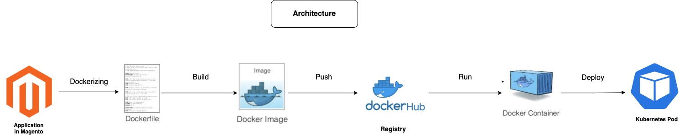

The flow depicts the whole process of dockerizing magento2 application and deploying it in Kubernetes.

* Writing a dockerfile to dockerize and make the application portable.
* Build the dockerfile to prepare a docker image.
* Push the built docker image to docker hub which can be pulled from any machine.
* Run the docker image in a container. Since magento needs a database to function, we are using MySQL database.
* Deploy the magento docker image and MySQL image in the Kubernetes with the K8s manifests.

**Steps:**

1. Magento application repo link: <https://github.com/V3Main-Tech/magento2/tree/2.4>
2. Docker file:
3. FROM alexcheng/magento2 -using magento official image as base image.
4. COPY . /var/www/html/. - copying our files into the image.
5. Push the docker image to docker hub after tagging.
6. To change the magento version change the version in composer.json and fire “composer update” to get the desired version.
7. Now time to write k8s manifests to deploy in pods.
8. **Magento-Deployment.yml**
9. 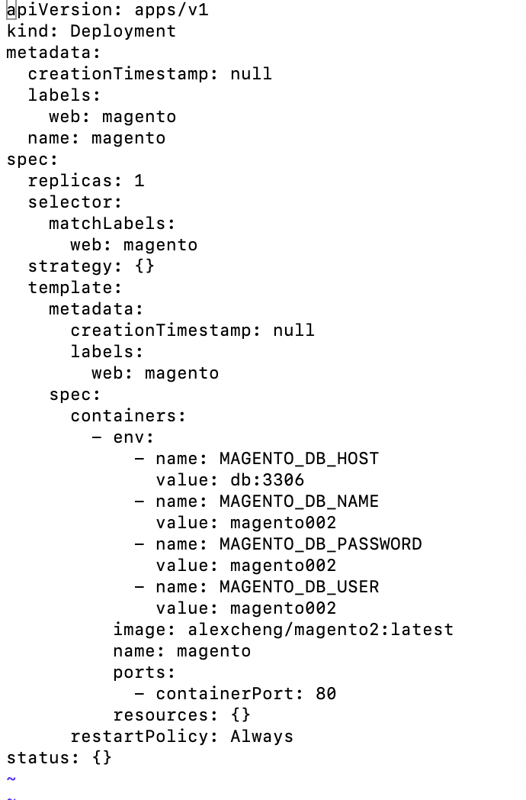
10. **Magento-Service.yml**
11. 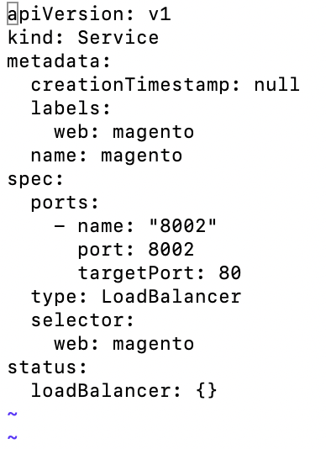
12. **Db-deployment.yml**
13. 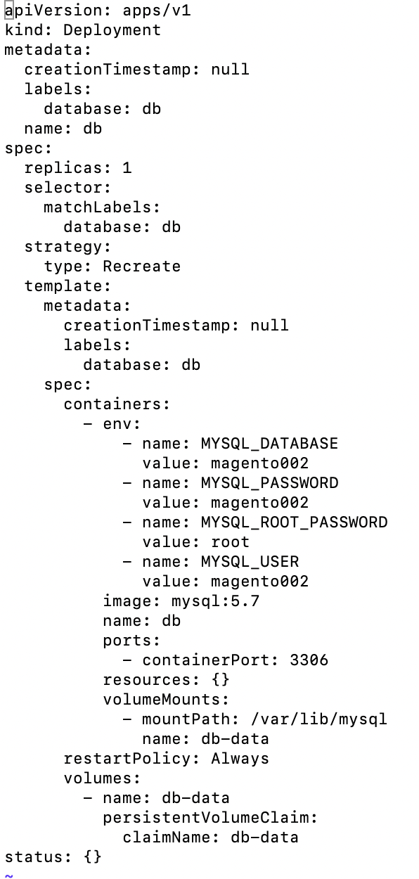
14. **Db-service.yml**
15. 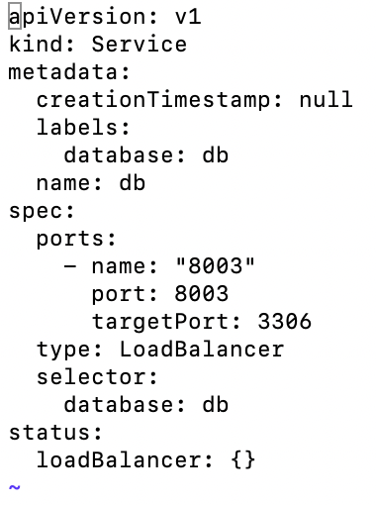
16. **PersistentVolumeClaim.yml**
17. 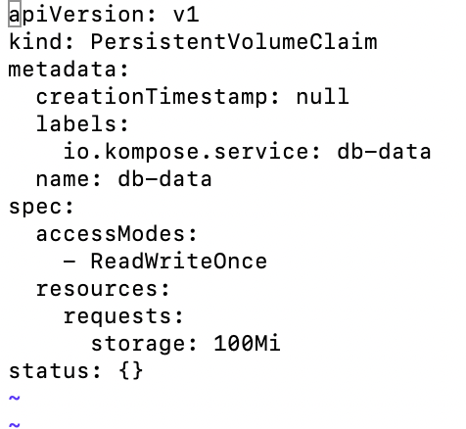

**Magento2 running on K8s.**

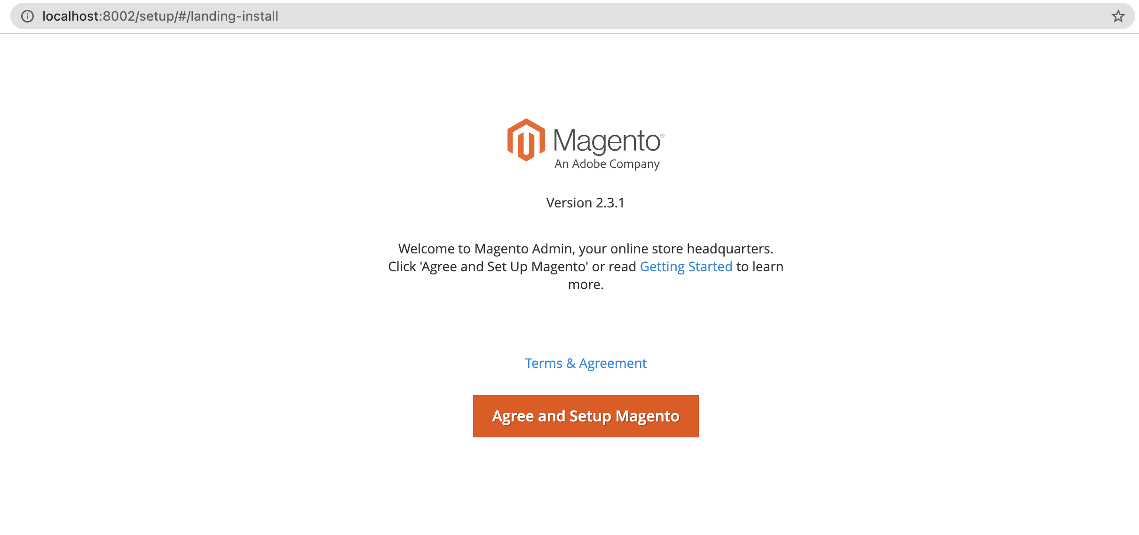

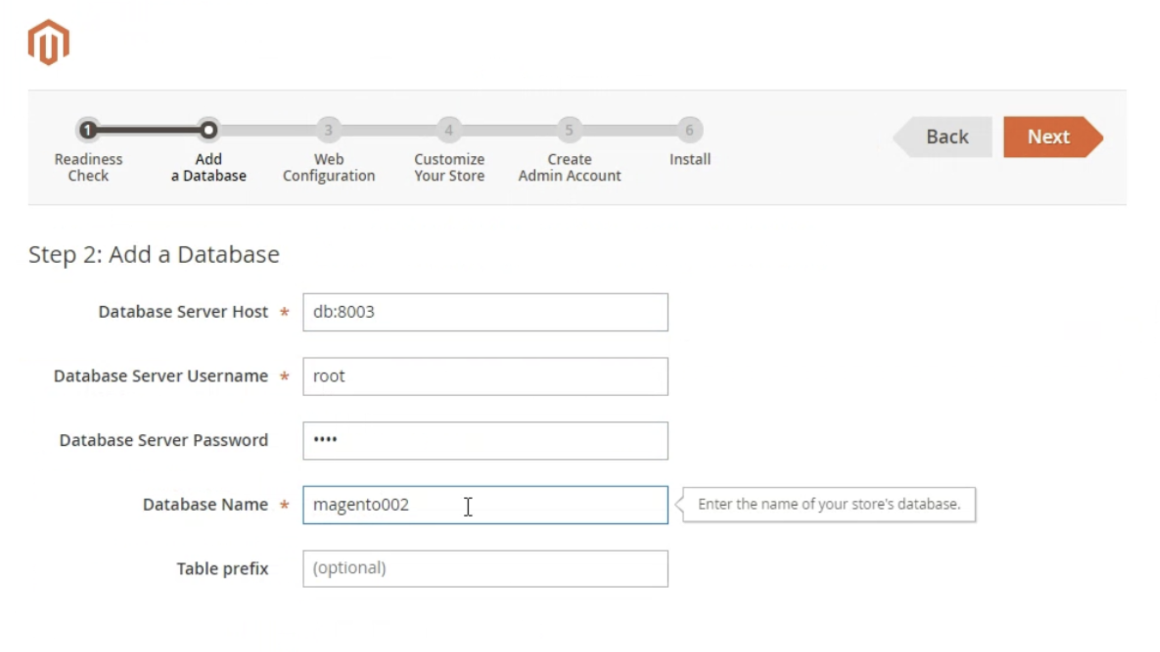

Source - <https://www.veonconsulting.com/install-magento-in-docker/>

<https://www.mgt-commerce.com/tutorial/setup-magento-2-local-development-environment-with-docker/>