系級:資工四 學號:402410096 姓名:吳憲發

1. 1 node:

Training accuracy curve:

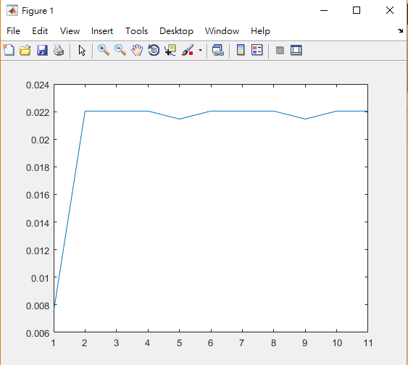

Accurancy:



1. 10 nodes:

Training accuracy curve:

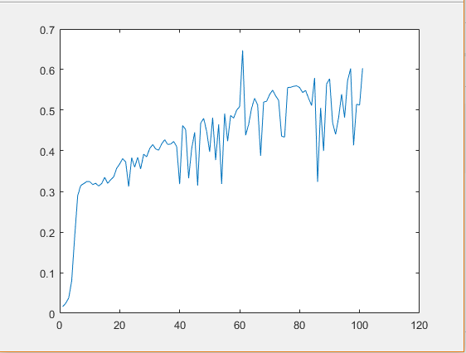

Accurancy: 

1. 50 nodes:

Training accuracy curve: 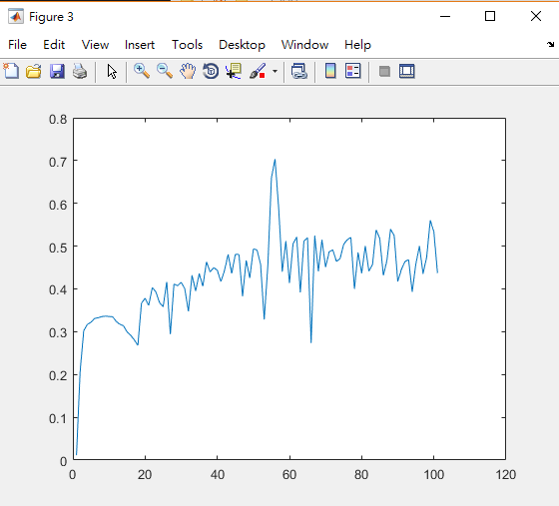

Accurancy:

