Steps of Install caffe

System: windows 10

Pre-build tool: visual studio 2013

1.caffe

Download : <https://github.com/BVLC/caffe/tree/windows>

<https://en.wikipedia.org/wiki/CUDA>

2.Use gpu accelerate

Download cuDNN v5 from [nVidia website](https://developer.nvidia.com/cudnn)

Download CUDA Toolkit 7.5 from [nVidia website](https://developer.nvidia.com/cuda-toolkit)

Install CUDA automatically, and unzip cuDNN in caffe-windows dir

3.build setting

1. Copy .\windows\CommonSettings.props.example and rename it to .\windows\CommonSettings.props
2. edit CommonSettings.props:

CpuOnlyBuild set false

UseCuDNN set true

CudaVersion set 7.5(根據你安裝的cuda版本)

CudaArchitecture : i.g. GTX660(cuda 3.0) compute_30,sm_30

CuDnnPath : Set path of your cuDNN dir

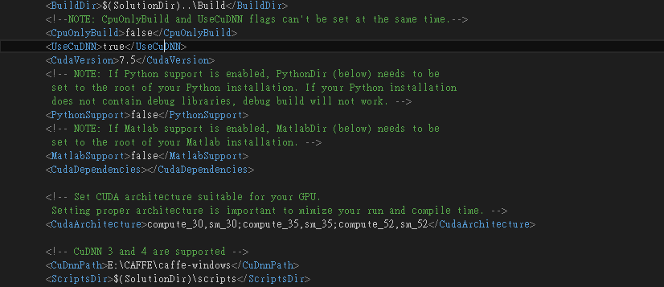

1. Open Caffe.sln

* Change debug to release





* Select and Click on the right button of your mouseproperty(屬性) 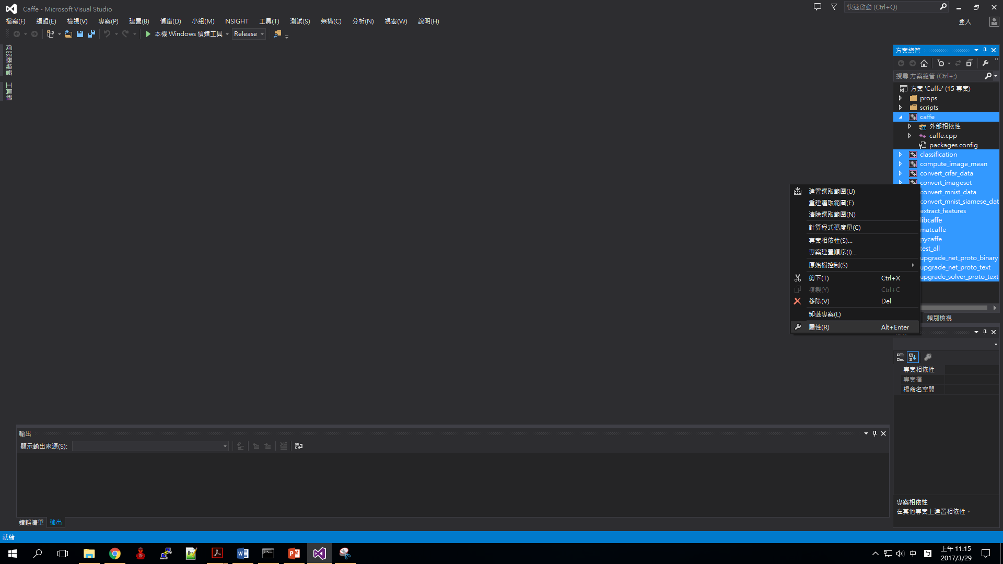
* Change 是(/WX) to 否(/WX-)

1. Build:選擇建置方案

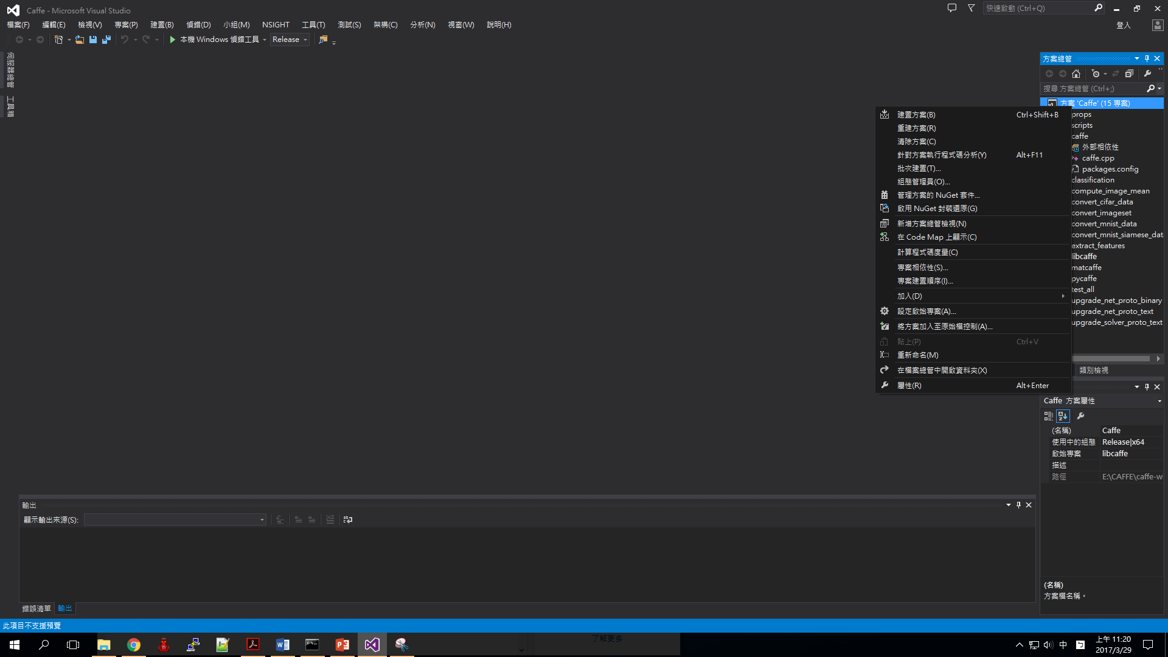

1. Problem

Error 1：data_reader.cpp: No such file or directory

Solution：delete the include line

Error 2：opencv Error

Solution：Select方案’Cafffe’and Click on the right button of your mouse管理方案的Nuget套件…and install OpenCV

Error 3：無法開啟輸入檔’libcaffe.lib’

Solution：Error 1 solves , it solves.

1. Result

