402410096 資工四 吳憲發

1. No ,I do nothing.

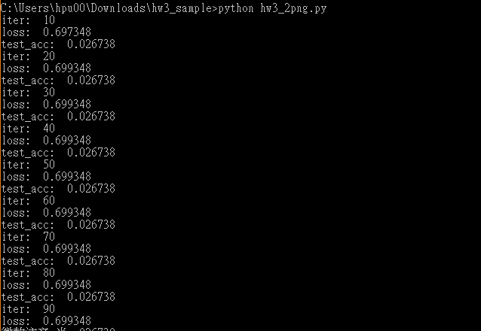

1. (1) 錯誤訊息: ImportError: DLL load failed: 找不到指定的模組。

解決方法:http://www.jianshu.com/p/84208372e2ef

(2)錯誤訊息:The TensorFlow library wasn't compiled to use FMA instructions, but these are available on your machine and could speed up CPU computations.

解決方法:https://github.com/tensorflow/tensorflow/issues/7778

1. 無。