

National Institute of Technology Rourkela

Department of Computer Science and Engineering

Master of Technology in Computer Science

LABORATORY ASSIGNMENT REPORT
Advanced Data Structure Laboratory
(CS 6173)
Assignment-I

Simulation of coin tossing, performance analysis of bubble, quick and insertion sorting

SUBMITTED BY:  Name: Sumit Karmakar  Roll No: 226CS1008  Branch: Computer Science & Engineering  Semester: 1st | SUBMITTED TO:  Dr. Bibhudatta Sahoo  Department of Computer Science & Engineering  Date of Submission: 29th August, 2026

1. EXPERIMENT OVERVIEW
For this assignment we have performed simulation of coin tossing. We have used random number generator for simulating the coin tossing event.
We have simulated comparison-based performance analysis of standard bubble sort and bubble sort with early stopping mechanism for different input classes (Sorted, nearly sorted, highly inversional).
We compared insertion sort and quick sort, then we design a hybrid sort where for subproblem size of 12 or less we do insertion sort and for bigger problem we do standard partition-based quicksort. A comparison-based study has also been performed to understand how merging two different type of sorting we can achieve better execution time for sorting of a given dataset.

2. OBJECTIVES
- To simulate coin toss with random generator in C++.
- To get performance-based analysis of bubble sort and bubble sort with early stopping.
- To compare insertion sort and quick sort and design a hybrid sort that utilizes benefits of both the sorting methods.
- Plotting of output data in MATLAB to get visual representation and performance analysis.

3. THEORY & BACKGROUND
For coin tossing we make use of inbuilt random number generator and uniform distribution provided by C++.
Bubble sort is a comparison-based sorting algorithm which runs in O($n^{2}$) time complexity. Classical Bubble Sort always runs n – 1 time where n is the size of the given input. We can include an
early stopping mechanism, which checks whether we need to go to next pass or not by checking that data is already sorted or not using a swap checking variable.

4. IMPLEMENTATION / CODE
Below is the C++ implementation of the assigned questions:
- Q1: Coin Tossing
- #include<iostream>
- #include<random>
- #include<fstream>

- void oneCoinToss(std::mt19937 generator){
- std::uniform_int_distribution<int> coin(0,1);
- int N = 5000;

- std::fstream file("oneCoinToss.csv", std::ios::out| std::ios::in | std::ios::trunc);
- if(!file.is_open()){
- throw std::runtime_error("Failed to open the file!!");
- }
- file << "Toss,Heads,Tails,HeadProbability,TailProbability";
- file << "\n";

- int heads = 0, tails = 0;

- for(int i = 1; i <= N; i++){
- int result = coin(generator);
- if(result){
- heads++;
- }
- else tails++;

- double head_prob = heads*1.0/i;
- double tail_prob = tails*1.0/i;

- file << i << ", " << heads << ", "
- << tails << ", " << head_prob << ", " << tail_prob << "\n";
- }
- file.close();
- std::cout<<heads << " " << tails << " " <<heads*1.0/N << " " << tails*1.0/N << std::endl;

- }

- void twoCoinToss(std::mt19937 generator){
- std::uniform_int_distribution<int> coin(0,1);

- int N = 5000;

- std::fstream file("twoCoinToss.csv", std::ios::out| std::ios::in | std::ios::trunc);
- if(!file.is_open()){
- throw std::runtime_error("Failed to open the file!!");
- }
- file << "Toss,HH,HT,TH,TT,P(HH),P(HT),P(TH),P(TT)";
- file << "\n";

- int HH = 0, HT = 0, TH = 0, TT = 0;

- for(int i = 1; i <= N; i++){
- int result1 = coin(generator);
- int result2 = coin(generator);
- if(result1){
- if(result2){
- HH++;
- }
- else HT++;
- }
- else{
- if(result2){
- TH++;
- }
- else TT++;
- }

- double HH_prob = HH*1.0/i;
- double HT_prob = HT*1.0/i;
- double TH_prob = TH*1.0/i;
- double TT_prob = TT*1.0/i;

- file << i << ", " << HH << ", " << HT << ", " << TH << ", " << TT << ", "
- << HH_prob << ", " << HT_prob << ", " << TH_prob << ", " << TT_prob << "\n";
- }
- file.close();

- std::cout<<HH << " " << HT << " " << TH << " " << TT << " " << HH*1.0/N << " " << HT*1.0/N << " " <<TH*1.0/N << " "<<TT*1.0/N << "\n";

- }
- int main(){
- std::random_device rd;
- std::mt19937 generator(
- static_cast<unsigned int>(rd())
- );

- // Experiment with single coin toss;
- oneCoinToss(generator);

- // Experiment with 2 coin tosses;
- twoCoinToss(generator);

- return 0;

- }

- Q2: Performance analysis of Bubble Sort
- #include "generation/RandomInputGenerator.hpp"
- #include "sorting/Sorting.hpp"
- #include <iostream>
- #include <fstream>
- #include <algorithm>

- int bSortWithoutEarlyStopping(std::vector<int>& data){
- size_t size = data.size();
- int comp = 0;
- for(int i = 1; i < size; i++){
- for(int j = 0; j < size - i; j++){
- if(data[j] > data[j+1]){
- std::swap(data[j], data[j+1]);
- }
- comp++;
- }
- }
- return comp;
- }
- int main(){
- RandomInputGenerator generator;
- BubbleSort bSortWithtEarlyStopping;
- // highly randomly ordered data;
- std::fstream file1("comparisonHighlyRandom.csv", std::ios::in | std::ios::out | std::ios::trunc);
- if(!file1.is_open()) throw std::runtime_error("File not openeed!!");

- file1<< "InputSize, Comp(NES), Comp(ES)" << "\n";

- int cmpWithoutEarlyStopping = 0, cmpWithEarlyStopping = 0;
- for(int datasize = 1; datasize <= 100; datasize++){
- std::vector<int> b1Data = generator.generateInput(datasize, 1, 1000, InputType::HIGHLY_INVERSIONAL);
- std::vector<int> b2Data= b1Data;
- cmpWithEarlyStopping = bSortWithtEarlyStopping.sort(b1Data);
- cmpWithoutEarlyStopping = bSortWithoutEarlyStopping(b2Data);
- file1 << datasize << ", " << cmpWithoutEarlyStopping << ", " << cmpWithEarlyStopping << "\n";
- }

- file1.close();

- // nearly sorted data;
- std::fstream file2("comparisonNearlySorted.csv", std::ios::in | std::ios::out | std::ios::trunc);
- if(!file2.is_open()) throw std::runtime_error("File not openeed!!");

- file2<< "InputSize, Comp(NES), Comp(ES)" << "\n";

- cmpWithoutEarlyStopping = 0, cmpWithEarlyStopping = 0;
- for(int datasize = 1; datasize <= 100; datasize++){
- std::vector<int> b1Data = generator.generateInput(datasize, 1, 1000, InputType::NEARLY_SORTED, SortOrder::ASCENDING,0.08);
- std::vector<int> b2Data= b1Data;
- cmpWithEarlyStopping = bSortWithtEarlyStopping.sort(b1Data);
- cmpWithoutEarlyStopping = bSortWithoutEarlyStopping(b2Data);
- file2 << datasize << ", " << cmpWithoutEarlyStopping << ", " << cmpWithEarlyStopping << "\n";
- }

- file2.close();

- // sorted data;
- std::fstream file3("comparisonSorted.csv", std::ios::in | std::ios::out | std::ios::trunc);
- if(!file3.is_open()) throw std::runtime_error("File not openeed!!");

- file3<< "InputSize, Comp(NES), Comp(ES)" << "\n";

- cmpWithoutEarlyStopping = 0, cmpWithEarlyStopping = 0;
- for(int datasize = 1; datasize <= 100; datasize++){
- std::vector<int> b1Data = generator.generateInput(datasize, 1, 1000, InputType::SORTED);
- std::vector<int> b2Data= b1Data;
- cmpWithEarlyStopping = bSortWithtEarlyStopping.sort(b1Data);
- cmpWithoutEarlyStopping = bSortWithoutEarlyStopping(b2Data);
- file3 << datasize << ", " << cmpWithoutEarlyStopping << ", " << cmpWithEarlyStopping << "\n";
- }

- file3.close();

- return 0;
- }

- Q3: Variants of QUICK SORT

#include "generation/RandomInputGenerator.hpp"
#include "sorting/Sorting.hpp"
#include <vector>
#include <algorithm>
#include <fstream>

class HybridSort{
private:
static constexpr int CUTOFF = 12;
static long long comparisons;

static int lomutoPartition(
std::vector<int>& data,
int start,
int end
) {

int pivot = data[end];

int left = start - 1;

for (int right = start; right < end; right++) {

comparisons++;

if (data[right] < pivot) {

left++;

std::swap(data[left], data[right]);
}
}

std::swap(data[left + 1], data[end]);

return left + 1;
}

static void hybridSort(
std:: vector<int>& data,
int start,
int end
){
if (start >= end)
return;

int size = end - start + 1;

// small problem -> insertion sort
if(size <= CUTOFF){
comparisons += InsertionSort::sort(data,start,end);
return;
}

int p = lomutoPartition(data,start,end);

hybridSort(data, start, p-1);
hybridSort(data, p+1,end);

}

public:
static void sort(std::vector<int>& data){
if(data.empty())
return;

hybridSort(data,0,data.size()-1);
}

static void resetComparisons()
{
comparisons = 0;
}

static long long getComparisons()
{
return comparisons;
}

};

long long HybridSort::comparisons = 0;

int main(){

RandomInputGenerator generetor;

std::fstream file1("iqSortComparison.csv", std::ios::in | std::ios::out | std::ios::trunc);
if(!file1.is_open()) throw std::runtime_error("File not opened!!");

file1<< "InputSize, Comp(ISort), Comp(QSort)" << "\n";
for(int datasize = 10; datasize <= 1000; datasize++){
std::vector<int> iSortData = generetor.generateInput(datasize, 1, 9999,InputType::HIGHLY_INVERSIONAL,SortOrder::ASCENDING, 0.75);
std::vector<int> qSortData = iSortData;

int iSortComparison = InsertionSort::sort(iSortData);

QuickSort::sort(qSortData, 0, qSortData.size()-1, PartitionScheme::HOARE);
int qSortComparison = QuickSort::getComparisons();
QuickSort::resetComparisons();

file1<< datasize << ", " << iSortComparison << ", " << qSortComparison << "\n";
}
file1.close();

std::fstream file2("qhSortComparison.csv", std::ios::in | std::ios::out | std::ios::trunc);
if(!file2.is_open()) throw std::runtime_error("File not opened!!");

file2<< "InputSize, Comp(QSort), Comp(HQSort)" << "\n";
for(int datasize = 100; datasize <= 400; datasize++){
std::vector<int> qSortData = generetor.generateInput(datasize, 1, 9999,InputType::HIGHLY_INVERSIONAL,SortOrder::ASCENDING, 0.75);
std::vector<int> hybridData = qSortData;

QuickSort::sort(qSortData, 0, qSortData.size()-1, PartitionScheme::LOMUTO);
int qSortComparison = QuickSort::getComparisons();
QuickSort::resetComparisons();

HybridSort::sort(hybridData);
int hSortComparison = HybridSort::getComparisons();
HybridSort::resetComparisons();
file2<< datasize << ", " << qSortComparison << ", " << hSortComparison << "\n";
}
file2.close();

return 0;
}

5. SAMPLE OUTPUT & SIMULATION RESULTS
- Q1: Coin Toss (Single and double-coin tossing simulation):
We have simulated for 5000 times for both single and double coin tossing.
Experiment | P(Head) | P(Tail) | Remarks
Single coin toss | 0.5154 | 0.4846 | Both converge near to 0.5 line

Experiment | P(H H) | P(H T) | P(T H) | P(T T) | Remarks
Double coin toss | 0.2520 | 0.2532 | 0.2554 | 0.2394 | All 4 lines converge near to 0.25 line
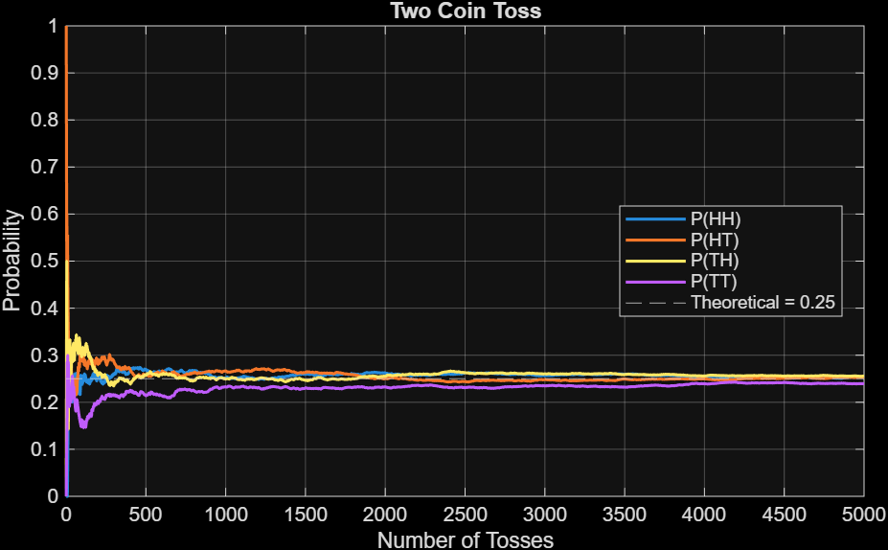
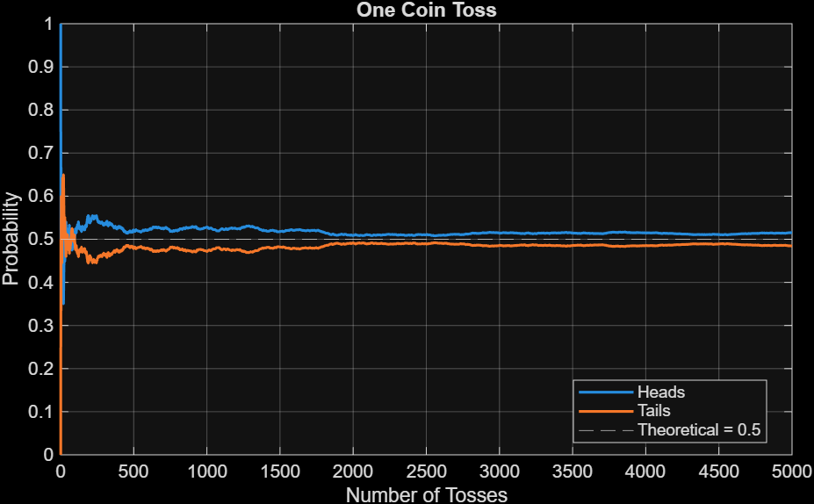
Fig 1: One coin toss simulation Fig 2: Two coin toss simulation

- Q2: Performance Analysis of Two Variants of Bubble Sort:
We take different input classes (sorted, nearly sorted and highly inversional) with different input size and get the number of comparisons that are performed by two variants of bubble sort.
Input size | Input Class | Classical Bubble Sort | RBubble Sort with early stopping
Single coin toss | 0.5154 | 0.4846 | Both converge near to 0.5 line

- Q3: Variants of Quick Sort:
Insert screenshots, console log outputs, or structured tables representing execution results here.
Algorithm | Best Case | Average Case | Worst Case
Quick Sort | O(N log N) | O(N log N) | O(N²)
Merge Sort | O(N log N) | O(N log N) | O(N log N)
6. DISCUSSION & ANALYSIS
Discuss your observations here. Detail performance differences observed, practical edge cases encountered, and how memory overhead impacts overall program efficiency.
7. CONCLUSION
State the final conclusions drawn from completing this experiment, confirming whether objectives were successfully met.

Simulation results and observations
Standards for cpp and matlab and java . credit and reference
cmake

