

What is Infinitest?
Infinitest is a continuous JUnit test runner designed to facilitate Test Driven Development. It helps you get the most out of TDD by reducing your feedback cycle from minutes to seconds.

Getting Started
Infinitest runs as a standalone application that monitors class files in your Java project. To start:
- Add the infinitest.jar file to your project classpath
- Run the main method in org.infinitest.Infinitest

Launching From Eclipse

Add Infinitest to the project classpath
- Right click on your project and select Properties from the menu
- Choose Java Build Path from the tree browser on the left
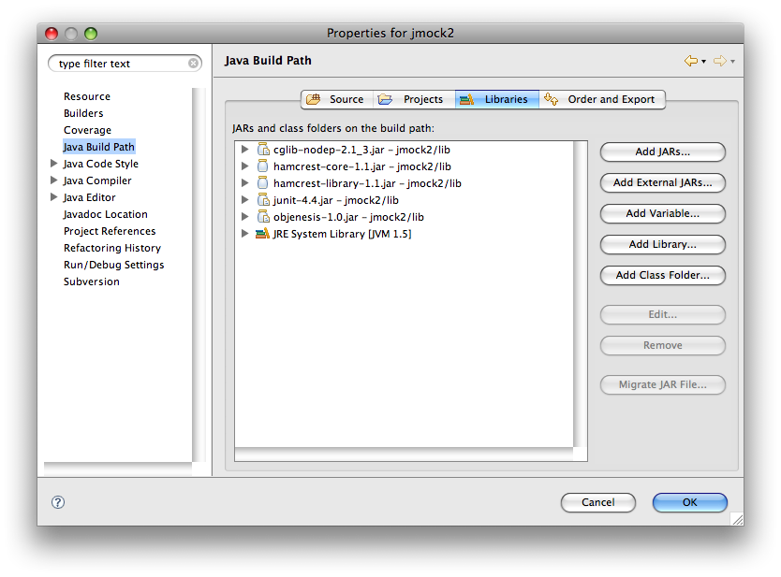
- Select the Libraries tab, and click Add External Jars
- Browse to the Infinitest installation directory, and select the infinitest.jar file
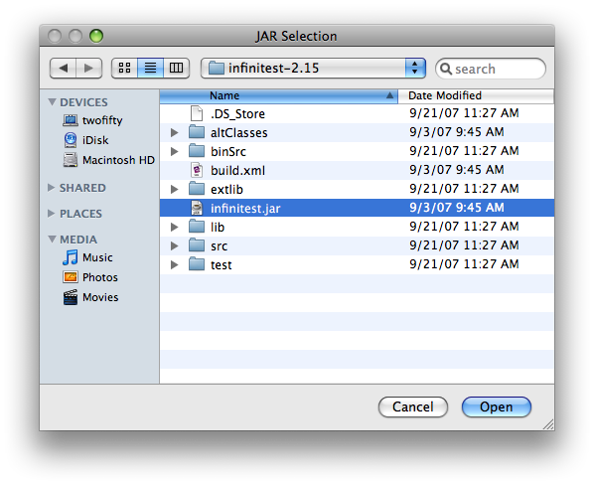

Configure run settings
- Create a new “Java Application” run configuration from the Eclipse “Run” menu
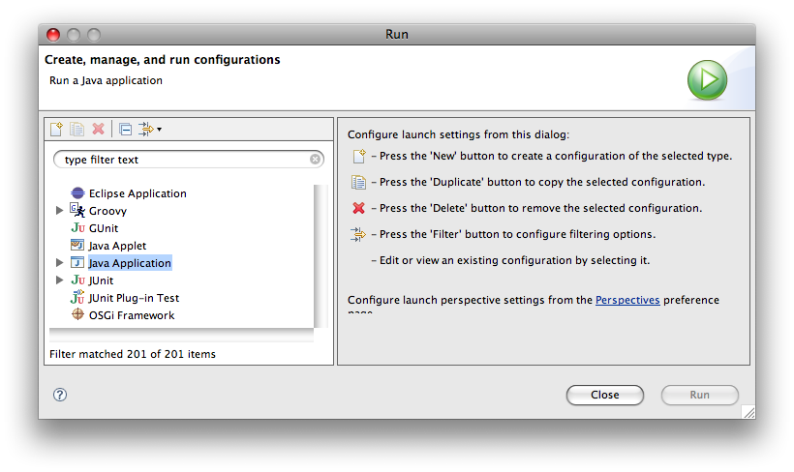
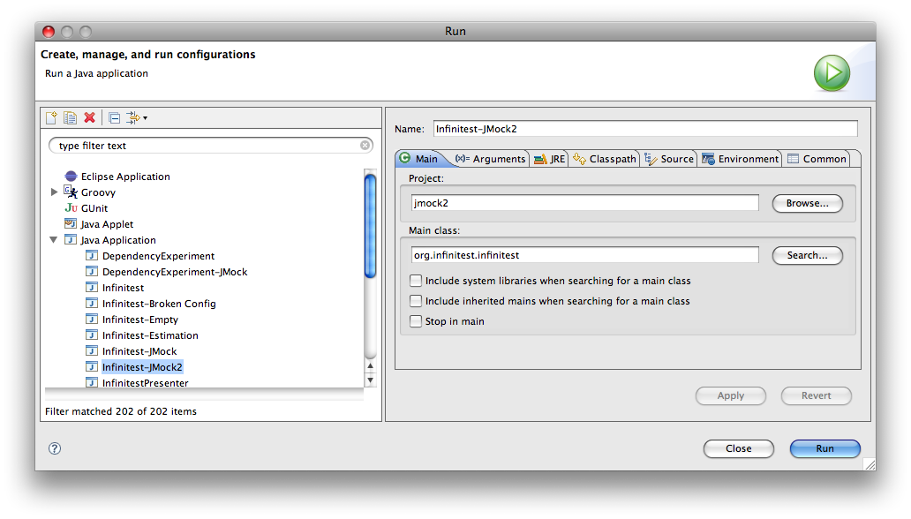
- Give the configuration a name
- Set the Main Class to org.infinitest.Infinitest
- Click Run

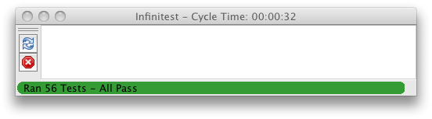
Infinitest should then appear and immediately start looking for tests to run.

Note that you can also add the infinitest jar as a classpath entry to the run configuration itself. It's not strictly necessary to add it to your entire project classpath.

Using Infinitest
When Infinitest first launches, it runs any test that extends from junit.framework.TestCase or has methods that have the org.junit.Test annotation. After that, Infinitest will run the test again if it, or one of it's dependencies, changes. Changes to direct and indirect dependencies will trigger a test run. Only the minimal set of tests which depend on those changed files will be run.

Test Priority
Infinitest runs failing tests first. It will also interrupt test runs if you make changes while the tests are being run. In this case, the current test (and any teardown methods) are allowed to run normally.

Test Driven Development
Infinitest is made with the Test Driven Developer in mind. You'll find yourself keeping your hands on the keyboard, in the flow, as Infinitest runs your tests for you with each change. Infinitest will act as a virtual pair programmer...keeping your honest and helping you take small steps.

Refactoring
Refactoring is easy with Infinitest. The bar should always stay green. If the bar turns red, you made a mistake! Back up and try again.

Refreshing The Graph
If you find yourself needing to run all of your tests from Infinitest, you can rebuild the dependency graph by hitting the reload button. This will rebuild the dependency graph and re-run all of your tests.

Stopping the tests
If you need to temporarily stop Infinitest from running your tests, you can hit the stop button. This will prevent Infinitest from running tests after changes occur. When you resume running tests (by hitting the button again), the entire test suite will be run.

Configuring Infinitest

Filtering Tests
You may have tests in your classpath that you don't want Infinitest to run. These tests can be filtered out by creating a file in the working directory of your project named infinitest.filters. It should contain one regular expression per line. Any class names (not file names) that match any regular expressions in that file will not be run. For example:
org\.myproject\.acceptance\..*
.*\$.*

will filter out all the classes in the com.myproject.acceptance package, and any inner classes (which always contain a $).

Settings
Setting | Description
runner.maxmemory | Sets the amount of memory, in megabytes, allocated to the test runner process.
infinitest.loglevel | Sets the level of logging. Valid levels are defined by the Java Logger class. Most of the interesting bits can be found at the CONFIG level.
runner.debugport | Tells the testrunner process to listen for a remote debugger on the given port. Note that this will cause the runner to block on each test run while waiting for the debugger to connect.
runner.vmargs | Specifies additional VM arguments to be passed to the testrunner process.
infinitest.greenhook | Specifies a shell command, script, or executable to be run whenever the tests go from failing to passing. The number of tests run is passed as an argument to this command.

Infinitest's settings can be configured in two ways:

Configuration File
The .infinitest.settings file created in your home directory holds Infinitest's saved settings. You can customize these settings by editing this file and restarting Infinitest.

System Properties
You can also customize the behavior of Infinitest by passing settings in as Java System Properties, like so:
-Drunner.maxmemory=1024

FAQ

Does Infinitest work with Groovy (Or Scala, or...)?
Sort of. Groovy is a dynamically typed language, and so the likelihood that Infinitest will run the correct minimal set of tests is much lower. However, Infinitest works with Java bytecode, not source, so you can use it with any language that can use JUnit and can compile to bytecode.

Infinitest isn't running my tests after I make a change!
Make sure that you haven't accidentally added a class to the classpath twice. Most commonly, this is caused when you've accidentally added two target directories to your classpath.

That's not it...
This can sometimes occur if you're dynamically loading classes in your tests (using Class.forName(), or the Spring dependency injection framework, for example). Infinitest has no way to index dependencies between classes that use dynamic classloading. Note that simply using dynamic classloading in your production code will not cause a problem...it only occurs if you're using dynamic classloading to wire up your tests.

About Infinitest
Infinitest was written by Ben Rady, with portions derived from JDepend. It distributed by the author(s) under the GNU General Public License v2. You can find updates, screencasts, and other info at infinitest.org.

