Name : U Ganesh Chowdari
Email : ganeshchowdary077@gmail.com
Date: 29-12-2025 Day 2 – Querying & Modifying Data
Create Sample Insurance database named InsuranceDB with tables, constraints, and initial sample data. Based on following er diagram and descriptions.
Entities we’ll model:
- Customers – people who buy insurance
- Policies – insurance products (Health, Motor, Life)
- Agents – insurance agents
- PolicyAssignments – which customer bought which policy
- Claims – claims raised against policies
Relationship Explanation
- One Customer → Many PolicyAssignments
- One Policy → Many PolicyAssignments
- One Agent → Many PolicyAssignments
- One PolicyAssignment → Many Claims

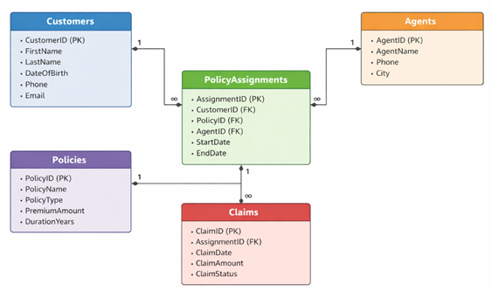

- Create Database command.
Query: CREATE DATABASE InsuranceDB;
Output:
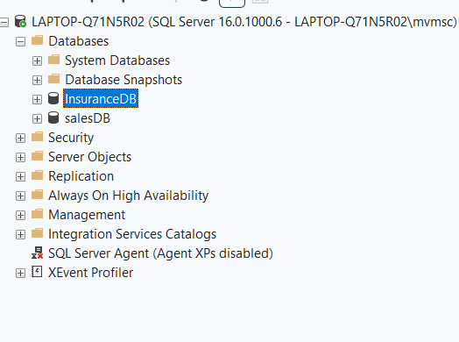
- Create table commands for all the tables with constraints, relationships etc.
Query:

-- Customers Table
CREATE TABLE Customers
(
CustomerID INT IDENTITY NOT NULL,
FirstName VARCHAR(30) NOT NULL,
LastName VARCHAR(30),
DateOfBirth DATE,
PhoneNumber VARCHAR(15) NOT NULL,
Email VARCHAR(50) NOT NULL UNIQUE,
CONSTRAINT custID_pk PRIMARY KEY (CustomerID)
);
Output:
dbo.Customers Design View:
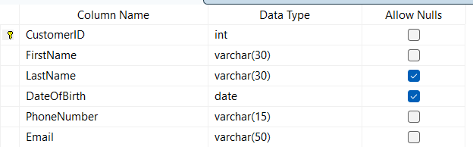
Query:
-- Policies Table
CREATE TABLE Policies
(
PolicyID INT IDENTITY NOT NULL,
PolicyName VARCHAR(50) NOT NULL,
PolicyType VARCHAR(50) NOT NULL,
PremiumAmount DECIMAL(10,2),
DurationYears INT
CONSTRAINT PK_policyID PRIMARY KEY (PolicyID)
);
Output:
dbo.Policies Design View:
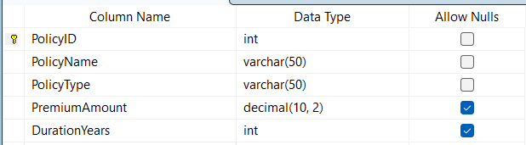

Query:
-- Customers Table
CREATE TABLE Agents
(
AgentID INT IDENTITY NOT NULL,
AgentName VARCHAR(50),
Phone VARCHAR(15),
City VARCHAR(50)
CONSTRAINT PK_agentID PRIMARY KEY (AgentID)
);

Output:
dbo.Agents Design View:
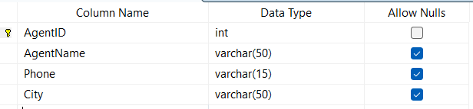

Query:
-- PolicyAssignments Table
CREATE TABLE PolicyAssignments
(
AssignmentID INT NOT NULL IDENTITY,
CustomerID INT NOT NULL,
PolicyID INT NOT NULL,
AgentID INT NOT NULL,
StartDate DATETIME DEFAULT GetDate(),
EndDate DATETIME,
CONSTRAINT PK_asgnmtID PRIMARY KEY (AssignmentID),
CONSTRAINT FK_custID FOREIGN KEY (CustomerID) REFERENCES Customers(CustomerID),
CONSTRAINT FK_policyID FOREIGN KEY (PolicyID) REFERENCES Policies(PolicyID),
CONSTRAINT FK_AgentID FOREIGN KEY (AgentID) REFERENCES Agents(AgentID)
);

Output:
dbo.PolicyAssignments Design View:
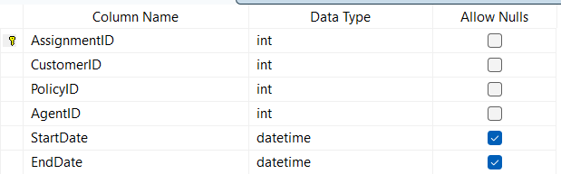

Query:
-- Claims Table
CREATE TABLE Claims
(
ClaimID INT IDENTITY NOT NULL,
AssignmentID INT NOT NULL,
ClaimDate DATETIME NOT NULL DEFAULT GetDate(),
ClaimAmount DECIMAL(10,2),
ClaimStatus VARCHAR(30)
CONSTRAINT PK_claimID PRIMARY KEY (ClaimID),
CONSTRAINT FK_asgnmtID FOREIGN KEY (AssignmentID) REFERENCES PolicyAssignments(AssignmentID)
);
Output:
dbo.Claims Design View:
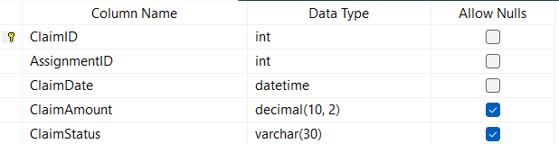

- Insert commands for all tables.
Query:
-- Customers Data Insertion
INSERT INTO Customers (FirstName, LastName, DateOfBirth, PhoneNumber, Email)
VALUES
('Amit', 'Sharma', '1998-05-12', '9876543210', 'amit@gmail.com'),
('Neha', 'Verma', '2003-07-20', '9876543211', 'neha@gmail.com'),
('Ravi', 'Kumar', '1995-03-15', '9876543212', 'ravi@gmail.com'),
('Sneha', 'Patel', '2001-01-10', '9876543213', 'sneha@gmail.com'),
('Arjun', 'Mehta', '2005-11-25', '9876543214', 'arjun@gmail.com'),
('Kiran', 'Rao', '1988-06-18', '9876543215', 'kiran@gmail.com');

Output:
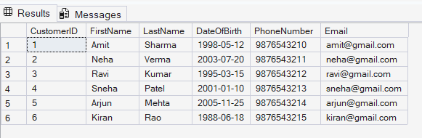

Query:
-- Policies Data Insertion
INSERT INTO Policies (PolicyName, PolicyType, PremiumAmount, DurationYears)
VALUES
('Life Shield', 'Life', 15000, 10),
('Health Plus', 'Health', 12000, 1),
('Motor Secure', 'Motor', 8000, 1),
('Health Gold', 'Health', 20000, 2),
('Life Premium', 'Life', 25000, 15);
Output:
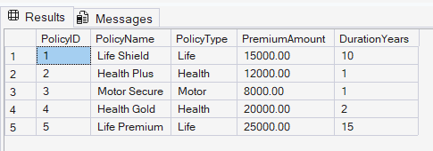

Query:
-- Agents Data Insertion
INSERT INTO Agents (AgentName, Phone, City)
VALUES
('Rajesh', '9000011111', 'Delhi'),
('Anita', '9000011112', 'Mumbai'),
('Suresh', '9000011113', 'Bangalore'),
('Kavya', '9000011114', 'Chennai'),
('Mahesh', '9000011115', 'Jaipur');

Output:
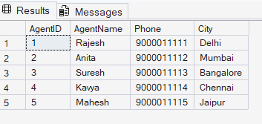

Query:
-- PolicyAssignments Data Insertion
INSERT INTO PolicyAssignments (CustomerID, PolicyID, AgentID, StartDate, EndDate)
VALUES
(1, 1, 1, '2020-01-01', '2030-01-01'),
(2, 2, 2, '2022-06-01', '2023-06-01'),
(3, 3, 3, '2021-03-01', '2022-03-01'),
(4, 4, 1, '2023-01-01', '2025-01-01'),
(5, 2, 4, '2024-02-01', NULL),
(6, 5, 5, '2019-05-01', '2034-05-01');
Output:
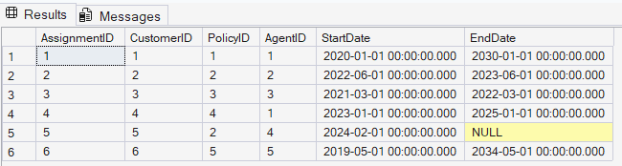
Query:
-- Claims Data Insertion
INSERT INTO Claims (AssignmentID, ClaimDate, ClaimAmount, ClaimStatus)
VALUES
(1, '2022-05-10', 30000, 'Approved'),
(1, '2023-07-15', 25000, 'Rejected'),
(2, '2023-08-20', 15000, 'Approved'),
(3, '2022-01-10', 10000, 'Rejected'),
(4, '2024-06-01', 60000, 'Approved'),
(4, '2024-07-10', 45000, 'Rejected');

Output:
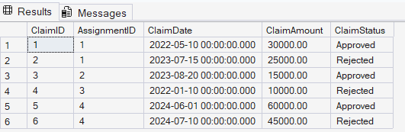

- Select commands

- View all records Customers table.
Query:
SELECT CustomerID, FirstName, LastName, DateOfBirth, PhoneNumber, Email
FROM Customers;

Output:
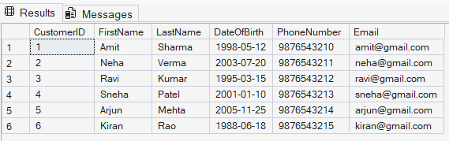

- View all records of PolicyAssignment table with CustomerId, PolicyId, StartDate and EndDate columns only.
Query:
SELECT CustomerID, PolicyID, StartDate, EndDate
FROM PolicyAssignments;

Output:
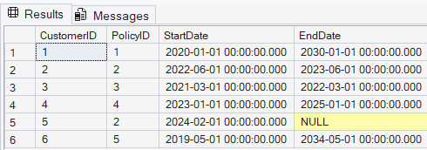

- Display all policies of Health type.
Query:
SELECT PolicyID, PolicyName, PolicyType, PremiumAmount, DurationYears
FROM Policies
WHERE PolicyType = 'Health';

Output:
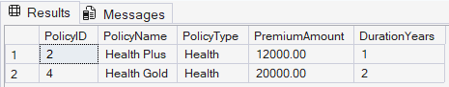

- Display policies having premium amount more than 10000 and DurationYears is 1.
Query:
SELECT PolicyID, PolicyName, PolicyType, PremiumAmount, DurationYears
FROM Policies
WHERE PremiumAmount > 10000 AND DurationYears = 1;

Output:
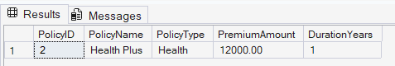

- Display unique city names from where agents belong to.
Query:
SELECT DISTINCT(City)
FROM Agents;

Output:
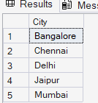

- List policies of type Life, Health, Motor use OR clause.
Query:
SELECT PolicyID, PolicyName, PolicyType, PremiumAmount, DurationYears
FROM Policies
WHERE PolicyType = 'Life' OR PolicyType = 'Motor' OR PolicyType = 'Health';

Output:
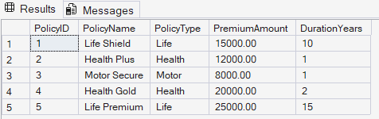

- List policies of type Life, Health, Motor use IN operator.
Query:
SELECT PolicyID, PolicyName, PolicyType, PremiumAmount, DurationYears
FROM Policies
WHERE PolicyType IN ('Life', 'Motor', 'Health');

Output:
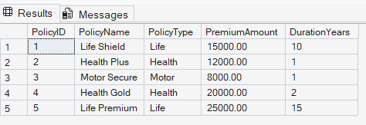

- Display list of customers born after January 1st, 2001 and before December 31st, 2020 using >= and <= operators.
Query:
SELECT CustomerID, FirstName, LastName, DateOfBirth, PhoneNumber, Email
FROM Customers
WHERE DateOfBirth >= '2001-01-02' AND DateOfBirth <= '2020-12-30';

Output:
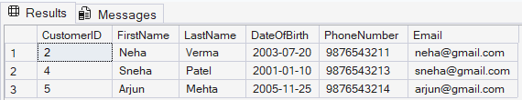

- Display list of customers born after January 1st, 2001 and before December 31st, 2020 using between operator.
Query:
SELECT CustomerID, FirstName, LastName, DateOfBirth, PhoneNumber, Email
FROM Customers
WHERE DateOfBirth BETWEEN '2001-01-01' AND '2020-12-31';

Output:

- Display claims data where claim status is Rejected.
Query:
SELECT ClaimID, ClaimDate, ClaimAmount, ClaimStatus
FROM Claims
WHERE ClaimStatus = 'Rejected';

Output:
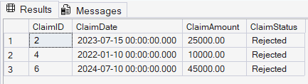

- Display records of Agents who stay in a city whose second letter is 'a'.
Query:
SELECT AgentID, AgentName, City, Phone
FROM Agents
WHERE LOWER(City) LIKE '_a%';

Output:
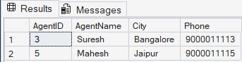

- Display highest and lowest claimAmount from Claims table.
Query:
SELECT MAX(claimAmount) AS [Highest ClaimAmount], MIN(claimAmount) AS [Lowest ClaimAmount]
FROM Claims;

Output:
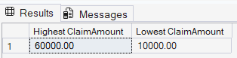

- Display latest claim record.
Query:
SELECT TOP 1 ClaimID, ClaimDate, ClaimAmount, ClaimStatus
FROM Claims
ORDER BY ClaimDate DESC;
Output:
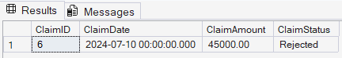

- Increase premium amount to 10% for all health insurance policies.
Query:
UPDATE Policies
SET PremiumAmount = (1.10 * PremiumAmount)
WHERE PolicyType = 'Health';
Output:
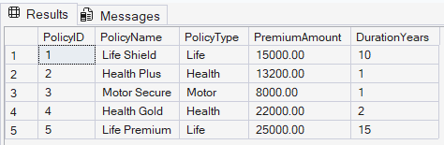

- Delete the record of PolicyAssignments whose EndDate is before today's date.
Query:
DELETE FROM Claims
WHERE AssignmentID IN (
SELECT AssignmentID
FROM PolicyAssignments
WHERE EndDate < CAST(GETDATE() AS DATE)
);

DELETE FROM PolicyAssignments
WHERE EndDate < CAST(GETDATE() AS DATE);

Output:
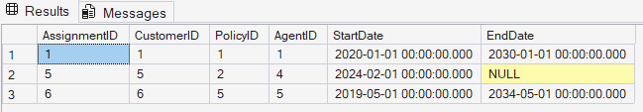

- Display no of claims rejected.
Query:
SELECT COUNT(*) AS [No Of Claims Rejected]
FROM Claims
WHERE ClaimStatus = 'Rejected';

Output:
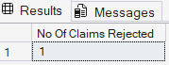

- Display PolicyId, PolicyName, PremiumAmount along with computed fields not in table à 6% LocalTaxes, PremiumAmountWithTax and MonthlyPremiumAmount considering PremiumAmount is Annual.
Query:
SELECT PolicyID, PolicyName, PremiumAmount,
(PremiumAmount * 1.06) AS [PremiumAmountWithTax],((PremiumAmount * 1.06) / 12) AS [MonthlyPremiumAmount]
FROM Policies;

Output:
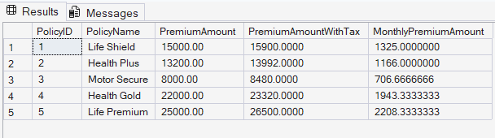

- Write a command to add Address and City Columns in the Customers table.
Query:
ALTER TABLE Customers
ADD Address VARCHAR(50), City VARCHAR(50);

Output:
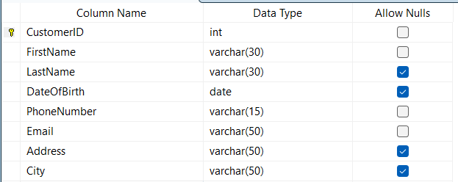

- Write a command to add a new column named DevOfId (DevelopmentOfficerId) in an existing Agents table.
Query:
ALTER TABLE Agents
ADD DevOfID INT;

Output:
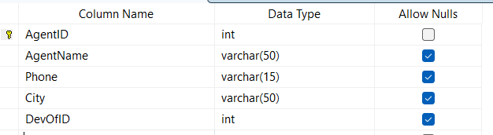

- Write command to make the above DevOfId as a recursive foreign key to AgentId as Parent.
Query:
ALTER TABLE Agents
ADD CONSTRAINT FK_Agents_DevOf
FOREIGN KEY (DevOfID) REFERENCES Agents(AgentID);

Output:
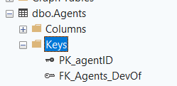

5. Queries using Joins, Group By, Having etc.
- List all Policies for a CustomerId 5.
Query:
SELECT pa.CustomerID, p.PolicyID, p.PolicyName, p.PolicyType, p.PremiumAmount
FROM Policies p
JOIN PolicyAssignments pa
ON p.PolicyID = pa.PolicyID
WHERE pa.CustomerID = 5;

Output:
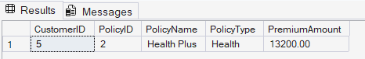

- View all customers with their policies.
Query:
SELECT c.FirstName, c.LastName, c.PhoneNumber, c.Email,
p.PolicyID, p.PolicyName, p.PolicyType, p.PremiumAmount
FROM Customers c
LEFT JOIN PolicyAssignments pa
ON c.CustomerID = pa.CustomerID
LEFT JOIN Policies p
ON p.PolicyID = pa.PolicyID;

Output:
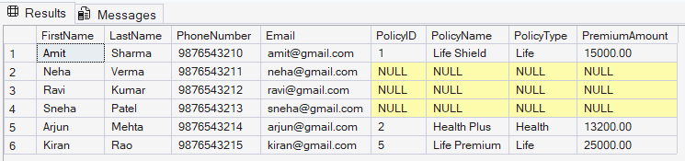

- View claims with customer name.
Query:
SELECT CONCAT(c.FirstName, ' ', c.LastName) AS [Customer Name],
cl.ClaimID, cl.ClaimDate, cl.ClaimAmount, cl.ClaimStatus
FROM Claims cl
LEFT JOIN PolicyAssignments pa
ON cl.AssignmentID = pa.AssignmentID
LEFT JOIN Customers c
ON c.CustomerID = pa.CustomerID;

Output:
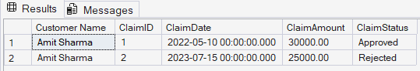

- Display FirstName, PolicyName, AgentName, StartDate and EndDate from their respective tables.
Query:
SELECT c.FirstName, p.PolicyName, a.AgentName, pa.StartDate, pa.EndDate
FROM Customers c
LEFT JOIN PolicyAssignments pa
ON c.CustomerID = pa.CustomerID
LEFT JOIN Policies p
ON p.PolicyID = pa.PolicyID
LEFT JOIN Agents a
ON a.AgentID = pa.AgentID;

Output:
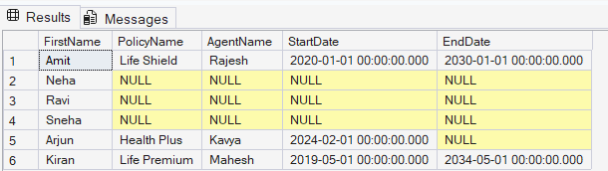

- Display claims report with FirstName, PolicyName, ClaimAmount, ClaimStatus, and ClaimDate from their respective tables.
Query:
SELECT c.FirstName, p.PolicyName, cl.ClaimAmount,
cl.ClaimStatus, cl.ClaimDate
FROM Claims cl
LEFT JOIN PolicyAssignments pa
ON cl.AssignmentID = pa.AssignmentID
LEFT JOIN Policies p
ON p.PolicyID = pa.PolicyID
LEFT JOIN Customers c
ON c.CustomerID = pa.CustomerID;

Output:
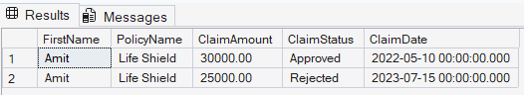

- Display records of Customers with or without Policies.

Query:
SELECT c.CustomerID,
c.FirstName,
c.LastName,
c.PhoneNumber,
c.Email,
p.PolicyID,
p.PolicyName,
p.PolicyType
FROM Customers c
LEFT JOIN PolicyAssignments pa
ON c.CustomerID = pa.CustomerID
LEFT JOIN Policies p
ON pa.PolicyID = p.PolicyID;

Output:
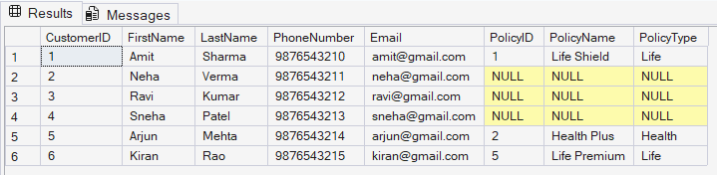

- Display all Customers with NO Claims.
Query:
SELECT c.CustomerID, c.FirstName, c.LastName
FROM Customers c
WHERE NOT EXISTS (
SELECT 1
FROM PolicyAssignments pa
JOIN Claims cl
ON pa.AssignmentID = cl.AssignmentID
WHERE pa.CustomerID = c.CustomerID
);

Output:
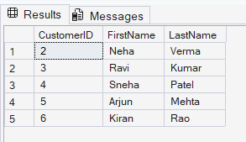

- Show CustomerName with Total Claim Amount per Customer.

Query:
SELECT CONCAT(c.FirstName, ' ', c.LastName) AS [Customer Name],
SUM(cl.ClaimAmount) AS [Total Claim Amount]
FROM Customers c
LEFT JOIN PolicyAssignments pa
ON c.CustomerID = pa.CustomerID
LEFT JOIN Claims cl
ON cl.AssignmentID = pa.AssignmentID
GROUP BY c.CustomerID, c.FirstName, c.LastName;

Output:
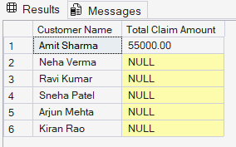

- Show names and total claim amount of Customers With Claim Amount > 50000 (Use HAVING Clause).
Query:
SELECT CONCAT(c.FirstName, ' ', c.LastName) AS [Customer Name],
SUM(cl.ClaimAmount) AS [Total Claim Amount]
FROM Customers c
LEFT JOIN PolicyAssignments pa
ON c.CustomerID = pa.CustomerID
LEFT JOIN Claims cl
ON cl.AssignmentID = pa.AssignmentID
GROUP BY c.CustomerID, c.FirstName, c.LastName
HAVING SUM(cl.ClaimAmount) > 50000;

Output:
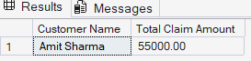

- Display list with Agent Wise Policy Count.
Query:
SELECT a.AgentID, a.AgentName, a.City, a.Phone,
COUNT(pa.AssignmentID) AS [Policy Count]
FROM Agents a
LEFT JOIN PolicyAssignments pa
ON a.AgentID = pa.AgentID
GROUP BY a.AgentID, a.AgentName, a.City, a.Phone;

Output:
