Final Project Report

REAL-TIME NETWORK INTRUSION DETECTION USING WIRESHARK AND ADVANCED ENSEMBLE LEARNING TECHNIQUES



Project Supervisor
Laraib Sana

Submitted By
F24PROJECTA686A
(BC210427835)

Software Projects & Research Section,
Department of Computer Sciences,
Virtual University of Pakistan
CERTIFICATE
This is to certify that MAHBOOB ALAM (BC210427835) has worked on and completed his Software Project at Software & Research Projects Section, Department of Computer Sciences, Virtual University of Pakistan in partial fulfillment of the requirement for the degree of BS in Software Engineering under my guidance and supervision.
In our opinion, it is satisfactory and up to the mark and therefore fulfills the requirements of BS in Software Engineering.

Supervisor / Internal Examiner
Laraib Sana
Supervisor,
Software Projects & Research Section,
Department of Computer Sciences
Virtual University of Pakistan

___________________
(Signature)

External Examiner/Subject Specialist

___________________
(Signature)
Accepted By:
_____________
(For office use)
EXORDIUM

In the name of Allah, the Compassionate, the Merciful.

Praise be to Allah, Lord of Creation,
The Compassionate, the Merciful,
King of Judgment-day!

You alone we worship, and to You alone we pray for help,
Guide us to the straight path

The path of those who You have favored,

Not of those who have incurred Your wrath,
Nor of those who have gone astray.

DEDICATION
To my beloved parents and supportive teachers whose encouragement and prayers made this work possible.

ACKNOWLEDGEMENT
I would like to express my sincere gratitude to my project supervisor Ms. Laraib Sana for her valuable guidance and continuous support throughout the project. Her encouragement and critical feedback helped me to refine the project to a professional level. I am also thankful to my friends and family for their constant encouragement and moral support.

PREFACE
This final year project report, titled “Real-Time Network Intrusion Detection Using Wireshark and Advanced Ensemble Learning Techniques,” is submitted in partial fulfillment of the requirements for the degree of Bachelor of Science in Computer Science.
The project has provided me with valuable learning and hands-on experience in integrating network security, machine learning, and web application development. It has enhanced my practical skills in system design, implementation, and evaluation while applying theoretical knowledge to a real-world problem.
I express my sincere gratitude to my supervisor, Ms. Laraib Sana, for her continuous guidance, support, and insightful feedback throughout the project. I also thank the faculty of the Department of Computer Science for their encouragement and assistance.
Finally, I extend my heartfelt appreciation to my family and friends for their constant support and motivation during this journey.

MAHBOOB ALAM
BC210427835

TABLE OF CONTENTS
CHAPTER 1 1
1.1 Introduction 2
1.2 Purpose 2
1.3 Scope 2
1.4 Definitions, Acronyms, and Abbreviations 3
1.5 Project requirements 4
1.5.1 Functional Requirements 4
1.5.2 Non-Functional Requirements 5
1.6 Use cases and usage scenarios 6
1.6.1 Use Case Diagrams 6
1.6.2 Usage Scenarios 7
1.7 Development Methodology 10
1.7.1 Chosen Methodology 10
1.7.2 Reasons for Chosen Methodology 12
1.7.3 Work Plan (Gantt Chart) 13
1.7.4 Project Schedule (Submission Calendar) 13
CHAPTER 2 14
2.1 Introduction 15
2.2 purpose 15
2.3 scope 15
2.4 definitions, acronyms and abbreviations 16
2.5 Architectural Representation (Architecture Diagram) 17
2.6 Dynamic Model: Sequence Diagrams 18
2.7 Object Model/Logical Model: Class Diagram 19
2.8 Database Model (Database Diagram) 20
2.9 Graphical User Interfaces 21
CHAPTER 3 24
3.1 Introduction 25
3.2 Development Environment 25
3.3 Tools and Technologies used in Project 26
3.4 Implementation of Modules 27
3.4.1 PCAP Conversion Module Implementation 27
3.4.2 Preprocessing Module Implementation 27
3.4.3 Machine Learning Models Integration 27
3.4.4 Web Application Backend Implementation 27
3.4.5 Web Application Frontend Implementation 28
3.5 Integration of Components 28
3.6 Key Implementation Challenges and Solutions 28
3.7 Data Flow Diagram 30
REFERENCES 31

TABLE OF Figures
Figure 1 Use case diagram 6
Figure 2 Incremental model as SDLC 10
Figure 3 Gantt Chart 13
Figure 4 Architecture Diagram 17
Figure 5 sequence diagram 18
Figure 6 Class Diagram 19
Figure 7 Database diagram 20
Figure 8 GUI: Home page 21
Figure 9 GUI registration 21
Figure 10 GUI: Login page 22
Figure 11 GUI dashboard 22
Figure 12 GUI: file upload page 23
Figure 13 Project Lab vscode 25
Figure 14 Tools and technologies 26

CHAPTER 1
Gathering & Analyzing Info

1.1 Introduction
The increasing frequency and sophistication of cyberattacks have heightened the demand for advanced network security solutions. Traditional intrusion detection systems (IDS) relying on signature-based approaches often fall short in identifying novel or unknown attacks. This project, titled “Real-Time Network Intrusion Detection Using Wireshark and Advanced Ensemble Learning Techniques,” aims to bridge this gap by leveraging machine learning techniques to analyze network traffic and detect intrusions. The system integrates Wireshark for packet capture, ensemble machine learning models for analysis, and a Django-based web application for user interaction. Through this integration, the project seeks to deliver an accurate, accessible, and practical IDS solution suitable for small to medium-scale networks.

1.2 Purpose
The primary purpose of this project is to develop a real-time intrusion detection system that utilizes ensemble learning models (TabNet, LightGBM, CatBoost) to classify network traffic as normal or malicious. By automating the data preprocessing and analysis pipeline, the system enables users to upload network traffic data (in .pcap format), process it, and receive detailed insights about potential threats. The project also aims to provide an intuitive web-based interface, making the system usable by both technical and non-technical users.

1.3 Scope
The project is designed for offline analysis of captured network traffic rather than live monitoring. The system supports the upload and analysis of .pcap and .pcapng files exported from Wireshark, targeting common attack types such as DDoS, port scanning, and brute-force attacks. It is optimized for single-server deployment with limited concurrent users, making it ideal for academic, research, or small enterprise environments. The system integrates a complete workflow—from data ingestion and preprocessing to machine learning-based prediction and result visualization—through a unified web platform.

1.4 Definitions, Acronyms, and Abbreviations
Term | Definition
IDS | Intrusion Detection System: A system designed to detect unauthorized access or anomalies in network traffic.
PCAP | Packet Capture: A file format that stores captured network packets for analysis.
Wireshark | A network protocol analyzer used for capturing and analyzing network traffic.
ML | Machine Learning: A field of artificial intelligence focused on building systems that learn from data.
DDoS | Distributed Denial of Service: A cyberattack that floods a target with overwhelming traffic.
TabNet | A deep learning model optimized for tabular data, used here as a meta-classifier.
LightGBM | Light Gradient Boosting Machine: A fast, efficient gradient boosting framework.
CatBoost | Categorical Boosting: A gradient boosting algorithm particularly effective for categorical features.
Django | A high-level Python web framework used for developing secure and scalable web applications.
CSV | Comma-Separated Values: A file format used to store tabular data.

1.5 Project requirements

1.5.1 Functional Requirements
The functional requirements define the essential operations that the system must perform to meet its objectives. For this project, the following key functionalities were identified:
- The system must enable users to upload network traffic capture files in .pcap or .pcapng format through a secure web interface for subsequent analysis.

- Upon upload, the system must automatically parse .pcap files into a structured dataset (e.g., CSV format) using packet analysis tools such as Scapy or PyShark, facilitating further data processing.

- The parsed data must undergo preprocessing to ensure quality and consistency. This includes cleaning missing or invalid entries, encoding categorical variables (e.g., protocol types), and normalizing numerical features such as packet sizes and time intervals.

- The system must support the generation of labeled datasets, classifying network traffic as either “normal” or “malicious” to facilitate supervised machine learning.

- The system must integrate ensemble learning models—including TabNet, CatBoost, and LightGBM—to perform intrusion detection based on the preprocessed data.

- The machine learning models must be evaluated using standard performance metrics such as accuracy, precision, recall, F1-score, and ROC-AUC to validate their effectiveness.

- A Django-based web application must be implemented, providing an interactive platform for users to upload files, view analysis results, and monitor system status.

- The system must present the analysis outcomes clearly, including traffic classification (normal/malicious), intrusion likelihood scores, affected IP addresses, involved protocols, and visual representations of traffic patterns.

- The system must incorporate robust error-handling measures to detect invalid or unsupported files and provide informative feedback to users.

1.5.2 Non-Functional Requirements
The non-functional requirements ensure the quality attributes of the system, focusing on performance, scalability, reliability, and usability:
- Performance: The system must be capable of processing .pcap files of up to 100 MB within 10 minutes under typical operating conditions, ensuring timely analysis without compromising result quality.
- Scalability: The system must handle up to 5 concurrent .pcap file uploads without a degradation in processing speed or prediction accuracy, allowing multiple users to utilize the platform simultaneously in academic or small enterprise contexts.
- Reliability: The system must maintain a minimum uptime of 95% to ensure availability and continuity of service. It must handle unexpected errors gracefully, providing descriptive error messages while safeguarding the integrity of user-uploaded data.
- Usability: The web interface must be intuitive and accessible to users with varying technical expertise. This includes clear navigation, well-labeled interface elements, step-by-step guidance for uploading files, and understandable presentation of analysis results.

1.6 Use cases and usage scenarios

1.6.1 Use Case Diagrams
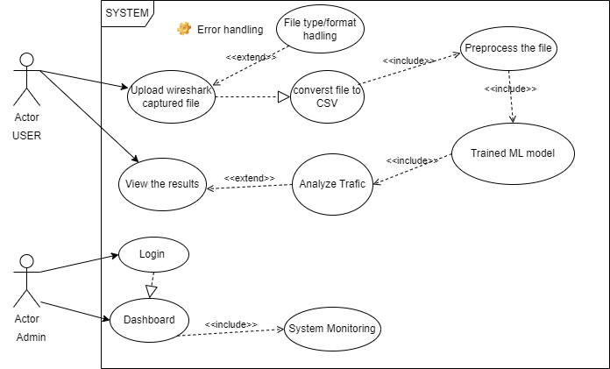
Figure 1 Use case diagram

1.6.2 Usage Scenarios

Use Case Title | Upload .pcap File
Use Case Id | 1
Requirement Id | FTN:NIDS-FR-1
Description: In this use case, the user uploads a .pcap file to the system for intrusion detection analysis.
Pre Conditions:
- The user has a .pcap file ready for upload.
- The web application is running and accessible.
- The user has logged into the system.
Task Sequence |  | Exceptions
- The user logs into the web application
- The user navigates to the file upload section.
- The user selects and uploads the .pcap file.
- The system validates the file and starts processing.
Post Conditions:
- The .pcap file is successfully uploaded and validated.
- The system initiates the parsing and preprocessing stages.

- Unresolved issues: Handling extremely large .pcap files in the future.
Authority: user
Modification history: 1.0
Author: F24PROJECTA686A (BC210427835)
Description: In this scenario, the user uploads a .pcap file to the web application The system validates the file and begins parsing it for further analysis.

Use Case Title | View Analysis Results
Use Case Id | 2
Requirement Id | FTN:NIDS-FR-2
Description: In this use case, the user views the analysis results of a previously uploaded .pcap file.
Pre Conditions:
- The user has uploaded a .pcap file.
- The system has completed the analysis.
- The user is logged into the system.
Task Sequence |  | Exceptions
  - The user logs into the web application
  - The user navigates to the "Results" section
  - The system displays a detailed report, including intrusion likelihood, affected IPs, and traffic patterns.
Post Conditions:
- The user has viewed the analysis report.
- The system logs the user’s activity for security purposes.

- Unresolved issues: Future support for exporting reports in PDF format.
Authority: user
Modification history: 1.0
Author: F24PROJECTA686A (BC210427835)
Description: The user accesses the analysis report generated after processing a .pcap file. The system displays detailed results to assist the user in identifying potential network intrusions.

Use Case Title | Train Machine Learning Model
Use Case Id | 3
Requirement Id | FTN:NIDS-FR-3
Description: In this use case, the system trains machine learning models using labeled datasets for intrusion detection.
Pre Conditions:
- A labeled dataset is available for training.
- The system has sufficient computational resources.
- The administrator initiates the training process.
Task Sequence |  | Exceptions
  - The administrator uploads the training dataset.
  - The system validates the dataset and starts the training process.
  - The system trains the models (TabNet, CatBoost, LightGBM) and evaluates their performance.
  - The system trains the models (TabNet, CatBoost, LightGBM) and evaluates their performance.
Post Conditions:
- The models are trained and ready for integration.
- The system logs the training session details.
- Unresolved issues: Support for automated retraining based on new datasets.
Authority: Administrator
Modification history: 1.0
Author: F24PROJECTA686A (BC210427835)
Description: In this scenario, the system processes labeled datasets to train machine learning models for traffic classification. The trained models are stored for future analysis tasks.

1.7 Development Methodology

1.7.1 Chosen Methodology
To manage the multifaceted nature of the project—encompassing network traffic capture, data preprocessing, machine learning model integration, and web application development—an Incremental Development Model was chosen. This model allowed progressive delivery of functional components, enabling early testing, iterative improvement, and integration without delaying overall system progress.
Each increment built upon the last, ensuring system stability while allowing modular validation of individual components.

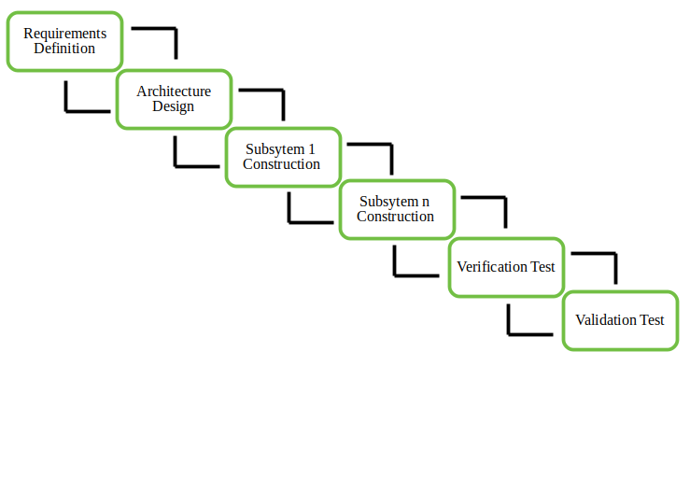
Figure 2 Incremental model as SDLC

1.7.1.1 Data Capture Phase
In the initial phase of development, the primary objective was to acquire network traffic data necessary for training and testing the intrusion detection models. To accomplish this, I configured Wireshark to capture live network traffic, saving the collected data in PCAP format to ensure packet-level details were preserved. The dataset was intentionally diversified by capturing traffic from various protocols such as HTTP, DNS, TCP, and UDP, covering both normal browsing activities and simulated attack scenarios. To prepare the captured data for machine learning, I developed a conversion script using Scapy and TShark that parsed the raw PCAP files into structured CSV format. This script systematically extracted relevant features, including protocol type, source and destination IP addresses, packet lengths, timestamp intervals, and port numbers.

1.7.1.2 Machine Learning Training Phase
The second phase focused on building and training the machine learning models. After completing data cleaning procedures to address missing and invalid values, the dataset was divided into training and testing subsets to support supervised learning. Three base models were selected for this system: XGBoost for its scalability and ability to handle regularization, LightGBM for its efficiency and fast computation, and CatBoost for its superior handling of categorical features without requiring extensive preprocessing. A TabNet meta-classifier was introduced to serve as the ensemble model, combining the predictions of the base models through a stacking ensemble approach. The models were evaluated using established performance metrics, including accuracy, precision, recall, F1-score, and ROC-AUC. Hyperparameter tuning was applied to each model to achieve optimal performance, with the final testing accuracy exceeding 90 percent.

1.7.1.3 Web Application Development Phase
The third phase involved the development of a web application using Django as the framework. The backend was engineered to manage file uploads securely, trigger the data preprocessing pipeline and machine learning inference process, and store the resulting analysis outcomes. The front end was implemented using Django’s template engine, creating a user-friendly interface that allowed users to upload PCAP files, monitor the real-time progress of analysis, and view the results, including traffic classification and identified malicious IP addresses. Security measures such as file validation and user authentication were integrated to safeguard user data and ensure system integrity during interactions.

1.7.1.4 System Integration Phase
The final development phase brought together all previously developed components into a unified system. This phase involved integrating the PCAP-to-CSV converter, the data preprocessing module, the machine learning inference engine, and the web interface. The integration ensured seamless data flow and communication across modules, enabling end-to-end functionality from file upload to intrusion detection results within a single, cohesive application.

1.7.2 Reasons for Chosen Methodology
The complexity of my project, involving ML models, preprocessing pipelines, and a web application, requires flexibility and early testing. Incremental delivery allows me to showcase progress at each milestone, which is critical for academic evaluations.
Time-sensitive tasks like prototyping are better supported by the iterative nature of Incremental.
Incremental Model is the better choice for my university project. It accommodates complexity, ensures steady progress, and allows early testing and feedback to minimize risks.
Waterfall model may seem suitable due to its simplicity, but its rigidity could jeopardize the timely delivery of a functional and well-integrated system.
The Spiral model, while effective for large, high-risk, and complex projects, was not selected for this project due to its heavy reliance on extensive risk analysis, detailed documentation, and iterative cycles, which can be time-consuming. As this is a solo university project with a tight 4-month deadline, the Spiral Model's thoroughness and complexity introduce unnecessary overhead. Additionally, the model's focus on risk management and iterative prototyping makes it more suitable for projects with higher levels of uncertainty or significant resource availability, which does not align with the requirements of this academic project.

1.7.3 Work Plan (Gantt Chart)
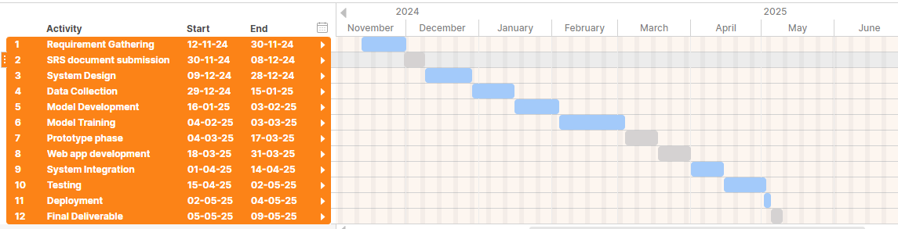
Figure 3 Gantt Chart

1.7.4 Project Schedule (Submission Calendar)

- SRS and Requirements Gathering:
  - Timeline: Nov 12 – Dec 8
- Design and System Architecture:
  - Timeline: Dec 9 – Mar 3
- Prototype Development:
  - Timeline: Mar 4 – Mar 17
- Final Integration and Testing:
  - Timeline: Mar 18 – May 9
  - Deliverable: Fully functional NIDS.

CHAPTER 2
Designing the Project

2.1 Introduction
The design of this project plays a crucial role in translating the requirements into a structured, implementable solution. This chapter outlines the architectural, logical, and structural aspects of the Real-Time Network Intrusion Detection System. It documents how the system component data capture, preprocessing, machine learning models, and the web application—are designed to work together in an integrated environment. The design approach ensures modularity, maintainability, and scalability while aligning with the functional and non-functional requirements established earlier.

2.2 purpose
The purpose of this design chapter is to provide a detailed representation of the system’s internal structure and interactions. It aims to define the architectural framework, dynamic workflows, object relationships, and database schema that will guide the implementation phase. By establishing a clear design, this chapter ensures that all system components can be developed cohesively, reducing integration risks and enabling systematic validation of each part of the project.

2.3 scope
This design documentation focuses exclusively on the structural and behavioral design aspects of the Real-Time Network Intrusion Detection System. It includes the architectural representation of the system’s modules, sequence diagrams depicting the dynamic flow of processes, class diagrams outlining the object-oriented structure, and the database schema supporting data storage and retrieval. The scope of this chapter is limited to design-level details and does not cover implementation code or testing procedures, which are addressed in later chapters.

2.4 definitions, acronyms and abbreviations
IDS: Intrusion Detection System – a security solution designed to detect unauthorized or malicious network activities.
PCAP: Packet Capture – a file format that stores network packet data captured by tools like Wireshark.
ML: Machine Learning – a field of artificial intelligence that enables systems to learn patterns from data.
CSV: Comma-Separated Values – a tabular data file format used to store structured datasets.
Wireshark: An open-source network protocol analyzer used for capturing and analyzing packet data.
Django: A high-level Python web framework for developing secure, scalable web applications.
XGBoost: Extreme Gradient Boosting – a machine learning algorithm used for classification tasks.
LightGBM: Light Gradient Boosting Machine – a fast, efficient gradient boosting algorithm.
CatBoost: Categorical Boosting – a machine learning algorithm optimized for handling categorical data.
TabNet: An interpretable deep learning model designed for tabular data classification.

2.5 Architectural Representation (Architecture Diagram)

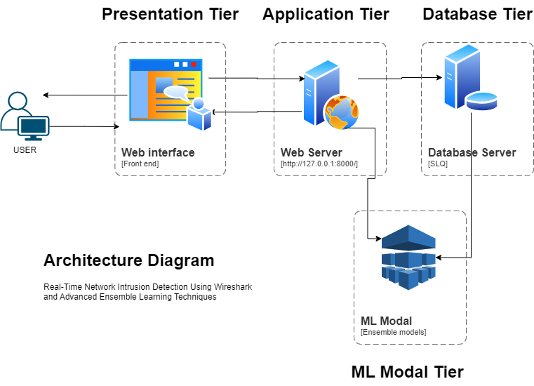
Figure 4 Architecture Diagram

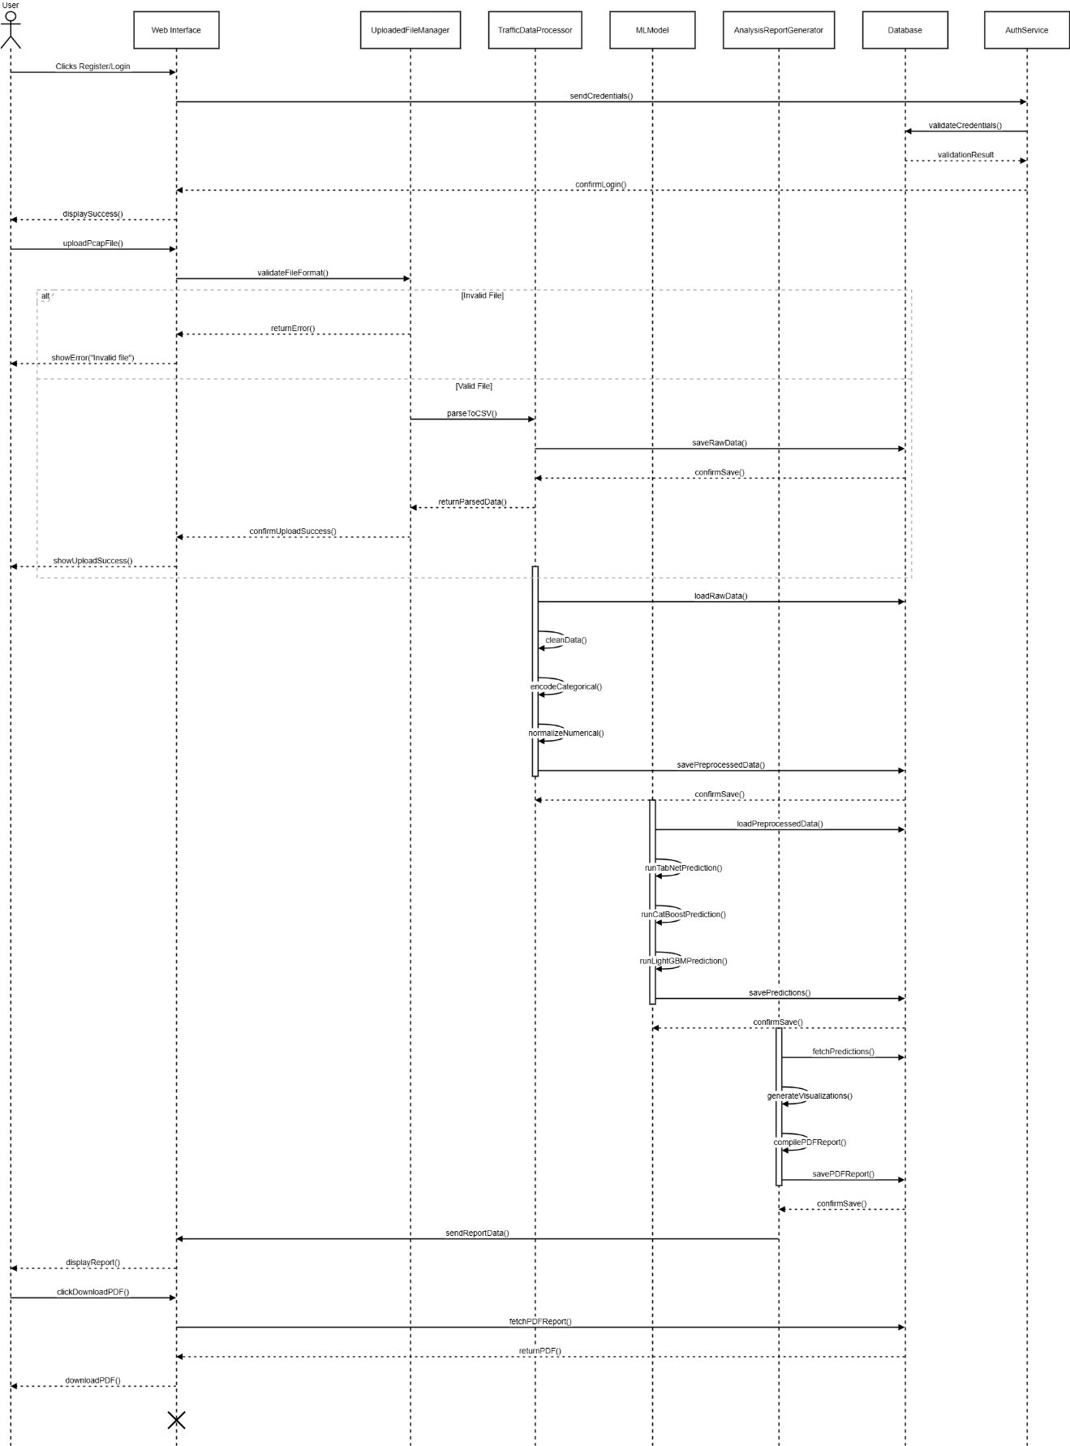
2.6 Dynamic Model: Sequence Diagrams
Figure 5 sequence diagram

2.7 Object Model/Logical Model: Class Diagram

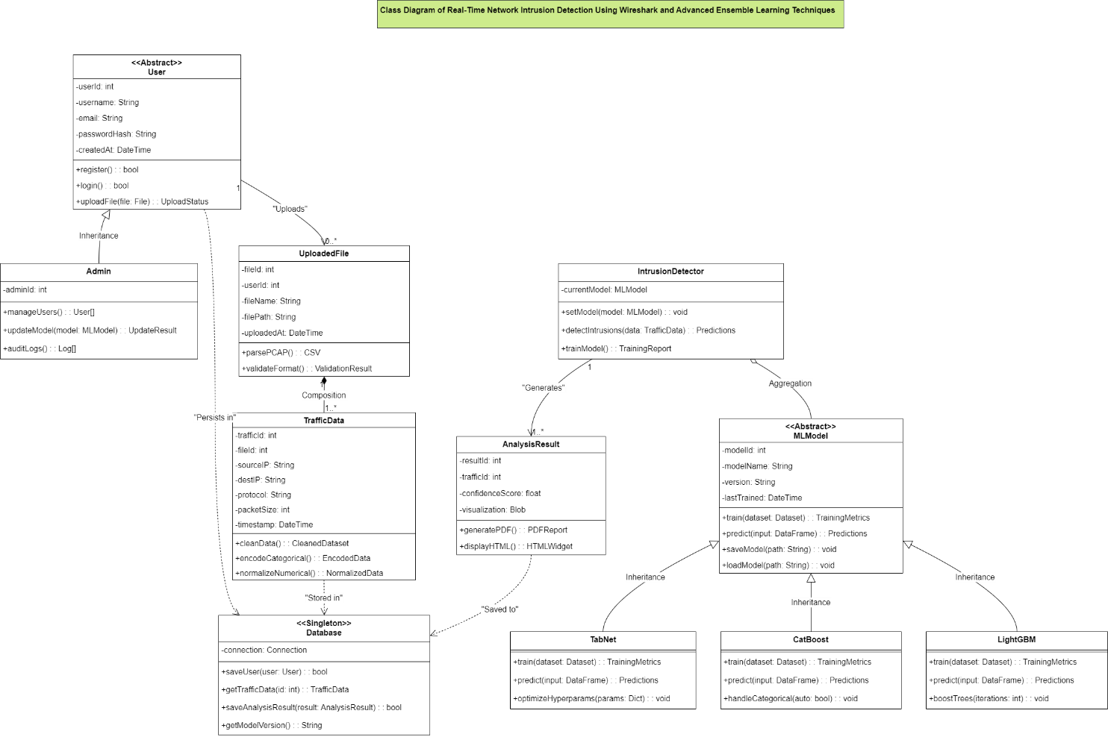
Figure 6 Class Diagram

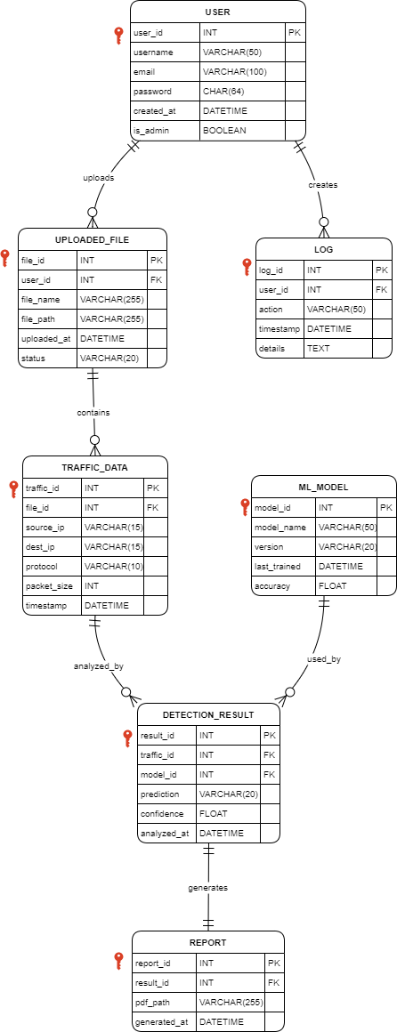
2.8 Database Model (Database Diagram)
Figure 7 Database diagram

2.9 Graphical User Interfaces

Figure 8 GUI: Home page
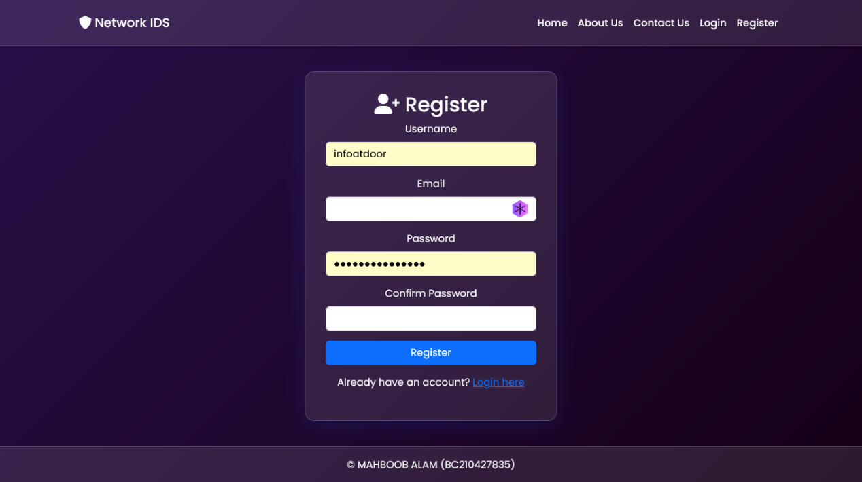
Figure 9 GUI registration
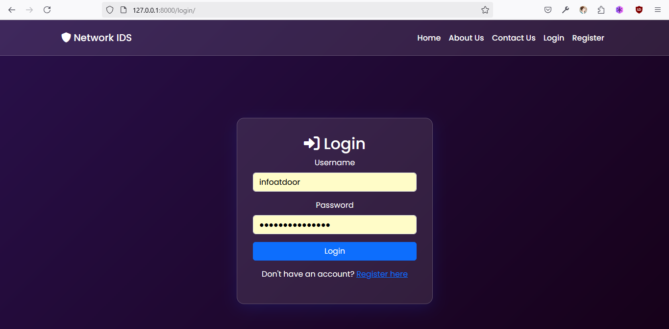
Figure 10 GUI: Login page
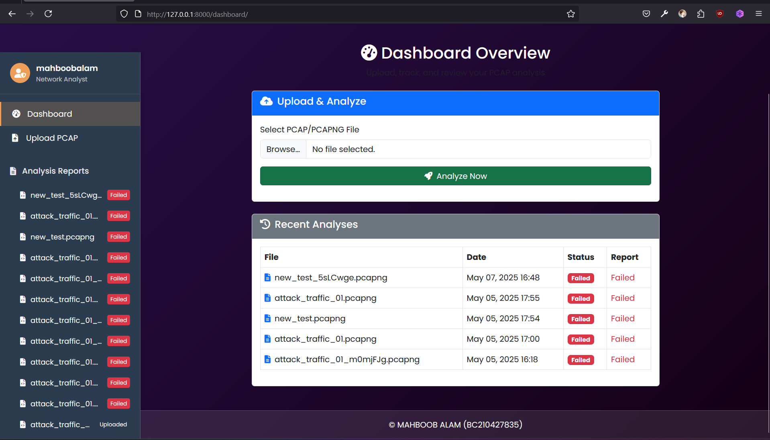
Figure 11 GUI dashboard
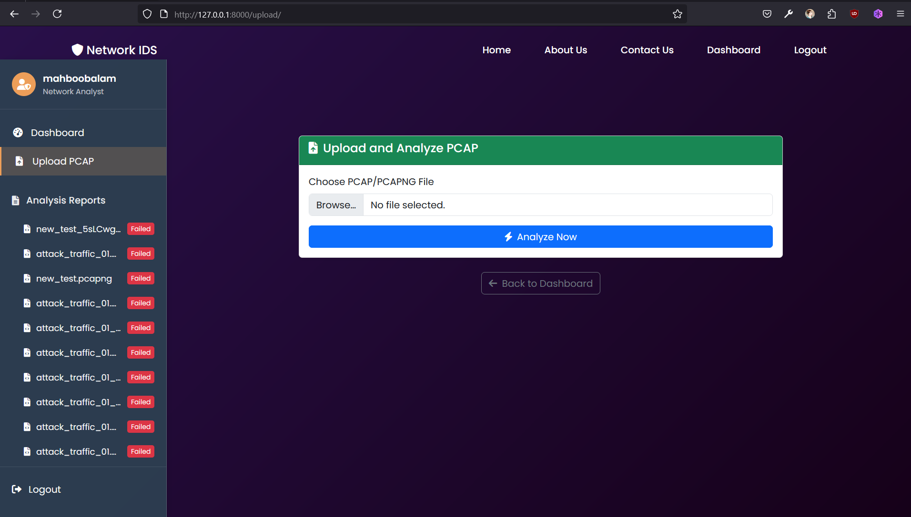
Figure 12 GUI: file upload page

CHAPTER 3
Development

3.1 Introduction
This chapter elaborates the development phase of the project, focusing on the practical implementation of all modules and components. It outlines how the source code was written, the technologies integrated, and the workflow maintained to transform the design into a functional system. It covers the development tools, the coding environment, step-by-step module implementation, integration of components, and the challenges encountered during this process.

3.2 Development Environment
The development environment for this project was configured using Python 3.13 as the core programming language, with Django 5.2 as the backend web framework. Development and testing were conducted on a Windows 11 machine with compatibility ensured for Linux-based deployment. Jupyter Notebook was used for machine learning model training, allowing visualization and debugging of model performance. The project leveraged libraries including Scikit-learn, XGBoost, LightGBM, CatBoost, PyTorch-TabNet, Pandas, NumPy, Matplotlib, and Seaborn. SQLite served as the default database via Django’s ORM, ensuring lightweight storage suitable for academic deployment.
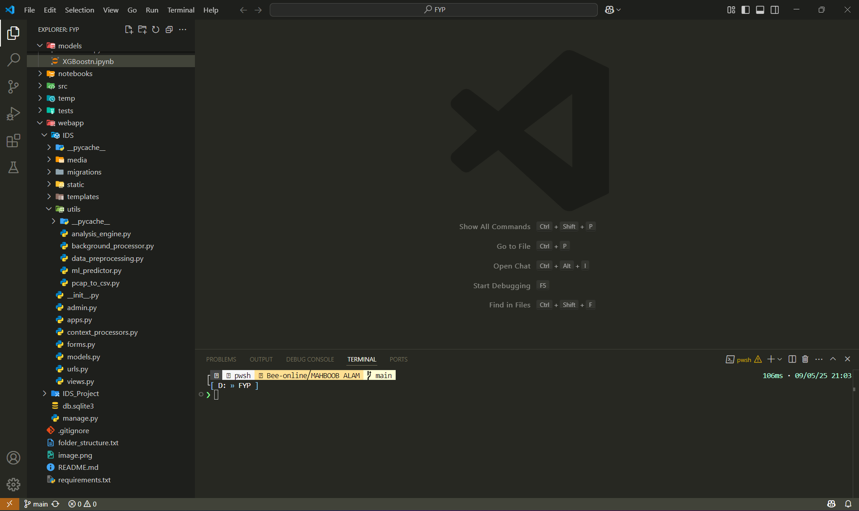
Figure 13 Project Lab vscode

3.3 Tools and Technologies used in Project
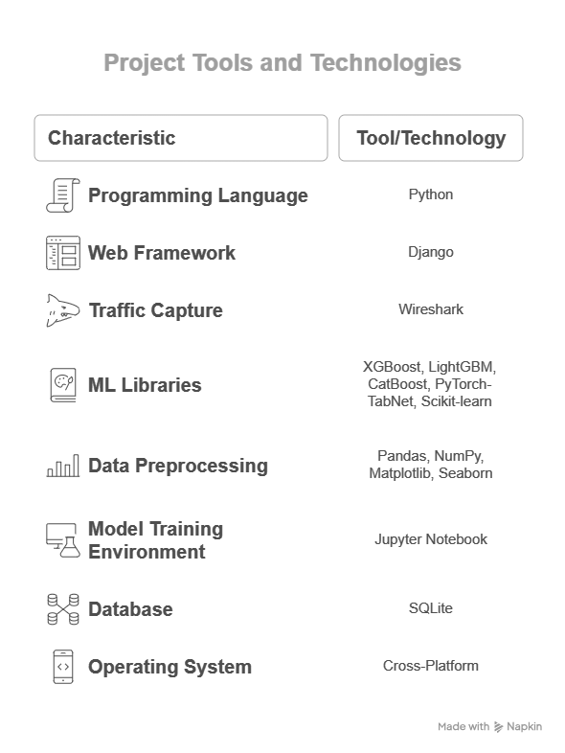
Figure 14 Tools and technologies

3.4 Implementation of Modules

3.4.1 PCAP Conversion Module Implementation
The PCAP conversion module was implemented to transform raw Wireshark .pcap files into structured CSV format for machine learning compatibility. This was achieved using tshark and Scapy libraries to parse network packet fields. The module extracted relevant features such as protocol type, source and destination IPs, source and destination ports, packet size, and timestamp intervals. This functionality was encapsulated in a dedicated Python script that validated input files, handled corrupted packets gracefully, and ensured output consistency for downstream preprocessing.

3.4.2 Preprocessing Module Implementation
The preprocessing module was developed to clean and transform the extracted CSV data for machine learning models. It addressed missing or invalid entries by applying imputation strategies, encoded categorical variables using one-hot encoding (e.g., protocol types), and normalized numerical features using MinMax scaling. This module was implemented as a standalone Python file, callable both via command line and programmatically through the Django backend, enabling seamless integration with the web application’s upload workflow.

3.4.3 Machine Learning Models Integration
The machine learning module integrated three base classifiers—XGBoost, LightGBM, and CatBoost—trained on the preprocessed dataset. A TabNet meta-classifier was implemented to combine their predictions through a stacking ensemble approach. Each base model was serialized and stored using their native APIs, and loaded dynamically at inference time through a unified ml_predictor.py interface. Hyperparameter tuning was performed within Jupyter Notebook, with model evaluation metrics exported and stored for later visualization. The integration was designed to return not only classification results but also probabilities and contributing features for interpretability.

3.4.4 Web Application Backend Implementation
The backend of the web application was developed using Django’s MVC architecture. It provided secure endpoints for file upload, preprocessing invocation, model inference, and result storage. File validation logic was implemented to ensure only .pcap and .pcapng formats were accepted. Upon successful upload, the backend triggered the preprocessing and prediction pipelines asynchronously. The results were stored in the SQLite database linked to authenticated users. Error-handling middleware was incorporated to manage invalid uploads, processing failures, and model inference exceptions.

3.4.5 Web Application Frontend Implementation
The frontend was developed using Django templates, HTML, CSS, and Bootstrap to ensure responsiveness and usability. Key interfaces included a user registration and login page, a file upload form, an analysis status page with live updates, and a results dashboard. The results dashboard displayed the classification outcome, affected IP addresses, and summary statistics, along with downloadable reports. Client-side validation was implemented using JavaScript to pre-validate files before server upload.

3.5 Integration of Components
Integration of components was achieved by establishing clear API boundaries between the PCAP conversion, preprocessing, and machine learning modules. The Django backend was invoking these components sequentially for each uploaded file by using analysis_engine.py. File paths and intermediate outputs were passed via Django models and temporary storage directories. The front end communicated asynchronously with the backend using AJAX for progress updates without requiring page reloads. Testing of integration involved uploading sample .pcap files and validating the end-to-end flow from upload to result display.

3.6 Key Implementation Challenges and Solutions
During integration, I encountered FileNotFoundError because the ML models were stored in media/trained_models/, but in my code I had written paths relative to the project root without considering Django’s MEDIA_ROOT.
I modified all file paths to use os.path.join(settings.MEDIA_ROOT, 'trained_models', filename) so that Django’s configuration dynamically resolved the correct directory regardless of deployment machine.

At first, I trained the models on a CSV with 25 features, but when converting new .pcap files, I realized the generated CSV only had 22 columns because certain protocols weren’t captured in new data. This led to a shape mismatch error in XGBoost and LightGBM inference.
I fixed this by ensuring the preprocessing script always added all expected columns (filling missing ones with zeros or default values) so that model input shape was consistent.

Another notable challenge was related to data labeling for training the machine learning models. Since effective supervised learning required accurately labeled data distinguishing between normal and malicious traffic, it was necessary to generate and identify attack traffic within the dataset. To accomplish this, a virtual machine environment was configured to simulate various network attacks directed toward the host Windows machine. This approach enabled the capture of controlled attack traffic using Wireshark, which was subsequently labeled manually during the preprocessing stage to distinguish attack instances from normal traffic, thus creating a reliable training dataset.
.

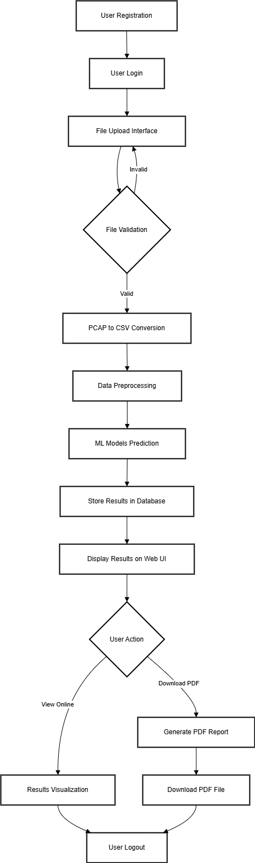
3.7 Data Flow Diagram

REFERENCES
- Kim, G., Lee, S., & Kim, S. (2014). A novel hybrid intrusion detection method integrating anomaly detection with misuse detection. Expert Systems with Applications, 41(4), 1690-1700.
- Shone, N., Ngoc, T. N., Phai, V. D., & Shi, Q. (2018). A deep learning approach to network intrusion detection. IEEE Transactions on Emerging Topics in Computational Intelligence, 2(1), 41-50.
- Wireshark Foundation. (2023). Wireshark User Guide. Retrieved from https://www.wireshark.org/docs/
- Chen, T., & Guestrin, C. (2016). XGBoost: A scalable tree boosting system. Proceedings of the 22nd ACM SIGKDD International Conference on Knowledge Discovery and Data Mining, 785-794.
- Ke, G., Meng, Q., Finley, T., et al. (2017). LightGBM: A highly efficient gradient boosting decision tree. Advances in Neural Information Processing Systems, 30, 3146–3154.
- Prokhorenkova, L., Gusev, G., Vorobev, A., Dorogush, A. V., & Gulin, A. (2018). CatBoost: unbiased boosting with categorical features. Advances in Neural Information Processing Systems, 31, 6638–6648.
- Sercan, Ö. A., et al. (2019). TabNet: Attentive interpretable tabular learning. arXiv preprint arXiv:1908.07442.

APPENDIX

