**FASTER_RCNN_R_101_FPN_3x**

**1000 ITERATIONS**

**PARAMETERS**

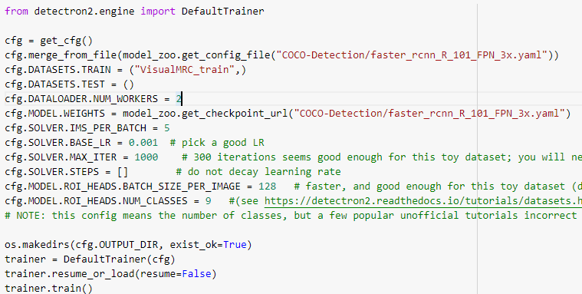

**PERFORMANCE**

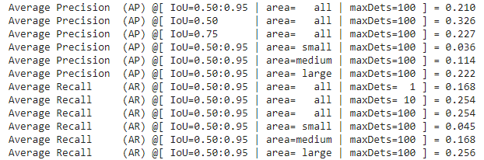

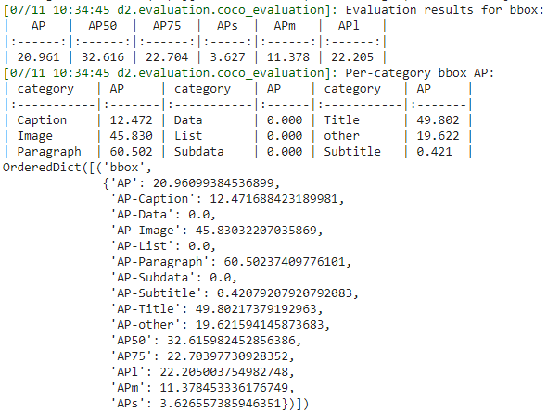

**PICTURE-1**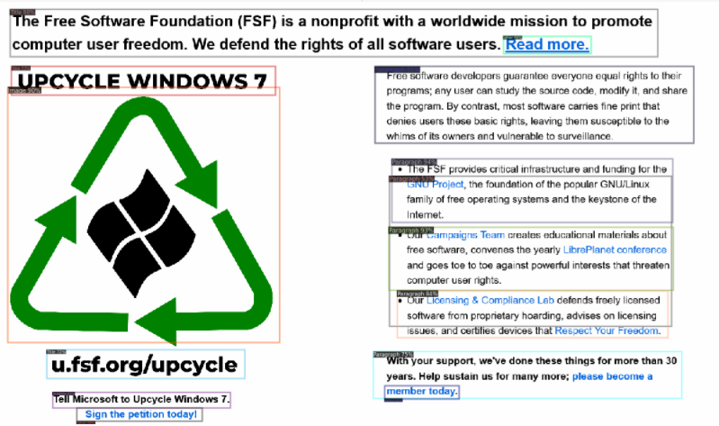

PROBLEMS:

When text in the paragraph are not justified, then multiple labels of paragraph are overlapping.

**PICTURE-2**

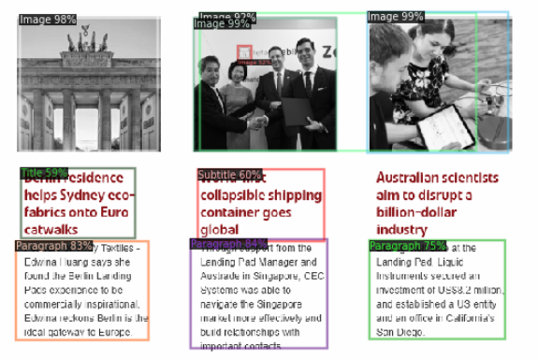

PROBLEMS:

* Images ROI get overlapped
* Same type of text is classified as Title and subtitle with similar accuracy
* Unable to classify some texts

**PICTURE-3:**

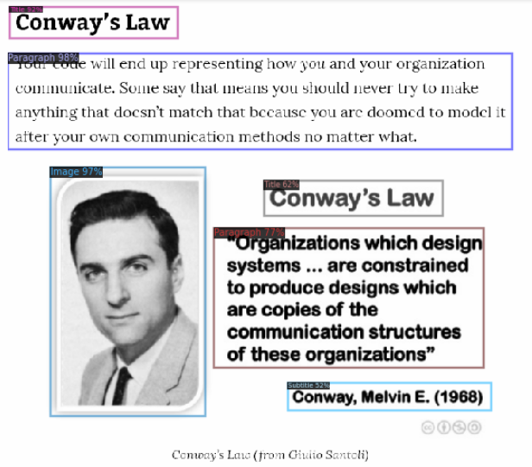

**PROBLEMS:**

Unable to detect image caption

**PICTURE-4:**

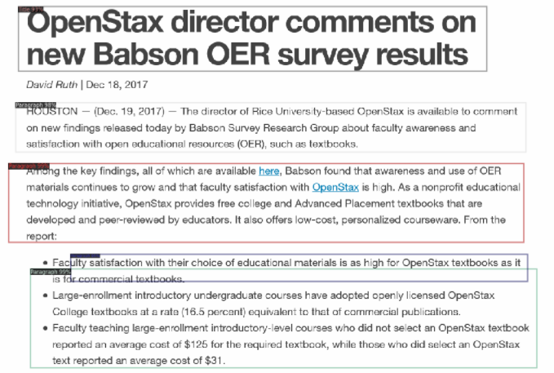

PROBLEMS:

* Unable to detect the Auther Name and date

**PICTURE-5**

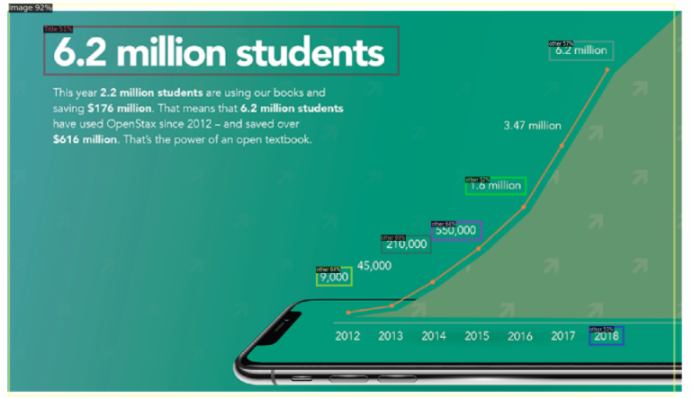

PROBLEMS:

* Creating Bounding boxes inside the image

**ITERATIONS:650**

**PARAMETERS:**

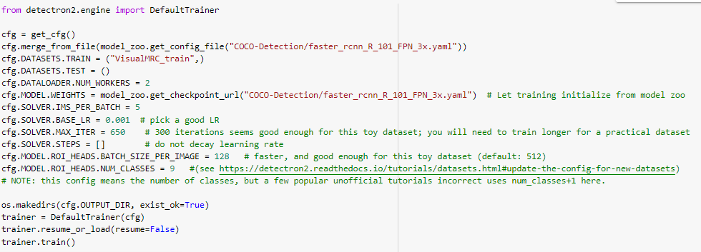

**PERFORMANCE:**

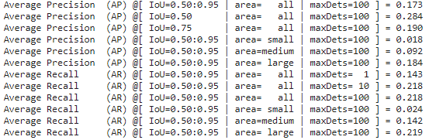

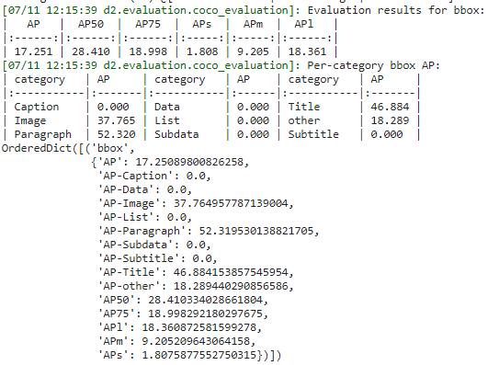

**PICTURE-1** 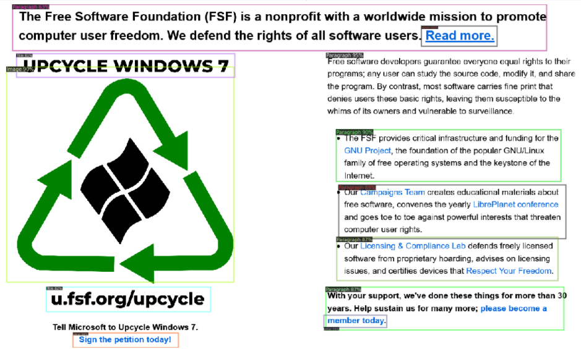

**PICTURE-2**

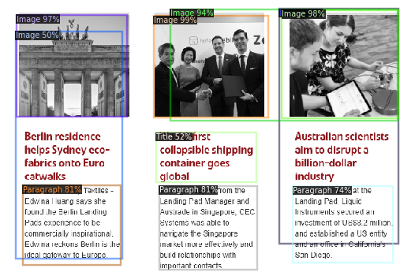

**PICTURE-3**

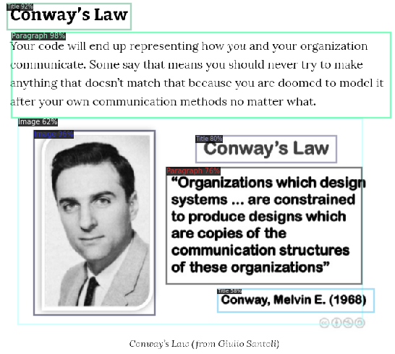

**PICTURE-4**



**PICTURE-5**

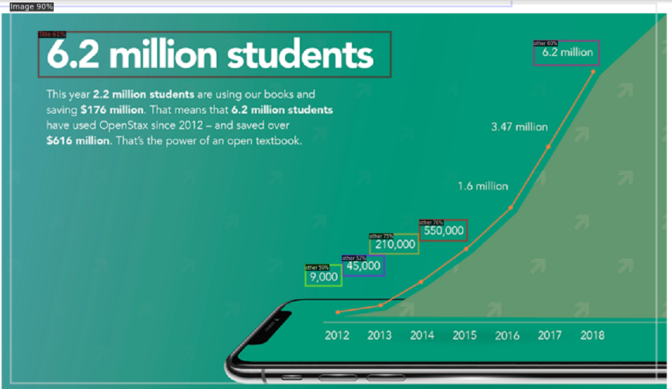

**PICTURE-6**



**ITERATIONS:300**

**PARAMETERS:**

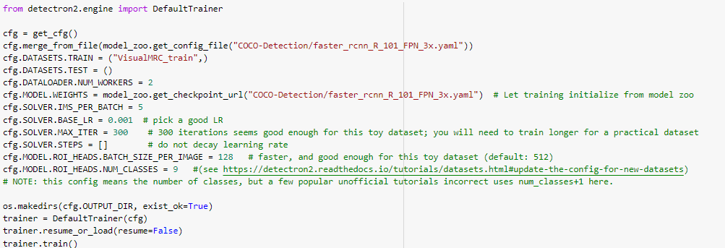

**PERFORMANCE**

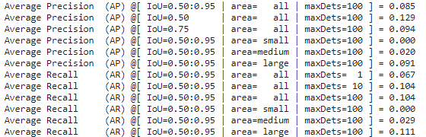

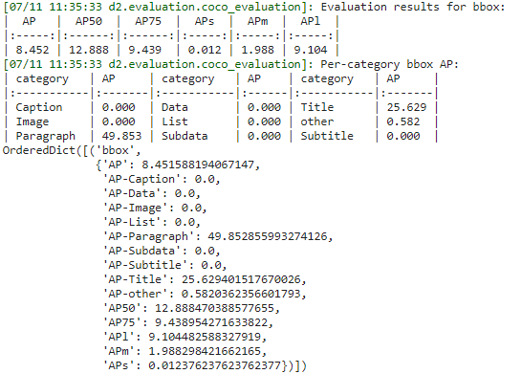

**PICTURE-1**

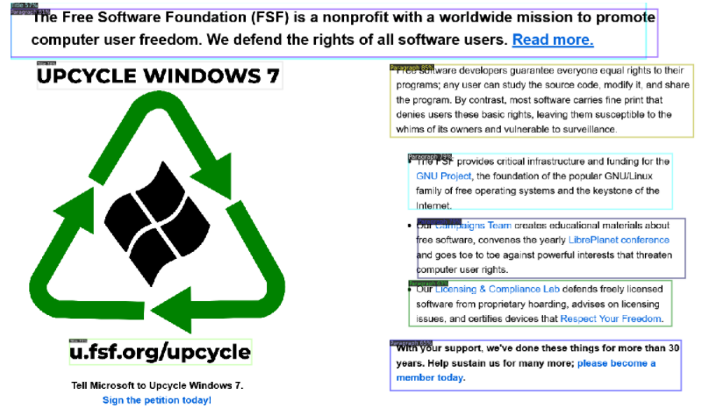

PROBLEM:

Unable to detect the recycle image

**PICTURE-2**

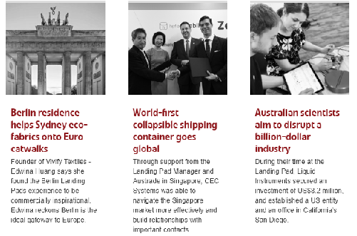

PROBLEM:

Unable to detect anything i.e No ROI

**PICTURE-3**

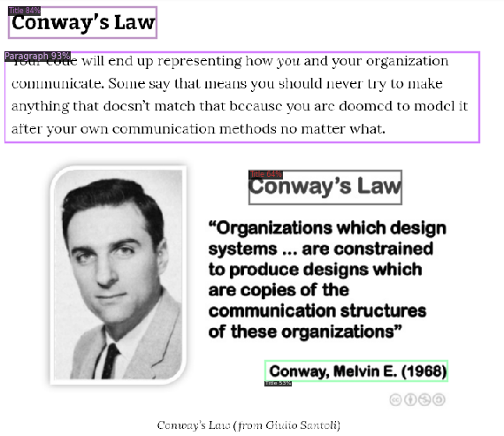

**PICTURE-4**



**PICTURE-5:**

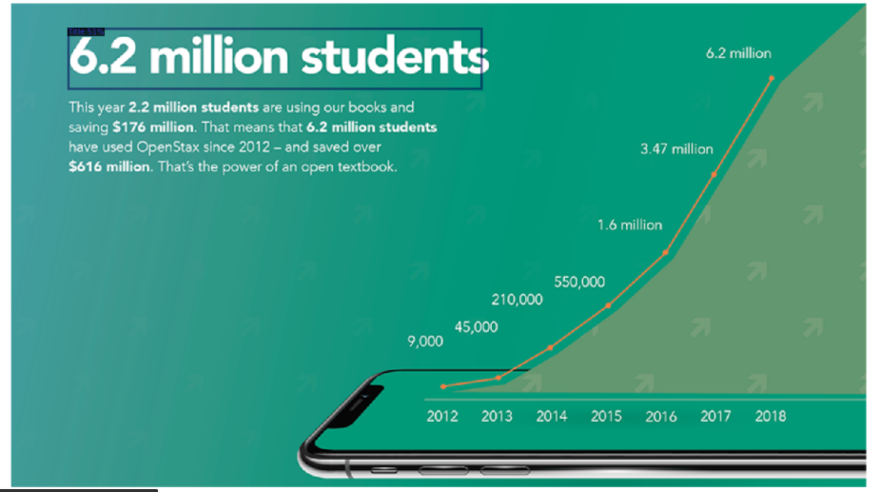

PROBLEM:

* Unable to detect whole as one image

**PICTURE 6:**

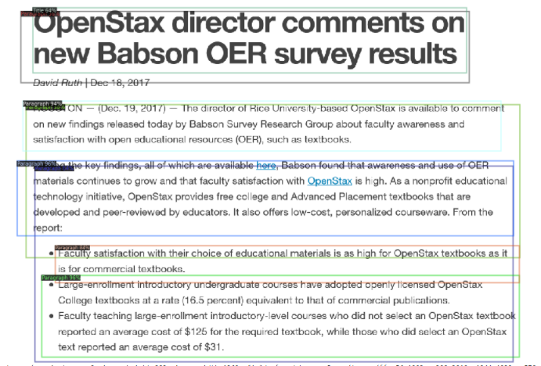

PROBLEM:

* Overlapping bounding boxes