use test

already on db test

show collections

db.sales.insertMany([

{ "_id" : 1, "item" : "Americanos", "price" : 5, "size": "Short", "quantity" : 22, "date" : ISODate("2022-01-15T08:00:00Z") },

{ "_id" : 2, "item" : "Cappuccino", "price" : 6, "size": "Short","quantity" : 12, "date" : ISODate("2022-01-16T09:00:00Z") },

{ "_id" : 3, "item" : "Lattes", "price" : 15, "size": "Grande","quantity" : 25, "date" : ISODate("2022-01-16T09:05:00Z") },

{ "_id" : 4, "item" : "Mochas", "price" : 25,"size": "Tall", "quantity" : 11, "date" : ISODate("2022-02-17T08:00:00Z") },

{ "_id" : 5, "item" : "Americanos", "price" : 10, "size": "Grande","quantity" : 12, "date" : ISODate("2022-02-18T21:06:00Z") },

{ "_id" : 6, "item" : "Cappuccino", "price" : 7, "size": "Tall","quantity" : 20, "date" : ISODate("2022-02-20T10:07:00Z") },

{ "_id" : 7, "item" : "Lattes", "price" : 25,"size": "Tall", "quantity" : 30, "date" : ISODate("2022-02-21T10:08:00Z") },

{ "_id" : 8, "item" : "Americanos", "price" : 10, "size": "Grande","quantity" : 21, "date" : ISODate("2022-02-22T14:09:00Z") },

{ "_id" : 9, "item" : "Cappuccino", "price" : 10, "size": "Grande","quantity" : 17, "date" : ISODate("2022-02-23T14:09:00Z") },

{ "_id" : 10, "item" : "Americanos", "price" : 8, "size": "Tall","quantity" : 15, "date" : ISODate("2022-02-25T14:09:00Z")}

]);

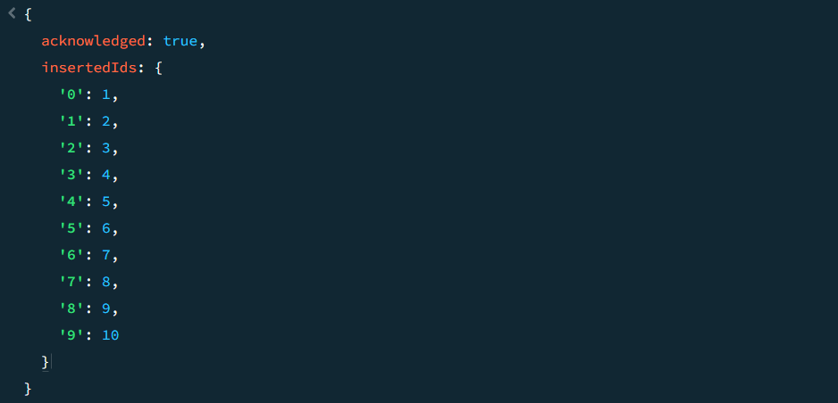

1. How do you find all documents where the field "item" is "Mochas"?

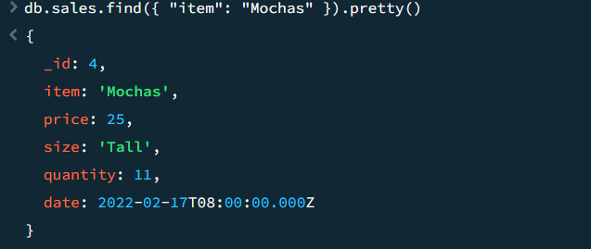

2. How do you find all items who are less than 15 of price?

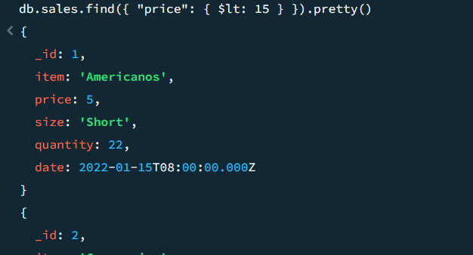

3. How do you find items who are either less than 10 or greater than 20?

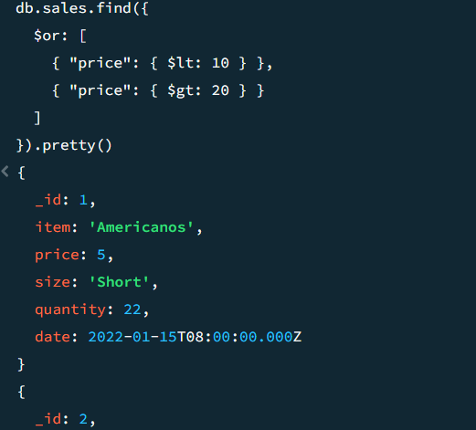

4. How do you find all documents where the quantity field exists?

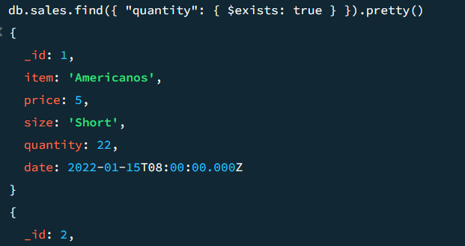

db.products.insertMany([

{ "_id" : 1, "name" : "xPhone", "price" : 799, "releaseDate": ISODate("2011-05-14"), "spec" : { "ram" : 4, "screen" : 6.5, "cpu" : 2.66 },"color":["white","black"],"storage":[64,128,256]},

{ "_id" : 2, "name" : "xTablet", "price" : 899, "releaseDate": ISODate("2011-09-01") , "spec" : { "ram" : 16, "screen" : 9.5, "cpu" : 3.66 },"color":["white","black","purple"],"storage":[128,256,512]},

{ "_id" : 3, "name" : "SmartTablet", "price" : 899, "releaseDate": ISODate("2015-01-14"), "spec" : { "ram" : 12, "screen" : 9.7, "cpu" : 3.66 },"color":["blue"],"storage":[16,64,128]},

{ "_id" : 4, "name" : "SmartPad", "price" : 699, "releaseDate": ISODate("2020-05-14"),"spec" : { "ram" : 8, "screen" : 9.7, "cpu" : 1.66 },"color":["white","orange","gold","gray"],"storage":[128,256,1024]},

{ "_id" : 5, "name" : "SmartPhone", "price" : 599,"releaseDate": ISODate("2022-09-14"), "spec" : { "ram" : 4, "screen" : 9.7, "cpu" : 1.66 },"color":["white","orange","gold","gray"],"storage":[128,256]}

])

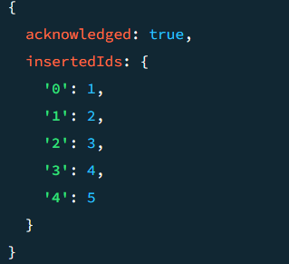

5. How do you find all documents where the color array contains the value "white"?

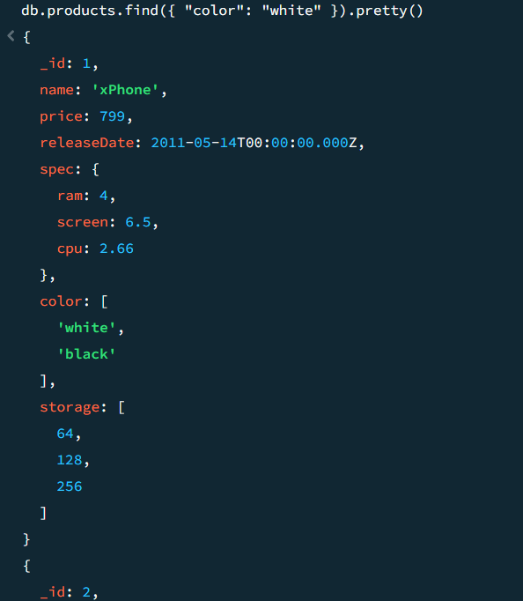

6. How do you update the ram of the user named "xTablet" to 24?

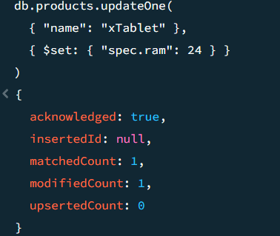

7. How do you find all products and only return their 'spec' field?

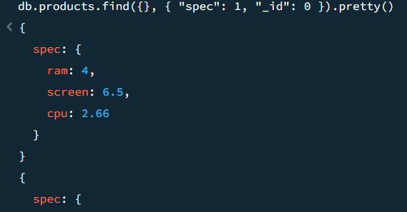

8. How do you find all products and sort them by their price in descending order?

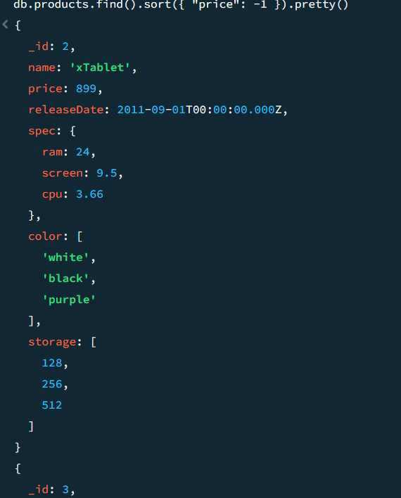

9. How do you find the first 2 products, skipping the first one?

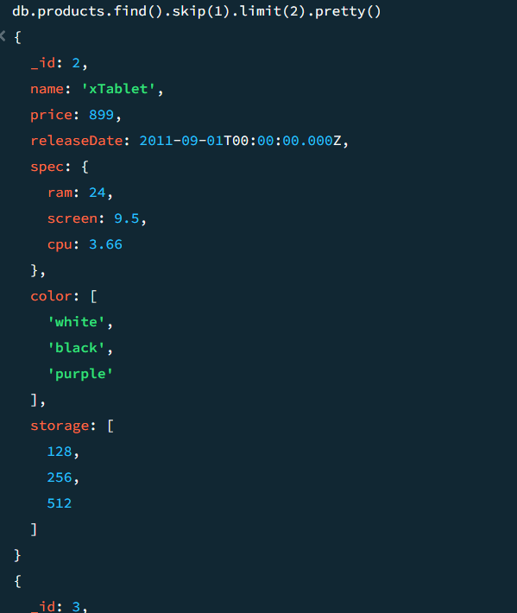

10. How do you find all users whose name starts with the letter "S" and price should be greater of 700?

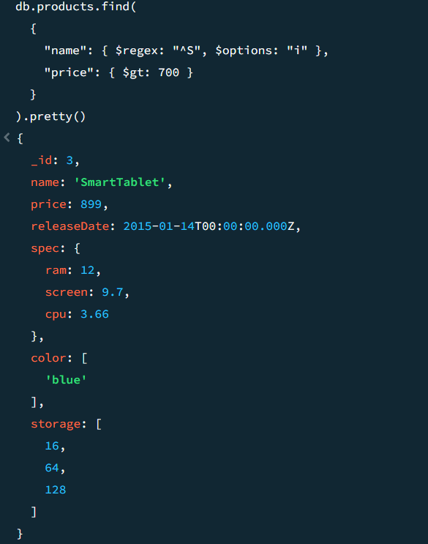

11. How do you calculate the total price of all items?

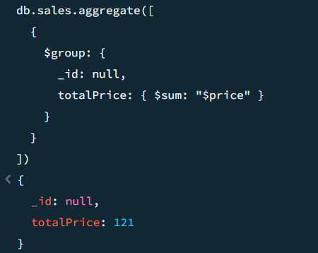

12.How do you project only the size field for each items?

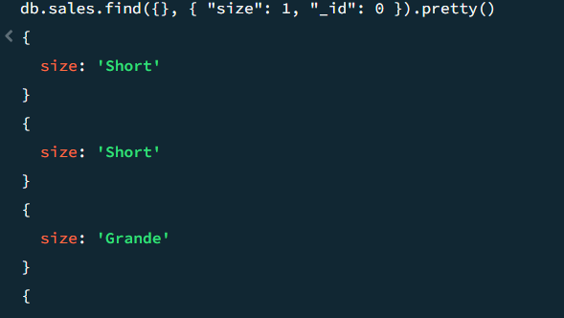

13. How do you find items who are Tall size & group them by item wise?

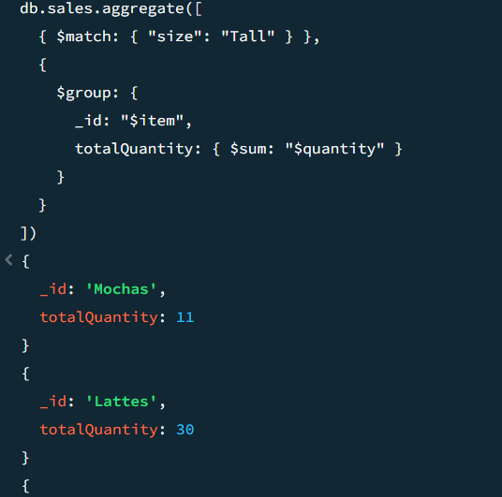

14. How do you find the second item when sorted by price in ascending order?

