**MEMORANDUM**

**Date:** March 28, 2023

**To**: Dr. James Stine

**From**: Marcus Mellor

**Subject**: ECEN-4233 Weekly Project Update

This week I worked on two primary tasks: rewriting the GDIV program in another language and laying initial groundwork for designing the FPDIV module.

I rewrote GDIV in Rust to ensure that I understood the sequence of math operations necessary to perform Goldschmidt division. The goal here was to reproduce with 1-to-1 accuracy the console output of the provided GDIV program. Unfortunately I haven’t yet figured out how to display the binary representations of decimal values. I’m still working on this, but decimal values do match the C code exactly.

Once I determined the sequence of math operations required, I created an initial diagram describing the FPDIV hardware. This diagram is shown below.

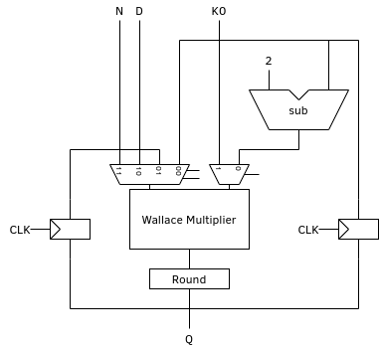

There are some notable omissions from this initial, very abstract design that will have to be implemented. For example, I’m not handling floating point exponent and mantissa values at all right now. That will have to be handled in hardware, and will be present in future, more detailed diagrams.

In addition to rewriting GDIV and developing the above diagram, I also wrote HDL for a resettable write-enabled flip-flop and stubbed out the Round module.