**MEMORANDUM**

**Date:** April 11, 2023

**To**: Dr. James Stine

**From**: Marcus Mellor

**Subject**: ECEN-4233 Weekly Project Update

This week I implemented a floating-point divider using Goldschmidt iteration. After some tweaking, the divider correctly computes the quotient of two mantissa operands. I also made an attempt at computing the remainder using the methods found in the GDIV program, but I suspect I have an issue with mismatching the radix point location between the two.

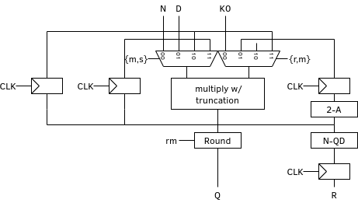

The diagram above shows how the Goldschmidt divider is implemented. On the final iteration, instead of calculating D and K again, we calculate the remainder R.

I’ve also made many small improvements to my testbench. Its output now matches the GDIV program bit-for-bit, displaying each bit during iterations and including the radix point.