Guided Practice - Legendary Layouts Lab Report
Use this template to document your work as you complete your assignment.

Your Information
Your Name: Jessica Hussain
Assignment Title: Legendary Layouts
GitHub Repository: https://github.com/influx-glitch/SDC260-Web-Interface-Design

Development Summary
The three new job listings I added to the job board are: Moonflower Gathering, Missing Child Rescue, and Crystal Mine Inspection. I linked the external CSS file. I used CSS Grid to arranged the quest cards into three columns with 25px spacing between them. The media query changes the layout to one column on screen that are smaller than 768px, which makes it easier to view on mobile devices.

Quest Listing Evidence
List the three new quests you added to the job board.
Quest Title | Quest Description Summary | Reward | Difficulty
Moonflower Gathering | Collect five moonflowers from the royal gardens. | 75 Gold | Easy
Missing Child Rescue | Find the missing children last seen playing near the spell shop. | 300 Gold | Hard
Crystal Mine Inspection | Discover the source of the strange whispers inside the abandoned crystal mine. | 275 | Medium

Code Evidence
Insert screenshots that show the completed code for this assignment. Make sure your screenshots are readable and show the relevant completed step sections.

Screenshot 1: Completed HTML code
Paste your screenshot below this line: 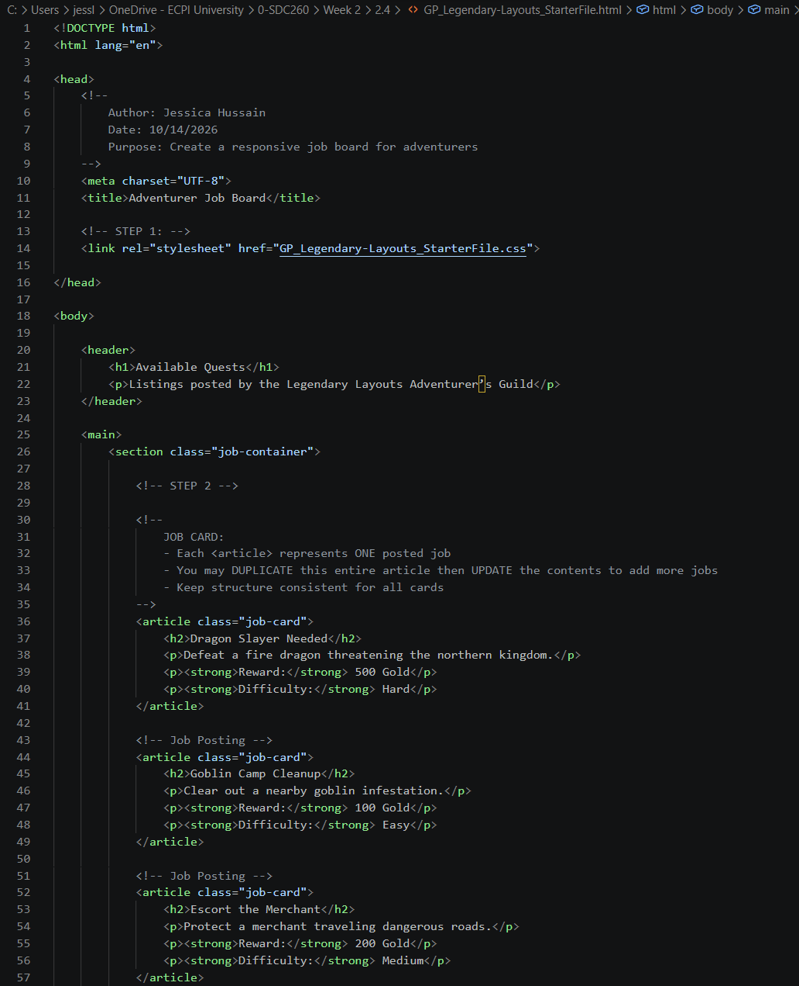
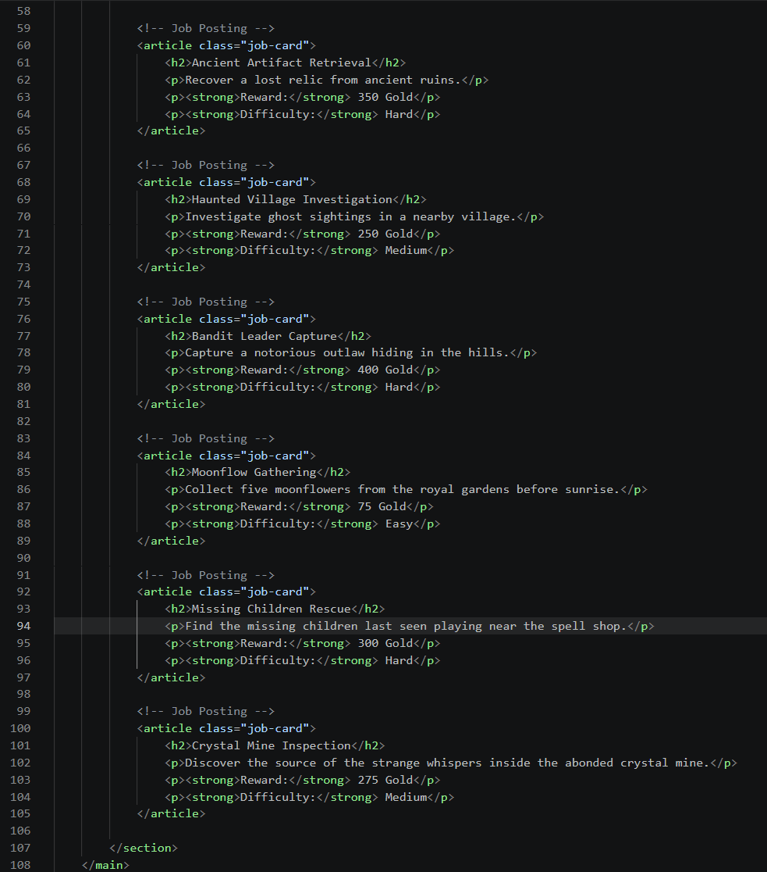
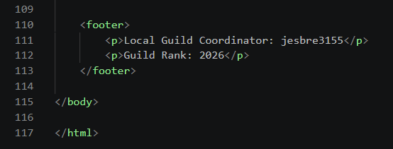

Screenshot 2: Completed CSS GridCode
Paste your screenshot below this line:
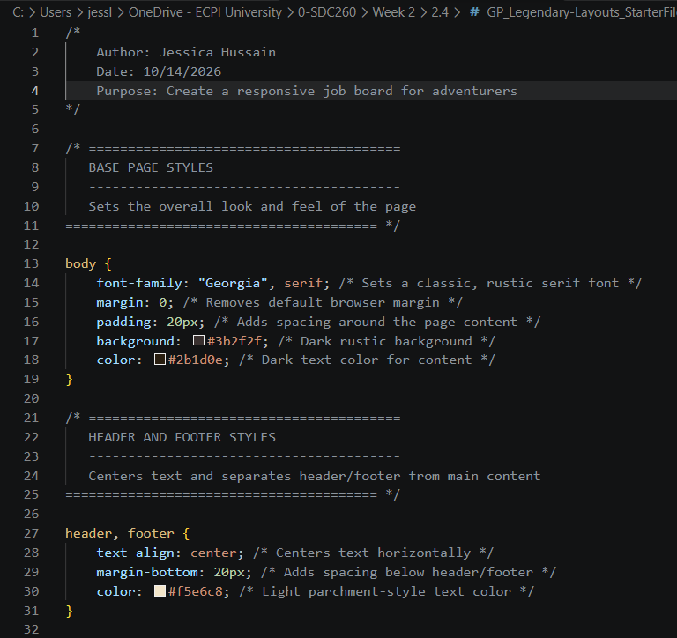
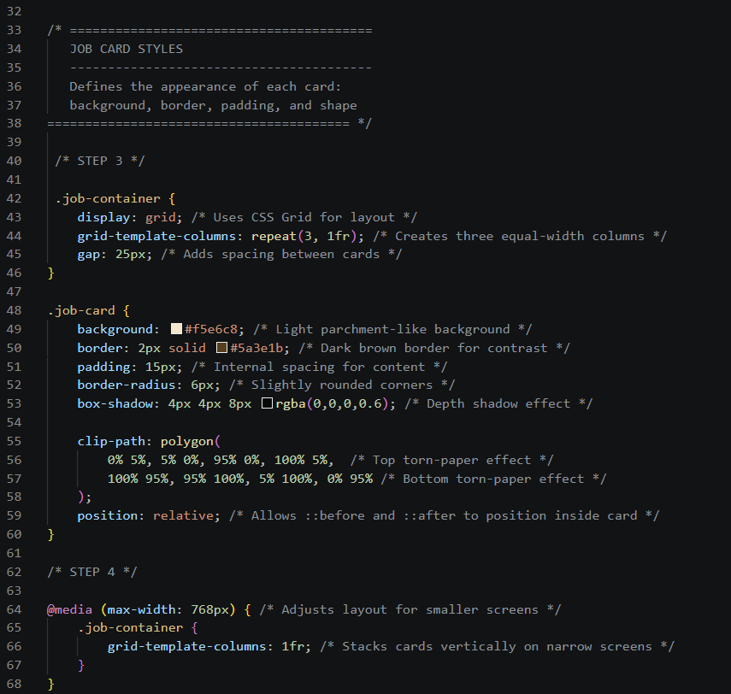
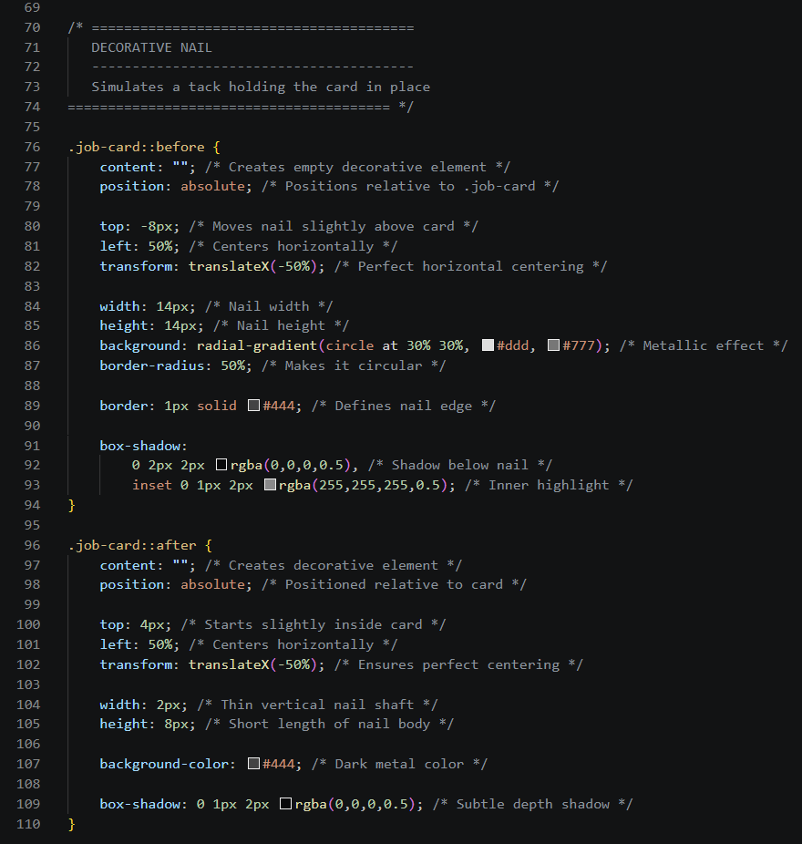

Screenshot 3: Completed Media Query Code
Paste your screenshot below this line:
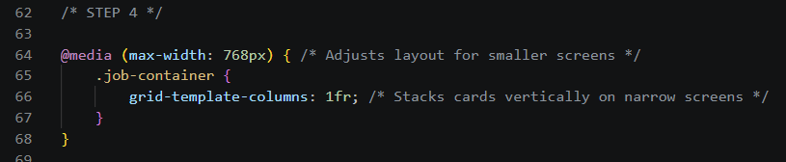

Rendered Web Page Evidence
Insert screenshots of the completed web page as it appears in your browser. Include one screenshot at a wider desktop size and one screenshot after resizing the browser window to a smaller/mobile width.

Screenshot 4: Desktop/Wide Layout
Paste your screenshot below this line:
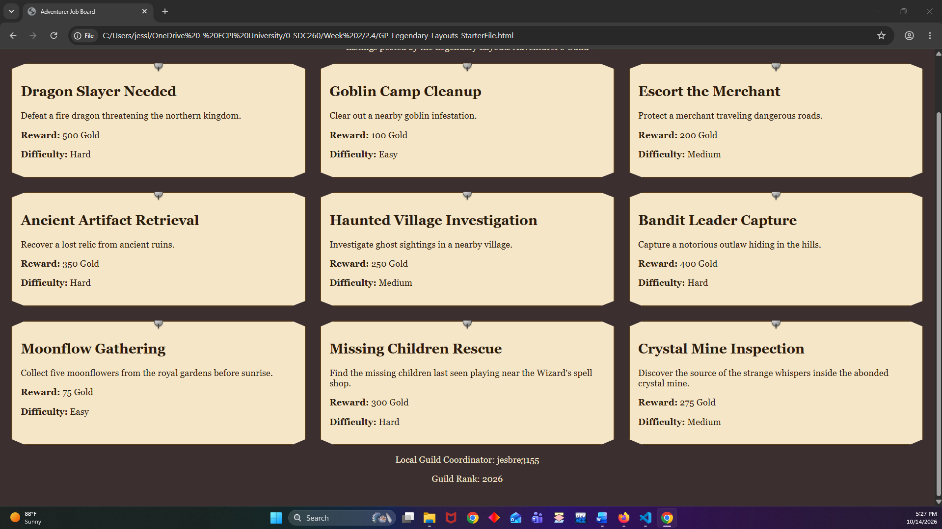

Screenshot 5: Mobile/Narrow Layout
Paste your screenshot below this line:
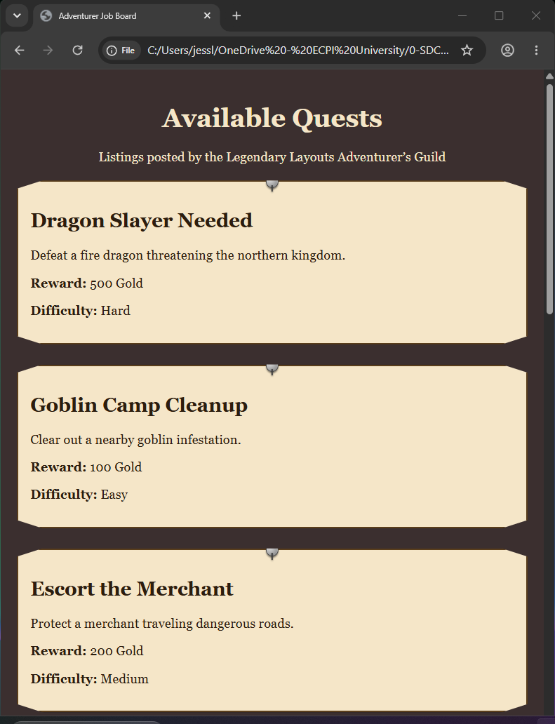

Responsive Design Check
1. What changed when you resized the browser window below the media query breakpoint?
- When the screen was narrowed to less than 768px, the job cards shifted into a single column.
2. Why does changing grid-template-columns to 1fr improve readability on smaller screens?
- This gives the quest listing a description more space without shrinking the size of the text, allowing for comfortable readability.

Reflection
1. How did CSS Grid help organize the quest listings on the job board?
- It helped by organizing the quest listings into columns and rows, keeps the cards aligned, and spaced. This makes it easier to look through the quests.
2. How did the media query make the job board more responsive for smaller screens?
- Media query allows the quest cards to be stacked in a single column for smaller screens by changing the grid-template-columns to 1fr. This let each card have more room for its text and makes the listing easer to read and scroll through.

