Assessment – Responsive Recipes Lab Report
Use this template to document your work as you complete your assignment.

Your Information
Your Name: Jessica Hussain
Assignment Title: Responsive Recipes
GitHub Repository: https://github.com/influx-glitch/SDC260-Web-Interface-Design

Development Summary
The three new potion recipes I added to the page are: Giant Strength Potion, Water Breathing Potion, and Mind Reading Potion. I linked the external CSS file using <link rel="stylesheet" href="PA_Responsive-Recipes_StarterFile.css">, and I used CSS grid to arrange the potion recipes into 1 column, as I made mobile the default. The media queries changes the layout to 2 columns when the screen reaches 768px-1023px, and 3 columns when 1024px or greater. These queries make it easier to view on tablets and desktops.

Potion Recipe Evidence
List the three additional potion recipes you added to the webpage. Each recipe should include a unique name, a brief effect description, and an ingredient table with quantities.
Potion Name | Effect Description Summary | Ingredients Included | Quantity Details Included?
Giant Strength Potion | Temporarily grants an increase in physical strength | Hill Giant Toenail  Ogre Root  Mountain Spring Water | 1 crushed clipping  3 thick slices  1 flask
Water Breathing Potion | Temporarily grants the ability to breathe under water | Merfolk Kelp  Crushed Pear  Enchanted Seawater | 2 strands  1 teaspoon  1 vial
Mind Reading Potion | Temporarily grants the ability to read minds | Mind Flayer Mucus  Silver Lotus Petals  Dream Crystal Dust | 3 drops  4 petals  1 pinch

Layout and Responsiveness Evidence
- Did you use Flexbox or CSS Grid for the main layout? Explain why that layout method was appropriate for this recipe page.
- I chose CSS Grid because it gives you control over rows and columns simultaneously, and items will always be aligned with the one above or below it when the screen size changes.

- What layout or spacing changes occur at the 768px breakpoint?
- At this breakpoint, the layout increases to 2 columns up until 1023px or decreases to 1 if it falls below 768px.

- What layout or spacing changes occur at the 1024px breakpoint?
- At this breakpoint and beyond, the layout increases to 3 columns or decreases to 2 columns it it falls below 1024px.

- How did you confirm that the page remained readable across mobile, tablet, and desktop screen sizes?
- I made sure the page remained readable by testing the window size after each change made in the CSS file.

Code Evidence
Insert screenshots that show the completed code for this assignment. Make sure your screenshots are readable and show the relevant HTML and CSS requirements.

Screenshot 1: Completed HTML Code
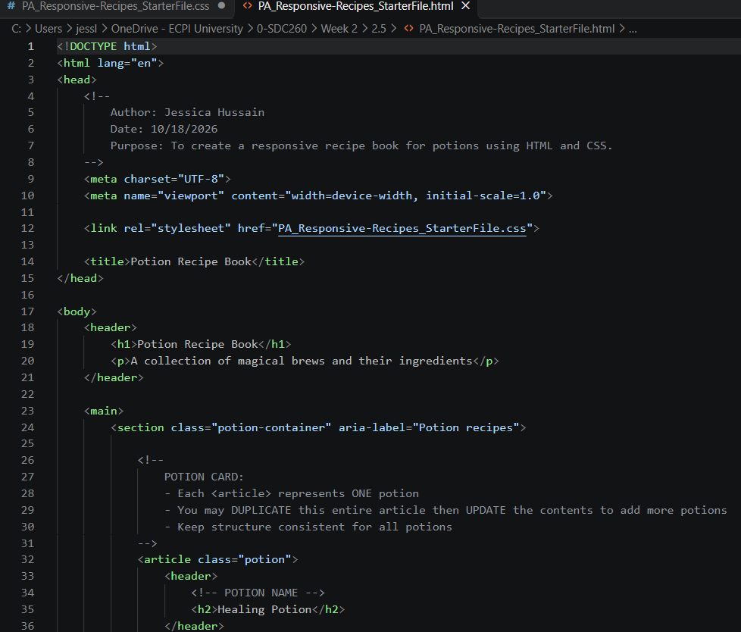
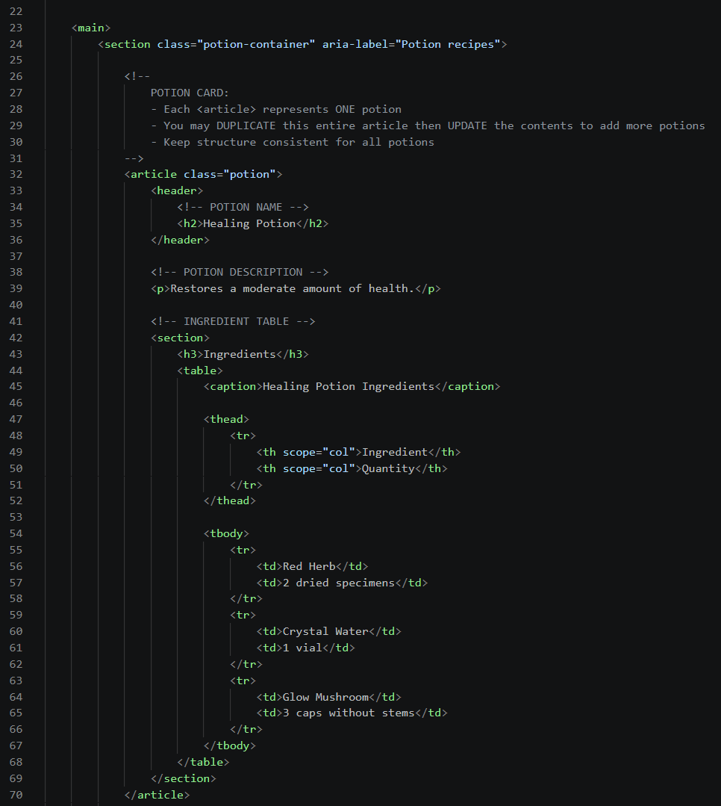
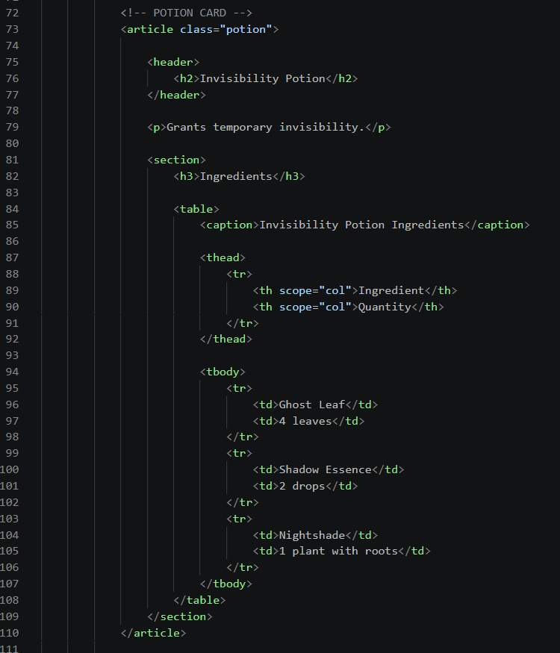
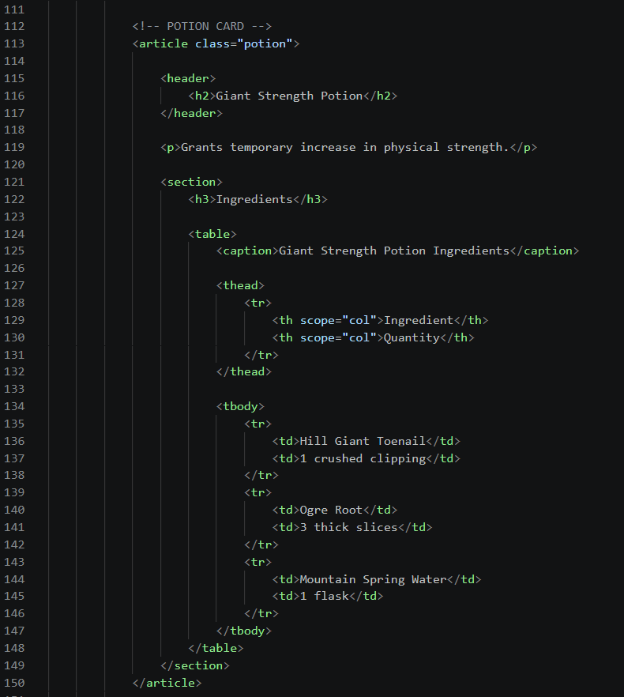
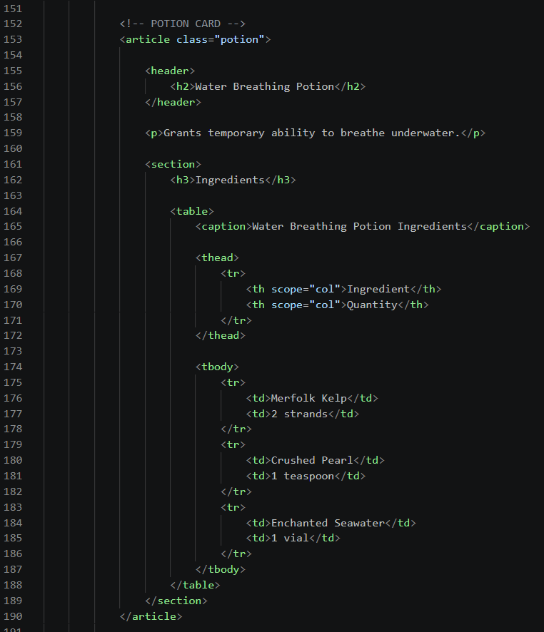
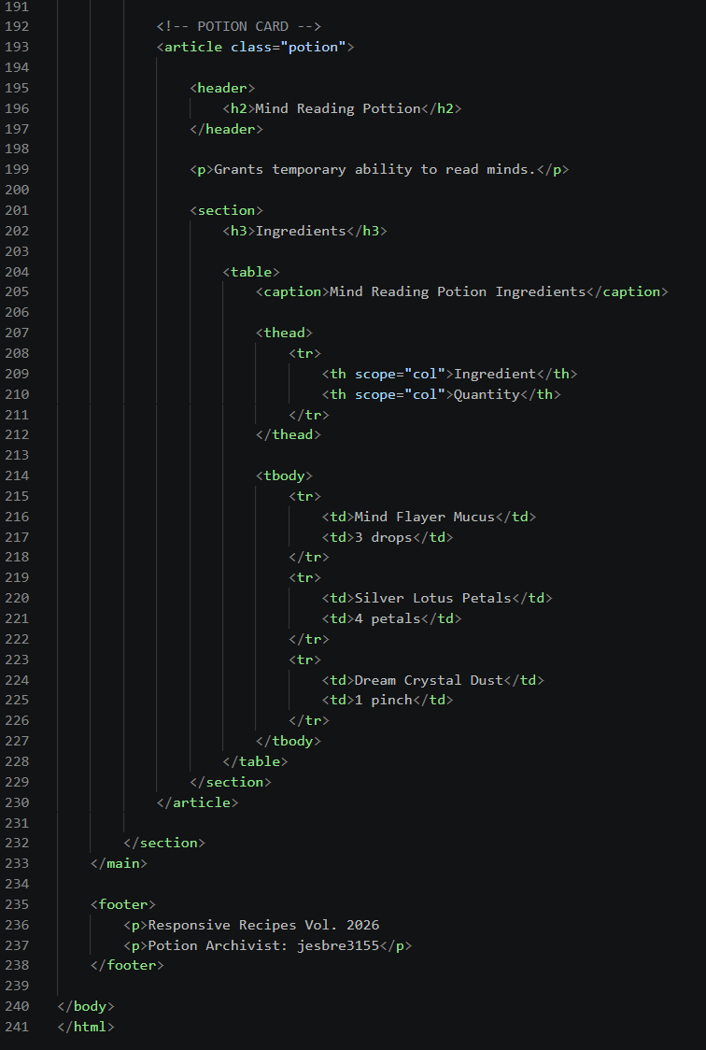

Screenshot 2 - Completed CSS Layout Code
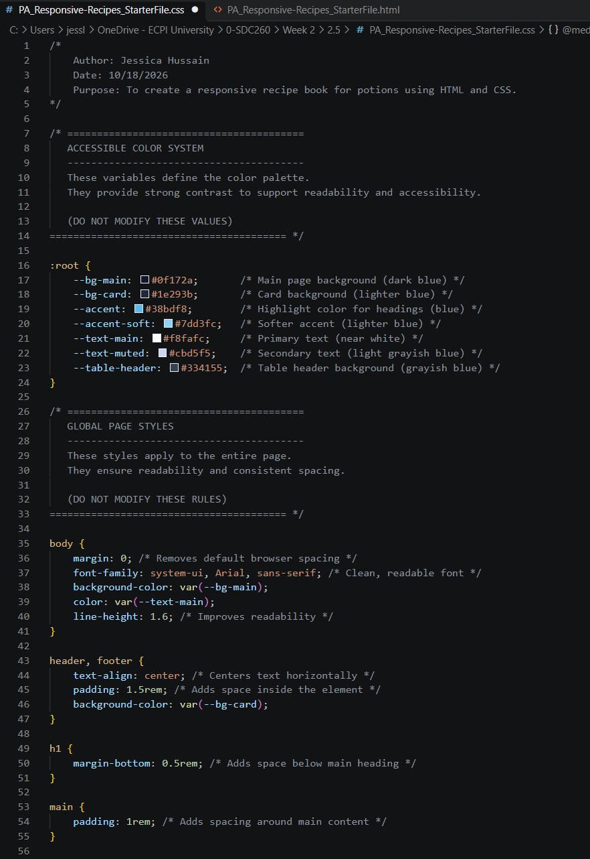
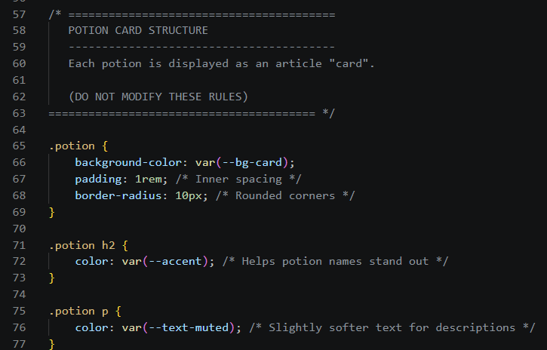
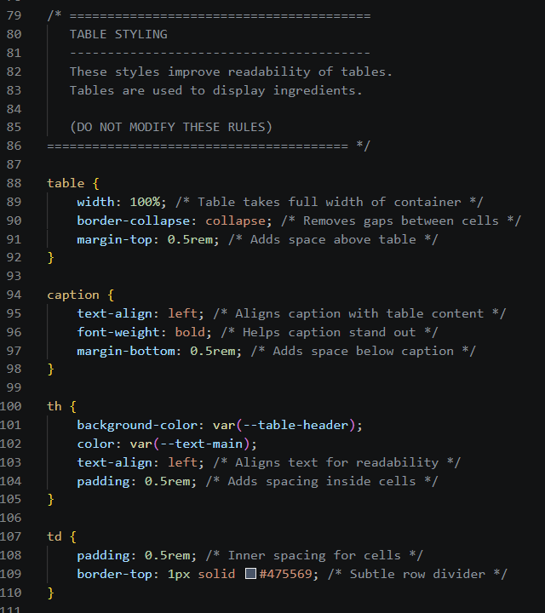
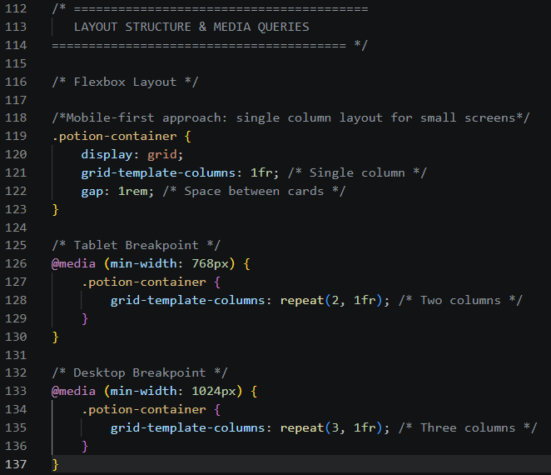

Screenshot 3 – Completed Media Query Code

Rendered Web Page Evidence
Insert screenshots of the completed web page as it appears in your browser. Include evidence that the page adjusts for mobile, tablet, and desktop screen sizes.

Screenshot 4: Mobile/Narrow Layout
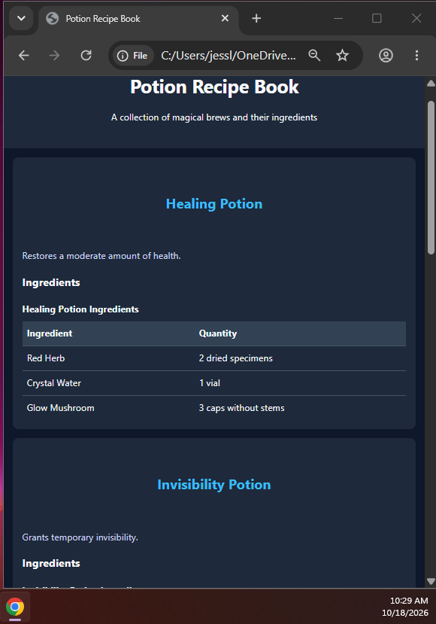

Screenshot 5 – Tablet Layout
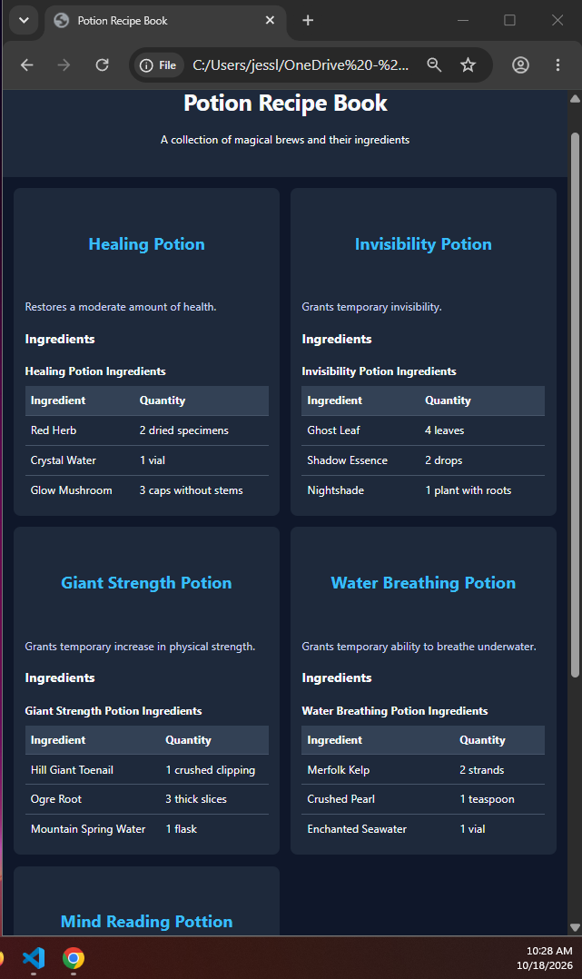

Screenshot 6 – Desktop/Wide Layout
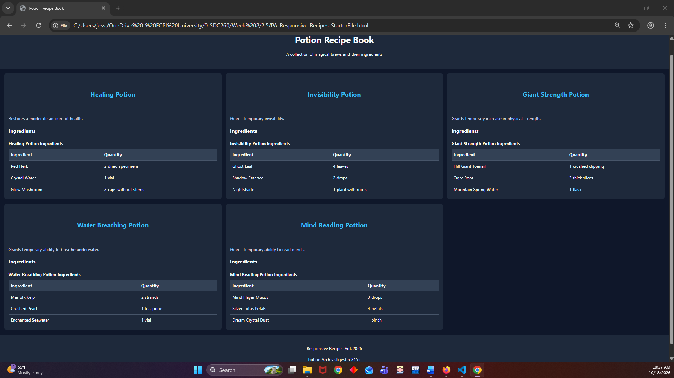

Reflection
Answer the reflection questions below in complete sentences.
1. What was the most challenging part of making the recipe page responsive?
- What I found most challenging was getting the page to respond to the media queries. I tried to make a separate contain that would apply to the whole page and just couldn’t understand why it wasn’t working. I stared at the code until my vision blurred before I gave up. This morning I had the bright idea to remove that extra container and like magic, everything was fine.
2. How did Flexbox or CSS Grid help organize the recipe content?
- CSS helped organize the content by keeping each card aligned with the one above and below depending on the size of the screen.
3. What would you improve about the page if you had more time?
- I would add color to the heading in each recipe cards and add a different color to the ingredient/quantity element to have visual separation from the main background color. I’d also remove <h3>Ingredients</h3> and just use the “Name Potion Ingredients” as the heading instead. Seems redundant to have both.

