The Office Report

Aaron He

2023-02-07

1. Give the report a new title and add your own name
2. Make a plot of average IMDB ratings per season
3. Find the highest and lowest IMDB ratings for any episode of The Office
4. Include an image from The Office somewhere in the report



Here’s a plot of average IMDB rating for each season of The Office. 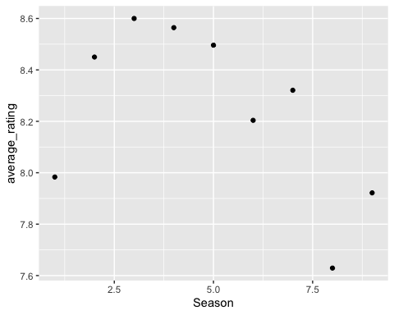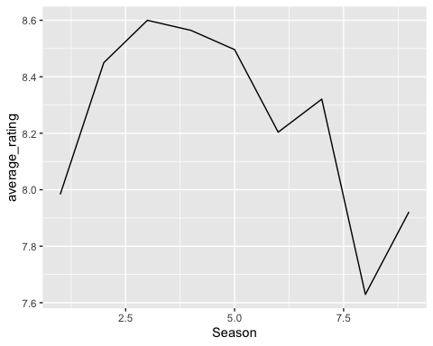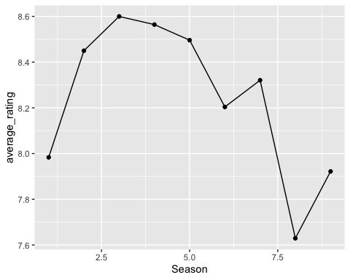

The highest IMDB rating for any episode of The Office is 9.8, 9.8, and the lowest rating is 6.6.