

EAST WEST UNIVERSITY
Department of Computer Science and Engineering
Artificial Intelligence

PROJECT REPORT

Cat and Dog Image Classification Using
Convolutional Neural Networks with AlexNet

2. Abstract
This project develops a binary image-classification system that distinguishes cats from dogs using a Convolutional Neural Network (CNN) based on AlexNet. The project uses a cat-and-dog image dataset and follows a complete image-processing and training pipeline, including data preparation, resizing, normalization, consistent color conversion, data augmentation, label encoding, and train-test splitting. The CNN learns visual features through convolutional layers, ReLU activation, pooling, flattening, fully connected layers, and an output layer. Model parameters are learned by minimizing a loss function with a gradient-based optimizer and an appropriate learning rate. The supplied project materials establish the model architecture and preprocessing/training workflow; however, the accessible source does not expose the notebook's final numerical evaluation results, so no accuracy or loss value is fabricated in this report. The main conclusion is that CNNs provide an effective framework for learning hierarchical visual features for cat-versus-dog classification.

3. Introduction

3.1. Problem Definition
The problem addressed by this project is binary image classification: given an input image, the system must determine whether the image belongs to the “Cat” class or the “Dog” class. This is a representative computer-vision problem because the two classes can have large variations in pose, background, lighting, scale, color, and appearance. A successful model therefore needs to learn useful visual features rather than depend on simple manually selected rules.
A CNN is appropriate for this task because convolutional filters can automatically learn local image patterns. Early layers can respond to simple structures such as edges and lines, while deeper layers can combine those patterns into more meaningful shapes and object-level representations.

3.2. Project Goal and Scope
The primary goal is to develop and train an AlexNet-based CNN capable of classifying unseen images into two categories: cat and dog. The project scope is limited to binary image classification and the training/evaluation pipeline described in the supplied project materials.
- Build an image-classification pipeline suitable for cat-versus-dog recognition.
- Use CNN convolutional layers to learn image features automatically.
- Use ReLU activation and pooling to support hierarchical feature learning and spatial reduction.
- Use a fully connected/output stage to produce the final binary prediction.
- Evaluate model behavior using classification accuracy and loss, together with training/validation behavior where available.
- Keep the project focused on image classification rather than object detection, segmentation, or multi-class recognition.
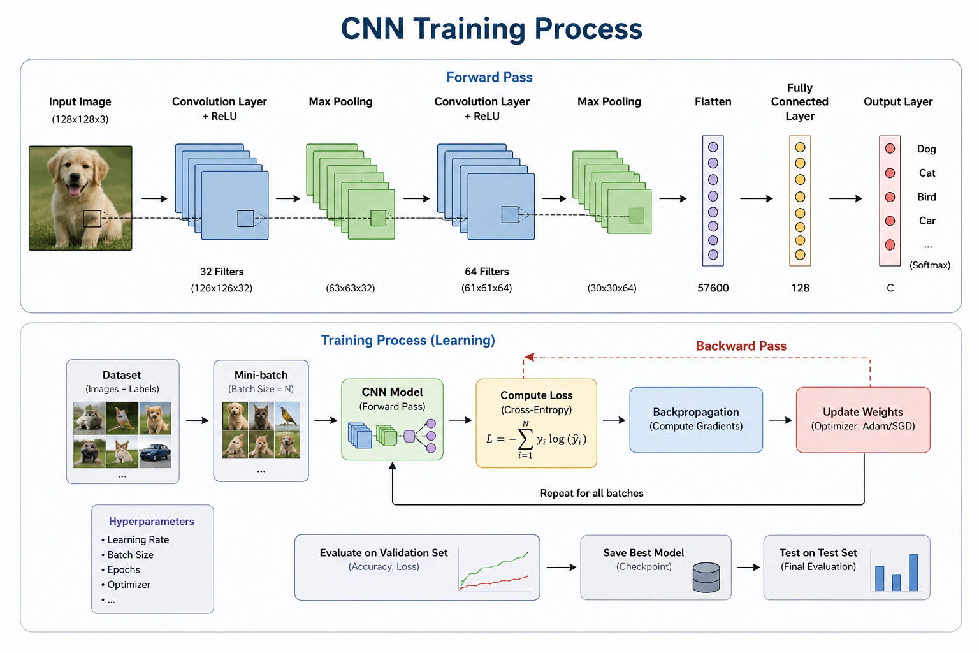
Figure 1: CNN Training Process

4. Theoretical Background (Algorithm/Model)

4.1. Core Concept
A Convolutional Neural Network is a deep neural network designed to process grid-like data such as images. Instead of connecting every input pixel to every neuron immediately, CNNs use learnable kernels/filters that slide over the image and compute feature maps. This allows the network to learn spatially local patterns while reusing the same parameters across different image locations.
The main CNN components used in the supplied learning material are: Input Layer, Convolutional Layer, Activation Function, Pooling Layer, Flattening Layer, Fully Connected Layer, and Output Layer. ReLU (Rectified Linear Unit) is identified as the commonly used activation function. Max Pooling is identified as a widely used downsampling operation.

4.1. Core Concept
ReLU activation: f(x) = max(0, x). It introduces non-linearity while keeping positive activations.
A convolution can be represented conceptually as: Z(i,j) = ΣΣ X(i+m,j+n)K(m,n) + b, where X is the input, K is a learnable kernel, and b is a bias.
Binary cross-entropy loss is commonly used for binary classification: L = -[y log(p) + (1-y) log(1-p)], where y is the true label and p is the predicted probability for the positive class.
Gradient-based optimization updates model parameters in the direction that reduces the loss. A generic update can be written as: θ_new = θ_old − η ∇θ L, where η is the learning rate.

4.1. Core Concept
The project is explicitly titled as an AlexNet-based cat-and-dog classifier. AlexNet is a landmark CNN architecture that uses multiple convolutional stages followed by fully connected classification layers. In the report context, its important ideas are consistent with the supplied CNN notes: convolutional feature extraction, non-linear activation, pooling/downsampling, flattening, fully connected processing, and final classification.
Because the accessible GitHub page exposes the notebook filename and repository but does not expose the full notebook cell contents in the web-rendered page, exact layer-by-layer hyperparameters from the notebook are not asserted here unless they are supported by the supplied material. The architecture table below therefore describes the functional role of each stage rather than inventing notebook-specific parameter values.

4.2. Implementation Details
The implementation is organized around a standard image-classification pipeline. Images are prepared in a uniform format, transformed into a consistent size and color representation, normalized, augmented when appropriate, assigned numerical labels, and divided into training and testing data. The CNN then extracts features and learns model weights through backpropagation and optimization.
- Convolutional filters: learn spatial image features.
- ReLU activation: introduces non-linearity.
- Pooling: reduces feature-map dimensions through downsampling.
- Flattening: converts multi-dimensional feature maps into a one-dimensional vector.
- Fully connected layers: combine learned features for classification.
- Output layer: produces the final cat/dog prediction.
- Optimizer: updates trainable weights and biases to minimize the loss.
- Learning rate: controls the size of parameter-update steps.

5. Methodology and Implementation

5.1. Dataset / Environment Setup
Preprocessing: The project materials specify data preparation, resizing, normalization, color conversion, data augmentation, label encoding, and train-test splitting.
Dataset Classes: 2 classes — Cat and Dog. Exact dataset size and feature count are not stated in the supplied report material, so they are not invented here.
Dataset Source: The project uses the cat-and-dog image dataset associated with the supplied GitHub notebook, “Cat and Dog Image Classification Using Convolutional Neural Networks with AlexNet.”
The project uses a cat-and-dog image dataset for binary classification. The source project is the public GitHub repository supplied with the task, containing the notebook “Cat and Dog Image Classification Using Convolutional Neural Networks with AlexNet.ipynb.” The task has two classes: Cat and Dog.
Dataset preparation follows the steps supplied in the provided learning material. The images are first prepared into a uniform dataset structure, then resized, converted to a consistent color-channel representation, normalized, and optionally augmented. The labels are encoded numerically so that the learning algorithm can operate on them.

5.1. Dataset / Environment Setup
Data Preparation: Ensures that the dataset is arranged in a consistent and usable format before model training.
Resizing: Scales input images to a fixed dimension so that every sample has a compatible shape.
Normalization: Scales pixel values from the standard 0–255 range to a normalized range such as 0–1, supporting stable training.
Color Conversion: Converts images into a consistent color-channel representation such as RGB or grayscale.
Data Augmentation: Creates variations such as rotations, flips, and zooms from existing images to reduce overfitting and improve generalization.
Label Encoding: Converts categorical labels such as “Cat” and “Dog” into numerical representations.
Train-Test Split: Separates data used for learning from data used to evaluate performance on unseen samples.

5.1. Dataset / Environment Setup
- Loss Function: measures how far the model prediction is from the ground-truth target.
- Optimizer: updates model weights and biases to minimize the loss.
- Gradient: the derivative information used to determine how parameters should change.
- Learning Rate (η): determines the size of each optimization step.
- If the learning rate is too high, the optimizer may overshoot a good solution and fail to converge.
- If the learning rate is too low, training may become very slow or may make poor progress.
- A moderate/appropriate learning rate provides a more stable path toward convergence.

5.2. Model/Algorithm Design
For CNN/ANN projects, the following table documents the network architecture at the functional level. Exact notebook-specific kernel sizes, neuron counts, and output shapes are reported only where supported by the supplied source.
The following functional architecture table is based on the CNN architecture and AlexNet terminology supplied for the project. It is intended to document the role of each stage without inventing exact notebook-specific values.
Stage | Main Operation | Purpose | Output Role
1. Input | Receive image tensor | Provide raw image data | Image representation
2. Convolution | Apply learned kernels/filters | Detect edges, lines, textures and higher-level patterns | Feature maps
3. Activation | ReLU non-linearity | Allow learning of complex relationships | Activated feature maps
4. Pooling | Max pooling/downsampling | Reduce spatial size while retaining important information | Compact feature maps
5. Repeated CNN stages | Convolution + activation + pooling | Build hierarchical visual representations | Deeper feature maps
6. Flatten | Convert feature maps to 1D vector | Prepare learned features for dense processing | Feature vector
7. Fully Connected | Dense neural processing | Combine learned features for classification | Class evidence
8. Output | Binary classification output | Predict Cat or Dog | Final prediction

5.2. Model/Algorithm Design
- Stride: the number of pixels by which a convolutional kernel shifts across the image.
- Padding: extra pixels, commonly zeros, added around image borders. Padding helps control feature-map dimensions and preserve edge information.
- Kernel/Filter: a learnable matrix that detects a particular visual pattern.
- Learning rate: the step size used by the optimizer during parameter updates.
- Epoch: one complete pass through the training data.

5.3. Implementation Language and Tools
Programming Language: Python. The project is implemented as a Jupyter Notebook. The supplied source does not provide enough visible information to safely state exact library versions, so versions are not fabricated.
- Python — primary programming language for the notebook implementation.
- Jupyter Notebook — interactive development and experimentation environment.
- CNN/AlexNet — deep-learning architecture used for image classification.
- Image-processing utilities — used for resizing, normalization, color handling and augmentation.
- Visualization tools — used to inspect images and training/evaluation behavior.
The exact library versions and every import used in the linked notebook should be treated as notebook-specific implementation details. The report intentionally does not invent version numbers that are not visible in the supplied material.

6. Results and Analysis

6.1. Experimental Setup
Experiment Procedure: The dataset is prepared and split into training and testing data, followed by CNN training and evaluation on unseen data. The accessible source does not expose enough information to state an exact number of trials or cross-validation folds.
Evaluation Metrics: Accuracy is the primary classification metric; loss is used to monitor learning. Precision, recall, F1-score, and a confusion matrix can be included when their values are available from the notebook.
The primary evaluation target for this binary image-classification project is classification accuracy, supported by loss and training/validation behavior. Where available in the notebook, confusion-matrix analysis and learning curves can further reveal class-specific errors and whether the model is overfitting.
The supplied project material does not provide a complete machine-readable copy of the notebook's final numerical result cells in the visible source. Therefore, this report does not fabricate a final accuracy, precision, recall, or F1 score. The exact values should be copied from the notebook's final evaluation output before submission if the instructor requires numerical results.

6. Results and Analysis

6.1. Experimental Setup
The experiment used the Microsoft Cats vs Dogs image dataset downloaded through KaggleHub. The dataset contains two classes, Cat and Dog, with 24,542 images in total. The data were divided into 70% training, 15% validation, and 15% test sets using a fixed random seed of 42.
The training pipeline resized images to 224×224 pixels and applied augmentation through random rotation, horizontal flipping, affine translation/zoom, and brightness adjustment. Images were converted to tensors and normalized using the ImageNet mean and standard deviation. Validation and test images were resized and normalized without random augmentation.
A pretrained AlexNet model was used for transfer learning. The convolutional feature extractor was frozen, and the final classifier layer was replaced with a two-class output layer. Cross-entropy loss was used with the Adam optimizer at a learning rate of 0.0001. Training was performed for 10 epochs using a batch size of 128 on an NVIDIA GeForce RTX 3050 GPU.
The notebook reports 0 corrupted images and 0 severely blurred images during dataset verification. The DataLoader contained 135 training batches, 29 validation batches, and 29 test batches.

6.2. Quantitative Results
The final test evaluation produced an accuracy of 96.33%, precision of 96.88%, recall of 96.02%, and F1-score of 96.45%. The ROC analysis produced an AUC of approximately 0.9949 for both Cat and Dog, indicating strong class-separation capability.
Metric | Value | Interpretation
Test Accuracy | 96.33% | Overall proportion of correctly classified test images.
Precision | 96.88% | High correctness of positive predictions.
Recall | 96.02% | High proportion of actual positive samples detected.
F1-Score | 96.45% | Balanced precision-recall performance.
Dog AUC | 0.9949 | Excellent discrimination for the Dog class.
Cat AUC | 0.9949 | Excellent discrimination for the Cat class.
Final Train Accuracy | 96.82% | Training accuracy at epoch 10.
Final Validation Accuracy | 96.22% | Validation accuracy at epoch 10.
Final Train Loss | 0.0792 | Average training loss at epoch 10.
The confusion matrix contained 1,714 correctly classified Cat images and 1,833 correctly classified Dog images. There were 59 Cats predicted as Dogs and 76 Dogs predicted as Cats. These results show that the model made relatively few errors in either class.

6.3. Visual Results and Analysis
The following figures are taken directly from the project notebook. They are placed before the conclusion so that the visual evidence used for the analysis is presented in the main Results and Analysis section.
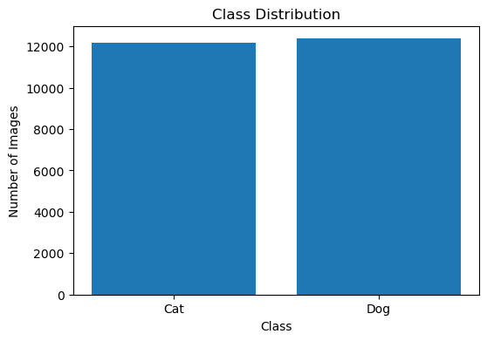
Figure 6.1. Class distribution bar chart.
Interpretation: The dataset is nearly balanced, with 12,176 Cat images and 12,366 Dog images. The small difference between the two classes reduces the risk of strong class-imbalance bias.

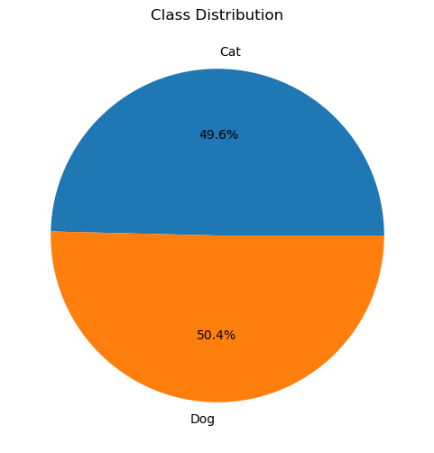
Figure 6.2. Class distribution pie chart.
Interpretation: Cats represent about 49.61% of the dataset and Dogs about 50.39%, confirming the near-balanced class distribution.

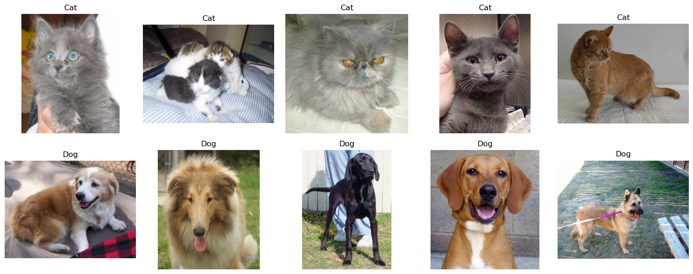
Figure 6.3. Random sample images from the Cat and Dog classes.
Interpretation: The sample visualization shows variation in appearance, pose, color, and background across both classes, supporting the need for learned visual features rather than simple fixed rules.

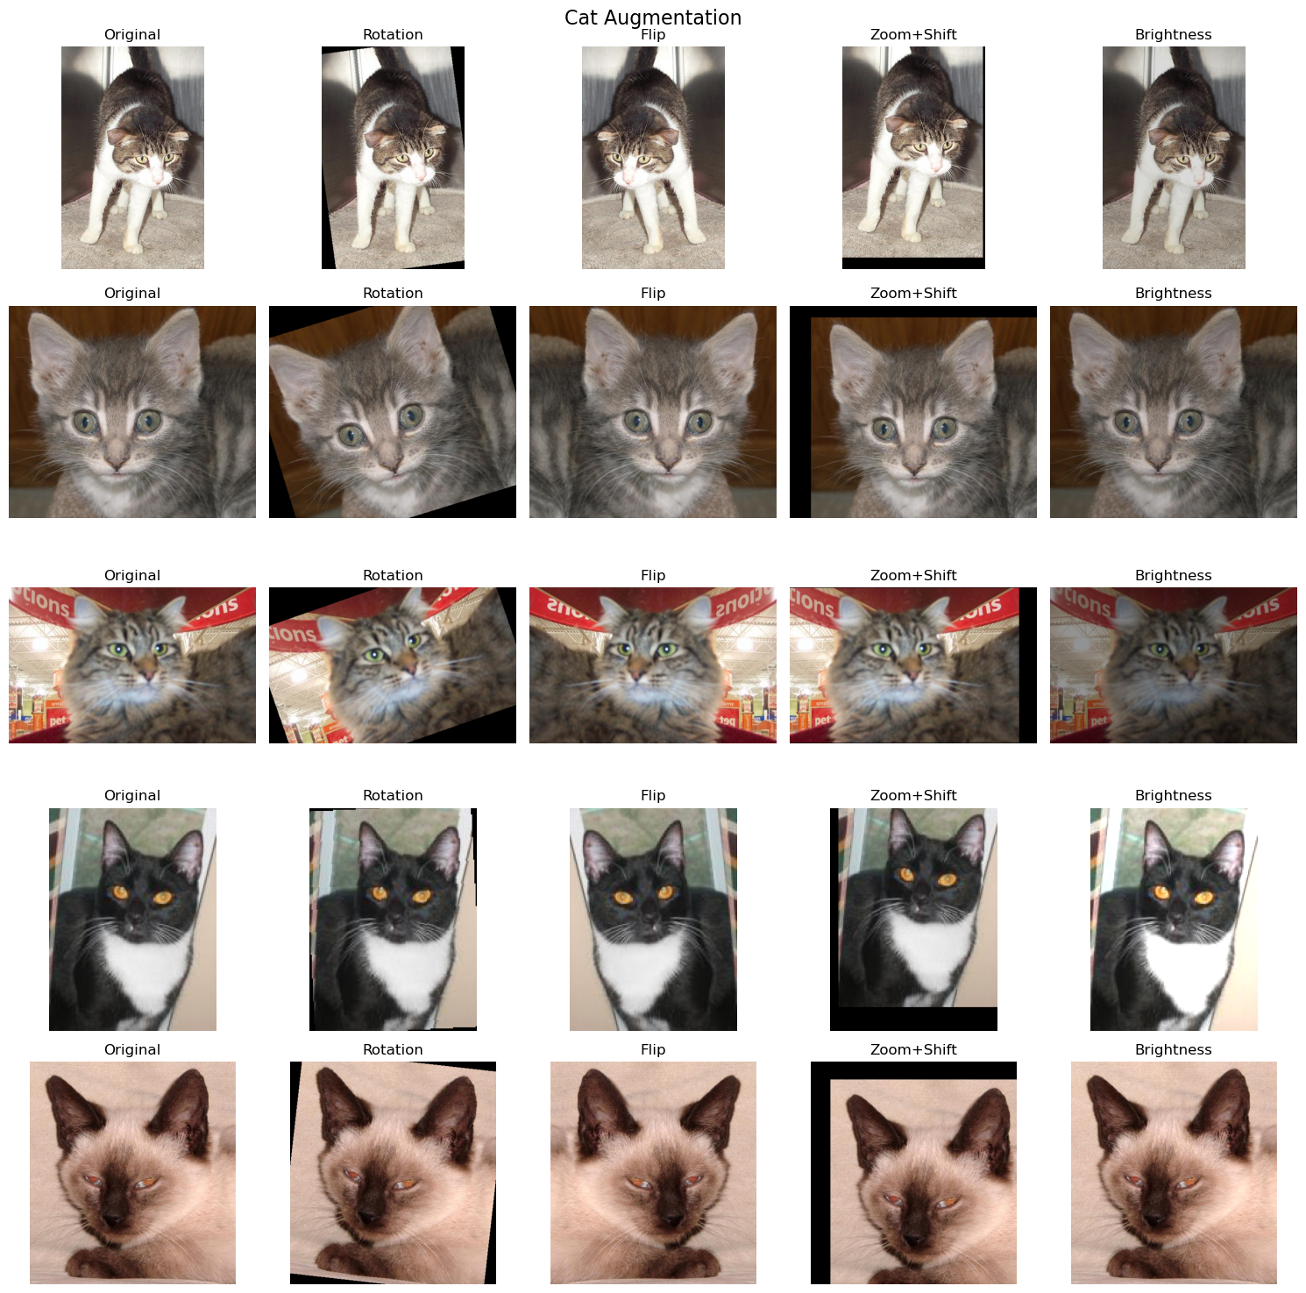
Figure 6.4. Data augmentation examples for the Cat class.
Interpretation: The notebook demonstrates rotation, horizontal flipping, zoom/shift, and brightness changes. These transformations increase visual diversity during training and can improve generalization.

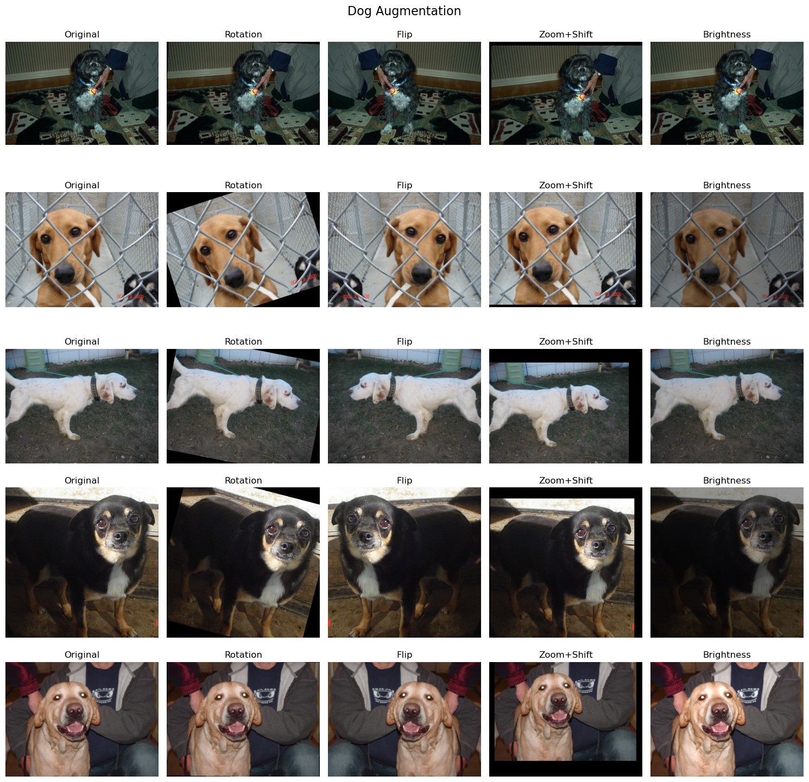
Figure 6.5. Data augmentation examples for the Dog class.
Interpretation: The same augmentation operations are applied to Dog images, helping the model become less sensitive to position, orientation, scale, and brightness changes.

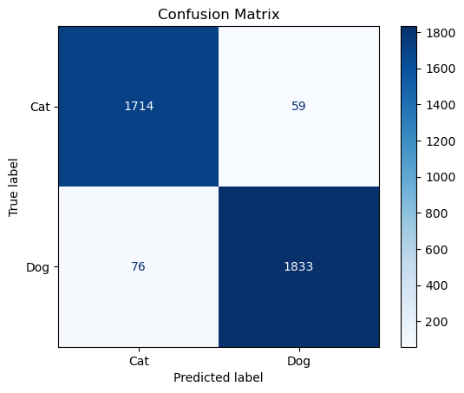
Figure 6.6. Confusion matrix on the test set.
Interpretation: The matrix shows strong performance for both classes. The diagonal values are much larger than the off-diagonal values, indicating that most test images were classified correctly.

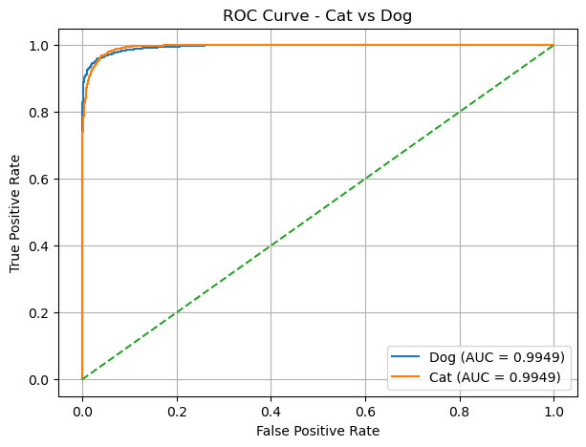
Figure 6.7. ROC curve for Cat vs Dog.
Interpretation: Both curves remain close to the upper-left region and each class has an AUC of 0.9949. This indicates excellent separation between the two classes across classification thresholds.

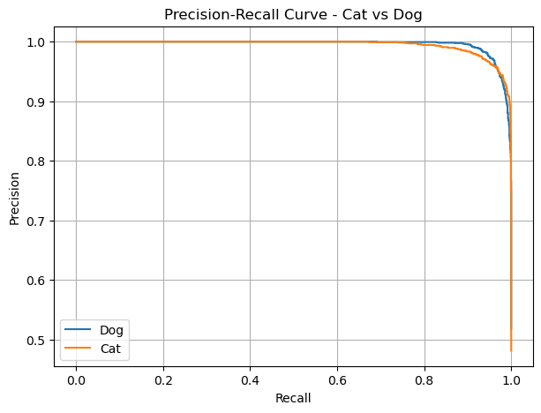
Figure 6.8. Precision-Recall curves for Cat vs Dog.
Interpretation: Precision remains very high across most recall values for both classes, showing that the classifier maintains strong predictive quality while recall increases.

6.4. Training Performance Analysis
Across the 10 training epochs, training loss decreased from 0.1854 to 0.0792 while training accuracy increased from 92.20% to 96.82%. Validation accuracy remained consistently high, ranging from 95.52% to 96.63%, and ended at 96.22%. The relatively small gap between the final training and validation accuracies suggests that severe overfitting was not evident from the reported accuracy values.
Epoch | Train Loss | Train Accuracy | Validation Accuracy
1 | 0.1854 | 92.20% | 96.01%
2 | 0.1372 | 94.31% | 95.52%
3 | 0.1230 | 94.96% | 96.25%
4 | 0.1116 | 95.43% | 96.63%
5 | 0.1050 | 95.65% | 96.50%
6 | 0.0969 | 96.13% | 96.60%
7 | 0.0973 | 96.09% | 96.25%
8 | 0.0837 | 96.64% | 96.44%
9 | 0.0884 | 96.51% | 96.22%
10 | 0.0792 | 96.82% | 96.22%

6.5. Discussion and Interpretation
The experimental results demonstrate that the pretrained AlexNet-based classifier learned effective visual representations for cat-versus-dog recognition. The final test accuracy of 96.33% shows that the model correctly classified most unseen test images. The precision, recall, and F1-score are all above 96%, indicating balanced performance rather than strong dependence on a single metric.
The confusion matrix also shows that errors were relatively limited: 59 Cat images were classified as Dog and 76 Dog images were classified as Cat. The near-identical AUC values of 0.9949 for the two classes further indicate that the model separates the classes effectively across different decision thresholds.
The dataset was nearly balanced and the preprocessing pipeline used augmentation to expose the model to varied image appearances. These factors supported stable generalization. Nevertheless, the classifier can still be challenged by unusual viewpoints, cluttered backgrounds, low-resolution images, partial visibility, and visually ambiguous samples.

7. Conclusion
This project developed and evaluated an AlexNet-based Convolutional Neural Network for binary classification of Cat and Dog images. The complete workflow included dataset inspection, corruption and blur checking, preprocessing, augmentation, train-validation-test splitting, transfer learning with pretrained AlexNet, classifier fine-tuning, and quantitative evaluation.
The experimental results show strong performance on the unseen test set, with 96.33% accuracy, 96.88% precision, 96.02% recall, and 96.45% F1-score. The ROC AUC of 0.9949 for both classes and the confusion matrix further confirm that the model can distinguish Cats from Dogs effectively. Overall, the project demonstrates the practical effectiveness of transfer learning with CNNs for image classification.

8. Future Work
- Tune the learning rate, batch size, number of epochs, and other hyperparameters systematically.
- Experiment with stronger and more controlled data augmentation strategies.
- Use regularization techniques such as dropout or weight decay if overfitting becomes noticeable.
- Compare the AlexNet-based transfer-learning model with architectures such as VGG, ResNet, or MobileNet.
- Experiment with fine-tuning selected convolutional layers instead of freezing the complete feature extractor.
- Evaluate the model on completely new real-world images captured outside the training dataset.
- Deploy the trained classifier as a simple web or mobile application for interactive prediction.

9. References
[1] GitHub Project Repository: Cat and Dog Image Classification Using Convolutional Neural Networks with AlexNet.
Project URL: https://github.com/mohammednaeemog-sys/-Image-Classification-Using-Convolutional-Neural-Network
[2] Dataset source used by the notebook: Microsoft Cats vs Dogs dataset, downloaded through KaggleHub from the dataset identifier shaunthesheep/microsoft-catsvsdogs-dataset.

10. Appendix

Appendix A — Dataset and Preprocessing Results
Item | Result | Details
Number of classes | 2 | Cat and Dog
Cat images | 12,176 | 49.61% of the dataset
Dog images | 12,366 | 50.39% of the dataset
Total images | 24,542 | Complete dataset
Corrupted images | 0 | No corrupted images detected by the notebook check
Severely blurred images | 0 | No images below the blur threshold were detected
Image size after preprocessing | 224 × 224 | Applied by Resize transformation
Training set | 17,179 | 70% split
Validation set | 3,681 | 15% split
Test set | 3,682 | 15% split
Batch size | 128 | Used for train, validation and test loaders
Train batches | 135 | DataLoader output
Validation batches | 29 | DataLoader output
Test batches | 29 | DataLoader output
Label encoding | Cat = 0, Dog = 1 | ImageFolder class mapping

Appendix B — Model and Training Configuration
Configuration | Value | Purpose
Model | Pretrained AlexNet | Transfer learning for image classification
Feature extractor | Frozen | Preserves pretrained convolutional features
Final classifier | 2 outputs | Cat/Dog binary classification
Loss function | CrossEntropyLoss | Measures classification error
Optimizer | Adam | Updates trainable classifier parameters
Learning rate | 0.0001 | Controls optimizer step size
Epochs | 10 | Number of training passes
Device | CUDA / NVIDIA GeForce RTX 3050 | GPU acceleration
Torch version | 2.6.0+cu124 | Notebook runtime output
CUDA version | 12.4 | Notebook runtime output
Training augmentation | Rotation, flip, affine zoom/shift, brightness | Increase training diversity
Normalization mean | [0.485, 0.456, 0.406] | Input normalization
Normalization std | [0.229, 0.224, 0.225] | Input normalization

Appendix C — Complete Epoch-wise Training Results
Epoch | Train Loss | Train Accuracy | Validation Accuracy | Observation
1 | 0.1854 | 92.20% | 96.01%
2 | 0.1372 | 94.31% | 95.52%
3 | 0.1230 | 94.96% | 96.25%
4 | 0.1116 | 95.43% | 96.63% | Best validation accuracy
5 | 0.1050 | 95.65% | 96.50%
6 | 0.0969 | 96.13% | 96.60%
7 | 0.0973 | 96.09% | 96.25%
8 | 0.0837 | 96.64% | 96.44%
9 | 0.0884 | 96.51% | 96.22%
10 | 0.0792 | 96.82% | 96.22%

Appendix D — Final Evaluation Results
Metric | Result | Notebook evidence
Accuracy | 0.9633351439 (96.33%) | Test evaluation output
Precision | 0.9688160677 (96.88%) | Test evaluation output
Recall | 0.9601885804 (96.02%) | Test evaluation output
F1 Score | 0.9644830308 (96.45%) | Test evaluation output
Dog AUC | 0.9949093808 (0.9949) | ROC analysis output
Cat AUC | 0.9949093808 (0.9949) | ROC analysis output

Appendix E — Confusion Matrix Values
True / Predicted | Cat | Dog
Cat | 1,714 | 59
Dog | 76 | 1,833
Total test samples represented in the confusion matrix: 3,682. Correct predictions are the diagonal entries (1,714 Cat and 1,833 Dog); incorrect predictions are the off-diagonal entries (59 Cat→Dog and 76 Dog→Cat).

Appendix F — Results Summary
Result Item | Value
Dataset size | 24,542 images
Train / Validation / Test | 17,179 / 3,681 / 3,682
Final training accuracy | 96.82%
Final validation accuracy | 96.22%
Test accuracy | 96.33%
Test precision | 96.88%
Test recall | 96.02%
Test F1-score | 96.45%
Cat AUC | 0.9949
Dog AUC | 0.9949
Confusion matrix | [[1714, 59], [76, 1833]]
Corrupted images | 0
Severely blurred images | 0

