MolSculpt: A Touchless Hand-Gesture Interface for Building Organic Molecules with a Tool-Using AI Agent for Compound Characterisation
Nisarg Vashi  Roll No. 23BCE370  Department of Computer Science and Engineering  Institute of Technology, Nirma University  Ahmedabad, Gujarat, India  23bce370@nirmauni.ac.in | Heli Shah  Roll No. 23BCE093  Department of Computer Science and Engineering  Institute of Technology, Nirma University  Ahmedabad, Gujarat, India  23bce093@nirmauni.ac.in
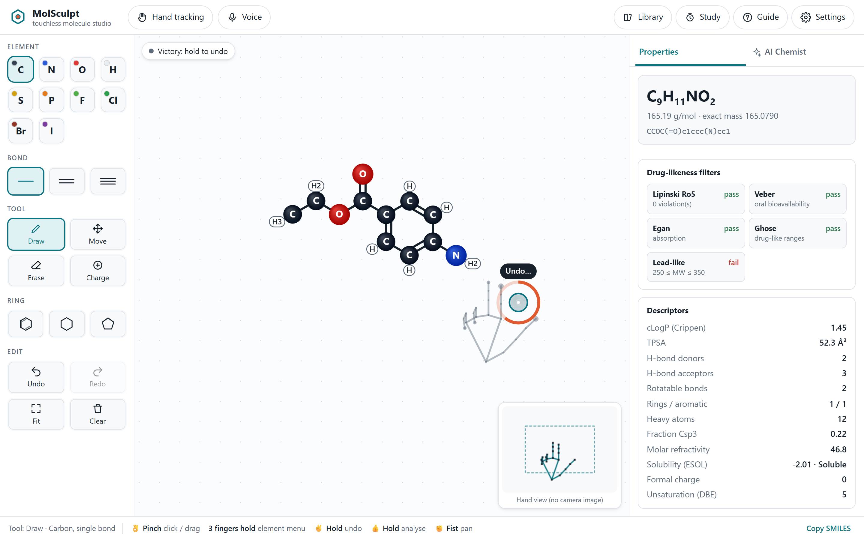
Fig. 1. MolSculpt with hand tracking: the user holds a victory pose (the orange ring shows the hold progress towards undo), a virtual hand follows the cursor, the mini-map shows the hand skeleton inside the reach box without any camera image, and the properties panel updates live. The hand in this figure is rendered from synthetic landmarks for illustration.

Abstract—Molecular editors used in chemistry education and early-stage drug discovery remain bound to the mouse and keyboard. We present MolSculpt, a browser-based system in which users construct organic molecules with bare-hand mid-air gestures captured by an ordinary webcam, and then delegate the characterisation of the drawn compound to a tool-using large-language-model (LLM) agent served by Groq. Hand tracking runs on-device with MediaPipe and the camera image is never displayed or transmitted. The interaction design targets the known weaknesses of mid-air input (low precision, unintended activation and arm fatigue) through pinch selection with hysteresis, hold gestures gated on hand stillness, speed-adaptive 1€ filtering, a reach box that raises the control–display gain, enlarged activation areas, angle and atom snapping, a radial element menu and continuous feedforward. A modality-independent editor lets gestures, mouse, touch and voice drive identical operations. An in-browser cheminformatics engine written for this work recomputes properties after every edit; on the 1128 molecules of the ESOL data set it reproduces the RDKit values of molecular formula, molecular weight, Crippen logP, molar refractivity, topological polar surface area, hydrogen-bond counts, rotatable bonds and aromatic rings exactly, with a median analysis time of 0.49 ms. The agent follows a reason-and-act loop over six tools (local descriptors, PubChem identity, similarity and hazard retrieval, structural alerts and drug-likeness rules), streams its trace to the user and returns a schema-validated report whose suggested analogues are re-checked locally and can be loaded back onto the canvas. We report technical and analytical evaluations and contribute an instrumented protocol for a comparative user study.
Index Terms—human–computer interaction, mid-air gestures, hand tracking, natural user interfaces, multimodal interaction, molecular editing, cheminformatics, LLM agents, drug discovery.
I. Introduction
Drawing chemical structures is a basic activity in chemistry teaching and in medicinal chemistry, where ideas for new compounds are sketched, evaluated and iterated. Mainstream molecular editors such as JSME [28] follow the WIMP paradigm: a palette of elements, a mouse for placing atoms and bonds, and menus for everything else. This works well at a desk, but there are settings where a touchless alternative is attractive: shared kiosks and laboratory benches where users wear gloves, classrooms where a teacher demonstrates at a projected screen away from the keyboard, and users for whom fine mouse control is difficult. Commodity webcams combined with on-device hand-landmark models [1], [2] have made bare-hand input feasible without gloves, markers or depth sensors [3], [4].
Mid-air input has well-documented problems. Without a physical button there is no clean separation between looking or pointing and acting, the "Midas touch" problem first described for gaze [5]; tracked hands jitter and drift; and holding the arm up quickly causes fatigue [6]. Structure drawing magnifies these problems because atoms and bonds must be placed precisely and in large numbers.
A second need arises once a structure is drawn: users want to know what it is and whether it is interesting. Is it a known compound? Is it drug-like? Is it hazardous? Answering these questions requires several calculations and database look-ups. Language-model agents that call external tools [21], [22] have been applied to chemistry [23], [24] and can orchestrate such steps and explain the result in natural language, but they may hallucinate and their reasoning is opaque. For an interactive system this raises the human–AI interaction questions of transparency, verifiability and control [20].
This paper presents MolSculpt, which addresses both needs in one interface. Our contributions are:
- An interaction design for touchless structure construction that combines a small gesture vocabulary with assistive techniques against imprecision, accidental activation and fatigue (Section III).
- A modality-independent editing model through which hand gestures, mouse, touch, keyboard and voice drive the same operations, with feedforward previews and valence-aware error prevention (Sections III–V).
- A dependency-free in-browser cheminformatics engine that agrees exactly with RDKit [27] on 1,128 molecules for all reported descriptors except two cage ring counts (Section VI-A).
- ChemAgent, a tool-grounded agent on Groq whose every step is streamed to the user, whose report is schema-validated and whose suggested analogues are verified locally and can be loaded back for further editing (Section V-D).
- A technical and analytical evaluation (validity, responsiveness, filter characteristics, Fitts's-law and heuristic analyses) and built-in instrumentation for a comparative user study (Section VI).
II. Related Work
A. Molecular editors and immersive molecular interaction
Line notations such as SMILES [26] and toolkits such as RDKit [27] underpin most chemistry software, and web editors such as JSME [28] brought structure drawing to the browser. Immersive systems let users manipulate molecules in virtual reality, for example interactive molecular dynamics with tracked controllers [29]. Most such systems focus on visualising and manipulating existing three-dimensional structures, whereas MolSculpt targets authoring new two-dimensional structures with an ordinary webcam.
B. Vision-based hand-gesture interaction
Surveys of vision-based gesture recognition [3], [4] list robustness, gesture vocabulary design and user fatigue as recurring challenges. MediaPipe [2] and its hand-landmark pipeline [1] provide 21 three-dimensional landmarks per hand in real time on commodity hardware. Wobbrock et al. showed the value of designing gesture sets around users' expectations [13]. Jacob's analysis of the Midas-touch problem [5] motivates explicit confirmation gestures and dwell thresholds, and consumed endurance [6] quantifies the arm fatigue of mid-air interaction. For noisy pointing input, the 1€ filter [7] adapts its cut-off frequency to speed. Target acquisition follows Fitts's law [8], [9]; enlarging the activation area of targets, as in the bubble cursor [10], and pie menus that place options at equal short distances [11] reduce the index of difficulty. Bolt's "Put-that-there" [12] combined pointing with speech, which we also support.
C. LLM agents and cheminformatics for drug discovery
ReAct interleaves reasoning traces with actions [21] and Toolformer showed that models can learn to call tools [22]. ChemCrow augmented an LLM with expert chemistry tools [23] and Coscientist planned and executed experiments autonomously [24]. Groq serves open-weight models on its LPU, a tensor-streaming architecture designed for low-latency inference [40], [41], [45], which matters when an agent is part of an interactive loop. The tools in our agent implement established medicinal-chemistry heuristics: Lipinski's rule of five [32], the Veber [33], Egan [34] and Ghose [35] filters, lead-likeness [36], Wildman–Crippen logP [30], topological polar surface area (TPSA) [31], ESOL solubility [37], and Brenk [38] and PAINS [39] structural alerts. Identity, similarity and hazard data come from PubChem [25].
III. Interaction Design
A. Design goals
From the target settings and the limitations above we derived eight design goals:
- DG1 Hardware-free: a laptop webcam suffices; no gloves, markers or depth camera.
- DG2 Precision from imprecise input: the system, not the user, makes drawings tidy.
- DG3 No accidental activation: resting or moving the hand must never trigger a command.
- DG4 Low physical effort: small hand movements, a rest pose and short sessions.
- DG5 Continuous feedback and feedforward: users should see what a gesture will do before doing it [15].
- DG6 Privacy by design: video stays on the device and is not even shown by default.
- DG7 Transparent, verifiable AI: agent steps visible, claims grounded in tools, output checked.
- DG8 Multimodal fallback: every action is also available by mouse, touch, keyboard or voice.
B. Gesture vocabulary
The vocabulary (Table I) is deliberately small. A single manipulative gesture, the thumb–index pinch, plays the role of the mouse button and is the closest analogue to grasping. Four static poses map to frequent commands with familiar meanings: thumbs-up for "go", a fist for grabbing and moving, victory for undo, and three raised fingers for the radial element menu (Fig. 5). The open palm, the most natural rest posture, is mapped to nothing at all, so users can relax at any time (DG3, DG4). Commands fire only after a pose has been held while the hand is still, and dwell clicking is restricted to explicit controls; dwell is never active on the canvas, where an accidental activation would modify the molecule.
TABLE I
Gesture vocabulary of MolSculpt
Gesture | Recognition rule | Action
Point / move | thumb–index midpoint, filtered | move cursor; hover preview
Pinch tap | d < 0.30 then d > 0.44 | place atom, grow chain, cycle bond, press control
Pinch drag | pinch held while moving | draw bond (snapped), move atom, erase
Three fingers | index, middle, ring extended; 0.65 s still | radial element menu at cursor
Victory ✌ | index, middle extended; 0.7 s still | undo (repeats every 0.9 s)
Thumbs-up 👍 | fingers curled, thumb up; 0.9 s still | analyse with ChemAgent
Fist ✊ | all fingers curled, 0.15 s | grab and pan canvas
Open palm ✋ | all fingers extended | rest (no action)
Dwell | cursor on control for 0.9 s | click control (UI only)

C. Compensating for imprecise mid-air input
Several mechanisms move precision from the hand into the system (DG2). The cursor is the midpoint of the thumb and index tips rather than the index tip, so it barely moves when the fingers close into a pinch, and the press and release points are taken from the cursor history 70 ms earlier. A reach box maps the central 60% of the camera image to the full screen, raising the control–display gain to 1/0.6 ≈ 1.67 relative to the camera field and reducing the arm travel needed to cross the screen (DG4). Atoms have an activation radius of 30 px in hand mode (18 px with the mouse) although they are drawn with a radius of 11.5 px, an expansion in the spirit of the bubble cursor [10]. Bonds are drawn with a fixed length and snap to multiples of 30°; their end snaps magnetically to an existing atom within 40 px, which also makes ring closure easy. Pinching an atom of the selected element grows the chain in the best free direction, alternating sides so that chains zig-zag as in textbook drawings; most acyclic molecules can therefore be built by repeated pinching on the newest atom with no dragging at all. Ring templates fuse onto an atom or bond on the side away from existing substituents and choose a Kekulé pattern compatible with the double bonds already present.
Error prevention follows the chemistry. Before adding a bond or increasing its order the editor checks the valence of both atoms and refuses with an explanatory toast and an error earcon; bond-order cycling skips orders that would break a valence. Changes that are still allowed but leave an atom over-valent (e.g. replacing a carbon by an oxygen) are flagged with a dashed red ring and a message in the properties panel. A nitro group drawn in the common pentavalent form is silently interpreted in its charge-separated form.
D. Feedback and feedforward
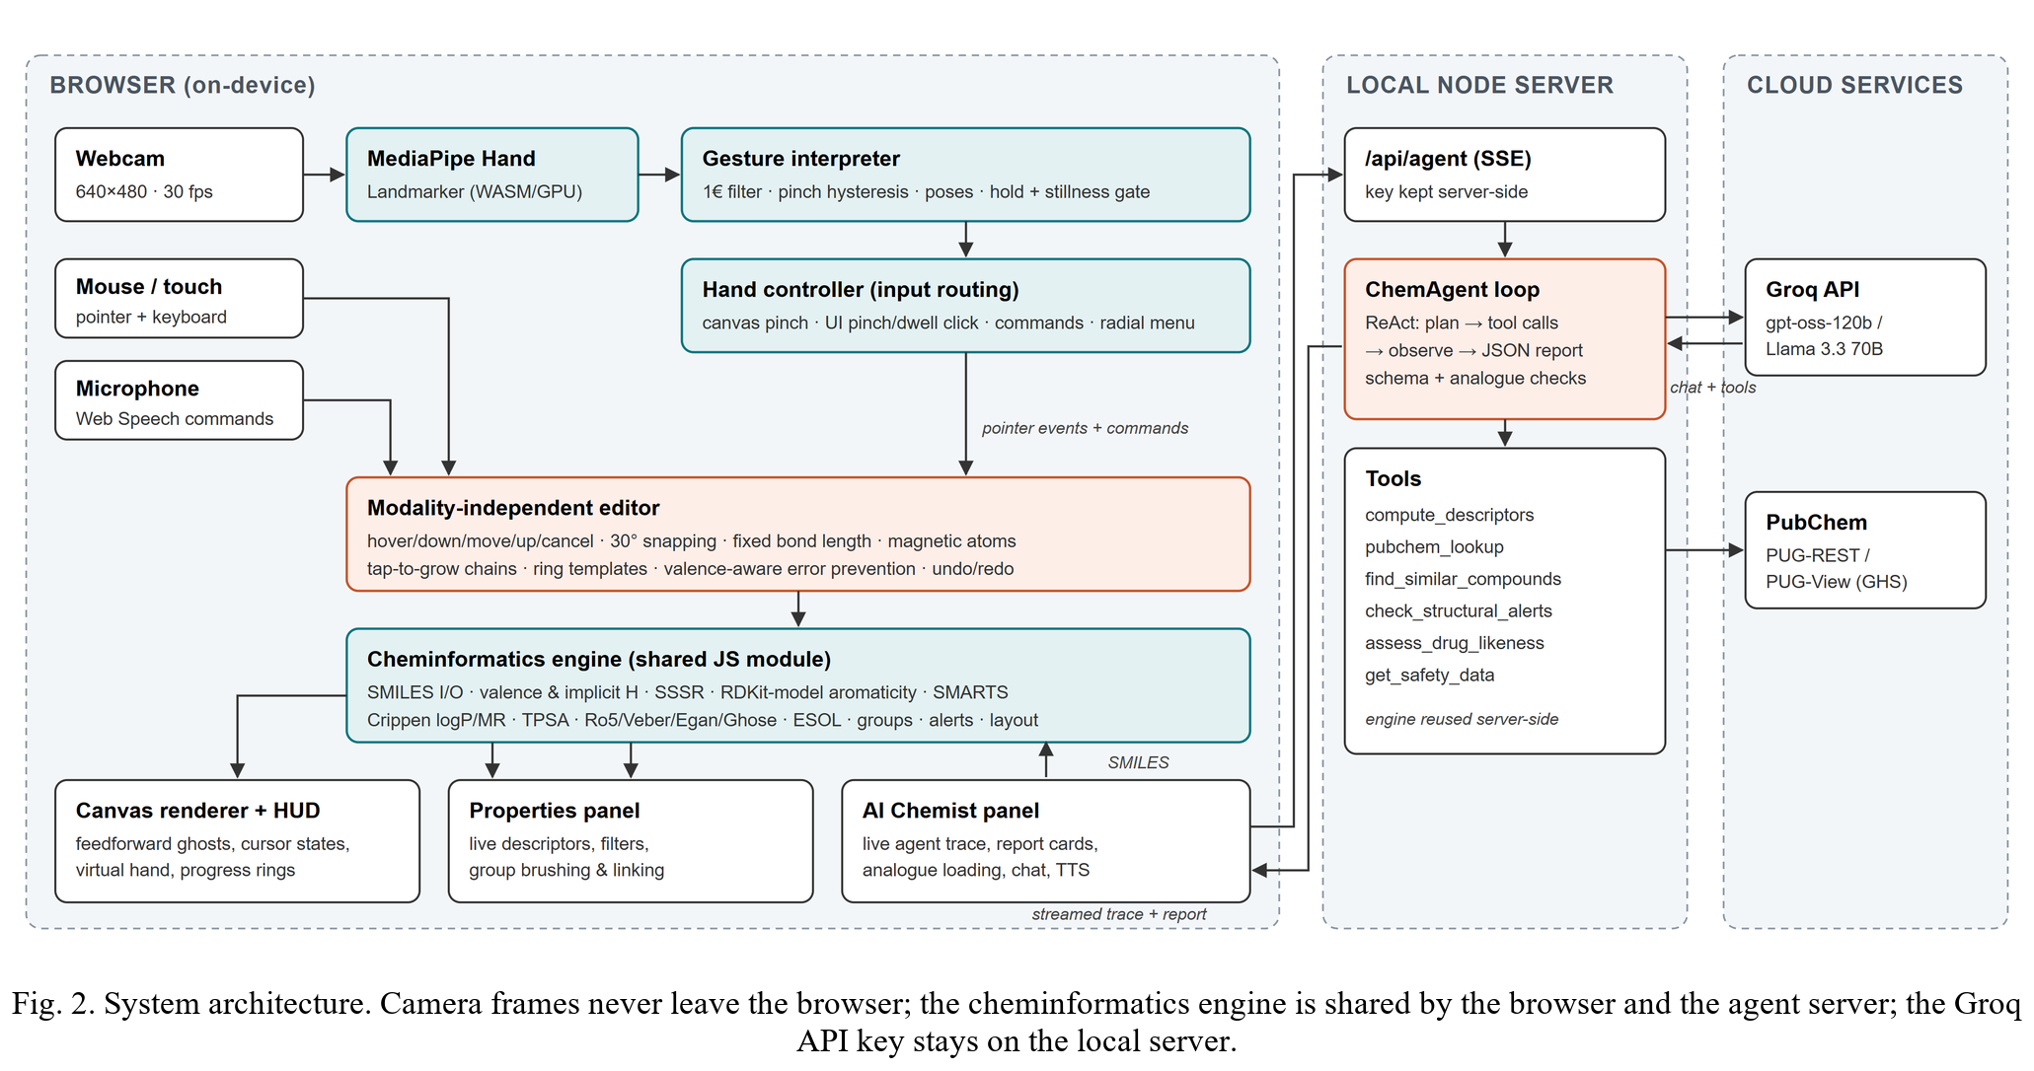
The overlay draws the cursor in distinct states (hovering, pinched, capturing a drag, panning), a ring that fills during dwell, and a larger labelled ring that fills while a hold gesture is being recognised, so the user can abort by moving or changing pose. A semi-transparent virtual hand rendered from the landmarks follows the cursor, and a mini-map shows the hand skeleton inside the reach box, giving users a sense of where their hand is in the camera field without showing any video (DG6). On the canvas, a ghost atom marks where a pinch would place an atom, and hovering an atom previews the bond a pinch would grow; when drawing, the snapped bond and target atom are shown dashed before release. Earcons and short toasts confirm each recognised action. The properties panel is recomputed after every edit and supports brushing and linking: hovering a functional group or structural alert highlights its atoms on the canvas (Fig. 1).
E. Human–AI collaboration
The agent is never invoked implicitly; it runs when the user holds a thumbs-up, presses the button or says "analyse". While it works, every tool call and result is streamed into a trace with timings, and after completion the trace collapses under the heading "How this answer was produced" so that the report stays prominent but the provenance remains one click away (DG7). The system prompt requires every number and identifier to come from a tool and every prediction to be labelled as such, and treats tool output as data rather than instructions. Suggested analogues are parsed by the local engine; invalid or unchanged structures are discarded, and the remainder are shown with their property changes and a button that loads them onto the canvas, closing a mixed-initiative design loop. Follow-up questions can be asked in a chat that keeps the report as context. Synthesis information is kept conceptual, and the agent declines to provide synthesis information for hazardous or controlled substances.
IV. System Architecture
MolSculpt is a web application with a small local server (Fig. 2). Everything that touches the camera runs in the browser: the MediaPipe Hand Landmarker (WebAssembly with a GPU delegate and a CPU fallback) produces landmarks, the gesture interpreter turns them into a filtered cursor and discrete events, and the hand controller routes these either to the editor (when over the canvas) or to user-interface controls. Mouse and touch events, keyboard shortcuts and Web Speech commands are routed to the same editor interface. The cheminformatics engine is a set of plain ECMAScript modules imported both by the browser and by the server, so the numbers shown in the panel and those seen by the agent are identical. The Node.js server has no third-party dependencies; it serves the application, keeps the Groq API key out of the browser and runs the agent, streaming its events with Server-Sent Events. Without a key, a deterministic pipeline runs the same tools and produces a template report.
V. Implementation
A. Hand tracking and gesture recognition
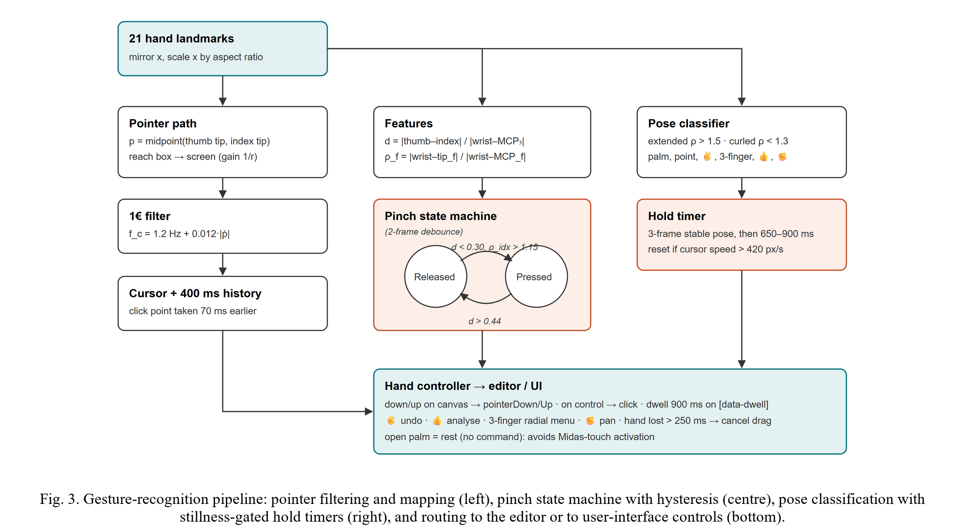
Landmarks L₀…L₂₀ are mirrored horizontally and their x coordinates scaled by the image aspect ratio so that distances are isotropic. With the palm scale s = ‖L₀ − L₉‖ (wrist to middle-finger knuckle), the pinch measure and the extension ratio of finger f are
d = ‖L₄ − L₈‖ / s, ρ_{f} = ‖L₀ − L_{tip(f)}‖ / ‖L₀ − L_{mcp(f)}‖. (1)
A finger counts as extended for ρ_{f} > 1.5 and curled for ρ_{f} < 1.3. A pinch begins when d < θ = 0.30 and the index finger is not curled (ρ_{index} > 1.15, which rejects the thumb resting on a fist) and ends when d > θ + 0.14; either transition must persist for two frames. The pipeline is summarised in Fig. 3. The pointer p (thumb–index midpoint) is mapped from the reach box of width r to screen coordinates
X = W · clamp((p_{x} − (0.5 − r/2)) / r, 0, 1), (2)
and analogously for Y with height 0.9r, then smoothed by the 1€ filter [7], an exponential smoother whose cut-off rises with the filtered speed:
x̂_{i} = α x_{i} + (1 − α) x̂_{i−1}, α = 1 / (1 + 1/(2π f_{c} T_{e})), (3)
f_{c} = f_{min} + β |dx̂/dt|, (4)
where T_{e} is the frame period. We use f_{min} = 1.2 Hz (user-adjustable) and β = 0.012. A pose must be classified identically for three consecutive frames before it becomes current; its hold timer restarts whenever the cursor moves faster than 420 px/s. If the hand disappears for more than 250 ms during a pinch, the drag is cancelled and the molecule restored rather than committed.
B. Modality-independent editor
All modalities drive five calls (hover, down, move, up, cancel) plus commands (undo, redo, tool and element selection, fit, analyse). Their meaning depends on the active tool: draw (tap to place or grow, drag to bond, tap a bond to cycle its order), ring, move (drag atoms or pan), erase (tap or scrub) and charge. Every committed change pushes a snapshot onto a 150-step undo history and is logged with its modality, which is what makes the study instrumentation of Section VI-F possible. Hit radii and snapping distances are larger when the last input came from the hand.
C. Cheminformatics engine
Molecules are graphs of atoms and Kekulé bonds. Implicit hydrogens follow a valence model in which charged atoms take the valences of their isoelectronic neighbour (e.g. N⁺ behaves like C). Rings are perceived as a symmetrised smallest set of smallest rings, selected from Horton candidate cycles [42] by Gaussian elimination over GF(2). Aromaticity follows RDKit's model: each ring atom is assigned the number of π electrons it can donate, single rings and combinations of fused rings are tested against Hückel's 4n + 2 rule, and only perimeter bonds of fused combinations become aromatic. A SMILES parser [26] kekulises aromatic input by backtracking matching, and the writer orders atoms by Morgan-like ranks [43]. A compact SMARTS matcher (atomic primitives, logic operators, ring closures and recursive SMARTS) evaluates the 101 Wildman–Crippen atom types [30] (logP and molar refractivity), RDKit's strict rotatable-bond definition, 47 functional-group patterns and 20 structural alerts adapted from [38], [39]. TPSA follows Ertl et al. [31]; ESOL [37] is computed as log S = 0.16 − 0.63 clogP − 0.0062 MW + 0.066 RB − 0.74 AP. A Weisfeiler–Lehman graph signature [44] recognises when the canvas matches a target molecule, independently of drawing order and Kekulé form. A 2-D layout routine places imported or suggested structures; the 37 library molecules use RDKit depictions.
D. ChemAgent
The agent runs a reason-and-act loop [21] (Fig. 4) against Groq's OpenAI-compatible chat-completions endpoint with function calling. The default model is openai/gpt-oss-120b [41]; any tool-capable Groq model can be selected. Each round sends the conversation and six tool schemas (Table II); tool calls returned in one round are executed in parallel and their JSON results (at most 6 kB each) are appended. After at most six rounds, or as soon as the model stops calling tools, its final message must be a JSON report with 16 fields: name, IUPAC name, PubChem CID, class, summary, key characteristics, physicochemical interpretation, drug-likeness verdict and explanation, biological activity, applications, safety level and notes, a conceptual synthesis idea, up to three suggested analogues, confidence and caveats. If the message is not valid JSON, one more call in JSON mode is made. The server normalises the report (types, lengths, allowed values, fallbacks computed from the local rules) and validates analogues as described above. The PubChem lookup resolves each structure to the lowest CID sharing its InChIKey, which avoids landing on duplicate tautomer records, and the hazard tool reports only GHS statements given by at least half of the notifiers, because PubChem aggregates rare notifications that would otherwise overstate hazards. Temperature is 0.2; latency and token usage of every run are logged. Fig. 6 shows the resulting report card.
TABLE II
Tools available to ChemAgent
Tool | Source | Returns
compute_descriptors | local engine | formula, MW, logP, TPSA, HBD/HBA, rings, Fsp3, ESOL, groups
pubchem_lookup | PubChem PUG-REST | CID, name, IUPAC, XLogP, synonyms, descriptions
find_similar_compounds | PubChem 2-D similarity | up to five known analogues
check_structural_alerts | local SMARTS | alerts with severity and rationale
assess_drug_likeness | local rules | Ro5, Veber, Egan, Ghose, lead-likeness, verdict
get_safety_data | PubChem PUG-View | predominant GHS hazard statements, level

E. Study instrumentation
A study mode presents timed construction tasks, shows the target structure and ends each trial automatically when the graph signature of the canvas equals that of the target. For every trial it stores completion time and counts of edits, undos, erasures, warnings, pinches, dwell clicks, gesture commands, menu selections, cancelled drags and tracking losses, together with the modalities used. The System Usability Scale [18] and the raw NASA-TLX [19] are administered in the application, and all data can be exported as CSV and JSON (Fig. 9).
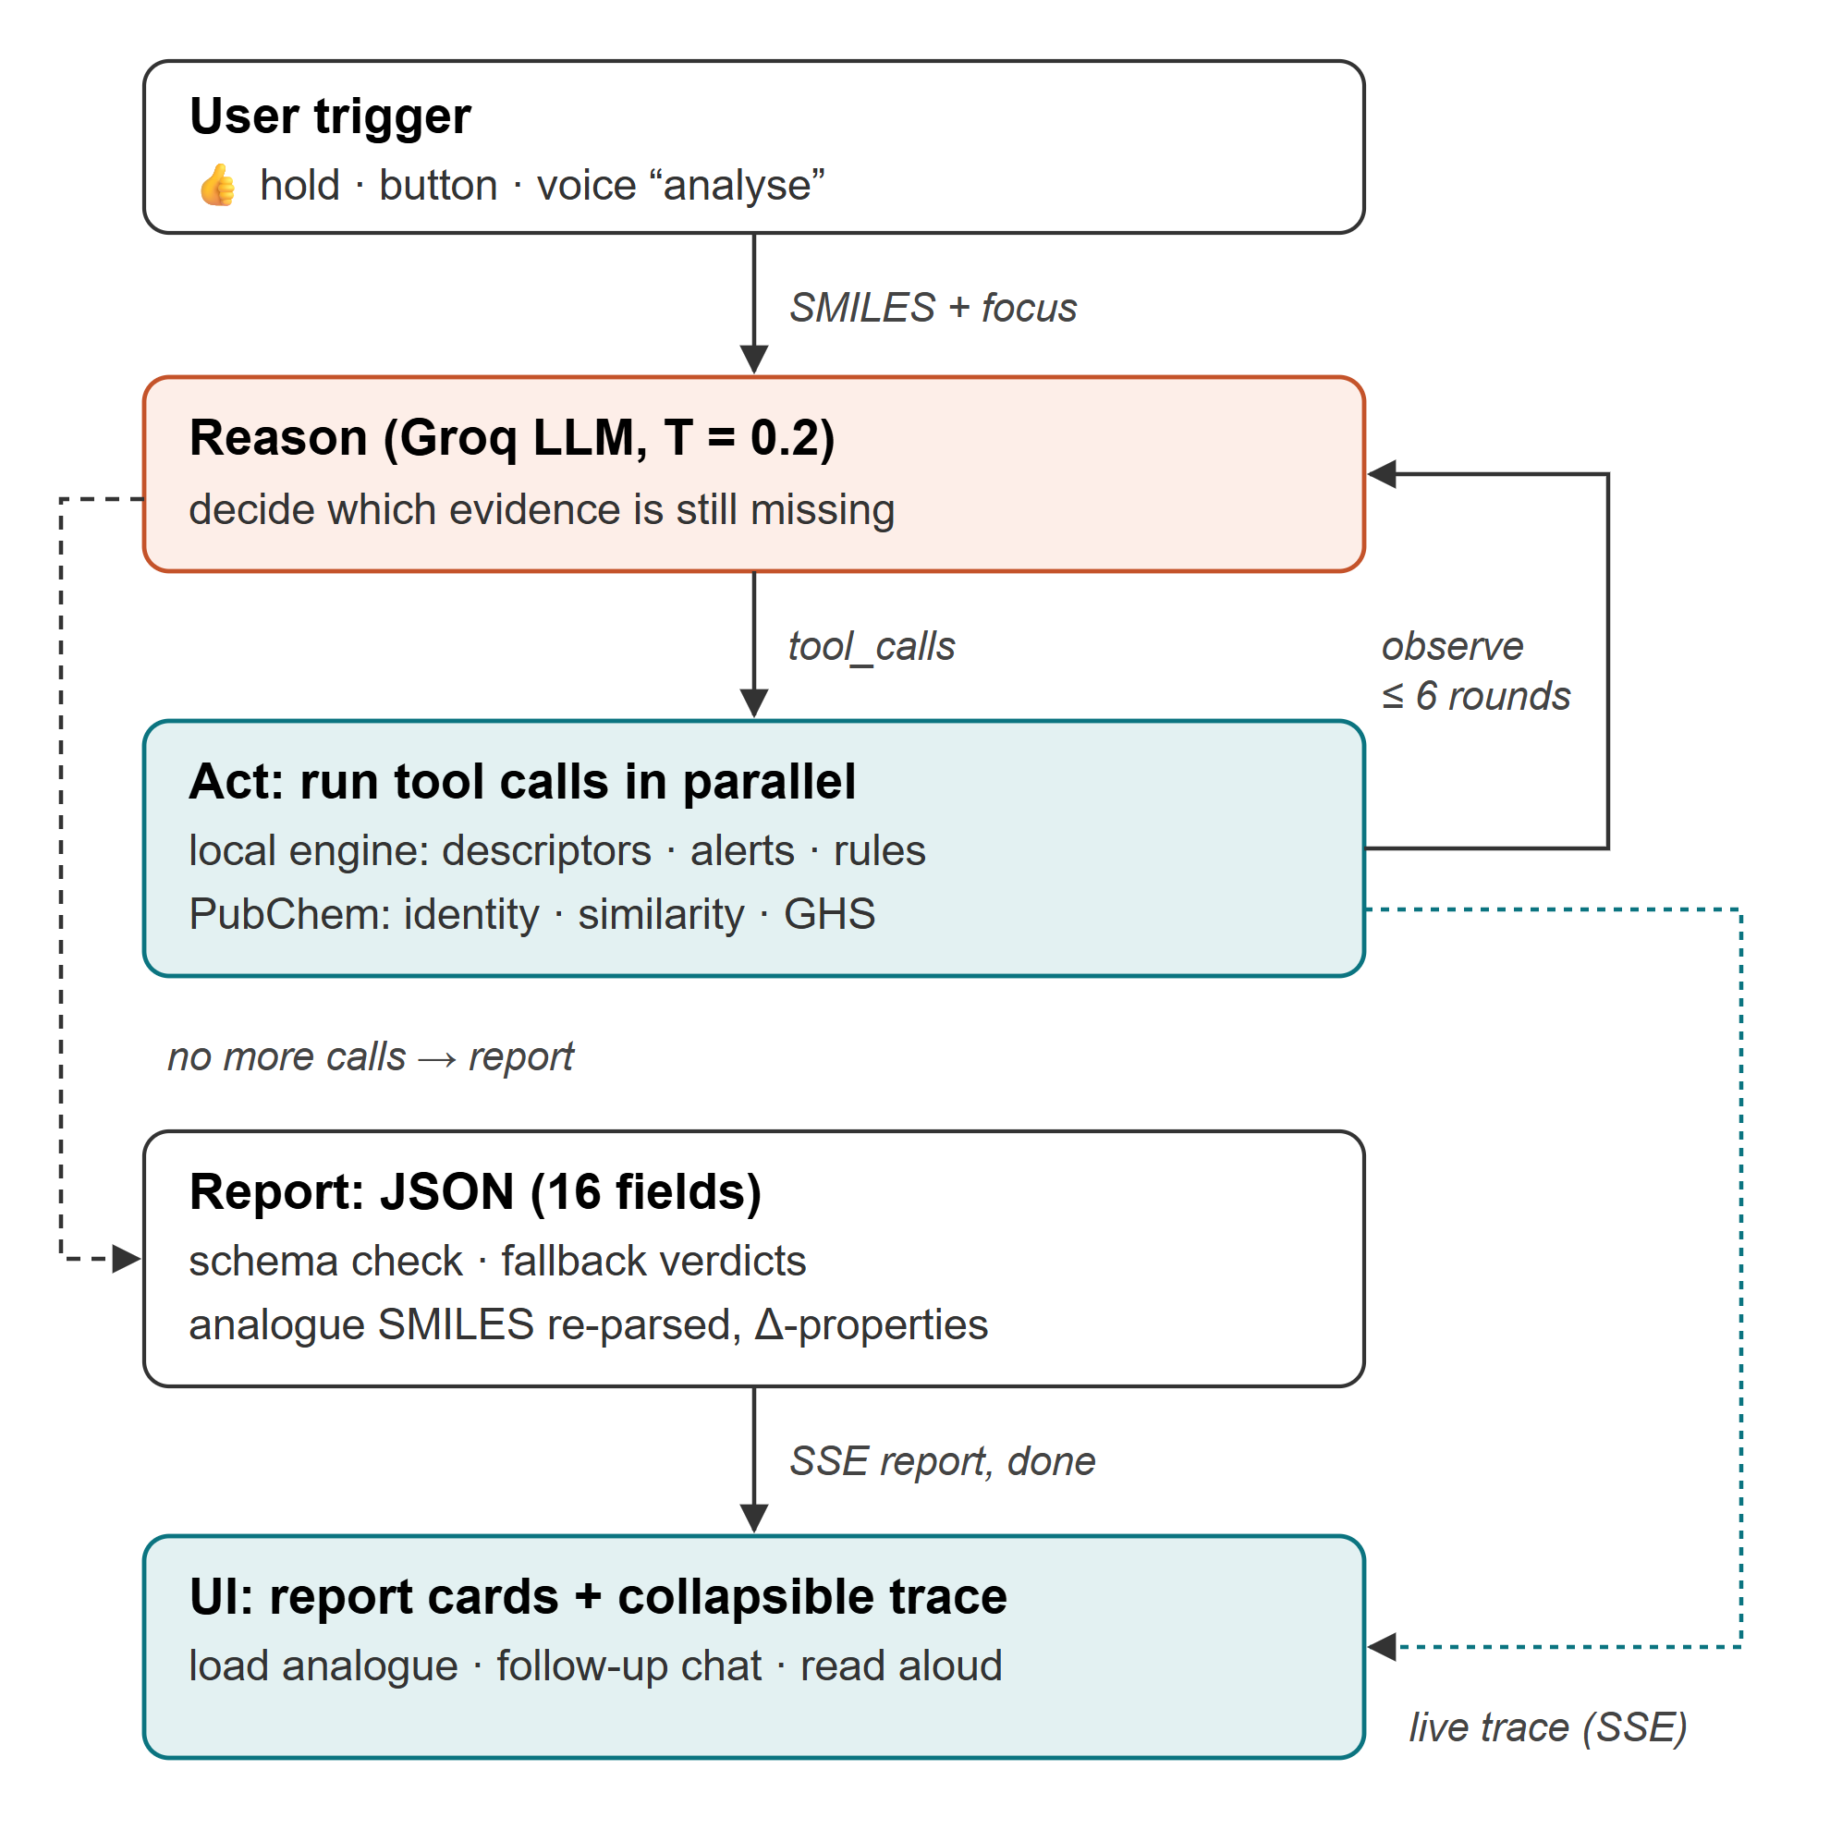
Fig. 4. ChemAgent reason-and-act loop with streamed trace.
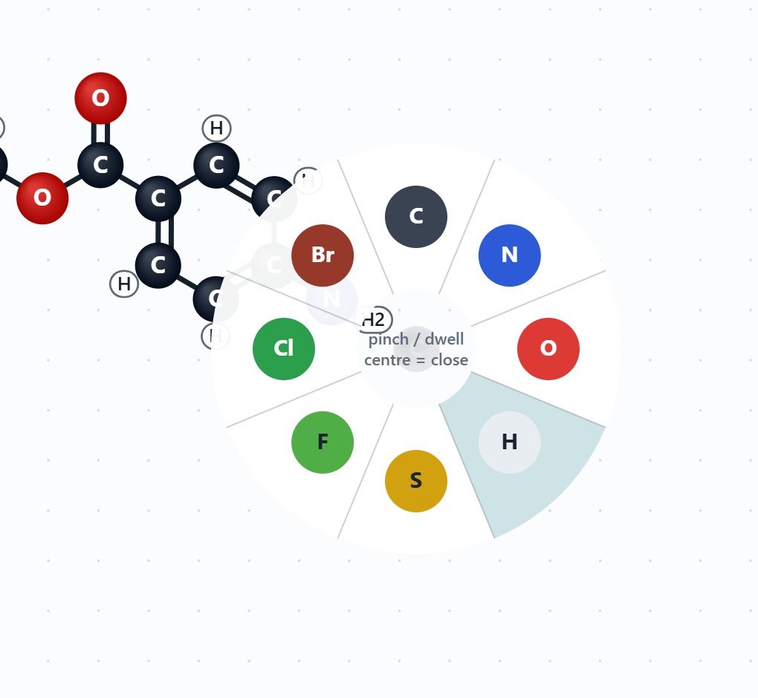
Fig. 5. Radial element menu opened at the cursor (three-finger hold or right-click); the hovered slice fills as the dwell progresses.
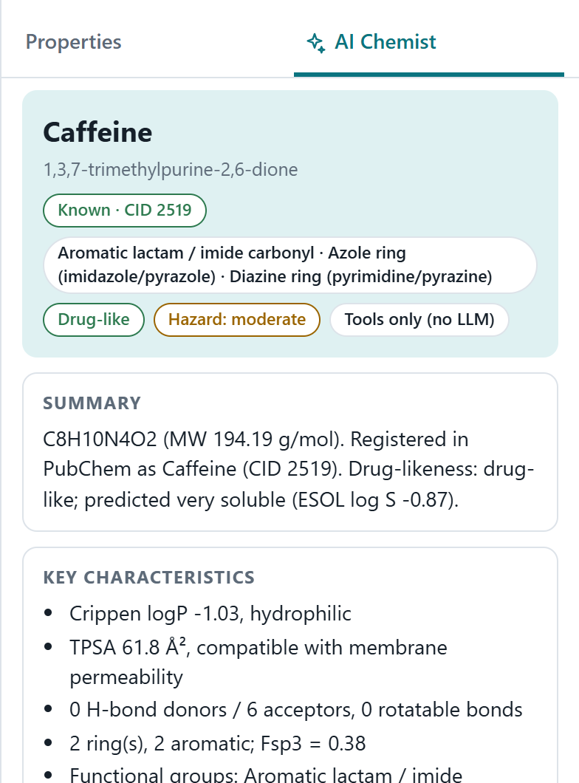
Fig. 6. Report card of the AI Chemist for caffeine (deterministic mode shown).
VI. Evaluation
We evaluated what can be measured without participants: the validity of the chemistry, the responsiveness of the system, the behaviour of the gesture logic, and analytical (Fitts's-law and heuristic) assessments. Measurements were taken on a laptop with an Intel Core i5-13450HX, 24 GB RAM and an NVIDIA RTX 3050 laptop GPU under Windows 11, using Node.js 22.7 and RDKit 2026.09.1. A user study is designed but has not yet been run (Section VI-F).
A. Validity of the cheminformatics engine
We compared the engine against RDKit on two sets: a curated benchmark of 60 molecules (simple organics, heteroaromatics and drugs such as atorvastatin, imatinib and morphine) and all 1128 molecules of the public ESOL solubility data set [37]. Every SMILES was parsed successfully. Table III shows that formula, heavy atoms, hydrogen-bond donors and acceptors (Lipinski definitions), rotatable bonds and aromatic rings agree for every molecule, and that molecular weight, exact mass, Crippen logP, molar refractivity, TPSA and fraction of sp³ carbons agree to four decimal places (Fig. 7). The only disagreements are the ring counts of two polychlorinated cage compounds (Kepone and Mirex), for which RDKit's symmetrisation heuristic reports one ring more than the cyclomatic number. All SMILES written by the engine re-parse in RDKit to the same canonical structure (stereochemistry is outside the scope of the editor).
TABLE III
Agreement of MolSculpt with RDKit
Descriptor | Benchmark (n = 60) | ESOL set (n = 1128)
Molecular formula | 100% | 100%
Heavy atoms | 100% | 100%
H-bond donors / acceptors | 100% | 100%
Rotatable bonds | 100% | 100%
Rings (SSSR) | 100% | 99.82%
Aromatic rings | 100% | 100%
SMILES round trip | 100% | 100%
MW, exact mass (max |Δ|) | < 0.0001 | < 0.0001
Crippen logP, MR (max |Δ|) | < 0.0001 | < 0.0001
TPSA, Fsp3 (max |Δ|) | < 0.0001 | < 0.0001

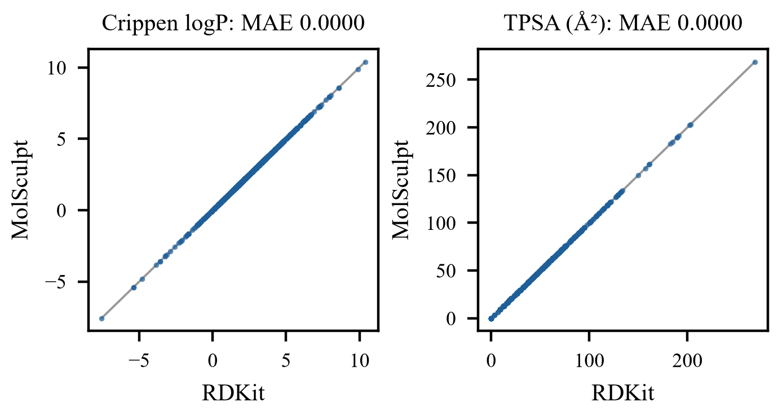
Fig. 7. Crippen logP and TPSA computed by MolSculpt versus RDKit for the 1128 ESOL molecules; all points lie on the identity line.
The ESOL equation evaluated with our Crippen logP predicts measured solubility with RMSE 1.10 log units and R² = 0.725 (Fig. 8), compared with RMSE 0.91 and R² = 0.811 for the published ESOL predictions, which use a different logP model. The estimate is therefore suitable for the coarse solubility classes the interface shows, not for quantitative prediction.
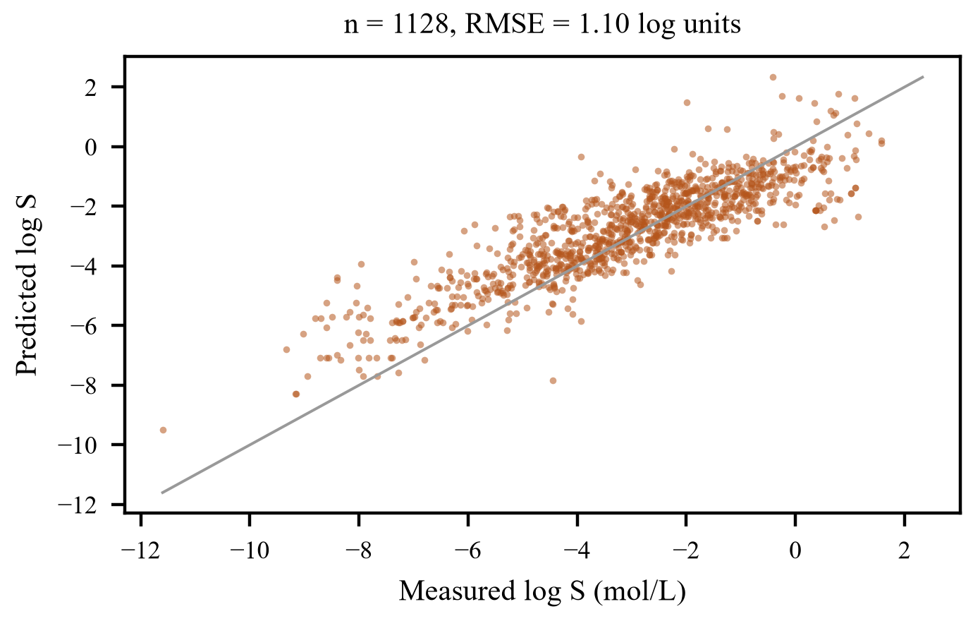
Fig. 8. ESOL solubility computed by MolSculpt versus measured aqueous solubility (ESOL data set).
B. Responsiveness
Nielsen's response-time limits [17] require feedback within about 0.1 s for direct manipulation and within 1 s to keep the flow of thought, while about 10 s is the limit for keeping attention on a task. A full analysis (perception, descriptors, groups, alerts, SMILES and signature) takes a median 0.49 ms and a mean 0.64 ms per molecule on the ESOL set, so the properties panel updates within the same frame as each gesture. Table IV lists the latency of each agent tool for ten structures (eight drugs and two hypothetical analogues) with an empty cache. Local tools take at most 12 ms; network calls to PubChem dominate. The complete deterministic pipeline took 4.1 s on average (2.9–4.9 s) and identified all eight drugs, while both hypothetical structures were reported as unregistered and triggered the similarity search. LLM inference adds to this; it is logged per run but was not measured here because no Groq key was used during development. Because the agent's latency can exceed the 1 s limit, the streamed trace provides continuous progress feedback.
TABLE IV
Latency of agent tools (ms, n = 10 structures, cold cache)
Tool | Mean | Median | Max
compute_descriptors | 5 | 6 | 10
check_structural_alerts | 6 | 6 | 12
assess_drug_likeness | 4 | 5 | 9
pubchem_lookup | 2854 | 3162 | 4190
get_safety_data (n = 8) | 913 | 1021 | 1674
find_similar_compounds (n = 2) | 2432 | 2630 | 2630

Hand-tracking throughput depends on the camera and GPU of the user's machine and is displayed live in the interface (frames per second and inference time per frame); it should be reported from the participants' sessions rather than from our headless test environment, whose software rendering is not representative.
C. Behaviour of the gesture logic
The interaction logic is covered by 30 automated tests (14 for the chemistry engine, 11 for gestures and voice, 5 for the server and an agent loop driven by a scripted mock of the Groq API). The gesture tests feed synthetic 21-point hands and verify that: static poses are classified correctly; a pinch produces exactly one press and one release and a single noisy frame is ignored; holding a victory pose still fires undo exactly once, whereas the same pose with a moving hand fires nothing; 120 frames of an open palm trigger no command; losing the hand during a pinch cancels the drag; and the reach box yields the intended control–display gain. These tests verify the logic, not recognition accuracy on real hands, which depends on MediaPipe and on users.
Table V characterises the cursor filter on a synthetic 30 Hz signal with uniform ±5 px jitter (raw SD 2.89 px). At the default setting the filter removes 63.4% of the jitter while lagging only 10 px behind a hand moving at 1200 px/s; a fixed low-pass filter with the same cut-off (β = 0) would lag 159.2 px. This combination of steadiness at rest and responsiveness in motion is the reason for using the 1€ filter.
TABLE V
Cursor filter: jitter and lag (synthetic, 30 Hz)
f_min (Hz) | Jitter SD (px) | Reduction | Lag @300 px/s | Lag @1200 px/s | Lag, β = 0
0.5 | 0.83 | 71.1% | 7.2 | 10.3 | 381.9
1.2 | 1.06 | 63.4% | 6.6 | 10 | 159.2
2 | 1.26 | 56.5% | 6.1 | 9.6 | 95.5
4 | 1.59 | 44.9% | 5.1 | 8.8 | 47.7

D. Fitts's-law analysis
Movement time grows linearly with the index of difficulty ID = log₂(D/W + 1) [8], [9]. Without fitting device constants, Table VI compares the ID of key selections in the interface geometry (1440 × 900 window). Expanding the activation area of atoms from the drawn 23 px to 60 px lowers the ID of selecting an atom 200 px away by 35%, and magnetic snapping lowers the ID of hitting a bond end further. Choosing an element from the radial menu, which opens at the cursor with eight slices about 70 px wide at a radius of 89 px, has an ID of 1.18 bits, versus 3.88 bits for travelling from the canvas centre to the palette, and it avoids the return trip to the canvas. The thumbs-up gesture replaces a 3.7-bit pointing movement to the analyse button by a 0.9 s hold that requires no pointing.
TABLE VI
Index of difficulty of selected interactions
Interaction | D (px) | W (px) | ID (bits)
Atom, drawn size | 200 | 23 | 3.28
Atom, hand activation area | 200 | 60 | 2.12
Bond end with magnetic snap | 200 | 80 | 1.81
Element: palette from canvas centre | 606 | 44 | 3.88
Element: radial menu at cursor | 89 | 70 | 1.18
Analyse button from canvas centre | 651 | 54 | 3.71

E. Heuristic evaluation
We reviewed the design against Nielsen's ten heuristics [16]. Table VII lists the main supporting features and the open issues we found. Because the reviewers are also the designers, this assessment is preliminary and must be complemented by independent evaluators and users.
TABLE VII
Heuristic review (summary)
Heuristic | Supporting features | Open issue
Visibility of status | pose chip, fps/latency, cursor states, progress rings, live trace | tracking quality shown only as present/absent
Match with real world | pinch = grasp, fist = grab, 👍 = go; CPK colours | three-finger menu pose is arbitrary
User control | undo by ✌, cancel on hand loss, rest pose, Esc | no multi-atom selection
Consistency | one editor for all modalities; same radial menu by gesture and right-click | F = fluorine, Shift+F = fit
Error prevention | valence checks, snapping, stillness gating, no dwell on canvas | element change may still over-valence
Recognition vs recall | gesture legend, ghost previews, menu shows options | poses must be learned once
Flexibility | keyboard, voice, tap-to-grow, rings, library, SMILES import | no user-defined fragments
Minimalist design | camera hidden, collapsible trace | dense right panel
Error recovery | red markers with explanations, refusal toasts | no automatic repair suggestion
Help | first-use gesture guide, tooltips, README | no interactive tutorial

F. User-study protocol
The planned study compares hand-gesture input with the mouse in a within-subjects design with counterbalanced order and at least 12 participants with basic chemistry knowledge. After a five-minute familiarisation with the gesture guide, each participant performs tasks T1–T5 of increasing complexity (ethanol, acetone, benzene, acetic acid, paracetamol) in each condition, then completes SUS [18] and raw NASA-TLX [19]; a short interview collects qualitative feedback, and a final task asks participants to analyse their paracetamol with ChemAgent and rate their trust in the report. The application records all measures automatically (Fig. 9). We will test completion time and error counts with paired t-tests or Wilcoxon signed-rank tests (α = 0.05), and report SUS against the commonly used benchmark of 68. We expect the mouse to be faster for the more complex tasks (H1), error counts to be comparable thanks to the assistive techniques (H2), SUS above 68 for the gesture condition (H3) and higher physical demand for gestures (H4).
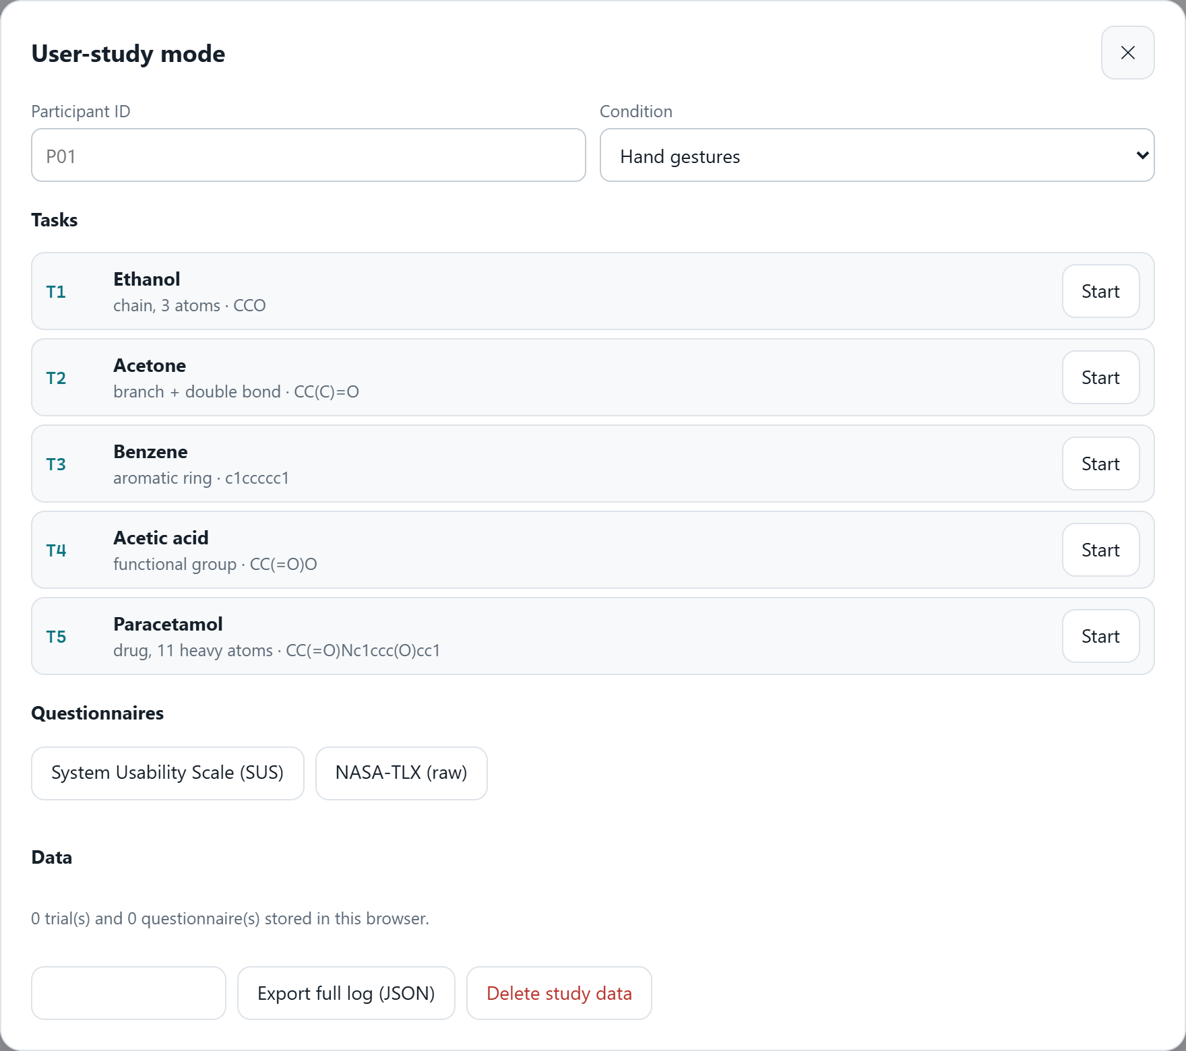
Fig. 9. Built-in study mode: participant and condition, tasks T1–T5 with automatic completion detection, SUS and NASA-TLX questionnaires, and export of trials and logs.
VII. Discussion and Limitations
The evaluation establishes that the system computes what it displays correctly and fast enough for direct manipulation, and that its interaction logic behaves as designed. It does not yet show that people can build molecules faster, more accurately or more comfortably by hand than with a mouse; we in fact expect the mouse to be faster for experienced users at a desk. The value of the gesture interface lies in situations where the mouse is unavailable or undesirable, and in its suitability for demonstration and teaching.
Several limitations remain. Gesture thresholds were set by hand and may need personal calibration; recognition depends on lighting, background and MediaPipe's robustness across hands and skin tones. Mid-air use remains tiring over long sessions despite the reach box and the rest pose [6]. The editor is two-dimensional and does not represent stereochemistry. The language model can still produce inaccurate statements; grounding, labelling of predictions, schema validation and the visible trace reduce but do not eliminate this risk, so reports are advisory and should be checked by a chemist. The PubChem hazard data are aggregated notifications and the ESOL estimate is coarse. Voice recognition relies on the browser's cloud speech service, unlike hand tracking, which is entirely local.
Future work includes the user study described above, two-handed gestures for zooming and rotating, gaze-plus-pinch selection, learned and personalised pose classifiers, stereochemistry and three-dimensional conformer views, additional agent tools such as retrosynthesis planning with safety filtering, and evaluation with users with motor impairments.
VIII. Conclusion
MolSculpt shows that a commodity webcam, on-device hand tracking and careful interaction design are sufficient for building organic molecules in mid air, and that a tool-grounded LLM agent can turn the drawn structure into an explained characterisation within seconds. The key design decisions were a minimal gesture vocabulary with a safe rest pose, hold gestures gated on stillness, assistive snapping and target expansion, continuous feedforward, a single editing model shared by all modalities, a local chemistry engine that matches RDKit exactly, and an agent whose evidence and reasoning steps remain visible to the user. The instrumented study mode makes the planned comparison with conventional input straightforward to run.
References
[1] F. Zhang, V. Bazarevsky, A. Vakunov, A. Tkachenka, G. Sung, C.-L. Chang, and M. Grundmann, "MediaPipe Hands: On-device real-time hand tracking," arXiv:2006.10214, 2020.
[2] C. Lugaresi et al., "MediaPipe: A framework for building perception pipelines," arXiv:1906.08172, 2019.
[3] J. P. Wachs, M. Kölsch, H. Stern, and Y. Edan, "Vision-based hand-gesture applications," Commun. ACM, vol. 54, no. 2, pp. 60–71, 2011.
[4] S. S. Rautaray and A. Agrawal, "Vision based hand gesture recognition for human computer interaction: A survey," Artif. Intell. Rev., vol. 43, no. 1, pp. 1–54, 2015.
[5] R. J. K. Jacob, "What you look at is what you get: Eye movement-based interaction techniques," in Proc. CHI '90, 1990, pp. 11–18.
[6] J. D. Hincapié-Ramos, X. Guo, P. Moghadasian, and P. Irani, "Consumed endurance: A metric to quantify arm fatigue of mid-air interactions," in Proc. CHI '14, 2014, pp. 1063–1072.
[7] G. Casiez, N. Roussel, and D. Vogel, "1€ filter: A simple speed-based low-pass filter for noisy input in interactive systems," in Proc. CHI '12, 2012, pp. 2527–2530.
[8] P. M. Fitts, "The information capacity of the human motor system in controlling the amplitude of movement," J. Exp. Psychol., vol. 47, no. 6, pp. 381–391, 1954.
[9] I. S. MacKenzie, "Fitts' law as a research and design tool in human-computer interaction," Hum.-Comput. Interact., vol. 7, no. 1, pp. 91–139, 1992.
[10] T. Grossman and R. Balakrishnan, "The bubble cursor: Enhancing target acquisition by dynamic resizing of the cursor's activation area," in Proc. CHI '05, 2005, pp. 281–290.
[11] J. Callahan, D. Hopkins, M. Weiser, and B. Shneiderman, "An empirical comparison of pie vs. linear menus," in Proc. CHI '88, 1988, pp. 95–100.
[12] R. A. Bolt, "'Put-that-there': Voice and gesture at the graphics interface," Comput. Graph., vol. 14, no. 3, pp. 262–270, 1980.
[13] J. O. Wobbrock, M. R. Morris, and A. D. Wilson, "User-defined gestures for surface computing," in Proc. CHI '09, 2009, pp. 1083–1092.
[14] B. Shneiderman, "Direct manipulation: A step beyond programming languages," Computer, vol. 16, no. 8, pp. 57–69, 1983.
[15] D. A. Norman, The Design of Everyday Things, rev. ed. New York, NY, USA: Basic Books, 2013.
[16] J. Nielsen, "Enhancing the explanatory power of usability heuristics," in Proc. CHI '94, 1994, pp. 152–158.
[17] J. Nielsen, Usability Engineering. Boston, MA, USA: Academic Press, 1993.
[18] J. Brooke, "SUS: A 'quick and dirty' usability scale," in Usability Evaluation in Industry, P. W. Jordan, B. Thomas, B. A. Weerdmeester, and I. L. McClelland, Eds. London, U.K.: Taylor & Francis, 1996, pp. 189–194.
[19] S. G. Hart and L. E. Staveland, "Development of NASA-TLX (Task Load Index): Results of empirical and theoretical research," Adv. Psychol., vol. 52, pp. 139–183, 1988.
[20] S. Amershi et al., "Guidelines for human-AI interaction," in Proc. CHI '19, 2019, paper 3, pp. 1–13.
[21] S. Yao, J. Zhao, D. Yu, N. Du, I. Shafran, K. Narasimhan, and Y. Cao, "ReAct: Synergizing reasoning and acting in language models," in Proc. ICLR, 2023.
[22] T. Schick et al., "Toolformer: Language models can teach themselves to use tools," in Proc. NeurIPS, 2023.
[23] A. M. Bran, S. Cox, O. Schilter, C. Baldassari, A. D. White, and P. Schwaller, "Augmenting large language models with chemistry tools," Nat. Mach. Intell., vol. 6, pp. 525–535, 2024.
[24] D. A. Boiko, R. MacKnight, B. Kline, and G. Gomes, "Autonomous chemical research with large language models," Nature, vol. 624, pp. 570–578, 2023.
[25] S. Kim et al., "PubChem 2023 update," Nucleic Acids Res., vol. 51, no. D1, pp. D1373–D1380, 2023.
[26] D. Weininger, "SMILES, a chemical language and information system. 1. Introduction to methodology and encoding rules," J. Chem. Inf. Comput. Sci., vol. 28, no. 1, pp. 31–36, 1988.
[27] G. Landrum et al., "RDKit: Open-source cheminformatics," version 2026.09.1. [Online]. Available: https://www.rdkit.org
[28] B. Bienfait and P. Ertl, "JSME: A free molecule editor in JavaScript," J. Cheminform., vol. 5, art. 24, 2013.
[29] M. O'Connor et al., "Sampling molecular conformations and dynamics in a multiuser virtual reality framework," Sci. Adv., vol. 4, no. 6, art. eaat2731, 2018.
[30] S. A. Wildman and G. M. Crippen, "Prediction of physicochemical parameters by atomic contributions," J. Chem. Inf. Comput. Sci., vol. 39, no. 5, pp. 868–873, 1999.
[31] P. Ertl, B. Rohde, and P. Selzer, "Fast calculation of molecular polar surface area as a sum of fragment-based contributions and its application to the prediction of drug transport properties," J. Med. Chem., vol. 43, no. 20, pp. 3714–3717, 2000.
[32] C. A. Lipinski, F. Lombardo, B. W. Dominy, and P. J. Feeney, "Experimental and computational approaches to estimate solubility and permeability in drug discovery and development settings," Adv. Drug Deliv. Rev., vol. 23, no. 1–3, pp. 3–25, 1997.
[33] D. F. Veber, S. R. Johnson, H.-Y. Cheng, B. R. Smith, K. W. Ward, and K. D. Kopple, "Molecular properties that influence the oral bioavailability of drug candidates," J. Med. Chem., vol. 45, no. 12, pp. 2615–2623, 2002.
[34] W. J. Egan, K. M. Merz, and J. J. Baldwin, "Prediction of drug absorption using multivariate statistics," J. Med. Chem., vol. 43, no. 21, pp. 3867–3877, 2000.
[35] A. K. Ghose, V. N. Viswanadhan, and J. J. Wendoloski, "A knowledge-based approach in designing combinatorial or medicinal chemistry libraries for drug discovery. 1. A qualitative and quantitative characterization of known drug databases," J. Comb. Chem., vol. 1, no. 1, pp. 55–68, 1999.
[36] S. J. Teague, A. M. Davis, P. D. Leeson, and T. Oprea, "The design of leadlike combinatorial libraries," Angew. Chem. Int. Ed., vol. 38, no. 24, pp. 3743–3748, 1999.
[37] J. S. Delaney, "ESOL: Estimating aqueous solubility directly from molecular structure," J. Chem. Inf. Comput. Sci., vol. 44, no. 3, pp. 1000–1005, 2004.
[38] R. Brenk et al., "Lessons learnt from assembling screening libraries for drug discovery for neglected diseases," ChemMedChem, vol. 3, no. 3, pp. 435–444, 2008.
[39] J. B. Baell and G. A. Holloway, "New substructure filters for removal of pan assay interference compounds (PAINS) from screening libraries and for their exclusion in bioassays," J. Med. Chem., vol. 53, no. 7, pp. 2719–2740, 2010.
[40] D. Abts et al., "Think fast: A tensor streaming processor (TSP) for accelerating deep learning workloads," in Proc. ISCA, 2020, pp. 145–158.
[41] OpenAI, "gpt-oss-120b & gpt-oss-20b model card," Aug. 2025.
[42] J. D. Horton, "A polynomial-time algorithm to find the shortest cycle basis of a graph," SIAM J. Comput., vol. 16, no. 2, pp. 358–366, 1987.
[43] H. L. Morgan, "The generation of a unique machine description for chemical structures—A technique developed at Chemical Abstracts Service," J. Chem. Doc., vol. 5, no. 2, pp. 107–113, 1965.
[44] B. Weisfeiler and A. Leman, "The reduction of a graph to a canonical form and the algebra which appears therein," Nauchno-Tekhnicheskaya Informatsia, ser. 2, no. 9, pp. 12–16, 1968.
[45] Groq, "GroqCloud documentation: Supported models." [Online]. Available: https://console.groq.com/docs/models (accessed Oct. 2026).

