EnterG front end: from prototype to production
Oct 3, 2026 · @Andreas Nikolopoulos

The question
Αυτό που έχει φτιάξει τώρα είναι mock. Αν δώσουμε server-side API για session management, scaling logic, HTTP REST API to in-memory DB to retrieve each website component's datasets, API for betslip, protocol for push data, μπορεί να το γυρίσει αυτό σε κανονικό site?
The website needs to have its own back end for session memory, and this back end will connect with the system back end (n-tier). For data pushed by the server, what is the proposed protocol and technology to dispatch them to the website front, if the back end sends data as compact delimited raw text containing only the changes, batched in max 100 ms at peak times? What is the recommended tool stack / frameworks?

Short answer
Yes. The prototype's screens talk to the back end through one typed layer (src/api), so a real back end plugs in without rebuilding the UI. The prototype itself is a starting point, not production code: it needs the website back end below, a real push channel, and hardening (tests, security, compliance).
- Website back end: a BFF (REST + session) and a separate realtime gateway, both stateless, sharing Redis or your in-memory DB.
- Push: WebSocket from browser to your own gateway, forwarding your delimited diffs per topic, one frame per 100 ms batch. Server-Sent Events as fallback.
- Stack: React + TypeScript on Next.js; Node.js/TypeScript BFF; Go (or Node uWebSockets.js) gateway; Redis; NATS or Kafka inside the back end; Kubernetes behind a CDN/WAF.

Architecture (n-tier)
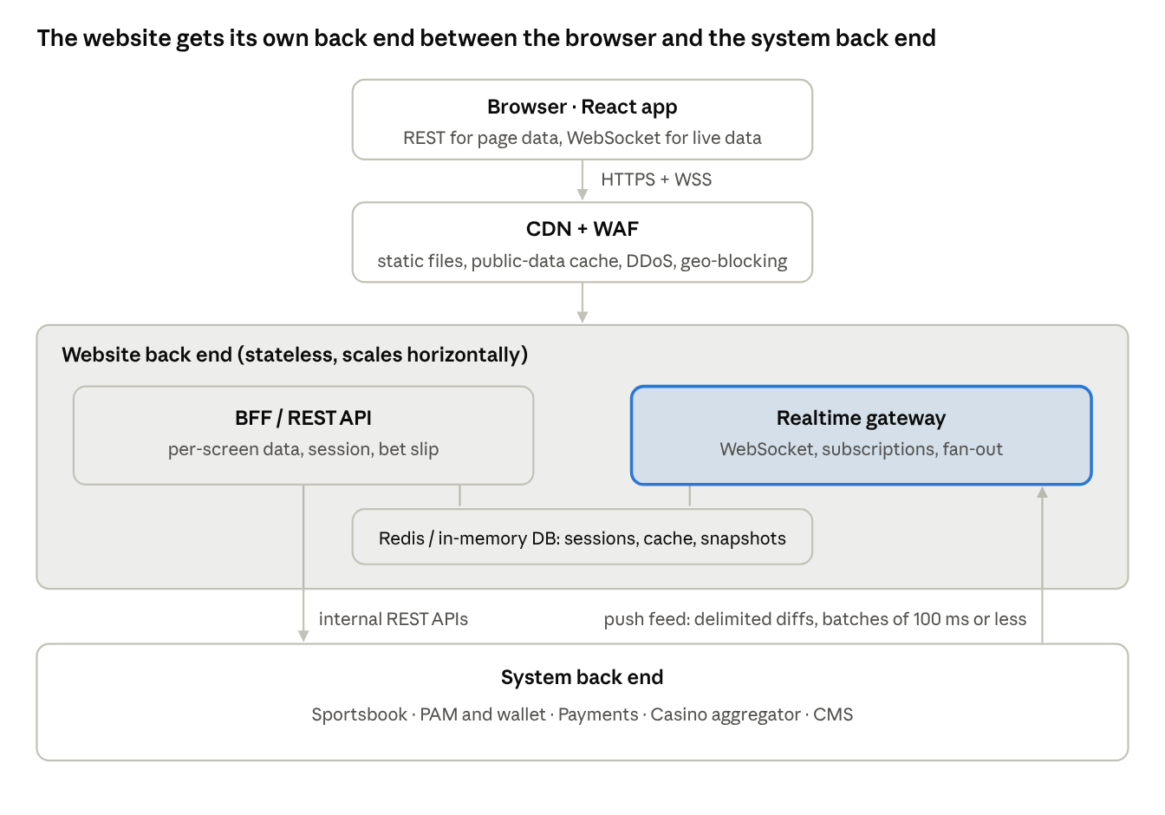
proposed n-tier architecture · 4 tiers
The browser never talks to the system back end directly. The website back end owns the session, shapes data per screen, and turns the system feed into per-player live updates.
Session memory. The website back end issues an opaque session ID in an HttpOnly, Secure, SameSite cookie; no tokens are stored in the browser. The session lives in Redis (or your in-memory DB) with a sliding expiry and holds the player ID, the system back-end token(s), and responsible-gaming flags (limits, self-exclusion). API instances keep no state, so they scale horizontally behind a load balancer without sticky sessions.
Component datasets. The BFF exposes REST endpoints shaped per screen, e.g. GET /api/sports/football/highlights, read from the in-memory DB. Public data (events, lobbies, stories) gets short cache times at the CDN; personal data (balance, bets) is never cached.
Bet slip API. The slip stays in the browser until the player places the bet. POST /bets goes to the BFF, which checks the session, limits and odds changes, then forwards to the system back end. The prototype already calls it this way (src/api/http.ts).

Push protocol for delimited diffs batched in 100 ms
Recommendation: WebSocket (RFC 6455) from the browser to your own realtime gateway, with Server-Sent Events as a fallback.
Why WebSocket:
- Two-way. The page must subscribe and unsubscribe as the player navigates (one event, one league list, their own balance). Without that, every client receives the whole feed.
- Low overhead. Small framing, and per-message compression (permessage-deflate) works well on repetitive delimited text.
Why not the alternatives: SSE is simpler but one-way, so subscriptions need separate REST calls. WebTransport is not yet supported widely enough (notably Safari).
How the gateway handles the feed:
- Consume the delimited-text diffs from the system back end through NATS, Kafka or Redis Streams, so every gateway node can read the same feed.
- Apply the diffs to an in-memory snapshot. A player who opens a page late gets the snapshot first, then only changes.
- Filter by topic (event:123, list:football:gr-sl, private player:{id} for balance, settlements and cash-out) and send each client one frame per 100 ms batch, containing only its subscribed topics.
- Stamp every topic with a sequence number. If the browser detects a gap, it re-fetches the snapshot over REST.
- Send a heartbeat every 20–30 s. Reconnect with exponential backoff and resume from the last sequence number.
Keep the raw delimited format all the way to the browser. It is the smallest and cheapest for the gateway, and compression shrinks it further. In the browser:
- parse it in a Web Worker so the main thread stays free;
- apply changes to a store;
- redraw at most once per animation frame, so even at peak only what changed is repainted.
Private channels (balance, bets) are authenticated by the session cookie at the WebSocket handshake. No token in the URL.
Scaling: gateways hold connections but no business state, sit behind a load balancer that supports WebSockets, and autoscale on connection count.

Recommended tool stack
Layer | Recommendation | Why
Front end | React + TypeScript (already used), moved to Next.js | Server-rendered sport, league and casino pages for SEO. Lighter option: keep Vite and prerender.
Front-end data | TanStack Query (REST cache), Zustand (live store), Web Worker for the feed | Live updates stay off the main thread
BFF / REST | Node.js + TypeScript (NestJS or Fastify) | Same language as the front end: shared types, one team
Realtime gateway | Go, or Node with uWebSockets.js | Go holds more connections per server at peak match times
Session, cache, pub/sub | Redis, or your in-memory DB if it has TTL and pub/sub
Feed transport inside the back end | NATS (low latency) or Kafka (if you also need replay or audit)
Infrastructure | Kubernetes, WebSocket-capable load balancer, CDN + WAF | Autoscale gateways on connection count
Monitoring and testing | OpenTelemetry, Prometheus/Grafana, Sentry; Vitest + Playwright
If the system back end is .NET or Java and that is where the team's skills are, writing the BFF in the same language is a valid choice. The front end does not depend on it.

What changes in the prototype, and open questions
Changes in the current code:
- Replace the timer in src/api/realtime.ts with the WebSocket client and Web Worker; switch src/api/index.ts to the real API.
- Move login to cookie sessions instead of the in-memory demo login.
- Replace the #/ addresses with clean URLs (BrowserRouter or Next.js routes).
- Enforce limits, KYC and age checks on the server with an audit trail; the mock only imitates them today.
- Add the Greek translation layer, automated tests, accessibility and performance work, and security testing.
- Check ΕΕΕΠ technical and certification requirements against this design before build (not verified here).
Open questions for the back-end team:
- ☐ Does the system back end keep its own snapshot of the feed, or only send diffs? If only diffs, the gateway must hold the snapshot.
- ☐ What is the delimited format (field order, separators, escape rules, message types)? A short spec lets the browser parser be written now.
- ☐ Peak volume: messages per second and concurrent players at the busiest match times, to size the gateways.
- ☐ Which language and runtime does the team prefer for the BFF?

