Deliivo Website – Baltic SEO Requirements

1. Multilingual URL Structure (Required)
Website should use language-based URLs.
Structure:
https://deliivo.com/en/
https://deliivo.com/ee/
https://deliivo.com/lv/
https://deliivo.com/lt/
https://deliivo.com/ru/

Language dropdown should update URL accordingly.
Examples:
/en/
/ee/
/lv/
/lt/
/ru/

URL prefixes should remain consistent across all pages.
Examples:
/ee/blog/
/lv/blog/
/lt/blog/
/ru/blog/

/ee/routes
/lv/routes
/lt/routes

2. Hreflang Implementation (Required)
Add hreflang on all pages.
Example:
<link rel="alternate" hreflang="en" href="https://deliivo.com/en/" />

<link rel="alternate" hreflang="et" href="https://deliivo.com/ee/" />

<link rel="alternate" hreflang="lv" href="https://deliivo.com/lv/" />

<link rel="alternate" hreflang="lt" href="https://deliivo.com/lt/" />

<link rel="alternate" hreflang="ru" href="https://deliivo.com/ru/" />

<link rel="alternate" hreflang="x-default"
href="https://deliivo.com/" />

Important:
/ee → URL
et → hreflang

Every page should include self canonical.
Example:
<link rel="canonical"
href="https://deliivo.com/ee/" />

3. Blog Section (Required)
Create dedicated blog section for all languages. ( Blog Same rhenge sab bass language change ho jyegi blog ki or URL change ho jyegi)
Structure:

/ee/blog/
/lv/blog/
/lt/blog/
/ru/blog/

Blog pages should support:
- SEO title
- Meta description
- Internal linking
- Breadcrumb
- Schema
- Author
- Publish date

4. Google Analytics (GA4)
<!-- Google tag (gtag.js) -->
<script async src="https://www.googletagmanager.com/gtag/js?id=G-MSG1B1Y353"></script>
<script>
window.dataLayer = window.dataLayer || [];
function gtag(){dataLayer.push(arguments);}
gtag('js', new Date());
gtag('config', 'G-MSG1B1Y353');
</script>
Instructions:
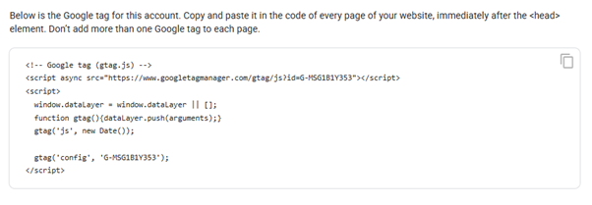

5. Google Search Console
<meta name="google-site-verification" content="SU-QN9TplRKM9Kn7lq1H07KiKc93qQZfRhMDveuw1H4" />

Instructions:
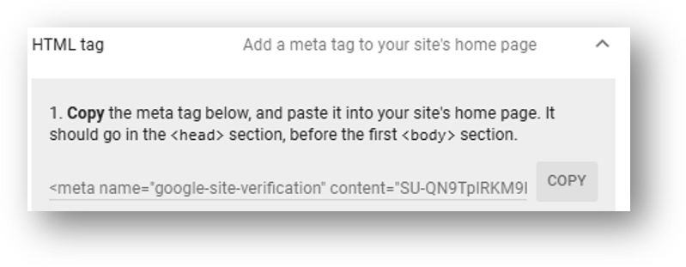

6. Sitemap
Create sitemap structure.
/sitemap.xml
/sitemap-pages.xml
/sitemap-blog.xml

Include all language URLs.

7. Technical SEO
Required:
- SSR / prerender
- robots.txt
- canonical
- hreflang
- structured data
- Open Graph
- WebP images
- lazy loading
- mobile optimization
- Core Web Vitals optimization

8. Baltic SEO Expansion
Create some landing pages.
Examples:
/ee/tallinn-to-tartu
/lv/riga-to-liepaja
/lt/vilnius-to-kaunas

