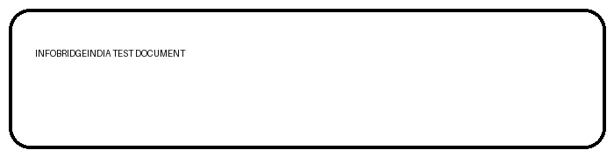
Word to PDF Conversion Test
Reference document for layout, tables, images, styling and page breaks

1. Text Formatting Test
This paragraph contains bold text, italic text, underlined text, and normal text. The purpose is to verify that the PDF conversion preserves common Word formatting.
This is a longer justified paragraph used to test line wrapping and paragraph alignment. A good Word-to-PDF converter should keep the paragraph readable, preserve spacing, and maintain the overall width and margin structure without clipping any text.
2. Bullet and Numbered List Test
- Preserve font size and weight
- Preserve paragraph alignment
- Preserve tables and images
- Open the Word document
- Convert it to PDF
- Compare the layout with the original
3. Table Test
Item | Description | Qty | Rate | Amount
1 | Premium Stainless Steel Kitchen Tool | 2 | 250.00 | 500.00
2 | Professional Consultation Service | 3 | 600.00 | 1,800.00
3 | Long description item to test text wrapping inside a table cell without breaking the table layout | 1 | 1,250.00 | 1,250.00

Subtotal: 3,550.00
Tax: 639.00
Grand Total: 4,189.00

Page 2 - Layout and Alignment Tests
Left aligned text
Centered text
Right aligned text
4. Address / Multi-line Content
Bill To:
Sample Customer Pvt Ltd
45 Business Avenue
Chennai, Tamil Nadu 600001
India
Email: customer@example.com
Phone: +91 90000 00000
5. Image Test

Figure 1 - Embedded image should remain sharp and centered in the PDF.
6. Final Conversion Checklist
- The output PDF should remain approximately two A4 pages.
- Headings, bold, italic and underline should remain visible.
- The table should stay aligned with all rows readable.
- The image should not be stretched, cropped or blurred.
- The manual page break should remain between Page 1 and Page 2.
- No text should overlap, disappear or move outside the page margins.

