Intranet Messaging System

Description :-
This is a very simple application which can be used in any organization by the employees to communicate online.The advantages of this application is it need very less resources and can be configured easily, as it does not use any databse of the user accounts.Any user who is interested in participating Online chat can simply use any Name to Login which is temporarily maintained by the application. One more advantage of this application is one can send a message to all or only to a particular user by selecting his name.The online users list will be updated whenever any user is logged in or logged out.

Technical Description :-

This is application is developed using Java ( JDK1.2 ) . This is done using RMI ( Remote Method Invocation) and AWT.

Flow of the Application :-

When the client application is started Login Dialog appears in which user has to type a Nick Name in order to login. If the Name is already used by another user the application raises an error to choose another name. Once the user logs all the users
User list will be updated and also it enables the application window to work with it.
Note :- See the figures below
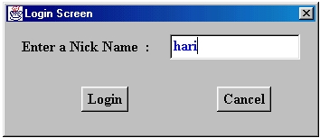

Login Window

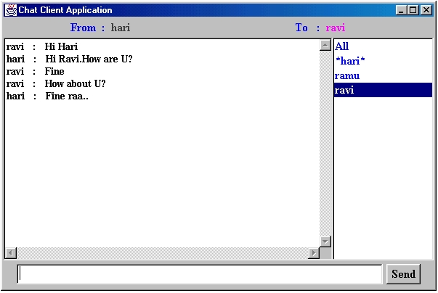

Main Window

