LDR
CP005
Image:
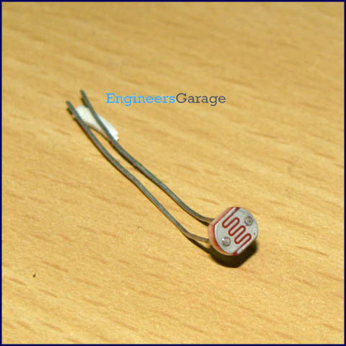
An LDR (Light dependent resistor), as its name suggests, offers resistance in response to the ambient light. The resistance decreases as the intensity of incident light increases, and vice versa. In the absence of light, LDR exhibits a resistance of the order of mega-ohms which decreases to few hundred ohms in the presence of light. It can act as a sensor, since a varying voltage drop can be obtained in accordance with the varying light. It is made up of cadmium sulphide (CdS).
An LDR has a zigzag cadmium sulphide track. It is a bilateral device, i.e., conducts in both directions in same fashion.
Pin Diagram:
