LED
CP003
Image:
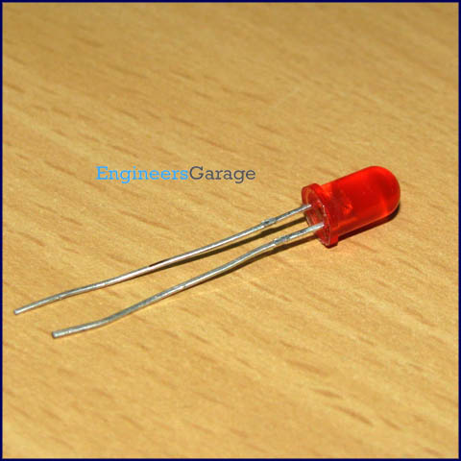
Light emitting diodes (LEDs) are semiconductor light sources. The light emitted from LEDs varies from visible to infrared and ultraviolet regions. They operate on low voltage and power. LEDs are one of the most common electronic components and are mostly used as indicators in circuits. They are also used for luminance and optoelectronic applications.
Based on semiconductor diode, LEDs emit photons when electrons recombine with holes on forward biasing. The two terminals of LEDs are anode (+) and cathode (-) and can be identified by their size. The longer leg is the positive terminal or anode and shorter one is negative terminal.
The forward voltage of LED (1.7V-2.2V) is lower than the voltage supplied (5V) to drive it in a circuit. Using an LED as such would burn it because a high current would destroy its p-n gate. Therefore a current limiting resistor is used in series with LED. Without this resistor, either low input voltage (equal to forward voltage) or PWM (pulse width modulation) is used to drive the LED. Get details about internal structure of a LED.

Pin Diagram:
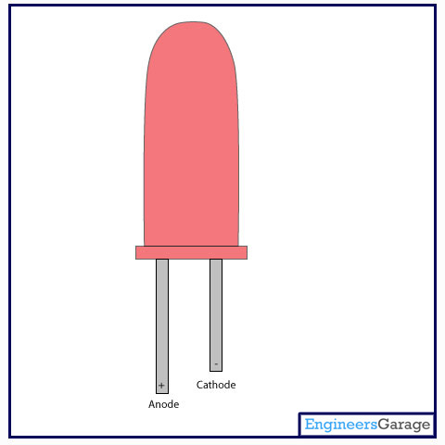

Insight - How LED works

Table of Contents:
- Insight - How LED works
- Front View
- Structure
- Outer Glass Casing
- Internal View
- Leads
- Cavity
- Semiconductor Die
LED (Light Emitting Diode) is a special diode that emits light when an electric voltage is applied to it. It is common electronic component that is being used in devices like TV, computer, etc. generally for indicating purpose. They are available in various colors like red, yellow, green etc.

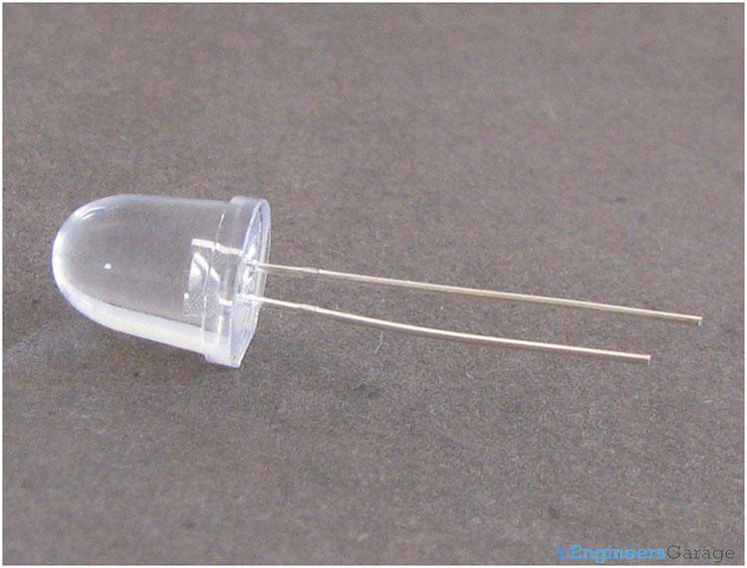
There are two leads of an LED that are used to supply input voltage. The longer lead is positive and known as ‘Post’, and the smaller is negative known as ‘Anvil’ as shown in the image above.
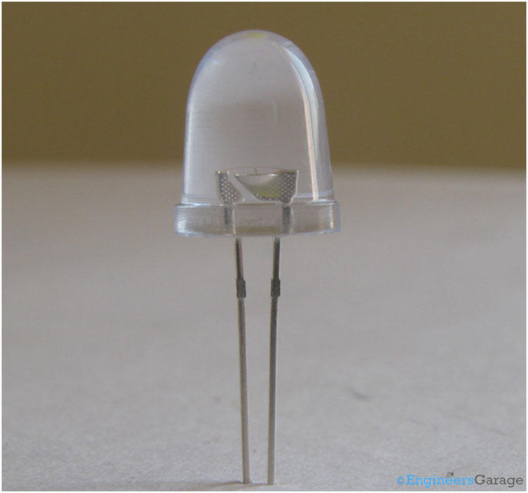
The above image shows the structure of an LED. A metal cup is placed on the negative lead (Anvil) which holds a semiconductor die. The semiconductor die is a combination of two semiconductor materials – N type and P type and an active region (known as P-N junction) between them. The outer body is formed of an epoxy glass that provides directionality to the light as well as protection to the die and leads.
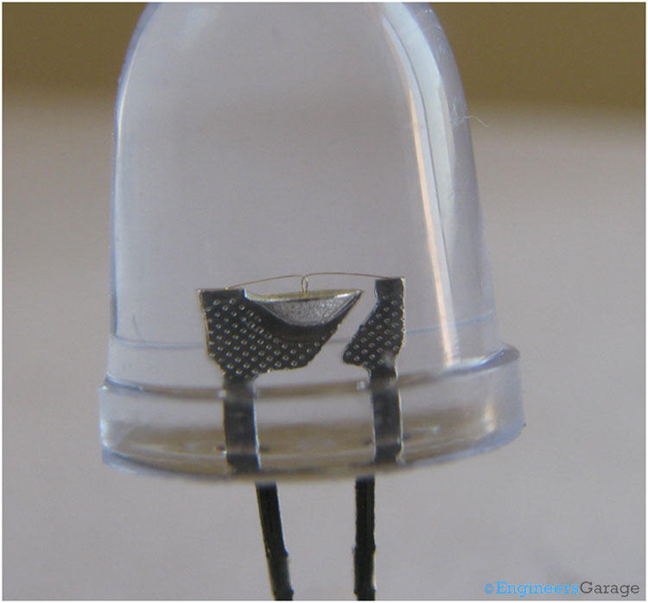
A closer look shows the structure of various components clearly. A cone shape cup, which holds the semiconductor die. The conical shape plays an important role to reflect the light emitted from the semiconductor die. Both leads are connected with the die by a wire bond.
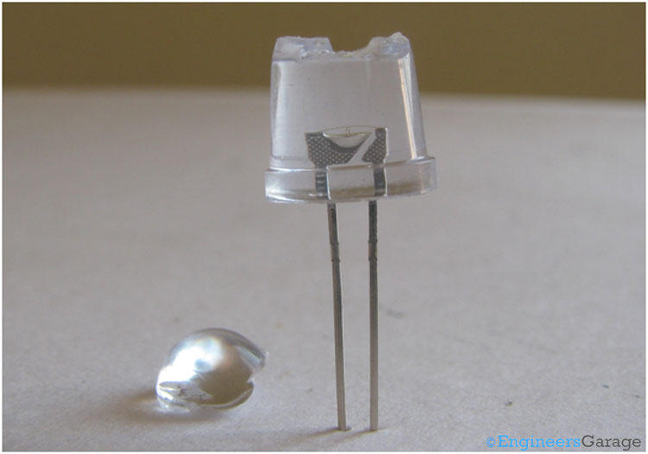
The entire assembly is encapsulated in a epoxy glass case. The shape of the glass gives directionality to the light emitted from semiconductor die.
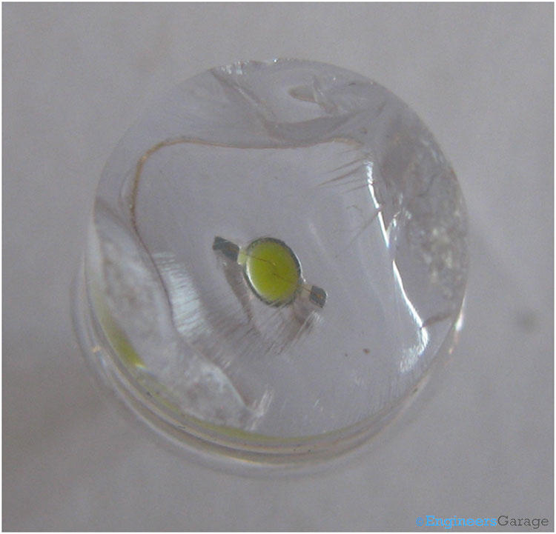
This image is the top view of the LED after removing some section of the epoxy glass case. You can see how the semiconductor die is placed in the cone. The wires are also visible on a closer look.
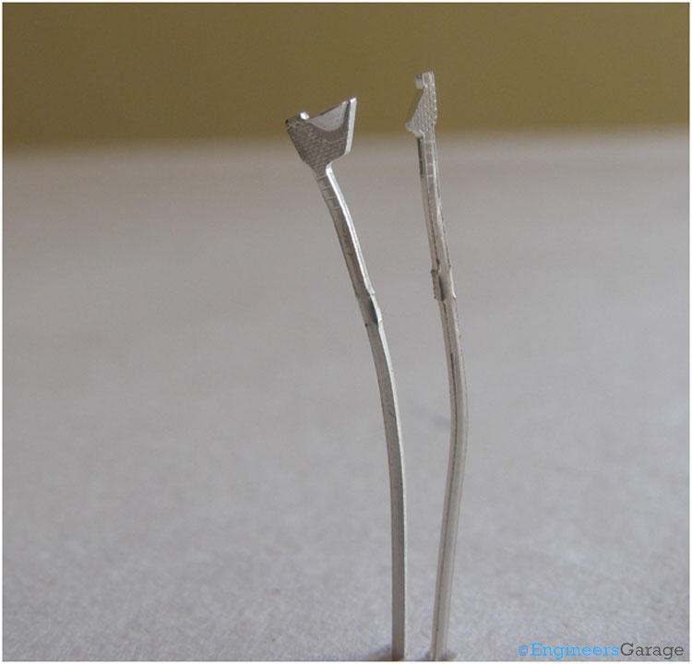
After removing the glass completely, the above image shows the front view of the leads. It showcases the structure of both the leads – Anvil and Post, which are connected to the N layer and P layer of the semiconductor die respectively by wire bond.
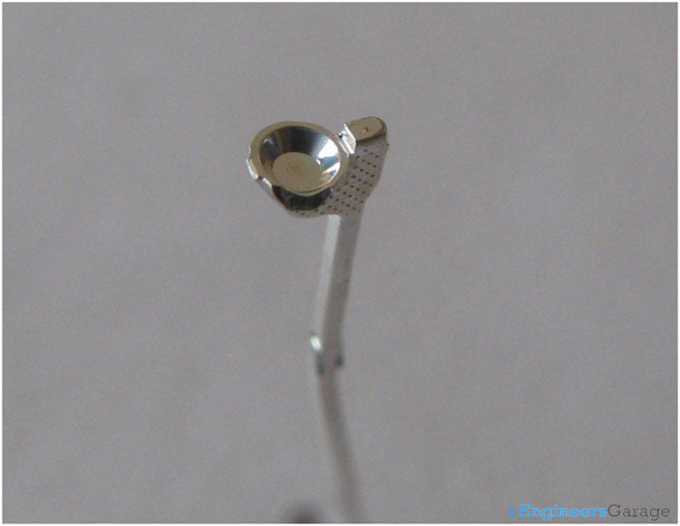
The negative terminal (Anvil) has a cavity where the semiconductor die is placed. This cavity is shaped so as to reflect the produced light into upward direction.
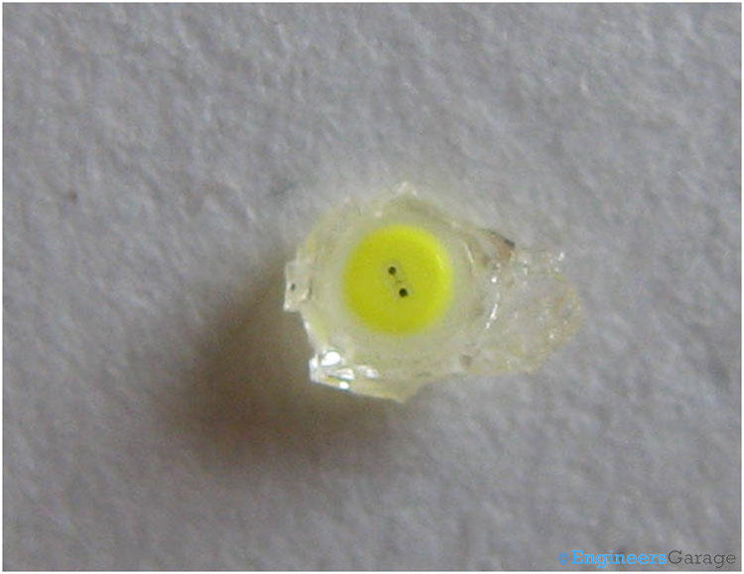
The semiconductor die which is the heart of the LED, placed on the cavity located on negative terminal (Anvil).

Working:
The P type semiconductor is connected with the positive end of battery and N type with the negative end of the battery. When a current is passed through the LED, free electrons from the N layer moves to the P layer in the active region (P-N Junction). This involves a drop from the conduction band to the lower orbit and electrons release some energy in the form of photons. The frequency and wavelength of the light produced photons is dependent on the material and doping level of the semiconductor. In case of LED, the material used and doping levels are set so as to produce photons with wavelength in the range of desired color of light in the visible spectrum.

