Capacitor
CP002
Image:
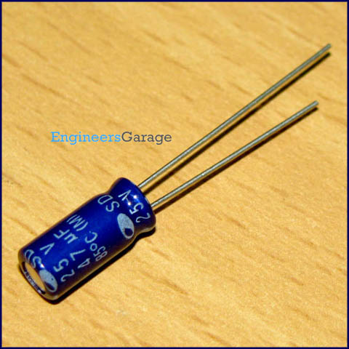

Capacitor is a passive component used to store charge. The charge (q) stored in a capacitor is the product of its capacitance (C) value and the voltage (V) applied to it. Capacitors offer infinite reactance to zero frequency so they are used for blocking DC components or bypassing the AC signals. The capacitor undergoes through a recursive cycle of charging and discharging in AC circuits where the voltage and current across it depends on the RC time constant. For this reason, capacitors are used for smoothing power supply variations. Other uses include, coupling the various stages of audio system, tuning in radio circuits etc. These are used to store energy like in a camera flash.

Capacitors may be non-polarized/polarized and fixed/variable. Electrolytic capacitors are polarized while ceramic and paper capacitors are examples of non polarized capacitors. Since capacitors store charge, they must be carefully discharged before troubleshooting the circuits. The maximum voltage rating of the capacitors used must always be greater than the supply voltage. Click to learn more about working of a capacitor along with its internal structure.

Pin Diagram:
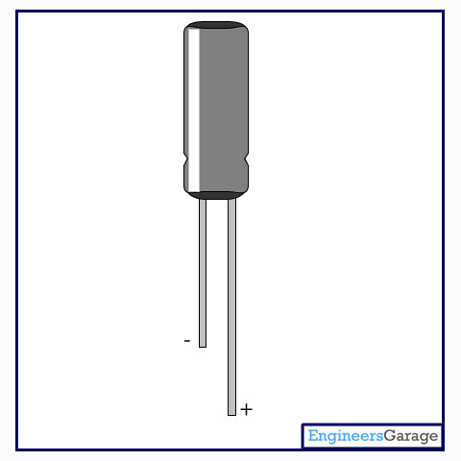

Insight - How Capacitor works

Table of Contents:
- Insight - How Capacitor works
- Internal Structure
- Metal Electrodes
Capacitor is a widely used electronic component. It stores electric charge and then discharges it into the circuit. It blocks the direct current and allows the alternating current to pass through it. Depending on the purpose, there are a variety of capacitors being used like ceramic, electrolytic, mylar, mica, etc. We will explore an electrolytic capacitor through this article.

Structure of a Capacitor: A capacitor contains two conductor plates which are generally made of metal and an insulator between them. This insulator also known as dielectric is made up of material like paper, plastic, ceramic or glass. The two plates are electrically connected to the external circuit with the help of two thin metal rods also known as the legs of the capacitor.

These two plates are used to store charge between them. One is connected with positive voltage and other one with negative voltage. A capacitor is characterized by the parameter capacitance. Capacitance is measured as ratio of difference of charges between the plates and total voltage drop between the plates.
C = dQ/dV
The unit of capacitance is FARAD.
Let’s have a closer look into the structure and how a capacitor is able to store charge.

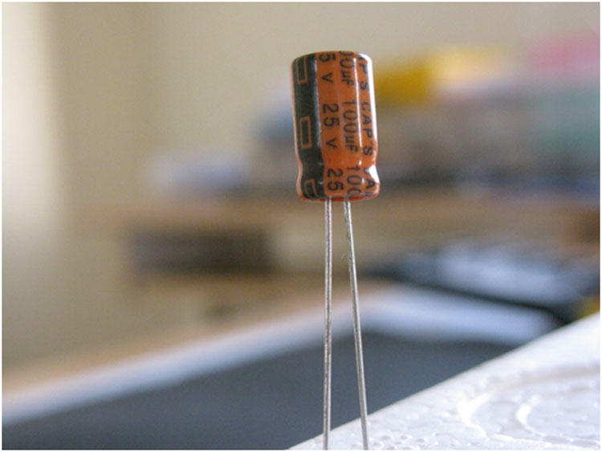

The above image shows a simple electrolytic capacitor with two thin rods coming out from the cylindrical container. The capacitor is wrapped up using a plastic covering. This covering is done to label the capacitor.
Metal Container

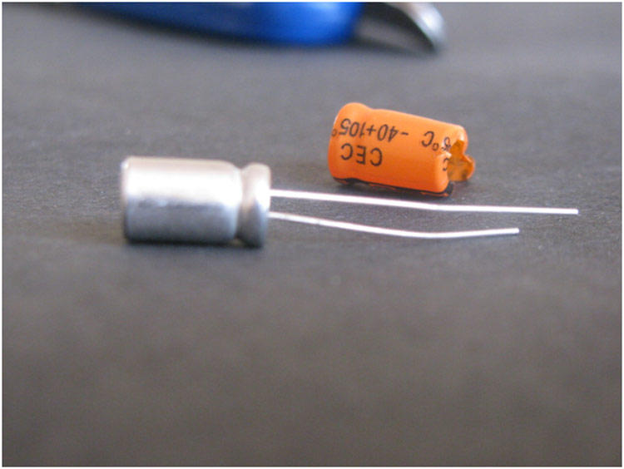

On removing the label, you can see a metal container adjoined with a rubber stand to hold the entire setup.
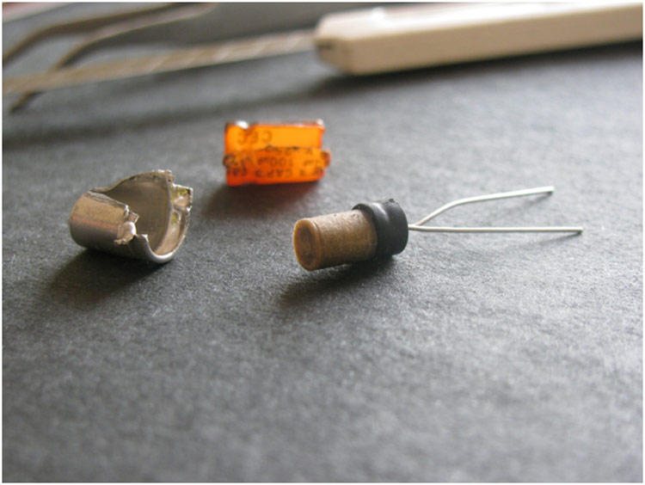

Inside the metal case is a folded layer of dielectric in between metal plates. Next images give a clear perception of the internal structure of the capacitor.
Dielectric

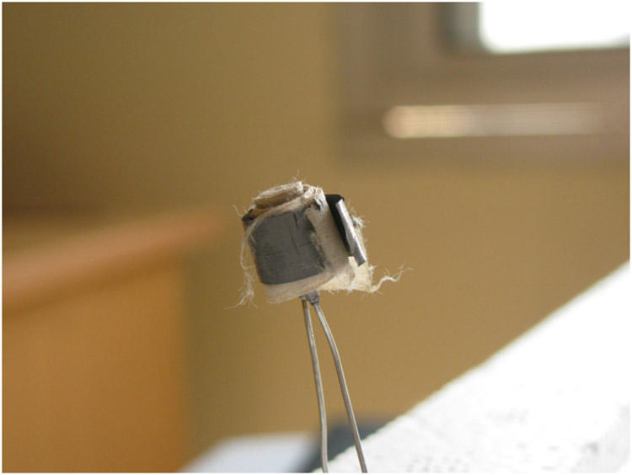

In the above image, we can clearly see two different types of layers, folded like a swiss roll. A dielectric layer is sandwiched between two metal plates. These metal plates are used to store charge and the dielectric works as an insulator between them. These plates are folded round to minimize the size of the capacitor.

One plate works as cathode and another as anode. To increase the value of a capacitor and the same time to keep the size smaller, we use electrolyte. However depending on the size and application, there are different types of electrolytes used in different ways within a capacitor.Generally, anode is soaked into liquid electrolyte to increase the surface area of the plate as well as efficiency.

Unfolding these plates brings us even closer to the internal architecture of the Capacitor.

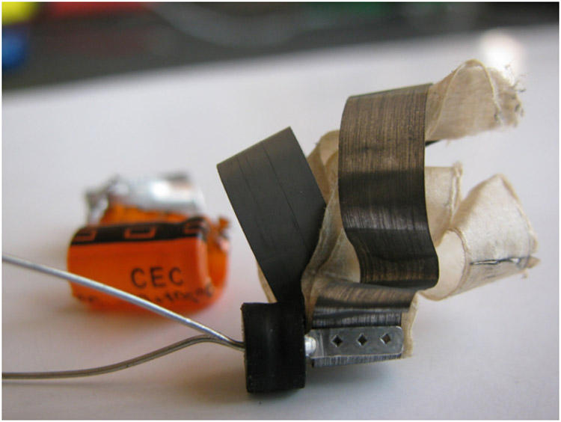

Now, you can see that the plates are directly connected to the legs of capacitor and a rubber stand is used to hold these plates.

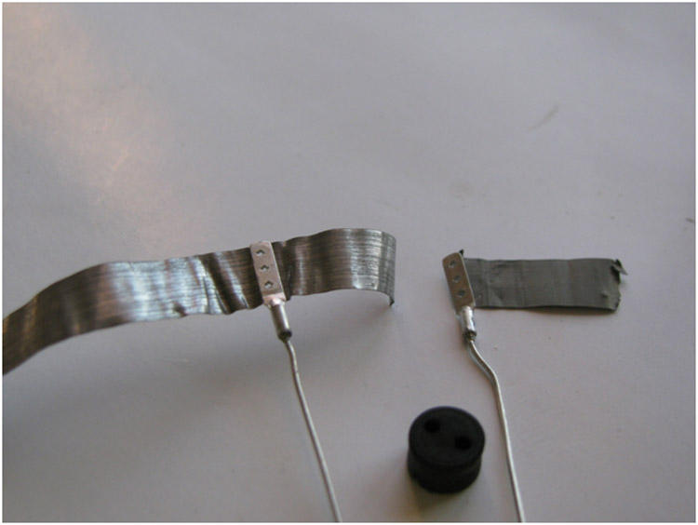

Lastly to summarize the building block of a capacitor includes a pair of metal plates, thin rods, a dielectric, a rubber stand, a metal container and a plastic covering.

