Resistor
CP001
Image:
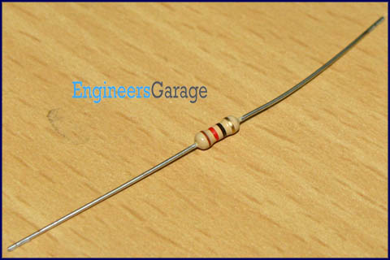
Resistor is a passive component used to control current in a circuit. Its resistance is given by the ratio of voltage applied across its terminals to the current passing through it. Thus a particular value of resistor, for fixed voltage, limits the current through it. They are omnipresent in electronic circuits.

The different value of resistances are used to limit the currents or get the desired voltage drop according to the current-voltage rating of the device to be connected in the circuit. For example, if an LED of rating 2.3V and 6mA is to be connected with a supply of 5V, a voltage drop of 2.7V (5V-2.3V) and limiting current of 6mA is required. This can be achieved by providing a resistor of 450 connected in series with the LED.

Resistors can be either fixed or variable. The low power resistors are comparatively smaller in size than high power resistors. The resistance of a resistor can be estimated by their colour codes or can be measured by a multimeter. There are some non linear resistors also whose resistance changes with temperature or light. Negative temperature coefficient (NTC), positive temperature coefficient (PTC) and light dependent resistor (LDR) are some such resistors. These special resistors are commonly used as sensors. Read and learn about internal structure and working of a resistor.

Pin Diagram:
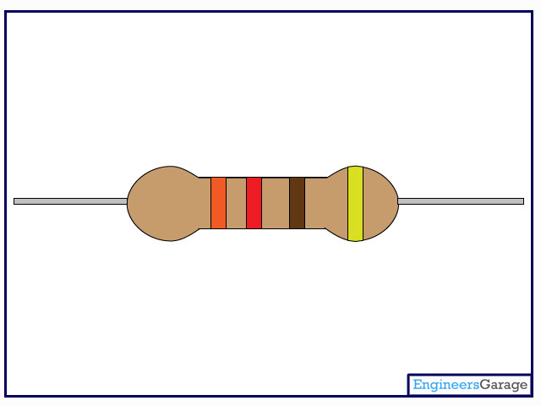

Insight - How Resistor works

Table of Contents:
- Insight - How Resistor works
- Outer Coating
- Metal Cap terminals
- Ceramic Capsule
Carbon Film Resistor
Resistors are one of the most crucial parts of any circuit. They vary from micro-ohms to mega-ohms in terms of their value. Also, they come in various forms like embedded as a chip in an IC, can be a bare metal or can be in form of a conductive plastic. This Insight will give a detailed exploration of carbon film resistor which has a ceramic core.

Outer Structure
Resistor looks like a solid capsule with leads at both ends which are used to connect it to the circuit.
On the capsule body, there are colored bands, typically four to six in number which tells the value of the resistance.

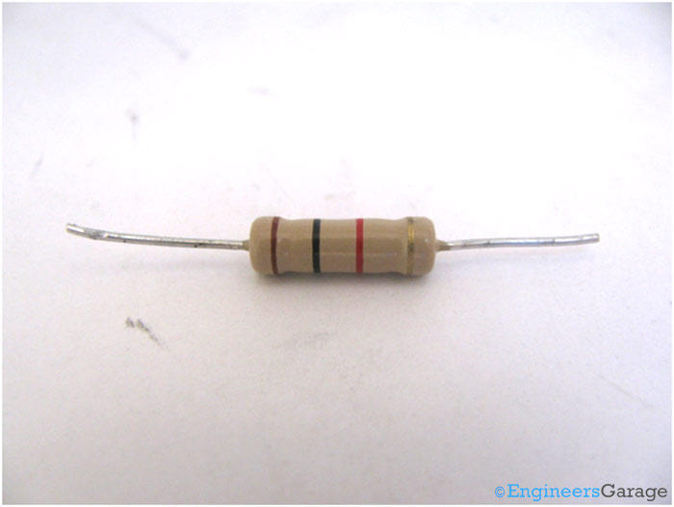

The resistance of the given resistor is 1000 ohm +/-5% tolerance.
It is interesting to know that the temperature coefficient is in ppm instead of being in °C . This can be explained using a simple example. Consider a resistor with a rating 30 ppm for its temperature coefficient. This means that for every 1°C rise in temperature, the resistance would not change more than 30/10000000 or 0.000030 ohms.
Outer Coating
The outer coating and color bands are composed of silicone conformal coating. This coating protects the resistor from high temperatures, moistures and thermal shocks, hence keeping the resistor intact and increasing working tendency at various ambient conditions.

The coating is very firmly adhered to the surface and cannot be easily removed using mechanical forces. Under the coating is the heat conducting ceramic covered with a carbon film that has a metallic alloy wiring engraved over it. This alloy wiring is the one that functions as per the specifications of the resistance.

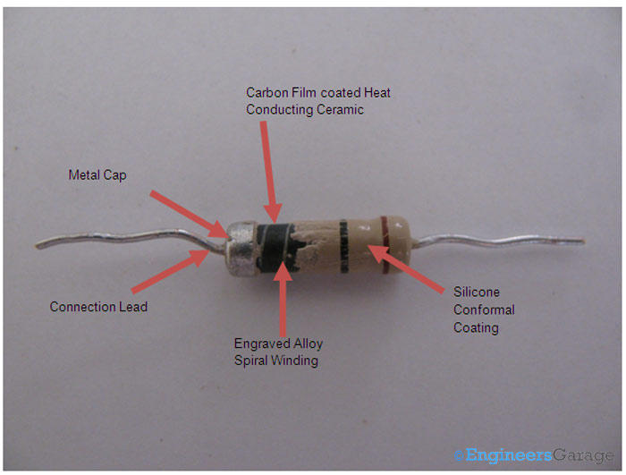

Metal Cap Terminals
When the coating is scrapped off from the terminals, two metal caps are seen fixed over the ceramic element at its ends. These metal caps form the electrical connections of the resistor with the circuit and vice versa.

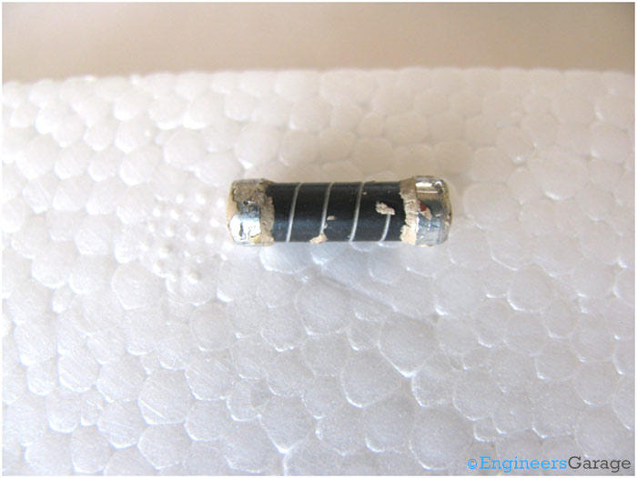

The metal caps are tightly attached to the capsule and the silicone coating tightens the bond even more. The leads are welded to the caps and hence both of them aid in sustaining electrical connections with the circuit.

Ceramic Capsule
After the caps are removed, carbon film covering a ceramic cylinder can be seen as a solid cylinder that has metal alloy wire embedded on it. The carbon film is closely adhered to the ceramic cylinder, making the wires strongly positioned. At the ends, where the caps were attached, there are no wires, indicating that they connect to the metal caps which through the lead connections complete the electric circuit.

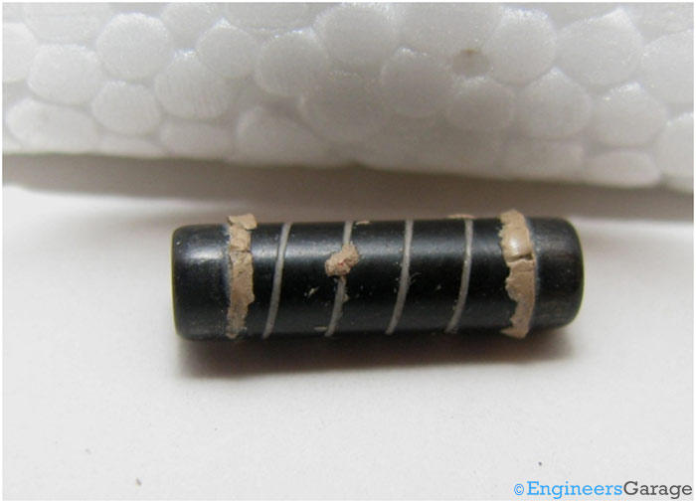

When the capsule is opened further, a solid internal structure of white ceramic is found as can be seen in the next image.

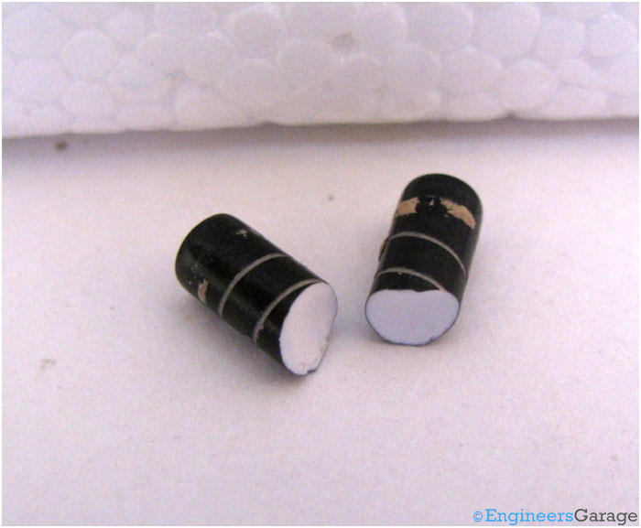

The ceramic works as a heat conductor and can handle thermal stress very well so that the desired resistance levels can be obtained and maintained across the resistor. Heat dissipation capacity of the resistor will increase with the thickness of the ceramic capsule. Resistance is dependent on the length of the metal alloy wire.

