2015
Prepared by:
Computronics Lab
3/3/2015
CELAB Work Shop and Students Training Manual
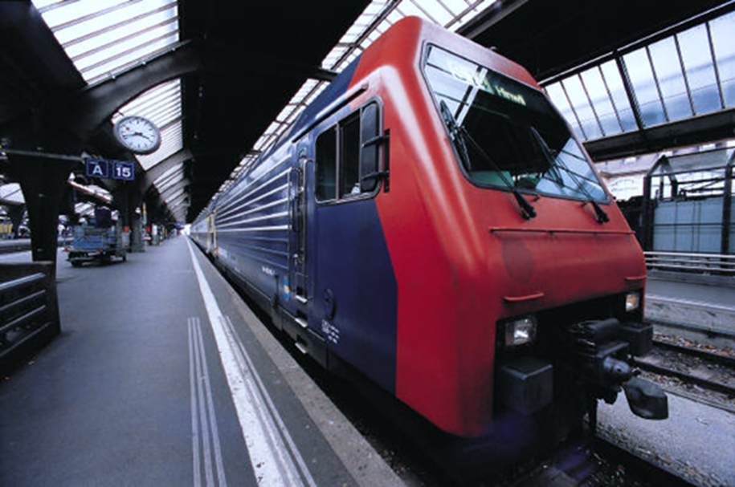

Contents
1 Basic Electronics 3
1.1 Electronic Components 3
1.2 Bread Board 3
1.2.1 Items Used 3
1.2.2 Internal Connection 4
1.2.3 Mini Projects on Bread Board (Any 2) 4
1.3 Soldering 8
1.3.1 Items Used 8
1.3.2 During Soldering 8
1.3.3 Mini Projects with Soldering (Any 2) 9
2 PCB Designing 10
2.1 Eagle win 10
2.1.1 Installation and Setup 10
2.1.2 Eagle Win Tool Bar 10
2.1.3 Creating Schematic Diagram 10
2.1.4 Creating PCB Layout 10
2.1.5 Make Mini Projects on Eagle Win (Any 2) 10
2.2 Toner Transfer Method 10
2.2.1 Items Used 10
2.2.2 PCB Etching Process 10
2.3 Make Mini Projects with PCB Etching (Any Two) 11
3 8051 Programming 11
3.1 Introduction to 8051 Microcontroller 11
3.2 Pin Diagram 12
3.3 Pin Description 12
3.4 General Basic Circuit 14
3.5 Introduction to Keil Compiler 14
3.5.1 Installation and Setup 14
3.5.2 Steps of Making a New Project in Keil 14
3.5.3 Sample Program of Led Blinking 14
3.5.4 Software Description 14
3.5.5 Variation in Led Blinking (by Student) 15
3.6 AVR Programmer for 8051 Program Uploading 15
3.6.1 Installation and Setup 15
3.6.2 Connection with 8051 15
3.6.3 Uploading the Hex File 15
3.7 Interfacing Modules with 8051 (Any 5) 15
3.8 Interfacing Motor Driver with 8051 15
3.9 Interfacing DTMF Module with 8051 16
3.10 8051 Interfacing with LCD 16
3.11 8051 Interfacing With IR Module 17
3.12 8051 Interfacing With Keypad 18
3.13 Projects based on 8051. 19
4 Arduino Programming 19
4.1 Pin Diagram 19
4.2 Ports of Atmega328 19
4.3 Installing Arduino Ide 19
4.4 Uploading Programs to Arduino 19
4.5 Interfacing Modules with Arduino (Any 5) 19
4.6 Arduino Interfacing with Motor Driver 20
4.7 Arduino Interfacing with LCD 21
4.8 Projects based on Arduino 22
5 Robotics 23
5.1 Introduction to 10 Components Used To Make a Simple Robot 23
5.2 Making Different Chassis Basis 23
5.3 Using Basis Modules Require For Robotics 23
5.4 Make Robots Using Arduino Uno Board (Any 3) 23
6 Demo Projects to Display 23
6.1 Remote Control Motor On Off 23
6.2 Wireless Power Transmission 23

Basic Electronics

Electronic Components
- Led
- Diode
- Resistor
- Capacitor
- Transistor
- Dc Motor
- Transformer
- Switch
- Connectors
- PCB
- IC’s/ IC Base
- Variable Resistor
- LDR
- Condenser Mic
- Speaker/Buzzer
- 7 Segment Display
- Relay
- MOSFET (IRF 540)
- IR LED (TX And RX)
- Bridge Rectifier IC

Bread Board

Items Used
- Both Side Male Connector
- Battery Connector
- 9 Volt DC Battery
- Bread Board Wires
- Electronic Components

Internal Connection

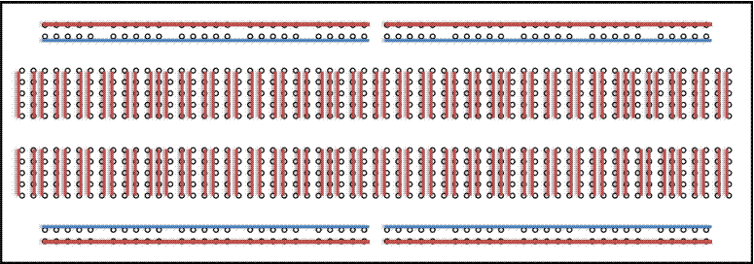

Mini Projects on Bread Board (Any 2)
NAME OF MINI PROJECT | PATH
Automatic Street Light | embedded-projects\pcb_designs\mini_projects
Clap Switch | embedded-projects\pcb_designs\mini_projects
Object Counter | embedded-projects\pcb_designs\mini_projects
Melody Generator Using UM 66 | embedded-projects\pcb_designs\mini_projects

Automatic Street Light

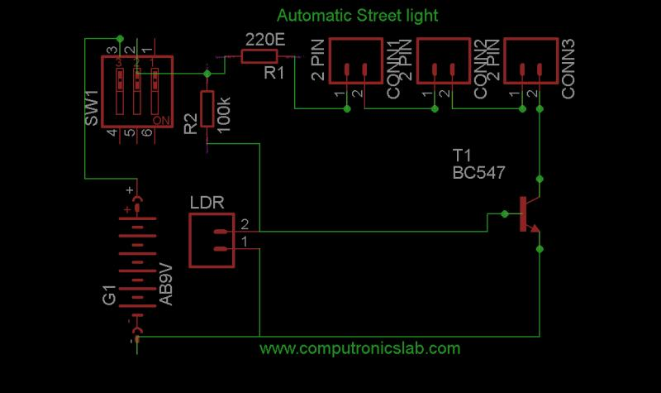

Clap Switch

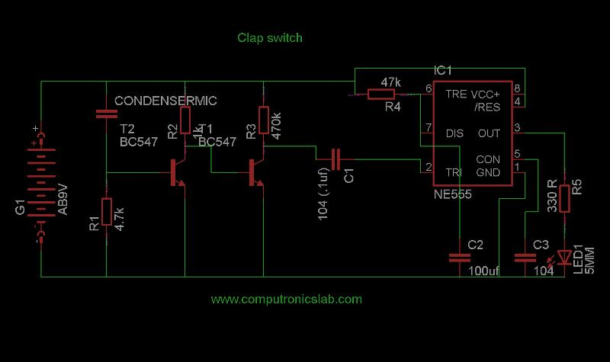

Object Counter

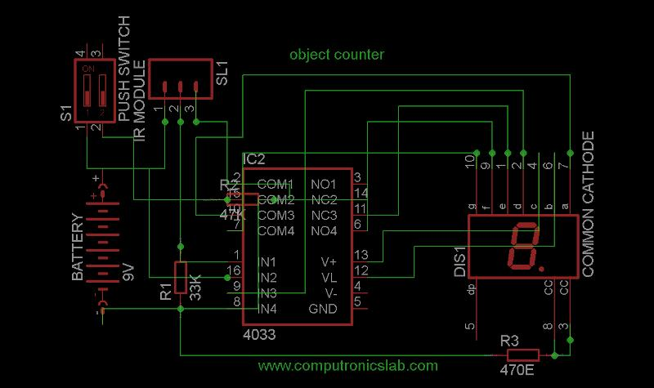

Melody Generator

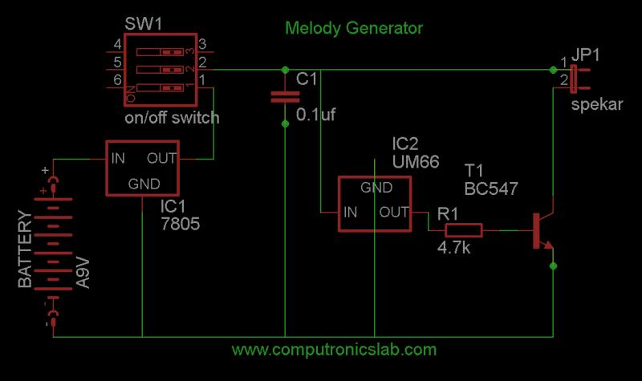

Soldering

Items Used
- Soldering Paste
- Soldering Iron
- Soldering Wire
- Zero PCB

During Soldering
DO’S
- Always Unplug the Soldering Iron When It Is Unattended
- Be Careful To Keep Clothes, Hair, Power Cables and Skin etc. Away From the Soldering Iron Tip and the Metal Shaft
- Always Handle the Iron By the Plastic Handle

DON’T’S
- Wipe tips dry.
- Overheat while cleaning
- Strike tip on holder.

Mini Projects with Soldering (Any 2)

NAME OF MINI PROJECT | PATH
Automatic Street Light | embedded-projects\pcb_designs\mini_projects
Clap Switch | embedded-projects\pcb_designs\mini_projects
Object Counter | embedded-projects\pcb_designs\mini_projects
Melody Generator Using UM 66 | embedded-projects\pcb_designs\mini_projects

PCB Designing

Eagle win

Installation and Setup
- Copy the .exe application setup of eagle win software from share folder.
- Run the setup on your system (double click on the exe application file)
- Click on the setup button to unzipping and installation of software.
- A welcome window will appear on your system after that click next.
- A software license agreement window will appear on your system click yes to continue the installation.
- In Choose destination directory window select the folder in which you want to install the setup.
- Now a start copying window will appear click on next to continue.
- In copying files window after copying 100% eagle license window will appear in which please click on run as freeware radio button to continue.
- Eagle setup is now complete window will appear in which click finish to complete the installation.
- After completing installation create a shortcut of application file in desktop to easily access the software whenever you need to design any circuit diagram.

Eagle Win Tool Bar
- Double click on shortcut to open the control panel window of eagle win.
- Now the following items will appear in the top most corner of the control panel file, view, windows and help.
- In control panel window in the topmost left corner click on file >new>project>give a proper name to your project.
- Right click on your given folder name>new>schematic now a schematic window will appear where you can create your schematic of desire circuit.

Creating Schematic Diagram
- The add tool on the left toolbar in schematic window is what you will use to place the every single component on the schematic.
- The add tool open up a library navigator where you can expand specific library and at the parts it holds .
- With a part selected on the left side the view on the half right side will update to show both the schematic symbol of the parts and its package.
- The add tool also has a search functionality in which you can find any desire component and its package by typing the appropriate keyword of the component.
- If after typing the name of electronic component you still are not able to access the library component then in schematic window, in the top of window click on the library option and inside it click on update all option and try again to add component.
- After selecting the part you want to add, it’ll “glow” and start hovering around following your mouse cursor. To place the part, left-click (once!)
- Right now your schematic is an untitled temporary file living in your computer’s so click on file >save with proper name in the desire directory.

Creating PCB Layout
- To switch from the schematic editor to the related board simply click the generate switch to board commands on the top toolbar.
- All the parts you added from the schematic should appear here.
- Arrange these entire components as much as possible for reliable routing.
- Check is to make sure you’ve actually routed all of the nets in your schematic for this hit the ratsnest icon and then immediately check the bottom left status box. If you’ve routed everything, it should say “Ratsnest: Nothing to do!”
- Now use the auto routing command in toolbar to route the schematic don’t worry about all other command appear in the small window open after clicking the auto router option just you need to set 1 in the top option in the radio button and bottom N/A.
- If you don’t like the job of auto router just hit the undo button to reach at your previous step.

Make Mini Projects on Eagle Win (Any 2)

NAME OF THE PROJECTS | PATH
Clap Switch | embedded-projects\pcb_designs\mini_projects
Object Counter | embedded-projects\pcb_designs\mini_projects
Automatic Street Light | embedded-projects\pcb_designs\mini_projects
Melody Generator Using Um66 | embedded-projects\pcb_designs\mini_projects

Toner Transfer Method

Items Used
- Electric Iron
- Glossy Paper
- FeCl3 Solution
- Laser Printer
- BRD File
- Copper Clad Board
- PCB Drill Machine

PCB Etching Process
- Print The Design Board File Pattern Using The Darkest Laser Printer Setting.
- Cut the Pattern out Using Scissors Leaving at least 1/8 Inch to ¼ Inch of Extra Paper.
- Cut The Copper Clad Board Of Size Same As Pattern.
- Scrub The Copper Clade Board Using Sand Paper.
- Lay The Copper Clad Board On A Rigid, Flat, Heat Resistant Surface.
- Lay The Paper Pattern Face Down On The Copper.
- Place the Clothes Iron on the Back of the Pattern Hold the Iron On The Whole Pattern For 1/3 Minutes or More Pressing Firmly.
- After The Board Is Well-Heated Place The Rear Of The Iron Along An Edge Of The Board (With The Rest Of The Iron On The Board), And Press Hard Near The Rear Of The Iron's Handle.
- Pick Up The Board And Drop It Into Hot Water.
- Peel Off The Paper If The Paper Underneath Is Still A Little Dries, Put The Board Back Into The Water, For Another Ten Minutes Or More.
- Rub The Remaining Paper Off, With Thumb Pressure Usually; Almost The Entire Paper Residue Comes Off.
- Rinse The Board And Wipe The Board Dry With A Clean Paper Towel Make Any Necessary Corrections, Using A Sharpie Or Other Etch-Resistant Permanent Black Marker Pen.
- Use Ferric Chloride, In A Tupperware-Style Plastic Food Container, In A Sink Of Hot Water. Hold It Flat and Push It Up And Down Vertically. Don't Get the Etchant on Anything Else, Especially A Good Stainless-Steel Sink or Your Clothing.
- Wipe And Flush Any Accidental Spills With Lots Of Water, Immediately. The Ferric Chloride Will Also Stain Your Skin. Wash It Off Immediately, If Possible.

Make Mini Projects with PCB Etching (Any Two)

NAME OF THE PROJECTS/MODULES | PATH
Clap Switch | embedded-projects\pcb_designs\mini_projects
Object Counter | embedded-projects\pcb_designs\mini_projects
Automatic Street Light | embedded-projects\pcb_designs\mini_projects
Melody Generator Using Um66 | embedded-projects\pcb_designs\mini_projects

8051 Programming

Introduction to 8051 Microcontroller
- A Highly Integrated 40 Pin Single Chip With All The Peripherals Like Ram, ROM,I/O Ports, Timers Etc.
- 8 Bit Microcontrollers (Perform 8 Bit Arithmetic And Logical Operation) Design By Intel.
- 32 General Purposes Register Each Of 8 Bits.
- Four Parallel Ports Each Of 8 Bits (Port0, Port1, Port2, And Port3).
- One Full Duplex Serial Communication Port
- 128 Bytes One Chip Data Memory (Ram).
- Kb One Chip Program Memories (Rom).
- 8 Bit Data Bus.
- 16 Bit Address Bus.
- 2 16 Bit Timers.
- Five Interrupts (3 Internal and Two Externals).

Pin Diagram
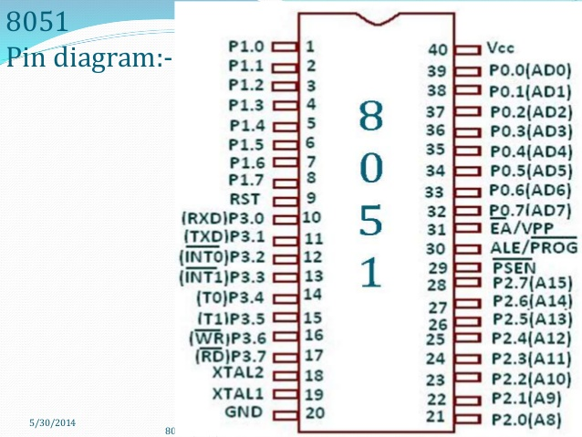

Pin Description
PIN | DESCRIPTION
9 | Pin 9 Is The Reset Pin Which Is Used To Reset The Microcontroller’s Internal Registers And Ports Upon Starting Up.  (Pin Should Be Held High For 2 Machine Cycles.)
18 and 19 | The 8051 Has A Built-In Oscillator Amplifier Hence We Need To Only Connect A Crystal At These Pins To Provide Clock Pulses To The Circuit
PIN 40 and 20 | Pins 40 And 20 Are VCC And Ground Respectively. The 8051 Chip Needs +5v 500ma To Function Properly.
PINS 29, 30 & 31 | Pin 29 Is Called PSEN. This Is "Program Store Enable". In Order To Use The External Memory It Is Required To Provide The Low Voltage (0) On Both PSEN And EA Pins  Pin 30 Is Called Ale (Address Latch Enable), Which Is Used When Multiple Memory Chips Are Connected To The Controller And Only One Of Them Needs To Be Selected. We Will Deal With This In Depth In The Later Chapters.  As Described In The Features Of The 8051, This Chip Contains A Built-In Flash Memory. In Order To Program This We Need To Supply A Voltage Of +12v At Pin 31. If External Memory Is Connected Then Pin 31, Also Called EA/VPP, And Should Be Connected To Ground To Indicate The Presence Of External Memory.
PORT P1 (Pins 1 to 8) | The Port P1 Is A General Purpose Input / Output Port Which Can Be Used For A Variety Of Interfacing Tasks. The Other Ports P0, P2 And P3 Have Dual Roles Or Additional Functions Associated With Them Based Upon The Context Of Their Usage. The Port 1 Output Buffers Can Sink/Source Four TTL Inputs. When 1s Are Written To Portn1 Pins Are Pulled High By The Internal Pull-Ups And Can Be Used As Inputs.
PORT P3 (Pins 10 to 17) | Port P3 Acts As A Normal Io Port, But Port P3 Has Additional Functions Such As, Serial Transmit And Receive Pins, 2 External Interrupt Pins, 2 External Counter Inputs, Read And Write Pins For Memory Access.
PORT P2 (pins 21 to 28) | Port P2 Can Also Be Used As A General Purpose 8 Bit Port When No External Memory Is Present, But If External Memory Access Is Required Then Port P2 Will Act As An Address Bus In Conjunction With Port P0 To Access External Memory
PORT P0 (pins 32 to 39) | Port P0 Can Be Used As A General Purpose 8 Bit Port When No External Memory Is Present, But If External Memory Access Is Required Then Port P0 Acts As A Multiplexed Address And Data Bus That Can Be Used To Access External Memory In Conjunction With Port P2.

General Basic Circuit
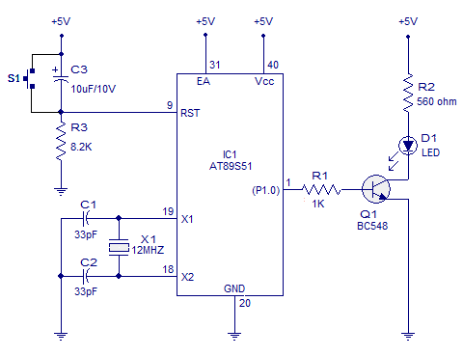

Introduction to Keil Compiler

Installation and Setup
- Copy the .exe application software from the share folder in your system.
- Run the .exe application.
- A welcome window will appear click next.
- A license agreement window will appear please tick on checkbox I agree to all the terms of the preceding license agreement and click next to continue.
- A folder selection window will appear to select your desire folder in which you want to install your keil compiler and click next to continue.
- A customer information window will appear please fill the necessary information required to continue and click next.
- Set up is now begin to install please wait for few minutes to completely install the setup.
- Now in keil micro vision setup completed window just click finish to complete the installation.
- You can see a shortcut will appear in your desktop if not just visit in the folder where you have saved keil exe file and create a shortcut in desktop to use the software frequently.

Steps of Making a New Project in Keil
- Open the keil compiler window.
- Click on the project option in the top of tools menu.
- Click on the close project now the current project will be close.
- Again click on the project option and inside this click on new µvision project and now create the folder for your new project in desire location and save it.
- A select device for target window will appear after saving in this click on the ATMEL and select the desire 8051 µcontroller on which you are going to program and click ok to continue.
- A small window with message “copy STARTUP.A51 to project folder and add file to project”? Will appear please click yes to continue and after that you can see a target folder will appear in the leftmost corner and within it there is two subfolder source group and STARTUP.A51.
- Click on the file to left top corner and inside this click new a new text window will open.
- Write the necessary software here and save it by visiting in file and click on save option, here it make sure that the folder which appear to save is the same folder which you have created and having three file .plg ,.uvproj and .A51.
- Give the proper name of the file with extension .c and save it.
- In compiler window right click on source group and click on the add existing file to group source a text file with extension .c will be appear click on that add it and close .
- You can observe the added file after adding the .c file in the leftmost of compiler window.
- In order to create the hex file of your written program in c language click on the configure target option on top of the tools menu a small window will open in which fill the desire crystal oscillator value (11.0592 in case of 8051) inside that small window click on the output option and tick on create hex file checkbox and click ok to continue and close this window.
- Now compile your program clicking on rebuild all targets files and in the bottom of compiler window please check is there any compiling error or not if there is no any compiling error visit at your saved file location and check the hex file has been created or not.

Sample Program of Led Blinking
Name of the project Path
- Led blinking

Software Description
- #include<reg51.h> header file for 8051
- Void delay (unsigned int x) /* delay function*/
{
Unsigned int I,j;
for(i=0;i<x;i++)
for(j=0;j<=1275;j++);
}
- Single bit defining syntax in 8051
sbit led=P2^0;

Variation in Led Blinking (by Student)
- Toggle of all bits of a port
- Sequential blinking of led of a port.

AVR Programmer for 8051 Program Uploading

Installation and Setup
- Copy the installation setup software from shared folder and copy it in your system.
- Run the progisp.exe file in your system and install this software.
- After installing the software you need the driver to work with this so inside the avr+8051 folder which you have been copied open the folder> software and install the driver usbasp-windriver.2009-02-28.

Connection with 8051

8051 AVR

MOSI → MOSI
MISO → MISO
SCK → SCK
RST → RST
GND → GND

Uploading the Hex File
- After compiling your written program in c and creating hex file you need to upload it in 8051 ic for this open the avr programmer window and make sure that it is connected with your system.
- Right side of avr window clicks on command button to make visible all the hidden commands.
- Click on the erase chip option and see left side of window there will be display a message chip erase successfully
- Now in order to upload the hex file click on the load flash option and load the hex file from the folder where you have created it
- Last one you need to click on write flash to write that hex file in 8051.

Interfacing Modules with 8051 (Any 5)

Name | Source code path | pcb design path
Motor Driver |  | embedded-projects\pcb_designs\modules
DTMF |  | embedded-projects\pcb_designs\modules
LCD Module |  | Use original
IR Module |  | embedded-projects\pcb_designs\modules
Keypad |  | embedded-projects\pcb_designs\modules
7 Segment Display |  | embedded-projects\pcb_designs\modules
PIR Motion Sensor |  | Use original(connect VCC, GND, Out pin to 8051)
Relay Driver |  | embedded-projects\pcb_designs\modules

Interfacing Motor Driver with 8051

8051

P2.0
P2.1
P2.2
P2.3

M111
M2
Motor Driver

2 3
7 6
10 11
15 14

Interfacing DTMF Module with 8051

8051

P3.0 P2.0
P3.1 P2.1
P3.2 P2.2
P3.3 P2.3

M111
M2
Motor Driver

2 3
7 6
10 11
15 14
11 12 13 14

DTMF

8051 Interfacing with LCD

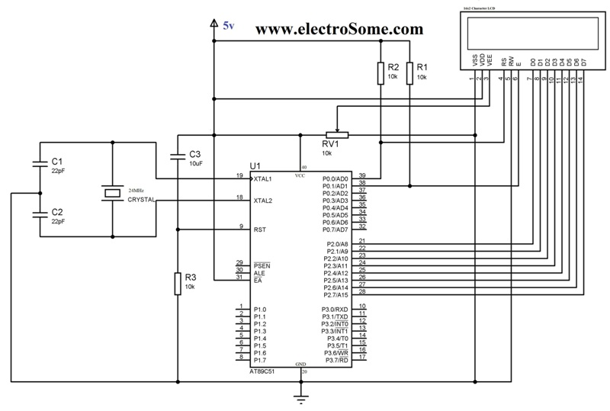

8051 Interfacing With IR Module

VCC GND OP
IR MODULE

8051 Interfacing With Keypad

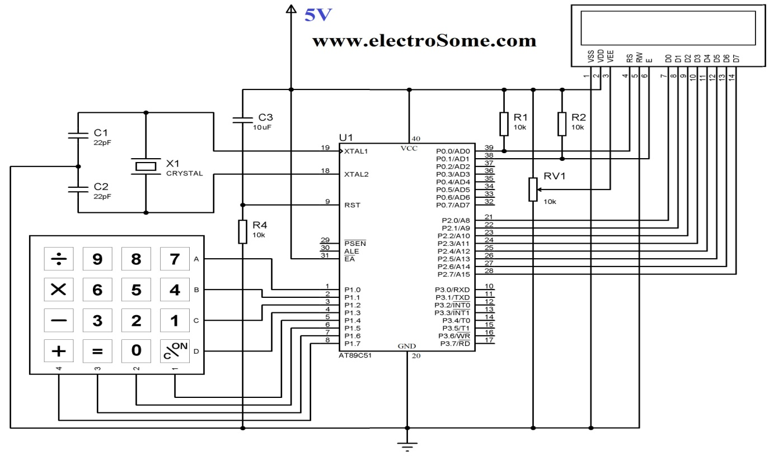

Projects based on 8051.

NAME OF THE PROJECT | PATH(source code) | PATH(pcb design)
Bidirectional Visitor Counter | embedded-projects\project_codes\8051\Projects | embedded-projects\pcb_designs\major_projects
PWM Motor Speed Control | G:\Celabcode\embedded-projects\project_codes\8051\projects | embedded-projects\pcb_designs\major_projects
Electronic Lock | embedded-projects\project_codes\8051\projects | embedded-projects\pcb_designs\major_projects
RS 232 Based Data Transfer | G:\Celabcode\embedded-projects\project_codes\8051\projects | embedded-projects\pcb_designs\major_projects

Bi directional visitor counter

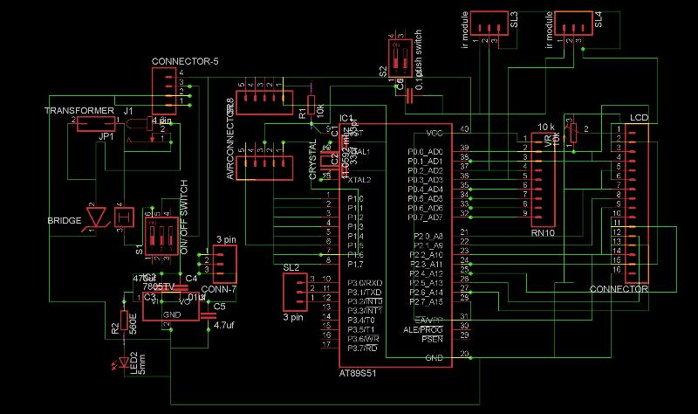

Pwm based motor speed control
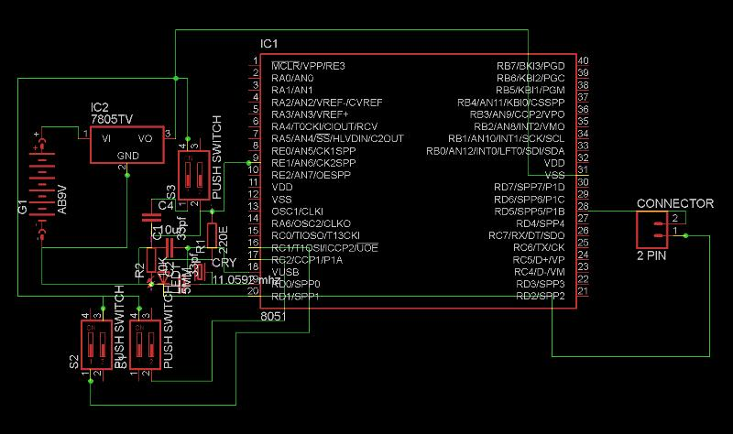

RS 232 Based Data Transfer
Circuit diagram not available in server
Electronic password lock
Circuit diagram not available in server

circuit diagram

Arduino Programming

Pin Diagram

Ports of Atmega328

Installing Arduino Ide

Uploading Programs to Arduino

Interfacing Modules with Arduino (Any 5)
- Motor Driver
- LCD Module
- IR Module
- 7 Segment Display
- DTMF Module
- Relay Driver
- Keypad
- PIR Motion Sensor

Arduino Interfacing with Motor Driver

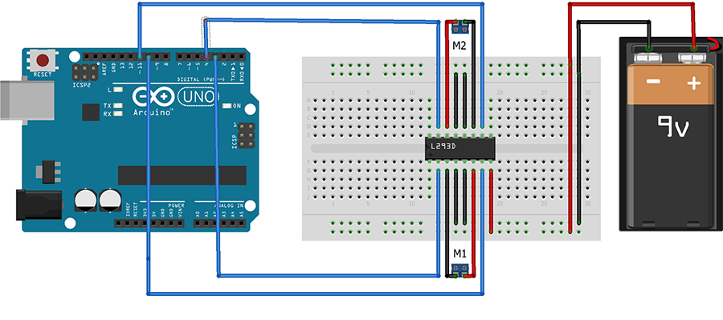
SOURCE CODE | PATH
ARDUINO INTERFACING WITH MOTOR DRIVER

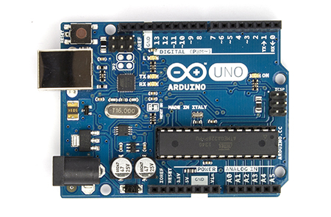
VCC O/P GND

IR MODULE

SOURCE CODE | PATH
ARDUINO INTERFACING WITH IR ODULE

Arduino Interfacing with LCD

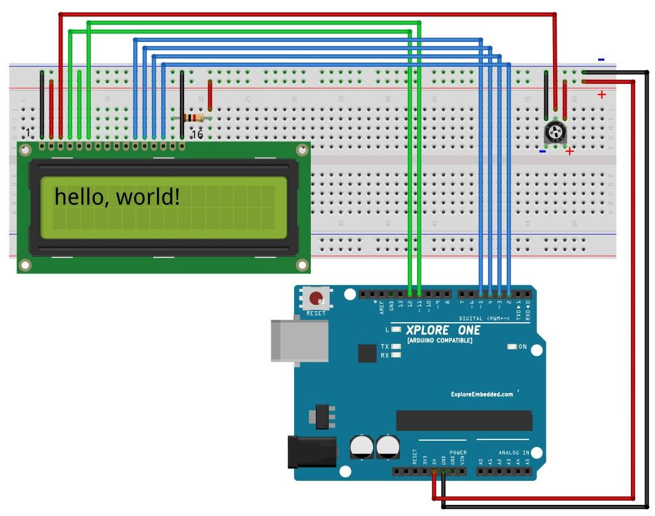

9VOLT
GND

SOURCE CODE | PATH
ARDUINO INTERFACING WITH LCD

ARDUINO INTERFACING WITH KEYPAD

Projects based on Arduino

NAME OF THE PROJECT | PATH
DTMF ROBOT | embedded-projects\project_codes\arduino\Projects
TEMPERATURE SENSOR USING LM 35 | embedded-projects\project_codes\arduino\Projects

Robotics

Introduction to 10 Components Used To Make a Simple Robot

L293D IC | FRONT WHEEL | WHEELS | CHACHIS | BATTERY
CONNECTORS | GEAR MOTOR

Making Different Chassis Basis

Using Basis Modules Require For Robotics
- MOTOR DRIVER
- IR MODULE
- LDR MODULE

Make Robots Using Arduino Uno Board (Any 3)

NAME OF THE PROJECTS | PATH
DTMF ROBOT | embedded-projects\project_codes\arduino\Projects
EDGE AVOIDING ROBOT | embedded-projects\project_codes\8051\Projects
LINE FOLLOWING ROBOT | embedded-projects\project_codes\8051\Projects

Demo Projects to Display

Remote Control Motor On Off

Wireless Power Transmission

