HT9170
CP052
Image:
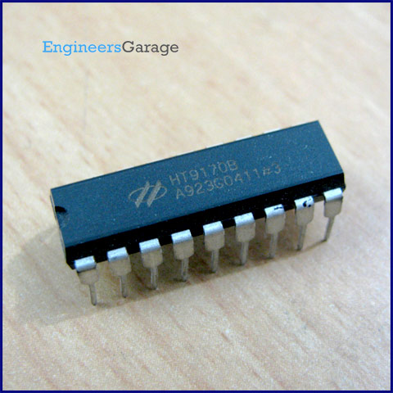
DataSheet:
HT9170 DTMF Decoder.pdf

HT9170 is the series of Dual Tone Multi Frequency (DTMF) receivers. They employ digital counting techniques to detect and decode the 16 DTMF tones into 4 bit output code.

HT9170 series receivers do not require any external filters as they use highly accurate switched capacitor filters for filtering low and high frequency signals from the DTMF tones. They also support power down (PWDN) and inhibit (INH) modes. PWDN mode is used to power off the crystal, while INH mode to inhibit the A, B, C & D DTMF tones. The clock is provided by a 3.58 MHz crystal.

In simple terms, HT9170 IC detects and decodes the 16 DTMF tones into 4 bit output. In case the tones are not detected, the four output bits remain low. The DV pin goes high on detection of a valid tone.

Pin Diagram:
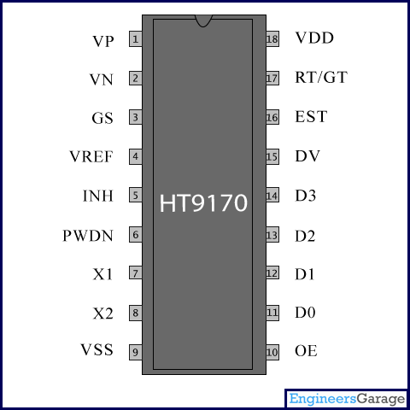
Pin Description:
Pin No | Function | Name
1 | Operational amplifier non-inverting input | VP
2 | Operational amplifier inverting input | VN
3 | Operational amplifier output terminal | GS
4 | Reference voltage output terminal | V_{REF}
5 | Active high. It inhibits the detection of tones corresponding to A, B, C and D. It is internally pulled down. | INH
6 | Active high. It leads the chip to power down mode and inhibits the oscillator. It is internally pulled down | PWDN
7 | Connection for standard 3.579545 MHz crystal | X1
8 | Connection for standard 3.579545 MHz crystal | X2
9 | Ground (0V) | V_{SS}
10 | Active high; Enables output D0-D3 | OE
11 | Output terminals | D0
12 | Output terminals | D1
13 | Output terminals | D2
14 | Output terminals | D3
15 | Data valid. It goes high on reception of valid DTMF signal; otherwise remains low | DV
16 | Early steering output | EST
17 | Tone acquisition time and release time can be set by using external resistor and capacitor | RT/GT
18 | Supply voltage; 5V (2.5V-5.5V) | V_{DD}

