ULN2003
CP057
Image:
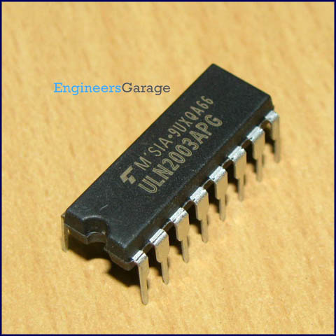
DataSheet:
ULN2003.pdf

ULN2003 is a high voltage and high current Darlington array IC. It contains seven open collector darlington pairs with common emitters. A darlington pair is an arrangement of two bipolar transistors.

ULN2003 belongs to the family of ULN200X series of ICs. Different versions of this family interface to different logic families. ULN2003 is for 5V TTL, CMOS logic devices. These ICs are used when driving a wide range of loads and are used as relay drivers, display drivers, line drivers etc. ULN2003 is also commonly used while driving Stepper Motors. Refer Stepper Motor interfacing using ULN2003.

Each channel or darlington pair in ULN2003 is rated at 500mA and can withstand peak current of 600mA. The inputs and outputs are provided opposite to each other in the pin layout. Each driver also contains a suppression diode to dissipate voltage spikes while driving inductive loads. The schematic for each driver is given below:
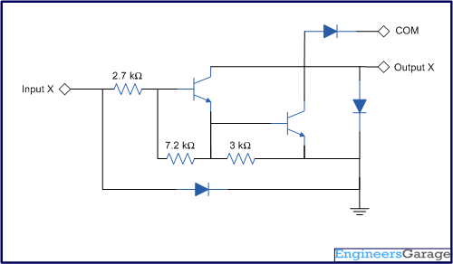

Pin Diagram:
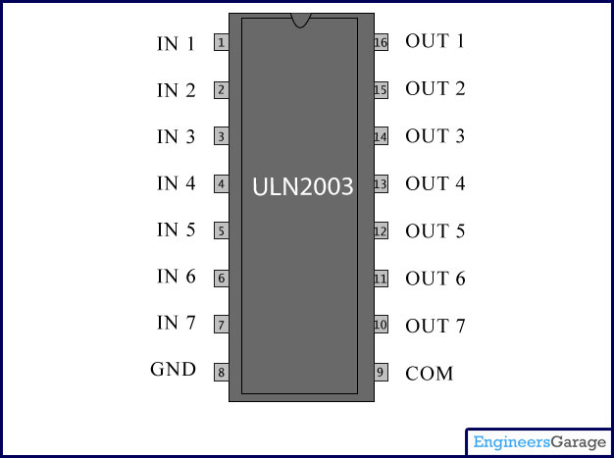
Pin Description:
Pin No | Function | Name
1 | Input for 1st channel | Input 1
2 | Input for 2nd channel | Input 2
3 | Input for 3rd channel | Input 3
4 | Input for 4th channel | Input 4
5 | Input for 5th channel | Input 5
6 | Input for 6th channel | Input 6
7 | Input for 7th channel | Input 7
8 | Ground (0V) | Ground
9 | Common free wheeling diodes | Common
10 | Output for 7th channel | Output 7
11 | Output for 6th channel | Output 6
12 | Output for 5th channel | Output 5
13 | Output for 4th channel | Output 4
14 | Output for 3rd channel | Output 3
15 | Output for 2nd channel | Output 2
16 | Output for 1st channel | Output 1

