Object-Oriented design and Analysis
Group
2
Library Administration System Project.
L ibrary System
User Guide
Library administration system project
Library System User Guide
Done by C206
C A Vijayan

Table of Contents
About System User Interfaces
Main Window 3
Add members 4
Add books 5
Borrowing Books 6
Returning Books 7
Transaction Records 8
Search 9
Important Notes 11
Designed by 12
About System User Interface

Main window
Below is the screenshot of main window.
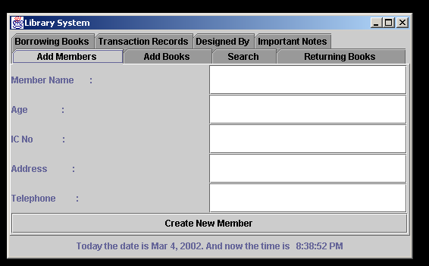
I
n the main window you can see all the panel names in the tab pane’s name. Each panel is for the corresponding function’s as mentioned in the name. Choose the panel for that function. We will see the each panels function and it’s operation details one by one.

Add Member’s Panel

In this panel, you can create new member account by enter the details of member. Below were the details that you need to enter in:
- Member’s Name
- Member’s Age
- IC Number
- Address
- Telephone number

Note:
Member’s ID number for using in library is member’s IC number.

Add Book’s Panel

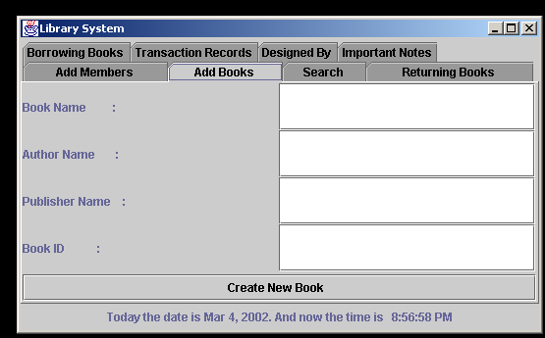
In this panel, you can create new book record by enter the details of book. Below were the details that you need to enter in:
- Book’s Name
- Book’s Author
- Book’s Publisher
- Book’s ID number
Note:
When you enter the book’s ID number make sure the number is not an existing number.

Borrowing Book’s Panel

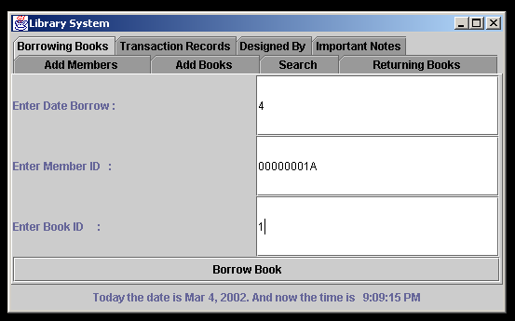
In this panel, you can borrow a book by entering the details. Below were the details that you need to enter in:
- Date Borrow
- Member ID
- Book ID
After you have entered the details a confirmation popup come (see below)
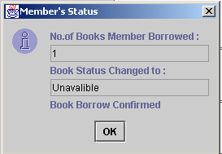

If the book is out of library a popup will come.
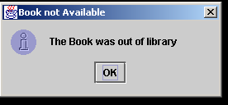

Returning Book’s Panel

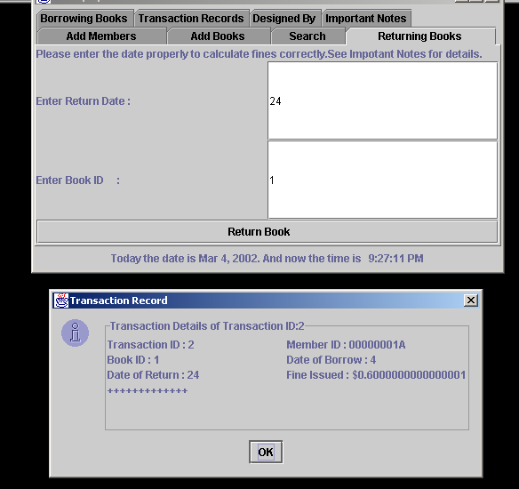
In this panel, you can return the books by enter the details. Below were the details that you need to enter in:
- Return date
- Book ID
When you enter the book’s ID number and return date it will calculate the fines and show the transaction details.
Note:
See the Important Notes panel for help on entering return date.

Transaction Record’s Panel

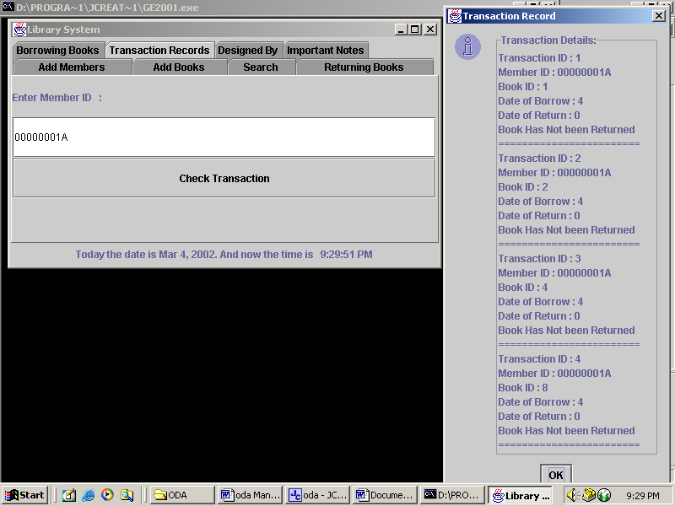
In this panel, you can check the transaction record of a member by enter the member ID.
Note:
When you enter the member’s ID number make sure you are entering as it is, because this system is case sensitive.

The result panel will be look like this:

Search Panel

In this panel, you can search records by enter the details of book or member. Below were the four options to search in the search panel:
- Book’s Name
- Book’s ID number
- Member’s Name
- Member’s ID number

- Book’s Name: When you search by the book need you need to enter the full book name.
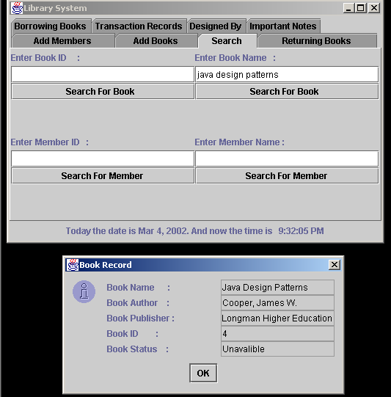
- Book’s ID: When you search by the book ID number need you need to enter the ID number only
.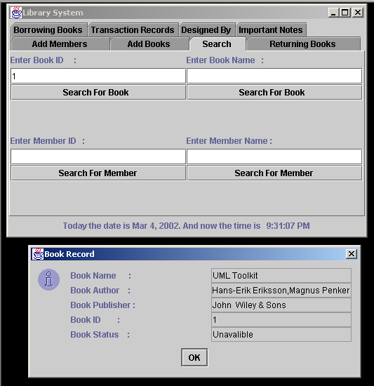

  - Member’s Name: Just by entering the member name you can find the details of the member.
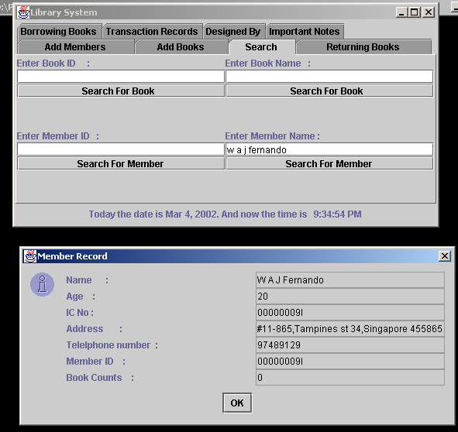

  - Member’s ID: Just by entering the member ID number you can find the details of the member.
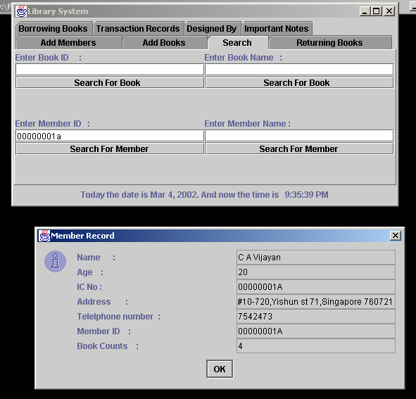

Important Notes Panel
In this panel, you can see some of the important notes that you need to keep in mind while using the system.

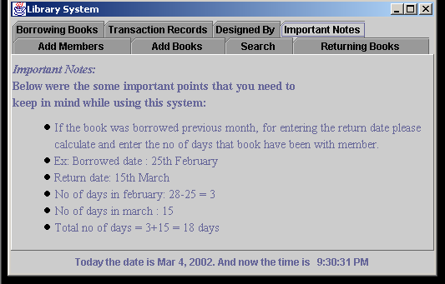

Designed by Panel

In this panel, you can see the details of our group.
